Case study

Sandrine

Counsellor
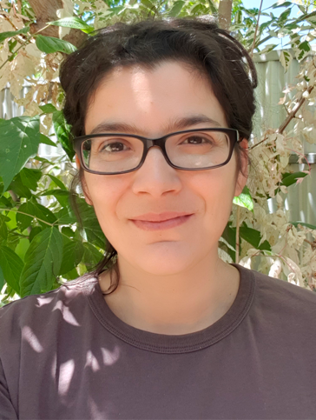
Arriving in Australia, Sandrine wasn’t sure what she wanted to do with her life.
However, some well-placed advice that she should add a counselling qualification to her art therapy background, led her to complete her Master of Counselling and Psychotherapy.
Sandrine is now a counsellor who has helped several clients share their story with the Disability Royal Commission.
“I really enjoy the holistic experience of the job. You are helping people grow in a healing space and in the process, you are also doing some growing yourself,” says Sandrine.
“In Australia, counselling is very much a partnership between counsellor and client. I am a guide – I help the client assess what they need in terms of wellbeing growth and goals, and we go from there.
“It’s a very individualised process and they are the master of that process – they have a voice about what they want to see happen and what makes them feel safe.”
As a migrant herself, Sandrine knows too well the stigma that can be associated with asking for help in some cultures.
“In some cultures, you don’t talk about your problems to a stranger. Some cultures also don’t believe in revisiting trauma,” Sandrine says.
“So sometimes we need to find a practical way of connecting before the client can feel comfortable talking – organising an event where food will be served, for example, as food is a high connector for CALD communities.”
Reflecting on the positive outcomes she’s seen from people reaching out for support, Sandrine highlights the importance of talking to someone who can relate to what it's like to move away from their country.
“Providing information about how the system works and addressing the stories they hear when migrating is very positive,” Sandrine says.
“Educating and supporting them to understand that you can be who you are with your language and culture, you just might need some help to navigate the system.”
Sandrine encourages anyone with disability, or their family members or carers, impacted by the issues being explored by the Disability Royal Commission to seek counselling support.
For more information visit: www.dss.gov.au/disability-royal-commission-support

