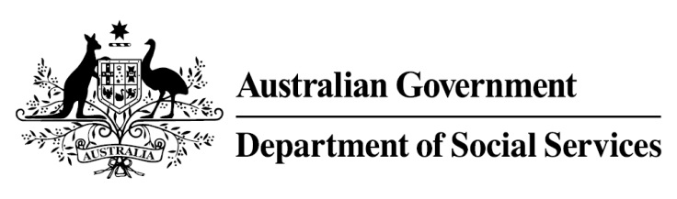

Try, Test and Learn Fund

Initiative: Online Business Lift-Off

Fast facts
Priority groups: Working-age carers and older unemployed persons
Participant numbers: 75
Location: Melbourne
Trial period: 14 months
Total funding: $0.74 million
Service provider: West Island Digital
Potential future saving:
If around 5 per cent of participants move off income support because of this project, the savings to the welfare system are likely to outweigh the costs of the project.

Location: Victoria

What are we trying to achieve?
This project aims to support participants to develop the skills and confidence required to set up an online business, or to work for an online business, as an alternative to traditional employment. It is directed at working-age carers and older unemployed people.

What is Online Business Lift-Off
Participants receive training in online business, including how to develop a viable business idea that aligns with their existing skills and strengths, and the skills and confidence needed to set up and grow their online business or to get a job working for an online business.
Individualised support, mentoring and coaching is provided to participants throughout the training and in the early stages of their online business.

What does the evidence tell us?
Working-age carers
- Carers face a number of barriers in accessing employment. In particular, they have limited time available to work due to caring responsibilities and as a result they are at elevated risk of long-term welfare dependence.
- On average, working-age carers who currently receive income support are likely to be on income support for some or all of 34 years over their lifetime.
- If nothing changes, 80 per cent of this group will be receiving income support payments in 10 years, and 73 per cent will be receiving income support payments in 20 years.
Older unemployed people
- Many older Australians want to work but find it difficult to get work. On average, older unemployed people currently receiving income support are likely to be receiving income support for some or all of 26 years over their lifetime.
- If nothing changes, 75 per cent will be receiving income support payments in 10 years, and 74 per cent will be receiving income support payments in 20 years.

How is this initiative new and innovative?
This project helps participants to identify their strengths and then match those strengths to an appropriate online business model. Participants receive training in line with those strengths enabling them to build confidence in their skills and to apply them in the online context; preparing them for the changing way in which work is done.
Using insights from the Priority Investment Approach, the $96.1 million Try, Test and Learn Fund is gathering evidence on new or innovative approaches to addressing barriers to work.
The Try, Test and Learn Fund will help achieve the objectives of welfare reform—that is, to develop a modern welfare system that increases the capacity of individuals, reduces the risk of welfare dependency and maintains a strong welfare safety net.

