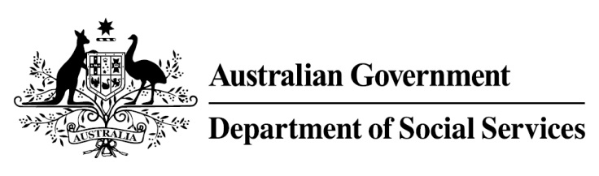

Try, Test and Learn Fund

Initiative: I Am Ready

Fast facts
Priority group: Other
Participant numbers: 90
Location: Gippsland and Latrobe
Trial period: 17 months
Total funding: $500,000
Service providers: Baw Baw Latrobe Local Learning and Employment Network Inc.
Potential future saving: This project is one that supports participants who for the purposes of the Try, Test and Learn Fund are classified as an ‘other’ group at risk of long-term welfare dependence, or are a sub-group of a priority group. This group of people was identified through the provider’s experience in working with vulnerable people, and other research. To date, potential future savings for this group have not been calculated using the Priority Investment Approach model. Such a calculation may be possible once we have data on participants in this project if an appropriate comparison group can be identified.

Location: Victoria

What are we trying to achieve?
An increase in the employment aspirations of students with disability as well as their parents, schools, and potential employers, that leads to real and lasting outcomes in further education or employment.

What is I Am Ready?
I Am Ready aims to help support secondary school students with a learning barrier or disability to achieve their employment goals by providing them with the knowledge, skills and opportunities to find work, or continue in vocational education and training.
The project takes place over three stages:
Stage 1: team building, industry visits, mock interviews and dressing for success, as well as career conversation workshops for parents and carers.
Stage 2: building understanding of employment-related strengths and interests, including work experience one day a week for a school term.
Stage 3: supported assistance to transition to school-based apprenticeships, vocational training and structured workplace learning, and after school employment.
The project will also provide disability awareness training to potential employers; and guidance to parents/carers on how to support students towards their employment goals.

What does the evidence tell us?
- We know that improving employment outcomes for people with learning barriers and disability will help in enhancing their quality of life, and will help to reduce their dependence on income support payments.

How is this initiative new and innovative?
The project targets a school-aged cohort that may have difficulty accessing employment opportunities after finishing their high school education. This includes students with learning barriers, who may not be eligible for support through Disability Employment Services. It develops future work aspirations of participants as well as their parents, carers and potential employers.
Using insights from the Priority Investment Approach, the $96.1 million Try, Test and Learn Fund is gathering evidence on new or innovative approaches to addressing barriers to work.
The Try, Test and Learn Fund will help achieve the objectives of welfare reform—that is, to develop a modern welfare system that increases the capacity of individuals, reduces the risk of welfare dependency and maintains a strong welfare safety net.

