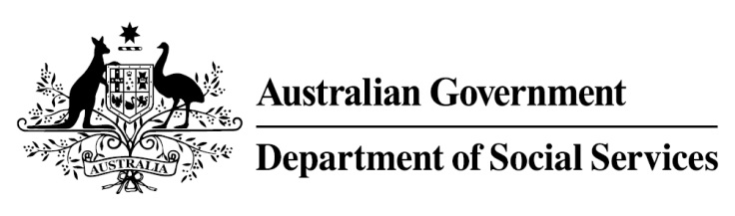

Try, Test and Learn Fund

Initiative: Demand-led education to employment in care
Location: New South Wales

What are we trying to achieve?
This project aims to support people aged 18-35 years old and who are at risk of long-term welfare dependence to build thriving, sustainable careers in the disability support and aged care sectors by developing a genuinely demand-led, holistic approach to training and employment.

Fast facts
Priority group: Other
Recipient numbers: 150
Locations: Sydney
Trial period: 18 months
Total funding: $1.16 million
Service provider: Generation Australia
Potential future saving: If around 22 per cent of participants move off income support because of this project, the savings to the welfare system are likely to outweigh the costs of the project.

What is Demand-led education to employment
in care?
Through this project, participants who have appropriate attitudes and values for employment in the disability support and aged care sector will receive targeted training, workplace support, and links to identified employment opportunities. Training in a group setting gives participants practical skills and knowledge for success along with a network of supportive peers.
Curriculum design begins when Generation Australia engage with employers to understand the behaviours and skills that are demonstrated by high-achieving staff. Generation Australia then develops training materials that prepare eligible candidates and provides mentoring and referral services to support participants through their critical first months and position them for long-term, sustainable employment in this high growth sector.

What does the evidence tell us?
- Young unemployed people face a variety of barriers to further education, training and employment.

- While some will face minimal barriers to engaging in further education or taking up employment opportunities, others will face a number of challenges to making a successful transition.

- If nothing changes, 38 per cent will be receiving income support payments in 10 years, and 29 per cent will be receiving income support payments in 20 years.

How is this initiative new and innovative?
Using insights from the Priority Investment Approach, the $96.1 million Try, Test and Learn Fund is gathering evidence on new or innovative approaches to addressing barriers to work.

The Try, Test and Learn Fund will help achieve the objectives of welfare reform—that is, to develop a modern welfare system that increases the capacity of individuals, reduces the risk of welfare dependency and maintains a strong welfare safety net.
This project engages with employers to identify their most needed requirements, pre-confirm vacancies, and
co-design curriculum so that participants can develop skills in hands-on group training. Generation matches participants to real employment opportunities and ensures that employers gain access to the highly skilled, motivated workforce they need.

