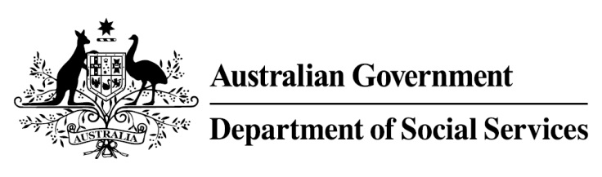

Try, Test and Learn Fund

Initiative: The Opportunity Account

Fast facts
Priority group: At-risk young people
Participant numbers: 100
Locations: Five communities in Cape York
Trial period: 15 months
Total funding: $2.13 million
Service provider: Cape York Institute
Potential future saving: This project is one that supports participants who for the purposes of the Try, Test and Learn Fund are classified as a sub-group of a priority group. This group of people was identified through the provider’s experience in working with vulnerable people, and other research. At this stage, potential future savings for this group have not been calculated using the Priority Investment Approach model. This calculation may be possible once we have data on participants, depending whether a comparison group can be identified on which to base those calculations.
Location: Queensland

What are we trying to achieve?
This project aims to support at-risk young people in Cape York, together with other members of their communities, to improve their capability and motivation to manage and earn money, and attend to their health and education needs.

What is The Opportunity Account
This project will design and trial a digital platform that uses behavioural drivers and incentives to encourage participants to improve their life circumstances.
The project will undertake an extensive engagement phase with young people in the local community to co-design a digital platform. Findings from the design phase will also determine the behaviours that will be incentivised and the drivers that will be used to encourage those behaviours. It could include sending out text message nudges or providing vouchers to encourage young people to use relevant available health services or to attend school.
Participants will also be encouraged to access existing Cape York Institute facilities including financial management, employment and case management services.

What does the evidence tell us?
- Young unemployed people face a variety of barriers to further education and employment. While some will face minimal barriers to engaging in further education or taking up employment opportunities, others will face a number of challenges to making a successful transition.
- If nothing changes, it is estimated that 44 per cent of 16-24 year olds residing in regional or remote Queensland who are currently receiving income support will be receiving income support payments in 10 years, and
36 per cent will be receiving income support payments in 20 years.

How is this initiative new and innovative?
This project integrates behavioural drivers and incentives into a digital platform that aims to encourage participants to make positive choices and improve their life circumstances.
Using insights from the Priority Investment Approach, the $96.1 million Try, Test and Learn Fund is gathering evidence on new or innovative approaches to addressing barriers to work.
The Try, Test and Learn Fund will help achieve the objectives of welfare reform—that is, to develop a modern welfare system that increases the capacity of individuals, reduces the risk of welfare dependency and maintains a strong welfare safety net.

