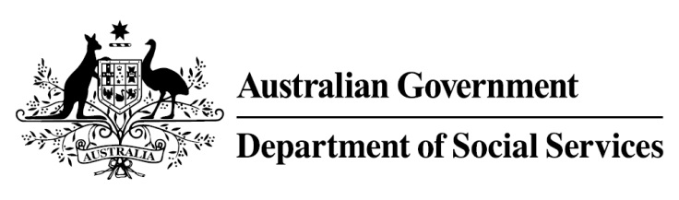

Try, Test and Learn Fund

Initiative: Explore, Discover and Empower
Location: Victoria

What are we trying to achieve?

Fast facts
Priority group: At-risk young people
Recipient numbers: 100
Locations: Southern Grampians Shire
Trial period: 19 months
Total funding: $400,000
Service provider: Southern Grampians Shire Council
Potential future saving: If around 10 per cent of participants move off income support because of this project, the savings to the welfare system are likely to outweigh the costs of the project.

This project seeks to empower and re-engage young people in education or employment by offering them short, practical trade-taster courses so they can explore a variety of industries.

What is Explore, Discover and Empower?
Unemployed and disengaged young people will be offered short, hands-on, free trade-taster courses in under-utilised existing facilities at the Hamilton District Skills Centre. Trade-taster courses will be in industries such as hospitality, automotive, building/carpentry, hair and beauty and creative IT.
Pending additional support, the project will establish a learning hub at a shopping centre in Hamilton, Victoria, which would be used to engage and recruit young people into the project, and for the delivery of the creative IT industries courses.
Young people can enrol in as many trade-tasters courses as they wish, at no cost to the participants. They will also be connected to a volunteer mentor who will support them into pathways to employment by providing informal advice.

What does the evidence tell us?
- The barriers to further education and employment for young unemployed people are varied. While some will face minimal barriers to engaging in further education or taking up employment opportunities, others will face a number of challenges to making a successful transition.
- If nothing changes, 42 per cent of 16-21 year olds currently receiving with Youth Allowance (other) or Disability Support Pension with mental health as the primary condition will be receiving income support payments in 10 years, and 33 per cent will be receiving income support payments in 20 years.

How is this initiative new and innovative?
This project exposes young people to a range of industry experiences without the barrier of enrolment expenses. It does this at a relatively low per participant cost by using existing facilities that are not being used to their full capacity.
Using insights from the Priority Investment Approach, the $96.1 million Try, Test and Learn Fund is gathering evidence on new or innovative approaches to addressing barriers to work.
The Try, Test and Learn Fund will help achieve the objectives of welfare reform—that is, to develop a modern welfare system that increases the capacity of individuals, reduces the risk of welfare dependency and maintains a strong welfare safety net.

