Minister’s introduction
I am pleased to continue the Government’s $96.1 million commitment to trialling new ways to help vulnerable Australians prepare for work, find work and keep work.
A key focus of the Try, Test and Learn (TTL) Fund is developing an evidence base on what works, for whom, and under what circumstances. This will enable the Government to begin transforming investment in existing programs or make a case for new investments.
The first project I have announced under tranche 2 is $600,000 for the Employer-led Refugee Employment Project. This 18-month trial in South Australia, Victoria, Queensland and New South Wales, will provide training, coaching and work experience to prepare 100 working-age migrants and refugees for paid positions within the Woolworths Group.
The Employer-led Refugee Employment Project aims to help migrants and refugees into work so that they can provide the essentials for their families, develop social networks and fully realise the opportunities that Australia offers.
For tranche 2, I am pleased to announce that my Department received well over 400 submissions at the point applications closed on 28 September 2018. Focusing on priority groups of older unemployed people, working age carers, working age migrants and refugees, and at-risk young people – tranche 2 has a total investment of $50 million.
In October, Assistant Minister Henderson launched the My Maintenance Crew project. This $2.3 million tranche 1 project offers real job opportunities in building maintenance and public event clean-up to 125 young people from Geelong over 28 months.
We have achieved a lot this year within the TTL Fund, but there is still much work to do.
I look forward to updating you across 2019 about TTL Fund progress and announcing other tranche 2 projects.
I wish you and your families all the best for the holiday season.
The Hon Paul Fletcher MP, Minister for Families and Social Services

Tranche 2 update
To date, eighteen projects from tranche 2 have completed co-development and we are working towards getting grant agreements in place for these projects.
We are working hard towards finalising outcomes for batches 3, 4 and 5.
As soon as we are able, we will notify you in writing of the outcome of your application.
Tranche 1 update
We congratulate Bernadette Black, founder of the BRAVE Foundation, who was presented with the 2019 Tasmanian Australian of the Year Award for her work with expectant and parenting teens. The BRAVE Foundation was supported under tranche 1 to coordinate delivery of the Supporting Expecting and Parenting Teens (SEPT) project. SEPT aims to help young parents adjust to the responsibility of parenting in a healthy, safe environment. It aims to have young parents in a better position to engage with education and the workforce in a positive, ongoing way, thereby also reducing intergenerational welfare dependency.
Australian Priority Investment Approach
The Australian Priority Investment Approach 2017 Valuation Report was released on
1 July 2018.
Each year valuation results will continue to help gain a better understanding of the success of the social security system in increasing self-reliance and improving the overall life chances of vulnerable Australians.
Key findings of the 2017 Valuation Report and other departmental modelling reveal that:
- Young people aged 22-24 who spent more than 80 per cent of their childhood with parents or guardians on income support are nearly three times more likely to be on welfare themselves, as opposed to children whose parents did not receive income support.
- Vocational Education & Training students, aged 16 to 17, are expected to spend 2.5 fewer years on income support over their future lifetime compared to secondary school students.
- The total future lifetime cost of the Australian population, as at 30 June 2017, is $4.681 trillion. This is an increase of 3.7 per cent from the 2016 valuation but a decrease of 1.7 per cent from the Baseline valuation (2015).
- The Government’s policies have led to an overall reduction of the total future lifetime cost of the welfare system.
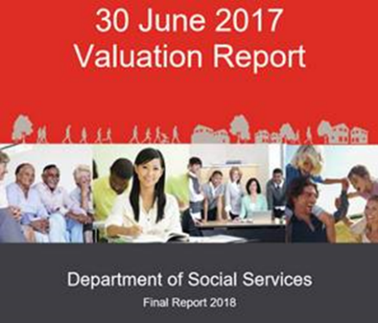

Results from previous valuations informed targeting of projects for tranches 1 and 2 of the TTL Fund, to ensure specific groups of people who are at risk of long-term welfare dependence and disadvantage receive the assistance they need.

Keep updated and in touch
More information about the TTL Fund can be found on the Department of Social Services website. You can also contact us at TTLFund@dss.gov.au.
Please feel free to distribute this newsletter to your networks, and encourage them to sign up for updates here.

