National Rental Affordability Scheme Risk Management Framework
2017-18
Reviewed December 2017

Copyright notice
This document Risk Management Framework: National Rental Affordability Scheme 2017-18 is licensed under the Creative Commons Attribution 4.0 International Licence
Licence URL: https://creativecommons.org/licenses/by/4.0/legalcode
Please attribute: © Commonwealth of Australia (Department of Social Services) 2015
Notice:
- If you create a derivative of this document, the Department of Social Services requests the following notice be placed on your derivative: Based on Commonwealth of Australia (Department of Social Services) data.
- Inquiries regarding this licence or any other use of this document are welcome. Please contact: Branch Manager, Communication and Media Branch, Department of Social Services. Phone: 1300 653 227. Email: communications@dss.gov.au
Notice identifying other material or rights in this publication:
- Australian Commonwealth Coat of Arms — not Licensed under Creative Commons, see https://www.pmc.gov.au/government/commonwealth-coat-arms
- Certain images and photographs (as marked) — not licensed under Creative Commons

Table of Contents
1. Introduction 1
1.1. Purpose of this Document 1
1.2. About the Program 1
1.3. Why a Risk Framework for NRAS? 1
1.4. Implementation, monitoring and review 1
2. NRAS Risk Management 1
2.1. Approach to Risk Management 1
2.2. Roles & Responsibilities 1
2.3. NRAS Risk Assessments 1
2.4. NRAS Risk Escalation 1
2.5. Business Continuity 1
2.6. Hierarchy of Current NRAS Risk-Related Documents 1
3. NRAS Program Integrity and Compliance 1
3.1. Risk-based Compliance Strategy 1
3.2. Management of Complaints or Allegations of Serious Non-Compliance 1
3.3. NRAS Fraud Risk Assessments 1
4. Program Governance and Reporting 1
4.1. Governance Mechanisms 1
4.2. Reporting under the Regulator Performance Framework 1
4.3. NRAS Quarterly Performance Report 1
4.4. Annual Performance Reporting 1
4.5. Reporting to Audit and Assurance Committee 1
5. Relationships & Resources 1
5.1. External Stakeholders 1
5.2. Key Internal Stakeholders 1
5.3. NRAS Regulatory Framework and Applicable Departmental Policy 1
5.4. Training Opportunities for Staff 1
5.5. NRAS Reports, Reviews and Performance Audits 1

Introduction

Purpose of this Document
The National Rental Affordability Scheme (NRAS or the Scheme) Risk Management Framework aims to clearly outline and communicate the approach the Department of Social Services (the Department or DSS) is taking to managing risk in its administration of NRAS in order to improve overall program integrity and accountability.
An underlying objective of the Framework is to promote a robust but proportionate approach to risk and a positive risk culture within the Housing Programs and Homelessness Branch (HPHB), which has responsibility for the management and administration of the Scheme, and to be an accessible and practical tool for all staff involved in the administration of the NRAS.
Under the Commonwealth Risk Management Policy, a risk management framework is defined as: ‘the set of components that provide the foundations and organisational arrangements for designing, implementing, monitoring, reviewing and continuously improving risk management’.

About the Program
NRAS is a partnership between the Australian Government and state and territory governments to invest in affordable rental housing. It is a regulatory program which commenced in 2008 and is governed by the National Rental Affordability Scheme Act 2008 (the Act) and the National Rental Affordability Scheme Regulations 2008 (the Regulations).
The object of the Act and the Regulations is to encourage large-scale investment in housing by offering an incentive to participants in the Scheme so as to:
- increase the supply of affordable rental dwellings; and
- reduce rental costs for low and moderate income households
The incentive is issued to housing providers to provide affordable rental dwellings at least 20 per cent below market rates.
As at December 2017, there are 131 approved participants, who may be property developers, not-for-profit organisations and community housing providers, in the Scheme throughout Australia. Individual private investors can also participate, either as part of a joint venture arrangement with an NRAS approved participant, or by purchasing NRAS dwellings from an approved participant.
The target group for NRAS is tenants with a low to moderate income. Potential and existing NRAS tenants must meet income eligibility criteria defined in the NRAS regulations, which are assessed by the approved participant or the tenancy manager of a particular property.
In the 2014-15 Budget, the Government announced it would not proceed with the final planned application round for NRAS and the Scheme would be capped at 38,000 dwellings (originally set at 50,000). The Department is committed to improving the administration of the Scheme for allocations already made. The Scheme will conclude in June 2026.

Why a Risk Framework for NRAS?
NRAS adheres to the Department-wide Risk Management Framework, which is aligned to the Commonwealth Risk Management Policy.
Ordinarily, it might be sufficient for a program area to be aware of the Departmental Framework and simply have its own risk management plan, or a current risk assessment to guide how it manages its program risk. However, NRAS has not been supported by a comprehensive risk framework since its inception in 2008 and needs to strengthen its capability in risk management and effective program management.
In 2015 the Australian National Audit Office (ANAO) published its first report of a two-phased performance audit into NRAS. While no recommendations were made in the report, conclusions drawn by the ANAO report were that the administration of the Scheme had not been effective, and the need was highlighted for improved planning and administration of the Scheme in order to meet the objectives and expected outcomes.
In November 2016, the ANAO published its second report into NRAS. The report found that the department was processing allocation requests, market rent valuations and incentive claims in accordance with the Regulations, but the effectiveness of its administration continued to be mixed. In terms of areas for improvement, the report found there was a lack of clarity with aspects of the Regulations, NRAS IT systems should be streamlined and developed to better support business practices, and the Department should develop a risk management framework to more effectively manage Scheme risks.
Listed below are the three recommendations made by the ANAO in November 2016.
Recommendation 1
The Department develops a risk management framework and implements a targeted risk-based compliance program, informed by a robust assessment of Scheme risks.
Recommendation 2
The NRAS component of FOFMS and NRAS Portal is further developed to:
  - streamline the input of required information by approved participants, including that information, where correct, is only required to be provided once; and
  - enhance the business rules and system controls to better identify potentially non-compliant or higher-risk incentive claims that require review prior to payment.
Recommendation 3
The Department implements a process to verify the reliability of information submitted by approved participants, as part of a risk-based approach to managing compliance.

NRAS will be in operation until 2026, when the last of the allocations reach the end of their 10-year incentive period.
A significant amount of Australian Government money is provided for the operation of NRAS ($309m in 2016-17 – being $85m from DSS and $224m from the Australian Taxation Office) and it works cooperatively with the State and Territory Government Housing Departments to complement social and community housing objectives across the jurisdictions.
For all the above reasons it is important that a Risk Management Framework is developed and implemented for NRAS, and ongoing effort is made to better communicate and embed the various components of its administration that will provide the foundation for this improvement.

Implementation, monitoring and review
Responsibility for implementation of the various elements and strategies contained within the RMF is shared among the NRAS Directors (Project Managers) and the Branch Manager, HPHB (Project Assurer) in line with their broad program responsibilities and defined project work. Responsibility for reporting on implementation progress will sit with the Director, NRAS Regulation and Accountability who will report regularly to the Branch Manager, HPHB.
The NRAS Framework will be reviewed every six months. Updates will be made as necessary with a view to ensuring the continuous improvement and currency of the Framework.
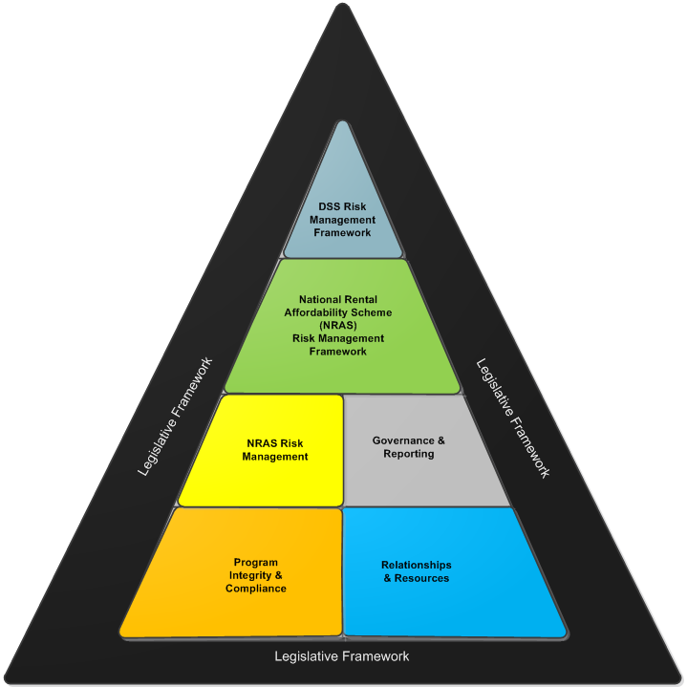

NRAS Risk Management

Approach to Risk Management
The DSS Risk Management Framework (DSS RMF) is underpinned by a philosophy that risk management is a key business process and essential component of sound management and good corporate governance. The Department’s philosophy is that risk frameworks, plans and assessments are effective planning and decision-making tools, which assist in making informed choices for effective prioritisation of resources. The DSS RMF also notes the need to integrate risk management practices in all business activities and systems, and actively build an administrative culture where risk management is not an ‘afterthought’.
The Commonwealth Risk Management Policy defines risk as ‘the effect of uncertainty on objectives’ and risk management as the ‘coordinated activities to direct and control … risk’.
The DSS RMF sets the context for the Risk Management Framework for the NRAS program. The DSS RMF promotes a proportionate approach to risk management that balances performance commensurate with its risk appetite. DSS accepts low to medium risks but prefers not to accept high or extreme risk level.
A key goal of the Framework as a whole is to promote the operating environment whereby NRAS is administered by the Department in a way that reflects the DSS policy on risk management and the Department’s approach to risk and its risk appetite. The 2017-18 NRAS RMF not only aims to step out the risk mitigation strategies for 2017-18, it also aims to actively promote a positive risk culture within the HPHB, where staff are appraised of administrative goals and reform objectives, are consulted on risks and risk strategies, and are trained and supported to effectively do their work.
Risk culture is defined in the Commonwealth Risk Policy as ‘the set of shared attitudes, values and behaviours that characterise how an entity considers risk in its day-to-day activities’ (p 15).

Roles & Responsibilities
It is the broad responsibility of all NRAS staff to understand, identify and help manage risks within the Scheme. Listed below are the positions with clearly defined responsibilities in relation to risk management within the NRAS program.
Group Manager, with responsibility for NRAS (Project Sponsor) - is responsible for endorsing the NRAS RMF, as well as monitoring any NRAS-risks that are classified as ‘High’ and in some instances these may be escalated to the Deputy Secretary level. Any ‘Extreme’ risks must be escalated via the Group Manager and/or Chief Risk Officer, to the Executive Management Group for decisions on how to proceed.
Branch Manager, with responsibility for NRAS (Project Assurer and Delegate of the Secretary for NRAS decisions) - is responsible for approving the RMF and evaluating the controls and treatments on any risks classified as Medium. This position also leads the NRAS sections/teams.
NRAS Directors (Project Managers) - are responsible for managing any risks with a rating of Low that fall within their area of responsibility. They must also model best practice risk management, and ensure staff are aware of their risk management obligations. More specifically:
- the Payments, Processing and Communications Director - ensures that compliance activities are aligned and supported by the Regulations, conducted in an effective and efficient manner, and aligned to the assessment of Scheme risks. The Director also oversees the Portal Enhancements Project and the NRAS mailbox.

- the Regulation and Accountability Director – oversees the development, publication and ongoing revision of the RMF, monitors its implementation, manages issues relating to the NRAS regulatory framework including liaison with external regulatory bodies, and oversees NRAS performance reporting.

NRAS Risk Assessments
Under DSS policy, program areas must assess risks and build risk planning into their business processes. Risk assessments are prepared following the six-step process presented in the graphic below, and using the departmental Risk E template.
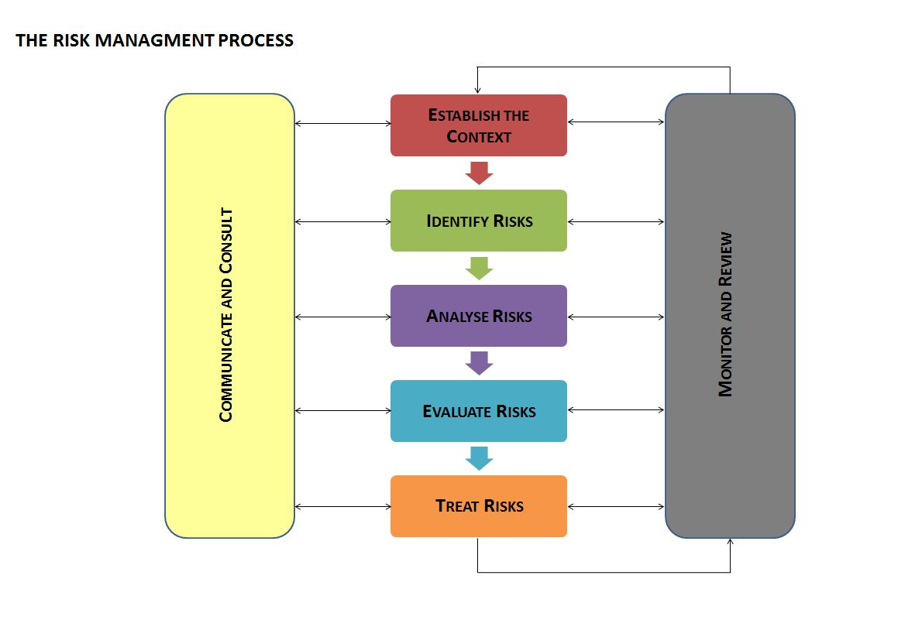
The current NRAS risk assessment was finalised in March 2017 after a development process which included the following:
- review of past NRAS risk assessments and project risk logs, and consideration of the current operating environment
- two workshops in late 2016 with NRAS staff and internal stakeholders on compliance risks
- early engagement with internal support areas including Enterprise Risk and Enterprise Compliance
- engagement with program areas facing similar governance challenges (such as Disability Employment Services) and
- a workshop facilitated by Enterprise Planning and Risk Management with NRAS staff in February 2017.
As part of the review in December 2017, Enterprise Planning and Risk Management facilitated a workshop for NRAS staff to evaluate the effectiveness of current controls and treatments for the NRAS risks.
While the risk assessment is subject to a regular review cycle, it may be reviewed more frequently when a need is determined. Triggers for out-of-cycle reviews of the assessment include:
- when changes are made to the Act or the Regulations, and
- when emerging risks are identified.

Major project-type work undertaken within NRAS typically has a project plan to guide the work, with an associated risk log that considers the factors that could impede the successful delivery of the project. For example, the NRAS Compliance Strategy (discussed further in Section 3) has a specific risk assessment attached to it, and each specific compliance activity will have its own consideration of risks, captured in a risk log.

NRAS Risk Escalation
NRAS risk escalation processes are consistent with DSS risk management requirements. Operational risks rated Low and are managed by relevant Directors, while risks of Medium rating require escalation to the Branch Manager level. Both Low and Medium risks may remain unreported (or un-escalated), whereas risks classed at High or Extreme, or that cannot be appropriately treated at the operational level, are required to receive direct attention from the Group Manager, with Extreme risks requiring Executive planning and management.
All NRAS risk decisions, supported by appropriate evidence and an audit trail, will be maintained. The table below provides a summary of escalation requirements.
Table 1: Escalation process for NRAS risks
Risk Level | Delegate | For
Extreme Risks | Group Manager/  Executive Management Group | Decisions on the acceptance / non-acceptance of the risk  Approval and oversight of treatment plans
High Risks | Group Manager | Decisions on the acceptance / non-acceptance of the risk  Approval and oversight of treatment plans
Medium Risks | Branch Manager or nominated staff (e.g. NRAS Directors) | Decisions on the acceptance / non-acceptance of the risk  Approval and oversight of treatment plans
Low Risks | NRAS Directors | Managed as part of general business/operations (BAU)

Business Continuity
Each year, business areas in the Department complete a Business Impact Analysis (BIA) identifying the business processes that are critical to meet their most important business objectives. Business areas then rate, on a set scale, the impact or consequence that a disruption to this process will have on meeting these objectives.
The most recent BIA for the HPHB was completed in January 2018, and minor impacts were noted for the two core NRAS business processes of incentive processing, and program policy, administration and reporting. The maximum acceptable outage for these processes were set between 14 and 30 days, and therefore not considered to be a ‘critical business process’ that needed further treatment through business continuity planning.

Hierarchy of Current NRAS Risk-Related Documents
Good governance requires good planning and the consideration of risk needs to be embedded into planning processes. The diagram below shows the relationship between the multiple risk-related and planning documents for NRAS. The first tier includes those that are core and required by Departmental policy. The second tier is more discretionary, and currently comprises planning documents for specific projects being undertaken in NRAS, each of which has an associated project risk log. The NRAS Regulation and Accountability section is responsible for ensuring all NRAS risk-related documents are kept in a single location in the Department’s electronic filing system and accessible to all NRAS staff.

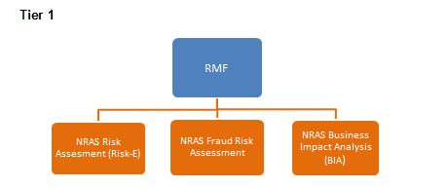
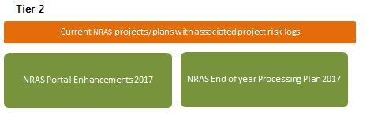

NRAS Program Integrity and Compliance

Risk-based Compliance Strategy
The ANAO, in its November 2016 report, noted that while the Department had implemented a clearly defined operational strategy for the processing of claims, it had not implemented a risk-based approach to compliance. Taking into account the ANAO findings and ongoing thinking about NRAS administrative reform, in order to complement the annual claims processing, the Department developed and introduced a targeted risk-based compliance program early in 2017 which will continue throughout the 2017 calendar year. Outlined below are the two key elements of the NRAS risk-based compliance strategy.
Annual Claims Processing
In the 2014-15 year, in a bid to improve processing timeframes the Department adopted a broad risk-based approach to assessing claims using a targeted and random sampling method.
The same methodology was applied to all claims submitted for the 2015-16 NRAS year and, together with the introduction of improved assessment tools and further automation of IT processes, further efficiencies were achieved in processing timeframes.
The Department employed the same methodology for the 2016-17 claims processing and is confident that further efficiencies gained will improve processing timeframes and resource requirements.
For the 2017-18 NRAS year, the Department implemented a real-time processing regime to continue to improve the overall performance in the annual claims processing.
While the Department’s performance in claims processing has continuously improved over recent years, and its processes do provide assurance that the information provided by approved participants is consistent with the NRAS Regulations, as found by the ANAO, the Department is aware that its processing methodology does not provide adequate assurance that the information provided by approved participants is reliable.
Targeted Risk-Based Compliance Program
The detail of the 2017 program of compliance activities is in the NRAS Compliance Strategy. The NRAS Compliance Strategy details eight separate compliance activities that have a particular focus on verifying the reliability of the information provided to the Department by approved participants. This focus supports mitigation strategies against a number of identified risks in the Scheme.
In designing this program of activities, the Department focused on areas of identified risk, drawn from the most recent risk assessments conducted, past experience of program operations and from audit findings. The Department also remained cognisant of its broader commitments under the Regulator Performance Framework (discussed further at 4.2) not to increase the regulatory burden on approved participants. The expected regulatory burden on the approved participants selected to participate in the compliance activities is minimal to negligible.
A project plan will guide each compliance activity, endorsed by the Branch Manager. The results or findings of the compliance activities as a whole will be summarised into a lessons learnt document that will help drive improvements in program administration in 2017. Data analysis of past claims processing outcomes will assist in effectively targeting the compliance activities. While the NRAS Compliance Strategy has identified a set program of compliance activities, it retains flexibility to amend this set program and add or subtract specific activities as new risks are identified, or there are other significant changes to operations, which give rise to new areas for compliance attention. The activities undertaken throughout 2017 will inform an ongoing program of strategic compliance activities in 2018.
The Department engaged with its peak stakeholder bodies for NRAS (the National Affordable Housing Providers Ltd and Community Housing Industry Association) on the planned implementation of the compliance program, in addition to writing to all approved participants. The Department is committed to maintaining regular communication with approved participants as the activities progress throughout 2017, and to working cooperatively to improve guidance that could avoid approved participants relying on insufficient evidence or documentation, and inadvertently not achieving the required evidence threshold.
The Department is obliged to implement processes that will help ensure public confidence in the Scheme. The 2017 compliance program aims to strike the right balance between protecting the public interest while not imposing unnecessary costs on regulated entities.

Management of Complaints or Allegations of Serious Non-Compliance
Through compliance processes, complaints or ‘tip-offs’ from the public and media coverage, the Department has identified practices ranging from potentially unethical to allegedly fraudulent within NRAS and damaging to the reputation of the Scheme and the Australian Government.
Between November 2010 and mid-March 2016, 32 NRAS related matters were referred to the Department’s Investigations area, either from the NRAS area of the Department, another government agency, or directly from the public.
Commencing from late 2016, processes were strengthened within the HPHB to provide better assurance that any referrals or complaints about approved participants’ compliance that are received directly to the NRAS administration are managed effectively.
A Standard Operating Procedure for the Management of Compliance Referrals was developed to outline how these referrals will be assessed and addressed by the NRAS Regulations and Accountability section, including protocols for when matters may need referral to the Department’s Investigations area. The guide was approved in March 2017 and its procedures have been implemented and will operate throughout 2017-18.
Ongoing analysis of referrals, tip-offs and public feedback in this area will be conducted throughout 2017-18 with a view to identifying any trends as early as possible. Early identification of any trends provides the Department with the opportunity to intervene in a timely way and introduce remedial actions.

NRAS Fraud Risk Assessments
The Department takes all allegations of fraud against its programs and services very seriously and undertakes its own investigations where appropriate. Serious matters are referred to the appropriate regulatory bodies such as law enforcement agencies, the Australian Competition and Consumer Commission and the Australian Securities and Investments Commission for further investigation.
Consistent with the Department’s Fraud and Corruption Control Policy and Fraud and Corruption Control Plan, DSS program areas are to develop and maintain a current Fraud Risk Assessment. Fraud Risk Assessments provide the opportunity to identify, assess and understand a program area’s exposure to fraud, both internal and external, and review existing controls and measures to maximise resistance to fraud in a manner proportionate to that exposure.
With support from the Department’s Fraud Analytics area, the NRAS Fraud Risk Assessment was updated, via a process including staff workshops, to reflect the current operating environment of the Scheme. It was finalised and endorsed in June 2017 and is expected to remain current for at least the 2017-18 year.

Program Governance and Reporting
This section outlines the key governance mechanisms that support, monitor and seek to continuously improve the administration of NRAS and manage current and emerging risks. It also outlines the principal mechanisms where the Department reports on its performance and risk-related commitments and improvement agenda.

Governance Mechanisms
The table below describes the current governance mechanisms to support the administration of NRAS and manage program risks.
Mechanism | Stakeholders | Frequency | Purpose
NRAS Branch Manager and Directors meetings | Branch Manager  NRAS Directors | Fortnightly face-to-face meetings | To consider sensitive policy or operational matters, emerging risks and a monthly dashboard of program metrics that measure workflow and performance.
NRAS and Assurance and Performance Branch (APB) meetings | Branch Managers (NRAS and APB)  Directors  Assistant Directors | Quarterly face-to-face meetings | To discuss matters of joint interest including risk management, compliance, stakeholder feedback, and related performance issues.
NRAS and Legal Services Branch (LSB) meetings | Branch Managers (NRAS and LSB)  Directors  Assistant Directors | Ad hoc | To discuss active specific legal queries or specific legal or regulatory matters affecting NRAS.
IT Project Steering Committee | Branch Managers (every second month)  IT Directors  NRAS Director, Payments, Processing and Communications  Assistant Directors | Ad hoc | To monitor the status and progress of the NRAS IT project and discuss any concerns.
Program Compliance Sub-committee | Group Manager, Corporate Services  Group Manager, Program Office  Branch Managers | Every six weeks | To oversee the implementation and operation of the DSS Enterprise Compliance Framework and to support the strengthening of compliance activities and culture across DSS.
NRAS and peak body meetings | National Affordable Housing Pty Ltd and Community Housing Industry Association (CHIA) | Every second month | To discuss NRAS operational and policy matters of mutual importance.
NRAS and state and territory governments | NRAS Directors and counterparts in state and territory government (housing departments) | Teleconference  every two months | For DSS to update on performance matters across jurisdictions including incentive processing, provisional allocations, and future reform agenda.

Reporting under the Regulator Performance Framework
In 2015 the Department developed a Regulator Performance Framework in line with Commonwealth policy to reduce red tape. The NRAS Regulator Performance Framework is designed to encourage regulators (in this case, the Department) to undertake their functions with the minimum impact necessary on regulated entities (in this case, approved participants).
NRAS is currently the only program in DSS that reports under the Regulator Performance Framework. Under broad Key Performance Indicators (KPIs), it has committed to a number of measures to improve its interaction with approved participants and the community, and increase its public accountability and transparency in the administration of NRAS. A number of the measures the Department has committed to under this framework relate to risk including a commitment to applying a risk-based, proportionate approach to compliance, a commitment to being open and responsive with approved participants about its risk framework, and regular reassessment of its approach to regulatory risk. The ANAO audit into NRAS noted that the Department’s progress in implementing the risk components of the Regulator Performance Framework had been slow, with little progress made in 2015-16. The Department has delivered more strongly in this area in 2016-17 and ongoing effort will be paid to meeting the risk-based KPIs and measures under this framework throughout 2017-18.

NRAS Quarterly Performance Report
The Department prepares an NRAS Quarterly Performance Report containing performance data on the allocation of incentives, and the number, type and location of dwellings available for rent in the Scheme. The report is published on the NRAS website within three months of the end of each quarter, and is available for download free of charge for the benefit of the public at NRAS Performance Reporting

Annual Performance Reporting
DSS publishes its Annual Report in October of each year. In the annual report, NRAS reports against its PBS Outcome measures and KPIs. This reporting provides public accountability for the delivery of Scheme outcomes. NRAS reports:
- the number of incentives paid in the financial year,
- the number of dwellings currently active in the Scheme at 30 June of that year, and
- the percentage of people who have had their rental stress reduced as a result of being in the Scheme.

Reporting to Audit and Assurance Committee
The role of the Department’s Audit and Assurance Committee (AAC) is to provide independent assurance and advice to the Secretary and Executive Management Group on DSS’ financial and performance reporting responsibilities, risk oversight and management, and system of internal controls. It also has a role to play to promote an ethical culture within DSS.
As part of its role, the AAC monitors the implementation of internal audit and ANAO audit recommendations. HPHB first reported to the AAC on its progress toward implementation of the November 2016 ANAO recommendations into NRAS at the AAC meeting in March 2017. HPHB is responsible for reporting to each meeting of the AAC until all three recommendations are complete, and information on actions taken to implement recommendations – and supporting evidence – is tabled at the committee before a recommendation will be endorsed for closure.

Relationships & Resources

External Stakeholders
The below diagram represents the key relationships the Department has in relation to NRAS, which are used strategically to help manage risks, and improve operational performance. A particular focus for 2017-18 will be to strengthen strategic relationships with external regulatory agencies such as Australian Taxation Office (ATO) and the Australian Competition and Consumer Commission (ACCC) and the Australian Charities and Not-for-profits Commission (ACNC) as part of overall risk management strategies.

Key Internal Stakeholders
Internal Stakeholder | Key Purpose of Engagement
Enterprise Planning and Risk Management Section | Advice and guidance on risk planning
Legal Services Branch | Advice on specific queries, assistance with regulatory matters and the development of amendments to the Act and the Regulations
Assurance and Performance Branch | Ongoing engagement with the following Branch sections for operational needs: Investigations; Fraud Analytics; Compliance and Feedback
Internal Audit Section | Reporting on ANAO and internal audit recommendations

NRAS Regulatory Framework and Applicable Departmental Policy
The HPHB will be responsible for driving a range of improvements throughout 2017-18 that seek to improve overall NRAS program management and management of NRAS risks.
A key element of this improvement path is to make concerted effort to ensure staff working in NRAS have a good knowledge of the objectives and operations of the Scheme and its legislative framework, have the capability to carry out their roles, and are supported by endorsed policies and procedures.
The various resources listed below are intended to provide an accessible reference point to staff who work in the administration of NRAS to help ensure they are aware of the regulatory framework and applicable Departmental policies, are committed to good practice and continuous improvement, and have a broad awareness of how NRAS has developed over time.
Regulatory Framework | Applicable DSS Policy Documents
Public Governance, Performance and Accountability Act 2013 (particularly sections 15 and 16)  National Rental Affordability Act 2008 (the Act)  National Rental Affordability Scheme Regulations 2008  Income Tax Assessment Act 1997 (Division 380)  DSS, Explanatory Guide: National Rental Affordability Scheme, August 2016  NRAS Internal Review Guidelines (December 2015) | DSS Risk Management Framework and Risk Management Guidelines  DSS Enterprise Compliance Framework  DSS Issues Escalation Policy  DSS Fraud and Corruption Control Policy  DSS Fraud and Corruption Policy Statement
Good Practice Reports
ANAO, Administering Regulation: Achieving the Right Balance, June 2014
Comcover, Better Practice Guide: Risk Management, 2008

Training Opportunities for Staff
Throughout 2017-18 there will be a concerted effort to increase the rate of staff training in areas including regulatory programs, risk management and compliance, with the broader objective of improving staff capability in administering a regulatory program.
The following courses have been identified as relevant for all NRAS staff to undertake, and will be actively promoted:
- APSC online training – Introduction to Risk in the Commonwealth
- APSC online training – Fraud Awareness
- DSS – Fraud and Corruption Awareness
- Certificate IV in Risk Management Essentials
Further training opportunities both within and external to DSS will be pursued in the areas of regulatory administration, risk management and compliance.

NRAS Reports, Reviews and Performance Audits
Australian Housing and Urban Research Institute, Subsidised affordable rental housing: lessons from Australia and overseas, AHURI Final Report No. 267, August 2016
Australian National Audit Office, Report No. 8 2015-16, Performance Audit, Administration of the National Rental Affordability Scheme, November 2015
Australian National Audit Office, Report No. 23 2016-17, Performance Audit, National Rental Affordability Scheme – Administration of Allocations and Incentives, November 2016
The list below details several external reports and audits relating to NRAS since 2008. The development of the RMF considered their accumulated findings.

Australian National Audit Office, Report No.23 (2016–17), National Rental Affordability Scheme (NRAS) - Administration of Allocations and Incentives, published on 7 November 2016.
ANAO (2104), Administering Regulation: Achieving the Right Balance, Better Practice Guide, June, foreword

