DSS2198.11.17

More information
For more information about support available to people seeking an external merits review go to www.dss.gov.au/ndis-appeals.
For more information and support from the Administrative Appeals Tribunal go to www.aat.gov.au or call 1300 366 700.
For more information about the National Disability Insurance Scheme (NDIS) go to www.ndis.gov.au or call 1800 800 110.

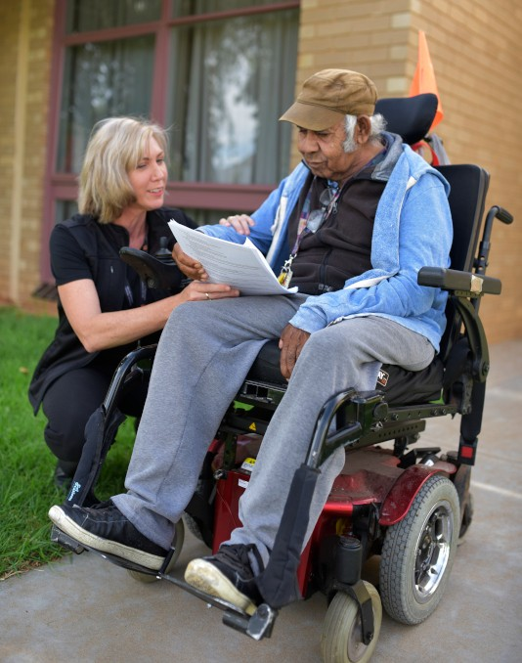

Disagree with a National Disability Insurance Agency (NDIA) decision?
Assistance available for people seeking an external merits review

How do I apply for a review of a National Disability Insurance Agency decision?
If you are unhappy with a decision made by the National Disability Insurance Agency (NDIA) you can request an internal review of that decision with the NDIA.
If you still disagree with a decision after the internal review has been completed, you can apply to the Administrative Appeals Tribunal (AAT) to conduct an external merits review. An external merits review is an independent assessment of an NDIA decision. The types of decisions that can be reviewed include, but are not limited to: whether you are eligible for the National Disability Insurance Scheme (NDIS); or what has or has not been approved for your plan.
An internal review must be conducted first by the NDIA before you can go to the AAT.

What help can I get if I apply to the AAT?
Help is available from an NDIS Appeals
support person to:
- assist you to understand the review process

- prepare documents needed for the external merits review
- assist you to apply for legal assistance to pursue an application to the AAT*
- provide you with advice and skills so that you can better represent yourself at the AAT, if you choose to do so, or
- attend AAT conferences and hearings with you, and help you in putting your case to the AAT.

The NDIS Appeals support person is funded by the Australian Government, and is independent from the NDIA and the AAT. There is no charge for their assistance or for an external merits review by the AAT.

* Legal assistance may be available where your matter is assessed by the Department of Social Services as raising a complex or novel issue.

Where can I find an NDIS Appeals support person?
NDIS Appeals support people are available in every NDIS site, and to all AAT applicants. For a full list of locations and provider details go to www.dss.gov.au/ndis-appeals.

