eNewsletter, Issue 6, December 2015

Welcome to the sixth issue of the National Plan e-Newsletter. This edition celebrates our collective achievements in 2015*.*

2015 has seen the start of a national conversation on how we can stop violence against women happening in the first place.

Over the past 12 months we have witnessed the extraordinary efforts of all governments, service providers, and the broader Australian community coming together to address the issue of violence against women and their children.

Across the country, we have been taking a stand against violence through community forums, marches, training programmes, local campaigns, candlelight vigils and a range of other initiatives. Unprecedented media attention on violence against women and their children has also played a significant role in shifting and intensifying the national conversation around the issue.

We would like to thank everyone for their support and efforts for implementing the   
National Plan and ongoing efforts to ensure Australian women and their children can live free from violence.

Table of Contents

[What has been happening? 3](#_Toc438636217)

[Feature stories 4](#_Toc438636218)

[Our Watch national media engagement 4](#_Toc438636219)

[Building Safe Communities for Women grants 4](#_Toc438636220)

[Perpetrator Interventions 5](#_Toc438636221)

[National campaign to reduce violence against women 6](#_Toc438636222)

[1800RESPECT Online Toolkit 7](#_Toc438636223)

[National Partnership Agreement on Homelessness (NPAH) 7](#_Toc438636224)

[Updates from around the country 9](#_Toc438636225)

[Highlights from Queensland 9](#_Toc438636226)

[Highlights from Tasmania 12](#_Toc438636227)

[Highlights from South Australia 14](#_Toc438636228)

[Highlights from Western Australia 17](#_Toc438636229)

[Highlights from the ACT 19](#_Toc438636230)

[Highlights from Victoria 20](#_Toc438636231)

[Highlights from New South Wales 21](#_Toc438636232)

[Dates for your diary 22](#_Toc438636233)

[Have your say! 23](#_Toc438636234)

[Do you need help? 23](#_Toc438636235)

# What has been happening?

**28 September** Our Watch launch of ['you can’t undo violence'](http://www.ourwatch.org.au/News-media/Latest-news/%E2%80%98You-can%E2%80%99t-undo-violence%E2%80%99-%E2%80%93-Our-Watch-launches-new) national campaign

**10 November** *Launch of* [*Change the story: A shared framework for the primary prevention of violence against women and their children in Australia*](http://www.ourwatch.org.au/getmedia/1462998c-c32b-4772-ad02-cbf359e0d8e6/Change-the-story-framework-prevent-violence-women-children.pdf.aspx)

**23 November** Release of report *[A high price to pay: the economic case for preventing violence against women](http://www.pwc.com.au/publications/economic-case-preventing-violence-against-women.html" \t "_blank)*

**24 November** [*Media Stand Up Against Violence*](http://www.ourwatch.org.au/News-media/Latest-news/Dr-Ann-O-Neill-addresses-Media-Stand-Up-Against-Vi)

**25 November** Start of[*16 Days of Activism against Gender-Based Violence Campaign*](http://www.unwomen.org/en/what-we-do/ending-violence-against-women/take-action/16-days-of-activism)

**25 November** White Ribbon Day

**25 November** [*International Day for the Elimination of Violence against Women*](http://www.un.org/en/events/endviolenceday/)

**2 December** [International Day for the Abolition of Slavery](http://www.un.org/en/events/slaveryabolitionday/)

**3 December** [International Day of People with Disability](http://www.idpwd.com.au/)

**10 December** [World human rights day](http://www.un.org/en/events/humanrightsday/)

**10 December** End of 16 Days of Activism

# Feature stories

## Our Watch national media engagement

In 2015, violence against women dominated the headlines as never before. As Australian of the Year and Our Watch Ambassador Rosie Batty said, the issue is now “out of the shadows and into the light”.

This year Our Watch established the [National media engagement project](http://www.ourwatch.org.au/What-We-Do-(1)/National-Media-Engagement-Project) (NME).   
This project harnesses the power of the media to aid in the prevention of violence against women and their children in Australia.

The Australian media play a vital role in raising awareness of the scale of the problem, and shape community attitudes – who is responsible, what leads up to the violence and what we can do to prevent it.

[Research](http://anrows.org.au/publications/landscapes/media-representations-violence-against-women-and-their-children-state), commissioned by Our Watch and Australia’s National Research Organisation for Women’s Safety (ANROWS), showed the way the media represented the issue of violence against women:

* lacked an informed analysis of the links between the proven drivers of violence against women - gender inequality
* blamed victims of violence; and
* lacked links to appropriate services for people needing help.

In the worst case scenarios, some media were found to perpetuate the attitudes that gave rise to a culture of silence (the traditional view that domestic violence is a ‘private matter’) or minimised or excused violence against women.

This is changing. In 2016, the media (supported by the NME initiative) is increasingly taking a leadership role in informing and sustaining a national conversation about how to prevent violence against women, made clear through the high quality entries submitted to the inaugural 2015 [Our Watch Awards](http://www.ourwatch.org.au/What-We-Do-(1)/Our-Watch-Awards) administered by the Walkley Foundation.

The Awards were launched by Rosie Batty earlier in the year with a [live address to the National Press Club](http://www.ourwatch.org.au/News-media/Latest-news/The-role-of-media-in-eradicating-family-violence).

Following on from the awards, the Australian Prime Minister Malcolm Turnbull hosted a [“Media Stand Up Against Violence”](http://www.ourwatch.org.au/News-media/Latest-news/Dr-Ann-O-Neill-addresses-Media-Stand-Up-Against-Vi) event in November 2015, attended by the entire Australian Press Gallery, calling on the media to adopt the [Our Watch Reporting guidelines.](http://www.ourwatch.org.au/News-media/Reporting-Guidelines)

More informed media commentary will help create a common, community-wide message of respect and non-violence.

## Building Safe Communities for Women grants

On 22 December, the Minister for Social Services, Christian Porter [announced](http://christianporter.dss.gov.au/media-releases/helping-local-communities-reduce-violence-against-women-0) the 28 successful applicants for the [*Building Safe Communities for Women* grants](https://www.dss.gov.au/grants/building-safe-communities-for-women). The grants are designed to support communities to develop and implement practical solutions to reduce violence against women and their children in their own community.

Funding of over $4 millionwas invested by the Commonwealth Government toprovide financial support over two years (2015-16 and 2016-17) to organisations to create practical solutions to address violence against women in their community.

Of the 28 successful applicants there are six projects being funded in New South Wales, five in Victoria, three in Queensland, four in Western Australia, three in the Northern Territory, three in South Australia, two in Tasmania, one in the ACT and a cross border project (Bairnsdale in Victoria, Palmerston in the Northern Territory and Kununurra in Western Australia).

There are 12 projects that focus on domestic violence, six projects focused on Culturally and Linguistically Diverse (CALD) communities, nine focused on Indigenous communities, four projects in regional areas, four in remote communities and two projects targeting schools.

These grants are an initiative under the Second Action Plan 2013-2016 of the *National Plan to Reduce Violence against Women and their Children (2010-2022)*.

## Perpetrator Interventions

To keep women and their children safe we must hold men who use violence to account.

The perpetrator accountability system includes a range of interventions that governments and community services use to respond to identified acts of domestic, family and sexual violence. These include interventions made by police, corrections agencies, legal and justice responses and men’s behavioural change programmes.

Often women and their children have a lack of confidence in the system to support and protect them when they report domestic, family and sexual violence. Furthermore, inadequate and poorly targeted perpetrator interventions are a persistent barrier to achieving accountability and lasting behaviour change.

In 2015 the Commonwealth Government, states and territories and partner organisations have been working hard to better understand perpetrator interventions. They have also been working together to ensure interventions are consistently applied between the jurisdictions.

### Research

On 9 December 2015, Australia’s National Research Organisation for Women’s Safety (ANROWS) released the [state of knowledge paper on perpetrator interventions in Australia](http://anrows.org.au/publications/landscapes/perpetrator-interventions-in-australia). An Australian first, this paper maps the pathways and interventions for perpetrators of domestic/family violence and sexual assault through civil and criminal legal systems.

It also examines existing response and service systems available to perpetrators and will help to build on the evidence base to undertake further research and inform policy development.

The four [perpetrator interventions research priorities](http://anrows.org.au/research-program/perpetrator-interventions-research-program/perpetrator-interventions-research) identified as part of this paper are:

* system effectiveness
* effectiveness of interventions
* models to address diversity of perpetrators; and
* the specific needs of Indigenous perpetrators and communities.

Research grants will be available to explore these priorities, with a call for applications expected in early 2016. Interested parties can [subscribe to ANROWS updates](http://anrows.org.au/node/123) to receive notice about these grants.

### National Outcome Standards for Perpetrator Interventions

On 11 December COAG endorsed the National Outcome Standards for Perpetrator Interventions (national outcome standards). They establish a nationally consistent approach to holding perpetrators of domestic, family and sexual violence to account.

The national outcome standards will help governments improve the systems and services that intervene with men who use violence against women. Public reporting against the national standards will help identify where our interventions are working well and where they need improvement.

The standards are based on extensive consultation with government and non-government sector experts.

For a copy of the national outcome standards go to the [National Plan website.](http://plan4womenssafety.dss.gov.au/resources/research/)

## National campaign to reduce violence against women

Development of the national campaign to reduce violence against women and their children is progressing. Developmental research has been conducted to determine the focus of the campaign.

[The report](https://www.dss.gov.au/women/feature/research-into-attitudes-that-can-lead-to-violence-against-women-released) was released by the Prime Minister on 25 November 2015. It shows that although most Australians agree domestic violence is wrong, too often we blame the victim, excuse men and minimise disrespectful behaviours and instances of gender inequality, specifically:

* from an early age, boys and girls begin to believe there are reasons and situations that can make disrespectful behaviour acceptable
* girls question whether the trigger for the behaviour is potentially their fault
* boys tell each other it was a bit of a joke - it didn’t mean anything
* adults accept the behaviour when they say ‘it takes two to tango’ or ‘boys will be boys’
* we think the cost of doing something is too high – as parents, we worry about embarrassing our child, or even ourselves. As teachers or coaches, we’re not sure how far to go; and
* without realising it, we’re making gender inequality and disrespectful behaviour acceptable.

The Commonwealth continues to work closely with states and territories to develop the campaign, which will focus on how people and communities can positively influence the attitudes of young people towards respectful relationships and gender equality. It will include advertising, public relations, media, community and corporate engagement, and education.

It is expected to launch in early 2016.

## 1800RESPECT Online Toolkit

During the [16 Days of Activism](http://www.unwomen.org/en/what-we-do/ending-violence-against-women/take-action/16-days-of-activism) 1800RESPECT released an [online toolkit](http://www.1800respect.org.au/toolkit) for frontline workers to help them better recognise the signs of sexual assault, domestic and family violence and empower them to respond well.

During the launch, the Prime Minister of Australia, Malcolm Turnbull, Minister for Social Service, Christian Porter, Minister for Women, Michaelia Cash, and Rosie Batty encouraged peak bodies, organisations and frontline workers across Australia to download the toolkit. You can view the [Prime Minister’s video message](https://youtu.be/kRu9t7ohLDk).

Developed in consultation with experts and funded by the Department of Social Services, the Frontline Workers Toolkit has information on good practice, webinars and educational videos with specialists, useful resources and apps.

The online toolkit also includes:

* a resilience training programme to help ensure staff take care of themselves, and
* resources for working with women with a disability, working with LGBTI communities, working with women going to court, and violence in times of disaster.

Workers can access the full toolkit, or tailor a toolkit according to their learning or development needs. New resources will continue to be added to the toolkit throughout 2016. To download the Frontline Workers Toolkit visit [here.](https://goshare.realtimehealth.com/1800respect/home)

## National Partnership Agreement on Homelessness (NPAH)

Homelessness is a complex issue that affects many Australians, requiring a long-term and systematic effort across government, sectors and the community. Domestic violence is a leading cause of homelessness in this country, and women, children and young people are particularly vulnerable.

The Commonwealth Government is providing $230 million to fund frontline homelessness services over two years under the [National Partnership Agreement on Homelessness (NPAH).](https://www.dss.gov.au/housing-support/programmes-services/national-partnership-agreement-on-homelessness) The 2015-17 NPAH commenced on 1 July 2015 and the Government has made frontline services focusing on women and children experiencing domestic and family violence and homeless youth a funding priority.

All state and territory First Ministers have signed the Agreement and agreed to match the Commonwealth’s funding contribution. In total, under the NPAH funding of nearly   
$250 million per year is being directed to homelessness services around the country. Nationally, over half of the NPAH funding is being directed to homelessness services focused on the priority areas of domestic and family violence and youth homelessness, with almost 250 services assisting clients who have experienced domestic or family violence.

States and territories retain responsibility for determining where services are located, which service providers are contracted, and the amount of funding each service provider receives.

The NPAH funding, of up to $115 million each year, is on top of the approximately   
$1.3 billion per annum provided by the Commonwealth to states and territories through the [National Affordable Housing Agreement (NAHA)](https://www.dss.gov.au/housing-support/programmes-services/national-affordable-housing-agreement), which includes around $260 million for homelessness services, and can be used to fund capital projects including women’s shelters and crisis accommodation.

For more information on the Commonwealth Government’s role in housing assistance and homelessness go to the [Department of Social Services webpage](https://www.dss.gov.au/housing-support) (https://www.dss.gov.au/housing-support).

# Updates from around the country

## Highlights from Queensland

### Queensland’s first Minister for the Prevention of Domestic and Family Violence

On 7 December, Queensland Premier Annastacia Palaszczuk announced that an expanded Cabinet team, comprising of 53% female representation, will drive the Government’s broad economic and social policy agenda. This Cabinet team also included Queensland’s first Minister for the Prevention of Domestic and Family Violence, Shannon Fentiman MP. Ms Fentiman will add domestic and family violence prevention to her existing communities, women, youth and child safety portfolios, coordinating the Queensland Government’s roll-out of domestic and family violence reforms.

### Domestic and Family Violence Reforms

On 18 August, the Queensland Government released its [response](https://www.communities.qld.gov.au/gateway/end-domestic-and-family-violence/queensland-government-response) to the Report of the Domestic and Family Violence Taskforce, [Not Now, Not Ever: Putting an end to Domestic and Family Violence in Queensland](https://www.qld.gov.au/community/documents/getting-support-health-social-issue/dfv-report-vol-one.pdf) (the Taskforce Report) accepting all 140 recommendations. Funding of $31.3 million over four years will be invested to implement the high priority initiatives in the report to tackle domestic and family violence.

Public consultation on a draft [Domestic and Family Violence Prevention Strategy](https://www.communities.qld.gov.au/gateway/end-domestic-and-family-violence/dfvp-strategy), outlining a 10 year collaborative plan of action has now closed. The final strategy will be announced soon on the Government’s [End Domestic and Family Violence website](https://www.communities.qld.gov.au/gateway/end-domestic-and-family-violence/home).

Implementation of the reforms will be overseen by an independent [Domestic and Family Violence Implementation Council](https://www.qld.gov.au/community/getting-support-health-social-issue/dfv-council/) chaired by Dame Quentin Bryce AD CVO. The Council’s membership includes representation from key sectors in the community and government members.

### Legislation

On 15 October 2015, two Bills were passed in the Queensland Legislative Assembly, the *Coroners (Domestic and Family Violence Death Review and Advisory Board) Amendment Bill 2015* and the *Criminal Law (Domestic Violence) Amendment Bill 2015.* These Bills respond to key Taskforce Report, including increasing the maximum penalties for offenders who breach a domestic violence orders and allowing victims ‘special witness’ status to offer victims greater protection and support in court.

The *Domestic and Family Violence Protection Act Amendment Bill 2015* was passed by the Queensland Parliament on 3 December 2015. It makes it mandatory for Magistrates to consider ‘ouster conditions’. These allow victims of domestic and family violence to remain in the home and force perpetrators to leave, where it is safe and with appropriate safety upgrades. The bill also introduced changes to reduce the chance of ‘cross applications’ being used to frustrate or slow the court process. A copy of these bills can be found at [https://www.legislation.qld.gov.au](https://www.legislation.qld.gov.au/acts_sls/Acts_SL.htm).

### Specialist domestic violence court

A trial of a specialist domestic violence court has commenced at Southport. This court is administered by magistrates with specialised expertise in domestic and family violence. The outcomes of this trial will inform future law and justice issues to be addressed as part of the reform agenda. In addition, funding of $1.1 million in 2015-16 has also been allocated to expand the Domestic and Family Violence Duty Lawyer Service to 14 locations state wide through Legal Aid Queensland.

### Prioritising victim safety

The Premier announced that operational policies will be revised to prioritise victim safety. This includes the reinstatement of a State Domestic and Family Violence Coordinator (Coordinator) with the Queensland Police Service. The Coordinator will work with district coordinators to drive direction and policy. Changes have also been made to the way police stations handle individual domestic violence complaints. These include:

* priority attention for anyone who attends the front counter of a police station for domestic violence issues
* the need for Police supervisors to conduct mandatory quality checks on all   
  over-the-counter requests to apply for a domestic violence order; and
* the urgent roll-out of 300 body-worn cameras for police on the Gold Coast, to assist in gathering evidence.

### Integrated response to domestic and family violence

Work has commenced across government and with the community to roll out integrated responses to domestic and family violence. These will be trialled in three sites and include the development of a common risk assessment framework, information sharing provisions and multi-agency responses to victims at high risk of violence. The first trial will be in Logan/Beenleigh with a further trial to be implemented in a regional area as well as a discrete Indigenous community. There will be close collaboration with the local communities selected in designing the specific models to be piloted. The outcomes of the trials will inform future implementation of the integrated service delivery models across the State.

### The Wider Agenda

Public consultation is currently wrapping up on:

* the development of a [Queensland Violence Against Women Prevention Plan](https://www.communities.qld.gov.au/gateway/end-domestic-and-family-violence/vaw-prevention-plan) which takes the government’s commitment to address domestic and family violence further by addressing other forms of violence against women.
* a [Queensland Women's Strategy](https://www.communities.qld.gov.au/communityservices/women/queensland-womens-strategy) to be launched during [Queensland Women’s Week](http://www.qld.gov.au/community/women/events-queensland-womens-week/) in March 2016, outlining the Queensland Government vision for women and girls with an emphasis on gender equality and related issues across safety, economic security, health and wellbeing, and leadership and participation.

### Sector Highlights

The [Ending Violence Against Women in Queensland (EVAWQ)](http://www.violenceagainstwomenqld.com.au/) peak body launched in October 2015. It provides a united and state-wide voice across the areas of sexual violence, women’s health, and domestic and family violence services.

Women’s House, Queensland's oldest women's shelter, and now Australia's oldest independent women's shelter, celebrated its [40th birthday](http://womenshouse.org.au/about-womens-house/40th-birthday/) in style in November 2015.

## Highlights from Tasmania

### Release of Safe Homes, Safe Families Implementation Plan

The Minister for Women, Jacquie Petrusma MP, and Tasmania Police Commissioner Darren Hine APM launched the [*Safe Homes, Safe Families Implementation Plan (August 2015 - December 2016)*](http://www.dpac.tas.gov.au/safehomessafefamilies) on 25 November 2015 to coincide with White Ribbon Day.

This first Implementation Plan (the plan) will support the Tasmanian Government's vision for Tasmanians to live free from family violence through the delivery of [*Safe Homes, Safe Families, Tasmania's Family Violence Action Plan 2015-2020.*](http://www.dpac.tas.gov.au/safehomessafefamilies)

The plan outlines the short-term milestones for each action planned for the period 13 August 2015 to 31 December 2016. It will ensure progress is tracked and areas for potential improvement are identified.

While the plan will guide the Tasmanian Government's actions, the government will take a flexible approach to implementation. This will enable it to respond to emerging priorities and take account of the great work being done across Australia to address violence against women.

***Tasmanian Government White Ribbon Walk 2015***

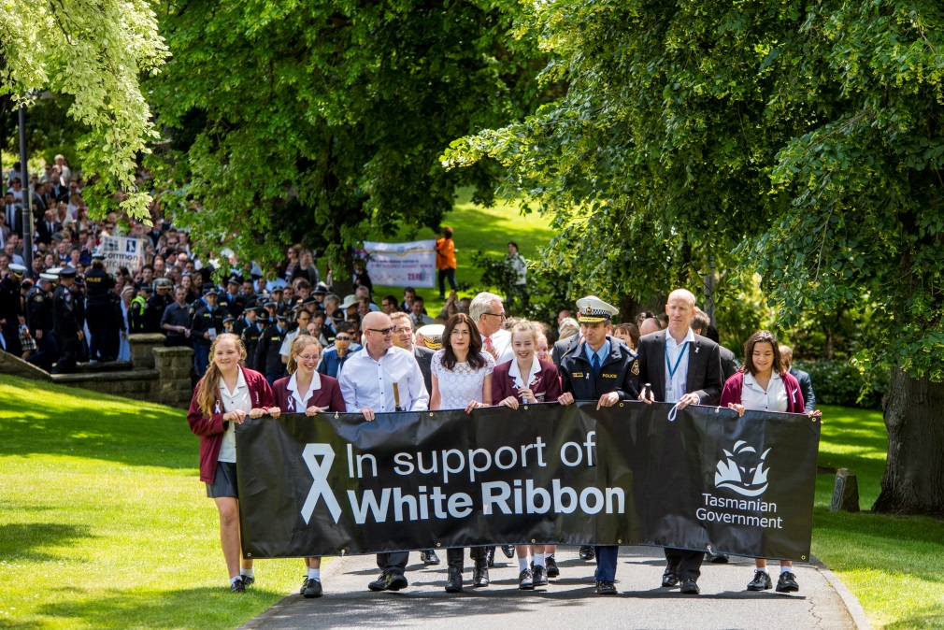On White Ribbon Day, hundreds of Tasmanians marched to Parliament Lawns in Hobart to take a stand for women’s safety.

All Tasmanian State Servants were invited to the White Ribbon Walk, which was led by the Minister for Women, the Hon Jacquie Petrusma MP, Police Commissioner Darren Hine, the Head of the State Service Mr Greg Johannes and the Secretary of the Department of Treasury and Finance, Mr Tony Ferrall.

Tasmanian Parliamentarians, White Ribbon Ambassadors, department heads, students, local businesses, non-government organisations and community members also participated in the walk.

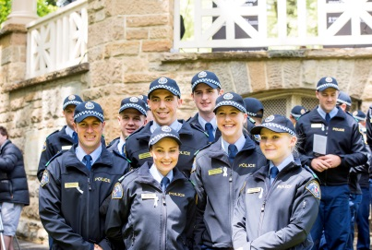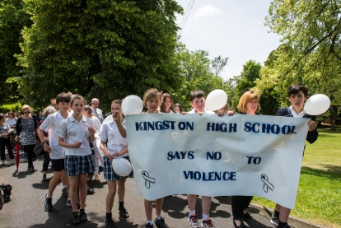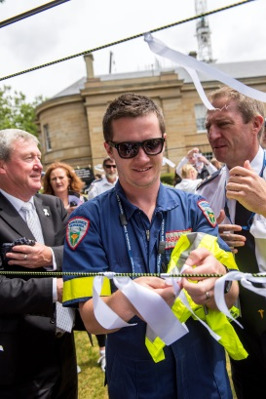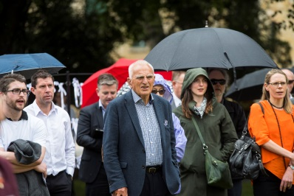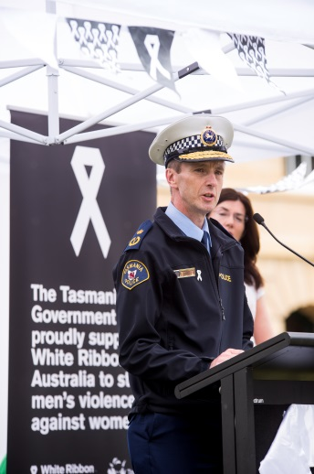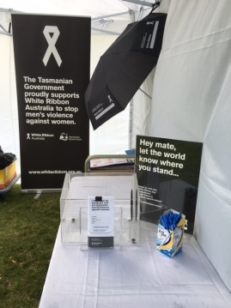

All participants were encouraged to wear white and take the White Ribbon Oath to stand up, speak out and act to prevent violence against women.

Participants were also asked to tie a white ribbon to an installation to show their commitment to reducing violence against women. This installation was displayed in Parliament House throughout the 16 Days of Activism against Gender Based Violence.

## Highlights from South Australia

### SA Office for Women Update

In July 2015 the South Australian Government released *Achieving Women’s Equality: South Australia’s Women’s Policy* which will guide the whole of South Australian government’s actions to:

* improving women’s economic status
* increasing women’s leadership and participation; and
* improving women’s safety and wellbeing.

Reporting will be produced every two years, holding departments to account for their actions under each pillar.



For more information on *Achieving Women’s Equality: South Australia’s Women’s Policy* go to the [Office for Women webpage](http://www.officeforwomen.sa.gov.au/womens-policy/achieving-womens-equality) (www.officeforwomen.sa.gov.au/womens-policy/achieving-womens-equality).

### Multi Agency Protection Service (MAPS)

An early intervention gateway for the sharing of information in relation to domestic and family violence and child protection matters has been operating since July 2014. Based on a similar model from the United Kingdom, MAPS is led by the South Australia Police.

MAPS is a partnership between the Police and other State Government departments, including correctional services, schools, child protection, health and housing. The statewide program brings agencies together in a unique co-location arrangement.

The service currently receives around 400 referrals per week, with each agency sharing their information about cases to build a clearer, more comprehensive picture and enable better informed responses. This integrated multi-agency approach strengthens relationships between agencies and is a clear example of collaboration in action.

Earlier this year the service was visited by 2015 Australian of the Year Rosie Batty, one of Australia’s most prominent campaigners against domestic violence following the tragic loss of her son at the hands of her ex-partner. During her visit, Rosie commented to staff that   
“if this kind of service had been operating for Luke and I, the outcome could have been very different.”

In addition to Rosie the service has hosted a number of prominent visitors including the Premier of South Australia Jay Weatherill and other Members of Parliament; staff from   
New South Wales and Victoria Police; the COAG Advisory Panel on Domestic Violence, officers from the Victorian Royal Commission into Family Violence; and numerous others.

### Women’s Domestic Violence Court Assistance Service

Since 1 July 2015 women in South Australia can access the [Women’s Domestic Violence Court Assistance Service](https://www.dcsi.sa.gov.au/services/latest-news/media-releases-2015/womens-domestic-violence-court-assistance-service) delivered through not-for-profit organisation Victim Support Service.

Funded by the South Australian Government the free, confidential service provides a greater level of support within the court system for victims of violence. Legal officers provide support and advocate on behalf of women who have difficulties applying for an Intervention Order, reporting a breach or raising safety concerns.

The Service has already achieved positive outcomes for women including:

* successfully applying to the Magistrates Court to have an Intervention Order varied to reflect the terms of the Federal Circuit Court Order; and
* to date, two Intervention Orders have been granted on grounds of emotional and psychological abuse.

Women can access the service from anywhere in South Australia using the free phone telephone number 1800 VICTIM (1800 842846) or the [website](http://www.victimsa.org/).

### D3 Challenge – technology enhancing women’s safety

Three teams of South Australian digital entrepreneurs will share in up to $60,000 grant funding to develop high-tech programs that help prevent violence against women.

The teams pitched the best ideas on 10 December 2015 at a [D3 Digital Challenge](http://christianporter.dss.gov.au/media-releases/sa-entrepreneurs-team-up-to-keep-women-safe) pitch night – a program where entrepreneurs are encouraged to “discuss, design and deliver” innovative solutions to longstanding social issues.

For more information on the D3 Digital Challenge, visit the [yourSAy webpage](http://www.yoursay.sa.gov.au/initiatives/d3-digital-challenge) (http://www.yoursay.sa.gov.au/initiatives/d3-digital-challenge).

**Legislative achievements**

South Australia has made significant legislative achievements including:

* Changes to the *Intervention Orders (Prevention of Abuse) (Miscellaneous) Amendment Bill 2014* which came into force on 1 December 2015. This will mean that Magistrates will have to take into account Family Court orders and alter these orders in order to make them consistent with Intervention Orders.
* On 10 December 2015 additional legal achievements have been made in the *Residential Tenancies (Domestic Violence Protections) Amendment Bill 2015.* The changes provide tenancy protections to victims of domestic violence. Included in these protections are opportunities for victims to either continue in the tenancy without the perpetrator, or leave the tenancy and no longer be liable for the premises. Further information is available on the [Consumer and Business Services](http://www.cbs.sa.gov.au/renting-and-letting/domestic-violence-protections-for-the-tenancy-sector/) website (http://www.cbs.sa.gov.au/renting-and-letting/domestic-violence-protections-for-the-tenancy-sector/).

### Zahra Foundation

One of South Australia’s National Plan Partners the [Zahra Foundation](http://www.zahrafoundation.org.au) (established September 2015) continues to build the economic and financial independence of South Australian women who have experienced domestic and family violence, and to help break the cycle of poverty and violence. Recently the Zahra Foundation ran a six-week financial literacy program pilot for five women. Four women completed the course, with two gaining employment prior to its completion. A more comprehensive pilot is due to be rolled out in 2016.

## Highlights from Western Australia

As discussed in the last e-newsletter, a number of resources and initiatives under Western Australia’s [Freedom from Fear Action Plan](http://www.dcp.wa.gov.au/CrisisAndEmergency/FDV/Documents/2015/FFFActionPlan2015.pdf) have now commenced.

### [Safer Families, Safer Communities](http://www.dcp.wa.gov.au/CrisisAndEmergency/FDV/Documents/Safer%20Families%20Safer%20Communities%20Kimberley%20Regional%20Plan%20LOW%20RES.PDF)

The Kimberley Family Violence Regional Plan (Kimberly Plan) was launched in Broome on 1 October 2015.

The Kimberly Plan is a key action under the Freedom from Fear Action Plan 2015. It includes a combination of strategies to strengthen the current services available to all community members. It also includes strategies that are specific to Aboriginal people, families and communities and uses Aboriginal law and culture to challenge the violence and make perpetrators accountable.

Work is progressing to implement Family Safety Teams in the Kimberley region. These teams will be a partnership between the Department for Child Protection and Family Support; Western Australian Police; a community sector specialist family and domestic violence service; and the Department of Corrective Services.  This new service will include four men’s family violence workers and two women’s family violence workers. It is expected that the Family Safety Teams will be fully operational early 2016.

For more information see the [Safer Families, Safer Communities Kimberley Family Violence Regional Plan (Kimberley Plan](https://www.dcp.wa.gov.au/CrisisAndEmergency/FDV/Pages/Prevention_safety_accountability.aspx)), and the [Family Violence in the Kimberly: Project Report.](http://www.dcp.wa.gov.au/CrisisAndEmergency/FDV/Documents/Family%20Violence%20in%20the%20Kimberley%20Project%20Report%20LOW%20RES.pdf)

***Youth Say No***

On 25 November 2015, the Department for Child Protection and Family Support’s updated [*Youth Say No*](http://www.youthsayno.wa.gov.au) campaign was launched. This update included a redeveloped website and related publications targeting young people about family and domestic violence.

Developed in consultation with young people, the updated materials educate young people about the importance of healthy, respectful relationships. They also promote the wide range of resources and services available for those experiencing violence in the home, or those supporting victims and survivors. Also included on the website is a new section for teachers to access learning materials, to help them embed respectful relationships education in classrooms.

Young male holding hand up with the text "youth say no" over his hand.
http://dcpnetprod.ad.dcd.wa.gov.au/News/PublishingImages/2015-1125%20-%20Youth%20Say%20No%20resources%20launched.png

The campaign aims to educate 12–24 year olds about the different forms of family and domestic violence. It also aims to raise awareness that family and domestic violence is a serious crime that should not be tolerated.

For more information about the launch of the revised campaign go to [STAND UP on White Ribbon Day](http://www.dcp.wa.gov.au/CrisisAndEmergency/FDV/Pages/Stand-up-on-White-Ribbon-Day.aspx).

### Risk assessment and risk management framework

The second edition of the Western Australian Common Risk Assessment and Risk Management Framework (CRARMF) was launched at Perth’s [25th Silent Domestic Violence Memorial March](http://www.womenscouncil.com.au/25th-annual-silent-march.html) on 27 November 2015.

The full CRARMF resource, including minimum standards, practice guides, fact sheets and practice tools, can now be accessed online here: [Western Australian Common Risk Assessment and Risk Management Framework (CRARMF)](http://www.dcp.wa.gov.au/CrisisAndEmergency/FDV/Pages/CRARMF2.aspx).

### Practice standards for perpetrator interventions

The new [*Practice Standards for Perpetrator Intervention: Engaging and Responding to Men who are Perpetrators of Family and Domestic Violence*](http://www.dcp.wa.gov.au/CrisisAndEmergency/FDV/Documents/2015/PracticeStandardsforPerpetratorIntervention.pdf) resource was launched on   
1 December at the Bringing Perpetrators into View Conference hosted by the Western Australia Family Pathways Network.

The purpose of the practice standards is to support agencies and organisations to provide a response to men using violence that holds them accountable and provides opportunity for them to take responsibility for their behaviour. The practice standards are separated into minimum standards for men’s family and domestic violence behaviour change programs, and outcome standards for perpetrator intervention.

## Highlights from the ACT

In 2015, 80 people from more than 25 community organisations participated in a four-day training workshop to address the issue of women experiencing domestic violence via technology. The Technology Safety Training was undertaken by the ACT Government Office in partnership by Women’s Services Network (WESNET).

Abuse via technology has an enormous impact on the wellbeing and safety of victims and their supporters. It includes the misuse of technology to target, track, stalk, harass and commit other acts of violence against women and girls.

The training educates service providers in the domestic and family violence sector to:

* understand how technologies work
* identify how abusers are misusing technology
* assess how technology use impacts women and girls experiencing violence
* discuss how technology can be used to help women and girls experiencing violence; and
* support women and girls with privacy and safety planning about technology and evidence collection.

For more information on the Technology Safety Training go to [http://wesnet.org.au](http://wesnet.org.au/2015/10/safetynet-training-canberra-3/).

## Highlights from Victoria

As communities across the nation united on 25 November to mark International Day for the Elimination of Violence Against Women, iconic buildings throughout the Melbourne CBD were lit up with orange lights to raise awareness of family violence. This marked the start of the first ever [Victoria Against Violence](http://www.vic.gov.au/news/victoria-against-violence.html) campaign.

Coinciding with the [16 Days of Activism](http://www.unwomen.org/en/what-we-do/ending-violence-against-women/take-action/16-days-of-activism), the Victorian Government campaign built momentum across the state by raising awareness of the issue of family violence and addressing its underlying causes. It provided numerous opportunities for women’s voices to be heard and highlighted the need for more community advocacy.

Day one of the campaign invited the public to show their support for those who have been impacted by family violence by decorating a t-shirt with prevention messages on the steps of Victoria’s Parliament House as part of the Clothesline Project. Victoria’s Parliament also hosted a series of speeches from family violence survivors and first responders, including 2015 Australian of the Year Rosie Batty.

[Other campaign highlights](http://www.vic.gov.au/victoriaagainstviolence) included the launch of the Gender Equality Consultation Paper. This paper will lead to Victoria’s first ever Gender Equality Strategy to highlight the link between violence and attitudes towards women. Highlights also includes the first ever Listening Project conference, staged at Victorian Parliament House, where victims and survivors of family violence voiced their stories and advised government on how to improve current systems.

The campaign finished on International Human Rights Day with a clear message that it takes the whole community to challenge stereotypes, support gender equality and speak out against sexist attitudes that lead to violence towards women, all year-round and not for just 16 days.

## Highlights from New South Wales

### The women in NSW report

In November, the NSW Government released the [*Women in NSW Report 2015*](https://www.women.nsw.gov.au/womens_data)*.* This report, the only report of its kind in Australia, is the fourth report in an ongoing series to chart the progress towards gender equality in New South Wales.

The *Women in NSW 2015* report provides findings on a range of social and economic outcomes for women across:

* health and wellbeing
* education and learning
* work and financial security
* leadership and representation; and
* safety and justice.

This report provides a high quality evidence base for strong decision-making and policy and program development to bridge gender gaps in NSW. This year, for the first time, the complete indicator data set is also available in the accompanying [*NSW Women’s Report Card* *2015.*](https://www.women.nsw.gov.au/womens_data)

### Blueprint for Domestic and Family Violence Response

As part of[*It Stops Here: standing together to end domestic and family violence in NSW*](https://www.women.nsw.gov.au/violence_prevention/It_Stops_Here)– the NSW Domestic and Family Violence Framework for Reform – the NSW Government is completing a service review through the development of a Blueprint for the Domestic and Family Violence Service response (the Blueprint).

The aim of the Blueprint is to improve the way we prevent and respond to domestic and family violence by creating a more accessible, flexible, person-centred and integrated service system that better meets client needs and make the best use of resources by:

* articulating the principles underpinning a client centred, needs based service response to DFV at the state-wide level
* examining the current DFV response for effectiveness, and identifying any current service gaps
* setting out an effective resource allocation model allowing for flexible, place-based response to client need; and
* providing strategies for implementing effective and tailored responses that can be adapted to address local or regional problems.

The Blueprint will set out the overarching principles and client outcomes to be achieved across the state while allowing for a flexible service response that meets local and regional needs. It will inform the next phase of the domestic and family violence response in NSW.

A public consultation process was recently launched through the ‘[Have Your Say’](http://www.haveyoursay.nsw.gov.au/consultations/search) portal to help inform the Blueprint. On the portal an issues paper and a toolkit are available to community organisations and groups to help them conduct workshops to engage with the issues paper and provide feedback to NSW Government. The public consultation process closes on 5 February 2016.

# Dates for your diary

**6 February** [International Day of Zero Tolerance to Female Genital Mutilation](http://www.un.org/en/events/femalegenitalmutilationday/index.shtml)

**23 February**  [Inaugural ANROWS National Research Conference](http://www.anrowsconference.org.au/)

**25 February** [2nd Annual National Family & Domestic Violence Summit](http://www.informa.com.au/conferences/health-care-conference/national-domestic-violence-conference)

**1 March** Zero Discrimination Day

**8 March** [International Women’s Day](http://www.internationalwomensday.com/)

**14 – 24 March** [60th session of the Commission on the Status of Women](http://www.unwomen.org/en/csw/csw60-2016)

# Have your say!

We would love to hear from you! If you’d like your event included in future editions of this   
e-Newsletter, or have other questions, comments or ideas, please email us at [NPSecretariat@dss.gov.au](mailto:NPSecretariat%20%3cNPSecretariat@dss.gov.au%3e).

If you’ve not done so already, please [subscribe](http://plan4womenssafety.dss.gov.au/latest-news/e-newsletter/) to receive this e-Newsletter.

# Do you need help?

If you or someone you know is experiencing domestic and family violence or sexual assault, get help by calling:

* 000 if you, a child, or another person is in immediate danger
* 1800RESPECT – 1800 737 732
* Relationships Australia – 1300 364 277
* Mensline – 1300 789 978
* You can ask for a free interpreter if needed.

National Relay Service

* TTY users - phone 133 677 then ask for the phone number you wish to contact
* Speak and Listen (speech-to-speech relay) users - phone 1300 555 727 then ask for the phone number you wish to contact
* Internet relay users - visit the [National Relay Service website](http://www.relayservice.com.au/) and ask for the phone number you wish to contact.