Research summary: No.3/2015

Partner violence in the Longitudinal Study of Indigenous Children (LSIC)
Laura Bennetts Kneebone
Key statistics
- Mothers who had arguments that included physical violence were much more likely to be in a partner violence situation in future waves, but were also much more likely to be single in future waves.
- Demographic characteristics related to employment, education and financial hardship were related to partner violence. Remoteness was the single biggest predictor of partner violence in LSIC.
- Children were more likely to have social and emotional problems if they had been upset by family arguments and/or if their parents have had violent arguments.
- Mothers experiencing partner violence were more likely to rate family violence as a big problem in their community.

Domestic violence in the LSIC context
The Longitudinal Study of Indigenous Children (LSIC) has interviewed the families of between 1,200 and 1,700 Aboriginal and Torres Strait Islander children every year since 2008. In the first year of interviewing most children were either 1 or 4 years of age. They live in urban, regional and remote areas of Australia (see Figures 1 and 2). While all of the children in the study are Indigenous, not all the primary carers or their partners are Indigenous.

Figure 1: LSIC 2008 sample by ASGC Remoteness area

Major cities of Australia | 26.0%
Inner regional Australia | 25.2%
Outer regional Australia | 13.4%
Remote Australia | 15.0%
Very remote Australia | 20.5%
Figure 2: LSIC survey sample distribution (2013)
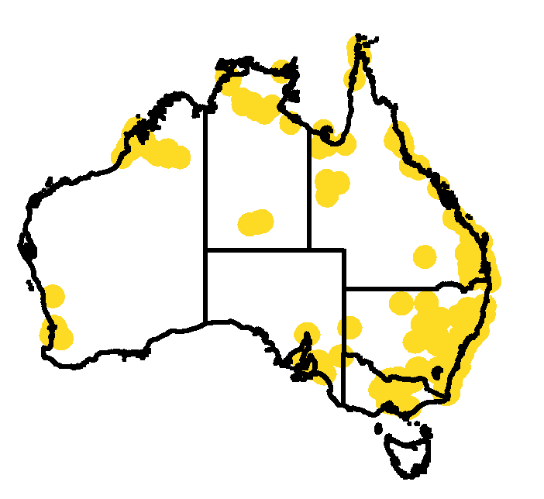

In the third year of interviewing (Wave 3), the primary carers, 97.4 per cent of whom were female (predominantly mothers), were asked about their relationship with their partners. At this point in time, 57.5 per cent of the participants had a partner living in the household (only slightly higher than at Wave 1). Parents living with a partner were asked whether they have arguments with their partner that end up with people pushing, hitting, kicking and shoving. Of those asked (n=833), 7.2 per cent refused to answer any relationship questions and a further 0.4 per cent refused the question about partner physical violence. Of those who answered (n=769), 86 per cent reported no partner physical violence (see Figure 3).
Figure 3: LSIC parents have arguments that include physical violence (2010)

Never | 86.2%
Rarely | 10.3%
Sometimes | 3.3%
Often | 0.3%

After taking into account children living in a single parent household (42.6 per cent), around 8 per cent of Indigenous children in the sample live in households where parents’ arguments occasionally end up with people pushing, hitting, kicking or shoving (combining responses “rarely”, “sometimes” and “often”) (see Figure 4).
Figure 4: Proportion of LSIC children growing up in homes with some violence (2010)

Single parent household (Family violence questions not asked) | 42.6%
No violence between parents | 49.5%
Some violence between parents (Rarely, sometimes, often) | 7.9%

Persistence of partner violence

The question about parental arguments ending in violence was asked in Wave 3 (2010) and again in Wave 6 (2013). This enables investigation of whether differences in characteristics between families experiencing physical violence and those who are not are stable over time. A number of characteristics do not show any relationship to partner violence. These include age of the study child, presence (or absence) of other males or females in the household and number of children in the household.
Experiencing partner violence in Wave 6 (2013) was related to experience of partner violence in Wave 3, three years earlier (see Figure 5). Of those experiencing some violence in Wave 3, 26 per cent were still experiencing violence in Wave 6 and 30 per cent were single by Wave 6. Of those who were in a non-violent relationship in Wave 3, 9 per cent were experiencing partner violence three years later and 16 per cent were single. Of those who were single in Wave 3, 75 per cent were still single, 22 per cent were in a non-violent relationship and 3 per cent were in a violent relationship at Wave 6.

Figure 5: Persistence of partner violence over three years in LSIC sample (2010–2013)

 | No Partner 2010, n=363 | No violence 2010, n=448 | Some violence 2010, n=70
Some partner violence 2013 | 2.8% | 9.2% | 25.7%
No partner violence 2013 | 22.3% | 74.6% | 44.3%
No partner 2013 | 74.9% | 16.3% | 30.0%

Education
Although there was no relationship between mother’s education level and experience of partner violence, there was a significant relationship between father’s education level and partner violence. If fathers had an education level of year 10 or above (Wave 6), 11 per cent of mothers reported partner violence, but if fathers had a year 9 or below education, that percentage increased to 23 per cent (see Figure 6).
Figure 6: Experience of partner violence of LSIC parents in relationships by father's education level (2013)

 | Father year 9 or below | Father year 10 or above
Some violence between parents | 22.6% | 10.5%
No violence between parents | 77.5% | 89.5%

Employment and financial hardship
Partner violence was also significantly related to employment for both fathers and mothers. In 2013, mothers who were not employed were more likely to be victims of partner violence than mothers who were employed. Mothers whose partner was not employed were twice as likely to experience domestic violence as mothers whose partner was employed (see Figure 7). This pattern was the same in 2010.
Figure 7: Proportions of families experiencing partner violence by mothers’ and fathers’ employment status (LSIC 2013)

 | Mother’s employment status | Mother’s employment status | Father’s employment status | Father’s employment status
 | Employed | Not employed | Employed | Not employed
Some partner violence | 9.0% | 15.7% | 10.1% | 20.7%
No partner violence | 91.0% | 84.3% | 89.9% | 79.3%

Financial hardship in the household had a strong and significant relationship to occurrence of partner violence. Primary carers reported a range of types of financial hardship from a list of six types including items such as difficulty paying bills on time, going without meals and needing to pawn or sell goods in the past year. Families were grouped into two categories, those with little or no experience of financial hardship and those with two or more types—‘multiple financial hardship’. In 2010, 25 per cent of families experienced multiple financial hardship and in 2013, 20.7 per cent of families did. The relationship between hardship and partner violence was very significant in both of those years. In 2013, 19.5 per cent of families experiencing multiple financial hardship also experienced partner violence compared to 11.2 per cent of families experiencing little or no financial hardship (Figure 8). Similarly, in 2010, 19.9 per cent of families experiencing multiple financial hardship also experienced partner violence compared to 11.8 per cent of families experiencing little or no financial hardship.

Figure 8: Proportions of families experiencing partner violence by experience of financial hardship (LSIC 2013)

 | Little or no hardship | Multiple financial hardship
Some partner violence | 11.2% | 19.5%
No partner violence | 88.8% | 80.5%

In 2010 and 2013, mothers were asked whether anyone in the family had a problem with drugs or alcohol. While there was a significant relationship between having a partner with a drug and alcohol problem and partner violence in 2013, the relationship was not significant in 2010. However, drugs and alcohol issues were only related to a small proportion of family violence reports. While a total of 12.7 per cent of respondents who were living with their partner reported the occurrence of partner violence in 2013, only 2.1 per cent of those living with their partner reported that their partner had an alcohol or drug problem.
Wave 3 included a special module asking about homelessness. Of the 122 respondents who identified as having been homeless in the past 5 years (8.7 per cent of the sample), the most common cause was domestic violence, affecting nearly 22.1 per cent of those who had been homeless.

Impact on children

The impact of family conflict and violence on children is an important topic for further research, and potentially affects many Indigenous children. In each wave of interviewing, parents are asked a range of questions about major life events. Approximately 20 per cent of families reported that their children had been upset by family arguments in the last year, and this proportion is consistent over time. Social and emotional difficulties were measured by the Strengths and Difficulties Questionnaire. In bivariate regression, children’s difficulties scores were 1.8 points higher if their parents reported them being upset by family arguments (a higher score indicates more difficulties). The results were highly significant (Table 1).
Compared to children with two parents whose mothers don’t report violent arguments, children whose parents do have violent arguments had social and emotional difficulties scores between 1 and 2 points higher (significant in Wave 3 but not in Wave 6) (Table 1).

Table 1: Relationship between children’s Strengths and Difficulties scores and their experience of conflict and violence in the home- bivariate regression analysis

Outcomes | Wave 3 | Wave 6
Child upset by family arguments | 1.8 points higher*** | 1.8 points higher***
Parents have had violent arguments | 2.1 points higher*** | 1.1 points higher
*** indicates significance at <0.001.

Perceptions of violence in the community

In 2013, parents were asked about the safety of their communities. One question focused on the question of whether family violence was a problem in their community (see Figure 9).

Figure 9: LSIC parents’ perceptions of frequency of family violence in their community (2013)

Don’t know | 7%
Doesn’t happen here | 64%
Happens a bit of the time | 14%
Happens a lot of the time | 10%
Happens all the time | 5%

Families who had reported having arguments that ended up with people pushing, hitting, kicking or shoving, were significantly more likely to rate family violence as a big problem in their community (see Figure 10).

Figure 10: LSIC parents’ perceptions of family violence in their community by personal situation (2013)

 | Single parent, n=444 | No violence, n=506 | Some violence, n=77
Family violence happens a lot/all the time in this community | 14.4% | 10.3% | 22.1%
Family violence rarely/never happens in this community | 85.6% | 89.7% | 77.9%

Geographic remoteness and community disadvantage

Families living in remote areas were significantly more likely to rate family violence in the community as a big problem. For example, in very remote areas, 29.2 per cent of respondents said family violence was a big problem (happens all or a lot of the time); however, 17.5 per cent said it was a big problem in outer regional areas, and 7.5 per cent said it was a big problem in major cities (Figure 11).

Figure 11: Perception of family violence in the community by AGSC remoteness area (LSIC 2013)

 | Major cities | Inner regional | Outer regional | Remote | Very remote
Happens all the time | 1.9% | 3.2% | 2.2% | 6.2% | 14.2%
Happens a lot of the time | 5.6% | 8.3% | 15.3% | 12.4% | 15.1%
Happens a bit of the time | 10.3% | 15.1% | 15.3% | 17.7% | 21.9%
Doesn’t happen here | 82.3% | 73.4% | 67.2% | 63.7% | 48.9%

The relationship of remoteness area to personal experience of partner violence is complex, and partner violence doesn’t increase incrementally with each level of remoteness in the same way as the perceptions of community violence increase. Instead, Major Cities share the same pattern with Inner Regional Areas, while Outer Regional, Remote and Very Remote areas share a pattern (see Figure 12).
Figure 12: Perception of family violence in the community and experience in the home—differences by Remoteness Area (LSIC 2013)

 | Urban (Remoteness areas 1 and 2) | Remote (Remoteness areas 3-5)
Perception of family violence in the community | 9.5% | 22.7%
Experience of partner violence in the home | 5.5% | 9.9%

Perceptions of family violence in the community were also significantly related to the Socio-Economic Indexes for Areas (SEIFA) Index of Relative Socio-Economic Disadvantage (see Figure 13). Among families living in the lowest SEIFA decile (where 43.4 per cent of LSIC families live), 23.5 per cent identified family violence as a big problem in their community, while only 8.8 per cent of families living in higher deciles (2–10) said the same. In no other decile did the proportion of people who thought it a big problem exceed 12.3 per cent. Personal experience of partner violence in the home was also significantly related to the Index of Relative Socio-Economic Disadvantage. As shown in Figure 12, both the perception and the reality of occurrence of family violence were higher in the most disadvantaged communities, as they were in remote communities.
Figure 13: Perception of family violence in the community and experience in the home—differences by community disadvantage (LSIC 2013)

 | Less severely disadvantaged (SEIFA decile 2-10) | Most severely disadvantaged (SEIFA decile 1)
Perception of family violence in the community | 8.8% | 23.5%
Experience of partner violence in the home | 5.8% | 9.4%

There is overlap between the remotest communities and the most disadvantaged communities (57 per cent of the sample living in the more remote communities are in the lowest SEIFA decile compared to 33 per cent of those living in the more urban communities). After controlling for other variables, the strongest single predictor of partner violence was remoteness, closely followed by SEIFA. Father’s education also remained a significant predictor (Table 2).
Table 2: Association between geographic and personal characteristics and partner violence, logistic regression analysis, LSIC 2013.
Factor | Association with partner violence
Lowest SEIFA decile (0=deciles 2–10) | Nearly twice as likely*
Remote (0=urban/inner regional) | More than twice as likely**
Multiple financial hardship (0=zero or one type of hardship) | Nearly twice as likely^
Primary carer has no job | No relationship
Partner has no job | Nearly twice as likely^
Father less than year 10 education | More than twice as likely*
** significant at <0.01; * significant at <0.05; ^ significant | at <0.1

Total sample here (881) are participants who responded to relationship question in both 2010 and 2013. Those with missing data were excluded from this analysis as were cases where the primary carer changed.
Chi² test, significance level set at 0.05.
The terms ‘mothers’ and ‘fathers’ are used in this article to refer to the female parent and her male partner respectively as approximately 95 per cent of the female primary carers are the mother of the study child. The small number of same sex couples and couples with a male as the primary carer are excluded from analysis relating to ‘mothers’ and ‘fathers’ characteristics, but included in all other analyses in this paper relating to LSIC.
Chi² test, significance level set at 0.05.
Chi² test, significance level set at 0.05.
Chi² test, significance level set at 0.05.
Chi² test, significance level set at 0.05.
Chi² test, significance level set at 0.05.
Chi² test, significance level set at 0.05.
Method used was logistic regression restricted to LSIC couples in 2013 (n=580), in which occurrence of partner violence is the outcome variable, and with SEIFA Index of Relative Socio-Economic Disadvantage, remoteness, financial hardship, parent and partner employment status and partner education as the predictors.

