National Longitudinal Data Conference 2016
The National Centre for Longitudinal Data is pleased to announce that the National Longitudinal Data Conference 2016 will be held at the National Convention Centre, Canberra, 25–27 October 2016.
The conference theme is Wellbeing over the Life Course and it is anticipated that a wide range of international and Australian researchers, policy makers, analysts, data users, data collectors and market researchers will attend.
The conference aims to bring together longitudinal analysts across disciplines, demonstrate the power of longitudinal data in evidence based policy making and showcase the predictive power of joining the longitudinal survey with administrative data.
A call for papers will be announced in January 2016. More information.

NCLD Seminar—Evidence for Social Policy
An Evidence for Social Policy seminar was held in Canberra on 26 November 2015. Presentations included:
The importance of engaging Indigenous children in early childhood education and care — Dr Nicholas Biddle, Fellow, National Centre for Aboriginal Economic Policy Research
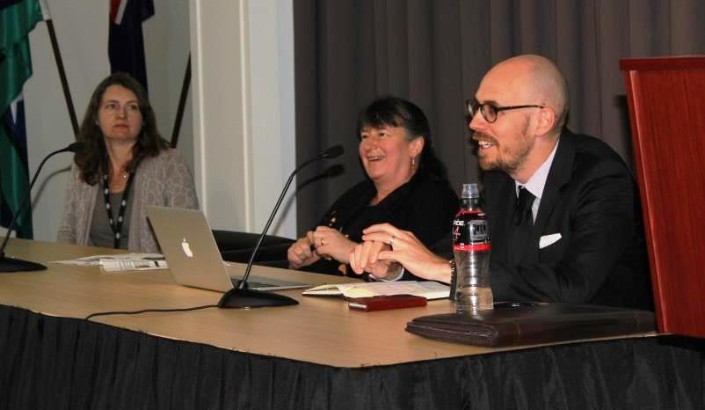
Predictors for a positive start for Indigenous children — Fiona Skelton, Assistant Director NCLD
What we know about partner violence from the longitudinal studies of both Indigenous and non-Indigenous children — Laura Bennetts Kneebone, Assistant Director NCLD.
The seminar video and transcript are now available.

New Data Releases
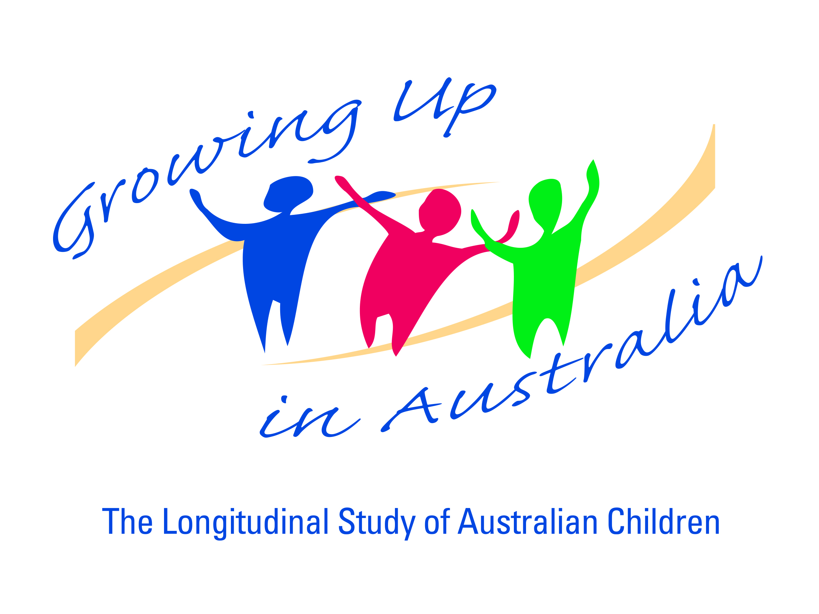
The Growing up in Australia Wave 6 dataset was released on 18 December 2015. This data includes many new items asked of the older cohort at 14-15 years. In addition, the Australian Early Development Census (AEDC) is linked to the B cohort for the first time. Information on how to apply for data is available online.
The Building a New Life in Australia Wave 1 dataset was released in September 2015. Information on how to apply for data is available online.
The Data Highlight — Building a New Life in Australia (BNLA): The Longitudinal Study of Humanitarian Migrants outlines the demographic characteristics of participants, their health and English proficiency and provides some initial findings.

The Longitudinal Study of Australian Children (LSAC) Annual Statistical Report
The LSAC Annual Statistical Report was released in August 2015. The initial mini-wave of Wave 7 interviews started in mid-2015. It includes new analysis of children’s views on parental separation, gender role attitudes, transition to secondary school, educational expectations, and early initiation of criminal behaviour. More information.

Australian Government Longitudinal Data Review
The NCLD is leading a review of national longitudinal data architecture and has established a Review Steering Committee which is made up of senior government officials and their academic equivalents.
The Committee held its inaugural meeting in early December 2015, building on the outcomes of a longitudinal data workshop held in July that involved senior officers from across different portfolios and senior academics involved in longitudinal research. A detailed workshop summary [ADD LINK] is available for download.
The Committee has agreed on a work schedule and set of key deliverables for the Review which has been structured in three stages:
- Identify core national data sets to assist in identifying gaps in data sets and set priorities for future development of data sets
- Review existing longitudinal data support mechanisms (including existing product offering, dissemination and use of longitudinal data) having regard to the identified priorities in Stage 1 above
- Provide strategic advice on priorities for improvement to assist in planning transition and implementation strategies for the future.
The final report to government, due in late August 2016, will include the outcomes and prioritised recommendations from all three stages. The findings will be presented at the National Longitudinal Data Conference, 25–27 October 2016.
Requests for information relating to the review can be sent to NCLD@dss.gov.au.

Adam Rowland starts as NCLD Executive Manager
Adam Rowland is the new NCLD Executive Manager. He worked most recently at the Australian Government Department of Health and has previously held positions in the private sector conducting social research for government.
Mr Rowland is delighted to take on this role at a time when the NCLD is taking the lead on a number of longitudinal data initiatives. “I am excited by the power of longitudinal data, both survey and administrative, to underpin Australia’s social policy”, said Mr Rowland.
He can be contacted by email at adam.rowland@dss.gov.au.

Indigenous children in schools analysis from LSIC data

Research Summary – Increased literacy scores for Indigenous children in schools using the cross-curriculum priority [ADD LINK]
Fiona Skelton
This research summary investigates the outcomes of children in Footprints in Time, around 6 years of age, who attended schools using the cross-curriculum priority of Aboriginal and Torres Strait Islander histories and cultures in their teaching. These children had higher average teacher reported literacy scores than children in schools that did not (or schools where the responding teacher did not know).

Domestic violence analysis from LSAC and LSIC data [ADD LINK]

Research Summary – Domestic Violence in the Longitudinal Study of Australian Children
Helene Shin, Helen Rogers and Vincci Law
This research summary looks at the six per cent of mothers who reported that they are afraid of their partners in Growing Up in Australia: The Longitudinal Study of Australian Children. It investigates the characteristics of these mothers and their partners as well as family relationships and child wellbeing.

Research Summary – Partner Violence in the Longitudinal Study of Indigenous Children [ADD LINK]
Laura Bennetts Kneebone
This research summary examines the incidence of physical violence reported by mothers in Footprints in Time: The Longitudinal Study of Indigenous Children. It investigates the characteristics of these mothers and their partners as well as family relationships and child wellbeing.

Have an issue or topic you would like to know more about?
Email ncld@dss.gov.au with your questions and suggestions for future e-newsletters.

