National Plan to Reduce Violence against Women and their Children
  - eNewsletter, Issue 2, December 2014
  - Diverse experiences of violence – Culturally and linguistically diverse women
Welcome to the second issue of the National Plan e-newsletter.
The National Plan aims to reduce violence against all women and their children, but some groups of women can be more vulnerable to violence and face challenges in accessing information, services and support. That is why the Second Action Plan has a particular focus on violence against Indigenous women, women with disability and culturally and linguistically diverse (CALD) women.
The focus of this eNewsletter is Diverse experiences of violence, particularly those faced by CALD women.
In this issue you will find articles on how the Australian Government is engaging with CALD communities on issues of violence against women, what is being done to build the evidence-base on women’s experiences of violence and how working with communities is helping to prevent violence.
To provide CALD women with accessible information on what we are aiming to achieve under the National Plan and Second Action Plan, the Second Action Plan brochure and CALD factsheet have been translated into 12 languages. You can access the documents on the DSS webpage and are invited to share these documents with your networks.
Thank you for your support of the National Plan and your ongoing efforts to make Australia safer for women and their children throughout 2014.

What has happened over the past two months?
31 October ANROWS’ Research Program 2014-2016 announced
24 November Police Commissioners Stand Together Against Domestic Violence on Women and Children
25 November White Ribbon Day
25 November United Nations International Day for Elimination of Violence against women
25 November- 16 Days of Activism against Gender Violence
10 December
28 November Women and Girls at Risk Symposium
29 November Following the Victorian Election, the Hon Fiona Richardson MP was appointed Minister for Women, and Minister for Prevention of Family Violence. The Victorian Government announced that it will establish a Royal Commission into Family Violence that will commence early in 2015 and report by the end of 2015.
2 December International Day for the Abolition of Slavery
3 December International Day of People with Disability
8 - 9 December National Domestic Violence Summit
9 December Launch of new 1800RESPECT resources for frontline workers
10 December World Human Rights Day

Feature stories

Engaging with CALD communities

Supporting engagement with CALD communities and helping to build a knowledge-base of CALD women’s experiences are key objectives of the newly established CALD Women’s Safety team in the Australian Government Department of Social Services. This team’s first key piece of work has been to support CALD community leaders in hosting kitchen table conversations, which are taking place throughout Australia.
These conversations provide an opportunity for CALD women to voice their opinions and concerns on a range of violence-related issues.
Invitees to these conversations have included service providers, community leaders, community members, bi-cultural workers and community workers. The conversations have focused on issues of domestic and family violence and sexual assault, including:
- barriers and challenges
- the role of the community
- the role of government
- what works well
- good ideas
- engaging with CALD men.
Kitchen table conversations will be hosted in all states and territories with over 20 expected to be held by the end of January 2015. Findings from these conversations will inform the implementation of the National Plan’s Second Action Plan.

New Resources on the 1800RESPECT website

As part of the 16 Days of Activism Against Gendered Violence, 1800RESPECT launched over 35 new resources designed to support domestic violence workers and professionals in their roles.
These resources cover topics including vicarious trauma, resilience and safety planning.
Included in this launch were resources specific to working with Aboriginal and Torres Strait Islander women and children covering:
- cultural competence in risk assessment and safety planning
- good practice principles
- an interactive Aboriginal and Torres Strait Islander service map – the first of its kind in the sector.
Additionally, workers and professionals now have access to:
- videos and fact sheets in 28 languages
- an AUSLAN video
- animated case studies.

National Action Plan to Combat Human Trafficking and Slavery 2015-2019
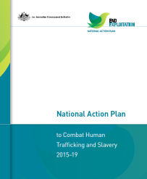
Launched on 2 December by the Commonwealth Minister for Justice, the Hon Michael Keenan MP, the Minister for Social Services, the Hon Kevin Andrews MP, and the Assistant Minister for Immigration and Border Protection and Minister Assisting the Prime Minister for Women, Senator the Hon Michaelia Cash, the National Action Plan to Combat Human Trafficking and Slavery 2015-2019 (the National Action Plan) sets the strategic aims of Australia’s whole-of-community response to human trafficking and slavery over the next five years. It also provides measures to monitor the impact and effectiveness of efforts to combat these crimes both here in Australia and internationally. The National Action Plan has strong linkages with a range of Commonwealth policy initiatives, including the National Plan.
At this launch, Minister for Social Services Kevin Andrews announced the expansion of 1800RESPECT to provide victims, and those at risk, of forced marriage with tailored, appropriate support and assistance nationwide. The expansion of the service will empower victims and those at risk of forced marriage by providing access to appropriate support and assistance, wherever they are, at any time of the day or night.

Police Commissioners take a united stand on violence against women and children
On 24 November, all Australian and New Zealand Police Commissioners convened in Canberra for the first time to stand together against domestic violence.
Police Commissioners were joined by the Governor-General Sir Peter Cosgrove and Lady Cosgrove, the Prime Minister the Hon Tony Abbott MP, the Leader of the Opposition the Hon Bill Shorten MP, Minister Assisting the Prime Minister for Women, Senator the Hon Michaelia Cash, and Australia’s Ambassador for Women and Girls and Chair of Our Watch, Ms Natasha Stott Despoja, to Stand Together against Violence on Women and Children.
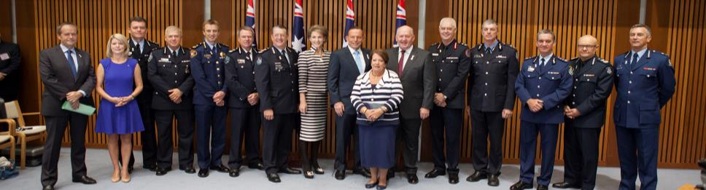
Photo courtesy of the Australian Federal Police
The event was organised by the Australia and New Zealand Policing Advisory Agency (ANZPAA) and hosted by Minister Cash, who said: "Today's event is a powerful demonstration of the fact that domestic violence is an issue of national significance and that strong, sustained leadership is required to promote cultural and attitudinal change.”
Find out more at the ANZPAA website.

GP’s working to support patients experiencing violence
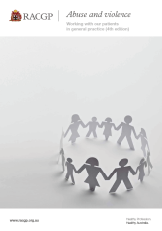
In October, the Hon Andrew Southcott, Federal Member for Boothby announced that the Commonwealth Government will provide around $225,000 to assist General Practitioners and Aboriginal Health Workers in supporting patients experiencing or at risk of domestic and family violence and sexual assault.
This announcement was made during the Royal Australian College of General Practitioners’ (RACGP) Annual Conference, with Professor Kelsey Hegarty from the University of Melbourne accepting this funding to develop products and provide expert guidance to inform the set-up of a Primary Care Professional Support and Information Telephone Line and online portal through 1800RESPECT.
Mr Southcott also launched the 4th Edition of the RACGP White Book Abuse and Violence: Working with our patients in general practice and the new online Active Learning Module to further support GPs in responding to women and children experiencing violence. The Commonwealth Government provided around $220,000 as part of the National Plan’s First Action Plan to extensively update the RACGP White Book and develop online learning modules to improve primary health care responses to women experiencing domestic and family violence and sexual assault.
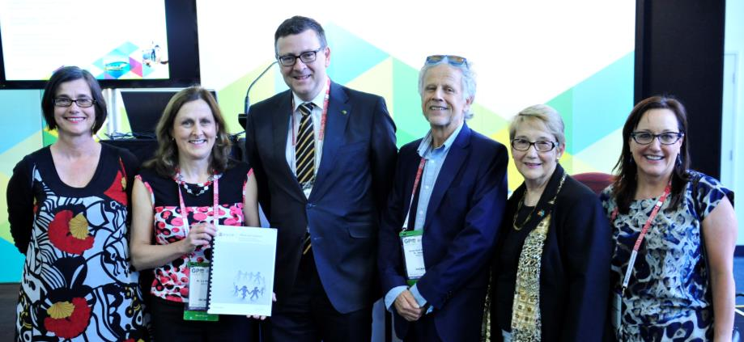
L-R: Professor Kelsey Hegarty, Liz Marles (outgoing RACGP President), Federal Member for Boothby Andrew Southcott MP, RACGP President Dr Frank R Jones, Dr Elizabeth Hindmarsh, and RACGP CEO Dr Zena Burgess.

Australia’s National Research Organisation for Women’s Safety update
ANROWS has produced its first research program to build knowledge on domestic, family and sexual violence.

Women with disabilities, immigrant and refugee women, women in rural areas and Australian Indigenous communities will be the focus of particular projects within the program.

ANROWS’s Research Program comprises 20 projects with a total value of around $3.5 million. Projects vary in length and will be delivered at different points over the next two years.

We are grateful for the expert advice we have received from across Australia. Many of the research projects see researchers and community organisations working together to produce innovative and relevant research. It’s exciting to see goodwill from so many organisations but it will be even better to see the results of their research.
- Heather Nancarrow, CEO
ANROWS CEO Heather Nancarrow said service providers, policy makers and researchers across Australia had an important role in the development of the research program.

Our Watch update
Last month, prominent journalists and editors attended Our Watch’s inaugural Media Advisory Group meeting. The Group was established by Our Watch as part of the National Media Engagement Project.
The Group brings together 21 people from television, radio, print and online media, as well as a number of key media academics, to review materials created through the project. Members will also act as champions within the media industry to build interest in the project, and encourage wider change in the way violence against women is reported in terms of context, language and links to services.
Our Watch Chair, Natasha Stott Despoja AM, welcomed the group to the inaugural meeting and led a wide ranging discussion about how journalists and the sector can work together to promote the ethical reporting of violence against women. Members heard the stories of three survivors of violence trained through Women’s Health East’s media advocacy programme who spoke about the importance of their role in getting messages out there to ‘stop violence before it starts’. One of these stories will be published in Women’s Agenda.
The National Media Engagement Project is funded by the Commonwealth Department of Social Services under the National Plan.

Stopping violence against women in Defence

The Department of Defence is committed to the whole-of-Government approach to creating an environment that reduces violence against women and their children.
A suite of reviews into aspects of Defence culture were conducted over 2011-12 and these reviews and accompanying recommendations were brought together under the Pathway to Change: Evolving Defence Culture strategy (Pathway to Change).
Two of the reviews were conducted by Sex Discrimination Commissioner, Elizabeth Broderick, and examined the treatment of women in the Australian Defence Force Academy (ADFA) and Australian Defence Force (ADF). Defence is currently implementing all 52 of the recommendations.
Some of the key outcomes associated with Pathway to Change include:
- establishing the Sexual Misconduct Prevention and Response Office (SeMPRO);
- developing and delivering sexual ethics training and an alcohol management strategy;
- better gender balance in leadership forums;
- the commitment to undertaking widespread Unacceptable Behaviour surveys to ensure baseline data exists and progress can be measured;
- implementing ADFA’s citizenship package, developed in consultation with a range of experts;
- recruiting and retention initiatives to increase numbers of women;
- opening of final employment categories to ADF women; and
- accreditation of the Royal Australian Navy as a White Ribbon workplace, the largest of the first 23 organisations in the world to achieve this status. Army and Air Force are working toward accreditation.
While Defence has actively pursued cultural reform, especially in regards to gender and personal accountability, there is still some way to go.
Over the next four years, Defence and the Australian Human Rights Commission are collaborating to monitor the implementation of cultural change.
For more information, visit Pathway To Change.

Updates from around the country

Multicultural Access Point in Tasmania
Tasmania is a culturally, religiously and linguistically diverse State, with a long history of migration.
The Multicultural Access Point (MAP) website is a quick and easy way to find information and services for migrants and former humanitarian entrants in Tasmania.
This website can help Tasmania’s CALD population to access the services and support they need in relation to domestic and family violence.
MAP provides important information about justice and legal responses to family violence, including connecting CALD groups with the Safe at Home initiative. Safe at Home involves a range of services working together to protect and support victims of family violence, including young people and children, while making offenders responsible for their behaviour.
MAP also provides information on housing through Housing Connect. Housing Connect is the one-stop shop for all housing and support needs. It is one assessment for everything from emergency accommodation to a long-term home. In particular, Housing Connect can help with those who are seeking assistance following family violence.
With an emphasis on primary prevention of violence against women, MAP links youth with information and programs about building respectful relationships to equip CALD youth with superior skills and strong self-esteem to model successful relationships. It also links other members of the CALD community with information on creating respectful, positive relationships and information about where to go for family violence or sexual assault counselling and support.
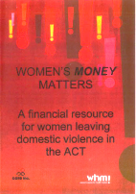

New financial resource guides for women escaping violence in the ACT
For many women the decision to stay or leave an abusive relationship is affected by financial factors. On 13 October 2014, as part of Poverty Week, the ACT Minister for Women, Ms Joy Burch MLA, launched Women’s Money Matters – a set of financial resources designed to assist vulnerable women in ACT, particularly those who experience domestic violence and other forms of disadvantage.

Financial security goes to the heart of women’s ability to leave an abusive relationship and recover from its impacts and gain control over their lives.
Knowing that there are people to talk to and there is support available can be critical in enabling women to leave a violent situation. I believe that Women’s Money Matters will assist women in the ACT and those who support them, find freedom from violence and abuse and allow them to take true agency in their lives and that of their children.
- Joy Burch MLA, ACT Minister for Women

Women’s Money Matters aims to provide simple, practical and local advice to woman to help guide them and help improve their access to support in the ACT.

NSW launches It Stops Here: Safer Pathway – a new approach to supporting victims
The NSW Government is changing the way victims of domestic and family violence get help through a new approach to protecting and supporting the state’s women and children. It Stops Here: Safer Pathway (Safer Pathway) is a key element of It Stops Here - the NSW Government’s Domestic and Family Violence Framework for Reform.
Under Safer Pathway, services are working together to create a coordinated, holistic response to victims of domestic and family violence and their children. Safer Pathway puts the safety of the victim and their children at the centre of the response. Victims have a single contact point, a specialised domestic and family violence worker, who will link them with the services they need, when they need them.
Under Safer Pathway, women needing support won’t have to tell their story over and over again to a multitude of service providers, reliving their traumatic experiences. For the first time in NSW, there is a consistent assessment by the NSW Police of the level of danger facing a victim. Safer Pathway also enables the tracking of referrals through the system to ensure victims receive a timely and appropriate response that meets their needs.
Significantly, where a victim is assessed to be at serious threat of further violence, their case will be referred to a local Safety Action Meeting, where relevant government and non-government agencies will develop a Safety Action Plan to protect the victim and their children.
The NSW Government is building on existing services to better support victims of domestic and family violence so they have more confidence in the system that’s there to protect them.
Safer Pathway started in Orange and Waverley in September 2014 and will be rolled out across NSW from 2015. For more information, including resources for service providers, go to: domestic violence NSW.

South Australia is Taking a Stand against violence against women
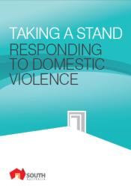
The South Australian Government is committed to the prevention of violence against women. In the wake of a shocking domestic violence murder in 2010 and the subsequent findings and recommendations from the coronial inquest, the South Australian Premier Jay Weatherill launched Taking a Stand: Responding to Domestic Violence in October 2014 (Taking A Stand). Taking a Stand builds on the initiatives of A Right to Safety 2011 – 2022, the next phase of South Australia’s Women’s Safety Strategy.
Taking a Stand brings together a whole-of-government response to the findings of the Coroner to better identify at an early stage any gaps in the system when responding to domestic violence.
The South Australian Police (SAPOL) response includes a new prosecutions staffing model, enhanced domestic violence training programs for police and formal protocols to flag and update domestic violence safe houses.
In addition to SAPOL’s action the South Australian Government will provide additional responses which include:
- establishing a Women’s Domestic Violence Court Assistance Service;
- establishing an Early Warning System designed to increase accountability and provide an escalation point when there have been flaws in responding to domestic violence; and
- considering strengthening penalties for people who are proven to be consistent domestic violence offenders.
Additionally all South Australian government departments will gain White Ribbon Workplace accreditation. This will build upon existing workplace policies on domestic violence. As the largest employer in South Australia, the South Australian Government is committed to leading by example.

ACT Partners in Prevention Awards
On 10 December 2014, the ACT Minister for Women, Ms Joy Burch MLA, hosted the ACT Partners in Prevention Awards. Award winners were:
  - YWCA of Canberra for their program Relationship Things, a primary prevention program that provides young people with the skills and knowledge to recognise and behave with respect in their relationships.
  - Menslink for their Silence is Deadly program that works with male high school students to highlight the importance of talking through their problems rather than reacting with violence when things go wrong.
  - Adrienne Frances, ABC journalist for her commitment to raising awareness of the impact of violence against women and children in the ACT through three different programs aired on the 7:30 report.
The Partners in Prevention Awards continue to promote and support public discussion about violence against women and children, a key objective of the ACT Prevention of Violence Against Women and Children Strategy.
The Awards were proudly supported by Blumers Personal Injury Lawyers, the CFMEU, the Royal Australian Navy and Delene White design. More information about the awards can be found on the ACT community services webpage..

ACT Government announces funding for violence prevention projects
During the 16 days of Activism against Gender Violence, the ACT Government announced funding for the six projects which support the prevention of domestic and family violence:
More information is available at Women ACT.

Safe at Home in Tasmania
Safe at Home is the Tasmanian Government’s whole of government strategy for responding to family violence. Now in its tenth year of operation, Safe at Home continues to evolve to meet the needs of adult and child victims while addressing offender’s behaviour by:
    - improving the safety and security for adult and child victims of family violence in the short and long term
    - ensuring that offenders are held accountable for family violence as a public crime (and change their offending behaviour)
    - reducing the incidence and severity of family violence in the longer term
    - minimising the negative impacts of contact with the criminal justice system on adult and child victims.
The National Plan has led to increased attention on domestic/family violence and with that has come renewed interest in the Safe at Home response. Throughout 2014, Safe at Home service providers have delivered a greater number of information sessions to a range of professional groups such as medical practitioners, Justices of the Peace and allied health professionals, in addition to a range of community groups. Training includes information on the dynamics of family violence as well as the Safe at Home response.

Coming up under the National Plan
We’ve got a lot planned for 2015, including a campaign from Our Watch on bystanders and the development and release of the National Plan Communication Strategy, so watch this space!

Dates for your diary

February 2015
6 February: International Day of Zero Tolerance to Female Genital Mutilation
17-20 February: 8th meeting of the ASEAN Commission on the Protection of the Rights of Women and Children

March 2015
8 March: International Women’s Day
9-20 March: 59th session of the Commission on the Status of Women

Have your say!
We want to hear from you! If you’d like your event included in this newsletter, or have other questions, comments or ideas, please email us at npsecretariat.gov.au.
If you’ve not done so already, subscribe to receive this e-newsletter direct to your inbox.

Do you need help?
If you or someone you know is experiencing domestic and family violence or sexual assault, get help by calling:

- 000 if you, a child, or another person is in immediate danger
- 1800RESPECT – 1800 737 732
- Relationships Australia – 1300 364 277
- Mensline – 1300 789 978

