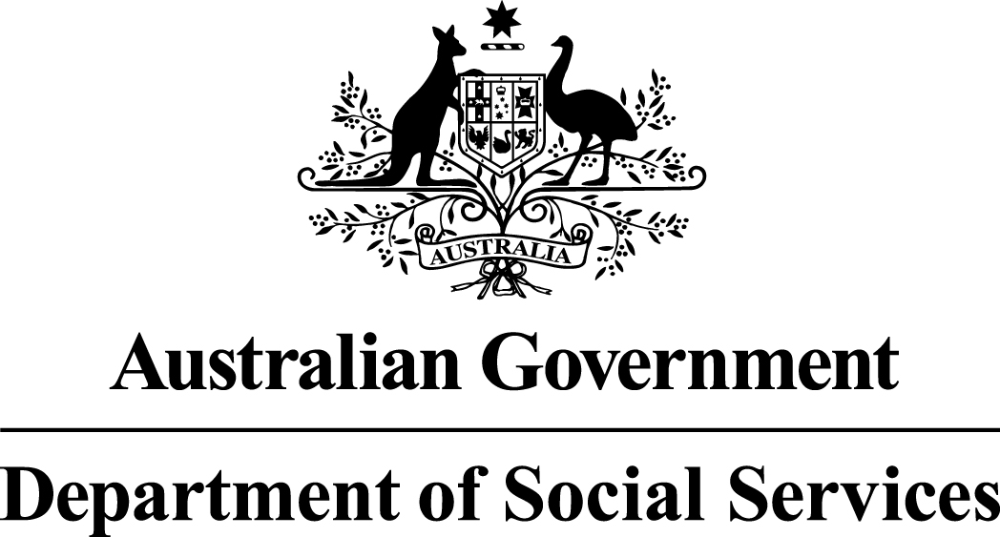

Disability, Mental Health and Carers Programme

Disability and Carer Support Activity

National Disability Conference Initiative 2014-15
Funding Round Summary – Restricted Selection
July 2014

National Disability Conference Initiative 2014-15
The Disability and Carer Support (DaCS) Activity provides assistance, support and services for people with disability and carers by providing and improving access to services and support including advocacy and through stakeholder engagement. The National Disability Conference Initiative 2014-15 is provided under the Disability and Carer Support Activity and provides funding to assist people with disability to attend conferences held in Australia with a national focus.

Selection type
This selection is a restricted competitive process, where an approach is made directly to selected service providers.

Eligibility
To satisfy eligibility requirements, applicants to the National Disability Conference Initiative (NDCI) 2014-15 must fall into one of the following categories:
- Incorporated Associations (incorporated under State/Territory legislation, commonly have 'Association' or 'Incorporated' or 'Inc.' in their legal name)
- Incorporated Cooperatives (also incorporated under State/Territory legislation, commonly have ‘Cooperative' in their legal name)
- Companies (incorporated under the Corporations Act 2001 (may be a proprietary company (limited by shares or by guarantee) or a public company)
- Aboriginal Corporations (incorporated under the Corporations (Aboriginal and Torres Strait Islander) Act 2006)
- Organisations established through a specific piece of Commonwealth or state/territory legislation (public benevolent institutions, churches, universities, unions etc.)
- Partnerships;
- Trustees on behalf of a Trust
As this is a restricted competitive process, only organisations who are invited to apply will be assessed against the selection criteria.

How much?
A total of up to $350,000 is available in 2014-15, for conferences held from 1 July 2014 to 30 June 2015. Eligible organisations may apply for funding of up to $10,000.

Closing Date and Time
Applications should be submitted by 2:00pm AEST, 13 August 2014.

Who to contact?
Please email your enquiries to: selections@dss.gov.au

Grant objectives
The NDCI aims to assist eligible conference organisers to support the inclusion and maximise the participation of people with disability (including family members or carer(s) supporting them) at nationally focused disability conferences in Australia.

Statement of Requirement
The National Disability Conference Initiative (NDCI) has been administered by DSS since 1999. Funding is provided to assist people with disabilities to attend disability conferences with a national focus held in Australia.
Eligible organisations may apply for funding of up to $10,000 for disability conferences with a national focus planned for 2014-15 to:
- Assist people with disabilities (or family members or carer(s) attending to provide support) with the costs of attending conferences, e.g. conference fees, accommodation, travel; and/or
- Facilitate access to such conferences for people with disability (including a family member or carer(s) attending to provide support). For example by funding Auslan interpreters, live captioning services, hearing loops and/or note takers for people who are deaf or hearing impaired and/or other aids or appliances.
Activities that are eligible for funding under the NDCI are those that assist in meeting the costs of a person with a disability (or a family member or carer(s) attending to provide support) to attend a disability conference with a national focus being held in Australia. These could include the costs of:
- transport to and from the conference;
- conference fees;
- accommodation during the conference; and/or
- assistance to improve access to, and participation in, the conference by people with disabilities, by providing interpreters or materials in alternative formats or other aids or appliance.

Funding may not be used for:
- a person without disability who is not a family member or recognised carer(s) who is attending specifically to support a person with disability;
- conferences that do not have a disability focus, do not have a national focus, or are not held in Australia between 1 July 2014 and 30 June 2015;
- international travel or conferences;
- carer organisations hosting a carer or support worker focused conference, even if people with disabilities are attending;
- supporting a person with a disability to attend a non-disability focused conference;
- presenters/speakers without disability to present at a conference; and
- administrative costs such as advertising, telephone, printing/publishing, staff expenses, catering or venue hire.
- If unsure, funding recipients should email selections@dss.gov.au for further advice regarding activity eligibility.

Selection Criteria
- Demonstrate your understanding of the need for the funded activity (assistance for people with disability to participate in your 2014-15 national disability conference). Please include:
- The name, date and venue of your 2014-15 conference.
- A brief description of your conference’s purpose, theme and/or content, in particular, how it has a national disability focus.

2. Describe how the implementation of your proposal will achieve the DACS Activity objectives for all stakeholders, including value for money within the Grant funding.
Please include:
- The specific ways which the grant funds will be used to assist people with disability to participate in the conference.
- How will this achieve the objectives for people with disability.
- How you will achieve value for money within the Grant funding.

Multicultural Access and Equity policy
Australia’s Multicultural Access and Equity Policy: Respecting diversity. Improving responsiveness obliges Australian government agencies to ensure that cultural and linguistic diversity is not a barrier for people engaging with government and accessing services to which they are entitled, for example, by providing access to language services where appropriate. Grant applicants should consider whether services, projects, activities or events may require the use of professional translating or interpreting services in order to communicate with non-English speakers. If your Application Form states that a budget is required, costs for translating and interpreting services should be included in your application.

Assessment
The Assessment Team may be comprised of Department of Social Services (DSS) officers from each state/territory and national offices. Teams will undertake training to ensure consistent assessment for all applications received. The Assessment Team will be bound by the APS Code of Conduct and the Department’s Chief Executive Instructions.

Probity
The selection of funding recipients for the Activity must be fair, open and demonstrate the highest level of integrity, consistent with the public interest.
The following probity principles will be applied through all stages of the selection process.
(a) fairness and impartiality
(b) consistency, accountability and transparency of process
(c) security and confidentiality of information
(d) identification and resolution of conflicts of interest
(e) compliance with legislative obligations and government policy.
These principles are intended to achieve an equitable, justifiable and sound process.
Adherence to the probity principles means that everyone involved with the selection process will act:
- impartially
- with integrity, including avoiding actual or perceived conflicts of interest.
A Probity Advisor has been appointed for the Activity. The role of the Probity Adviser is to assist DSS meet its probity obligations in relation to the Activity by ensuring that the selection processes are defensible and will withstand external and internal scrutiny.
The role of the Probity Adviser is to independently monitor procedural aspects of the selection process to ensure compliance with the published relevant Programme Guidelines and to advise DSS in relation to such matters. The Probity Adviser plays no part in the assessment of applications.

Programme Guidelines
The Programme Guidelines Overview provide the key starting point for parties considering whether to participate in the activity and form the basis for the business relationship between the Department and the funding recipient. Applicants are strongly advised to read the Programme Guidelines Overview prior to completing an Application Form. The Programme Guideline Suite comprises of the following documents:
- Programme Guidelines Overview
- Funding Round Summary
- Application Form
- DSS Streamlined Grant Agreement - General Grant Conditions
- Questions and Answers (will be provided directly to the applicant).

Grant Agreement Information
The type of grant agreement you are asked to enter into will be influenced by the nature of the Activity, the assessed Activity risk level, the length of the Activity and the value of the Activity.
In your Application Pack you will receive a draft copy of a grant agreement for information. The grant agreement is a performance-based, legally enforceable agreement between the Commonwealth (represented by DSS) and the successful applicant that sets out the terms and conditions governing the funding to be provided.
Your executed grant agreement represents the Department’s and your entire agreement in relation to each grant provided within it and the relevant Activity and supersedes all prior representations, communications, agreements, statements and understandings, whether oral or in writing.

