WOMEN WITH DISABILITIES WA INC.
SUBMISSION TO WORKPLACE GENDER EQUALITY ACT 2012

29 January 2013

To whom it may concern,

Women With Disabilities WA Inc is an unfunded, not for profit organisation, run by women with disabilities for women with disabilities that works to improve the status of women in Western Australia and to educate the community and government on our issues.

We strongly believe that any legislative instrument that focuses on gender equality, needs to also highlight issues that women with disabilities face, as we have been historically left out of research both about women and about people with disabilities.

An effective Workplace Gender Equality Act needs to have reporting requirements that include the following –

- number of women with disabilities in workplaces
- support provided to enable women with disabilities to participate in paid work – both disability related support and support for their roles as carers/parents
- types of work women with disabilities are in and if it is meaningful, productive work that utilises their abilities
- opportunities for advancement for women with disabilities, including access to training and continuing eduction
- flexibility of work roles
- number of women with disabilities in high level positions
- how workplaces deal with and prevent discrimination against women with disabilities
- pay rates of women with disabilities compared to others who are in similar roles

We would like to refer you to the extensive research on the issues facing women with disabilities in employment done by Women With Disabilities Australia. This research gives more detail on what needs to be done to record and improve the status of women with disabilities in paid employment.

Please find attached copies of the following Women With Disabilities Australia papers:

Policy Paper: 'Assessing the situation of women with disabilities in Australia: A human rights approach – see pages 37 and 38
http://www.wwda.org.au/employm2011.htm

Submission to the Parliamentary Inquiry into pay equity and associated issues related to increasing female participation in the workforce
http://www.wwda.org.au/wwdapesub1.htm

Yours sincerely

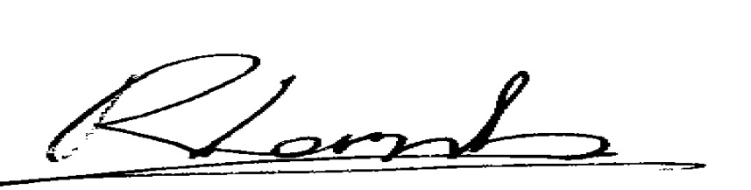

Rayna Lamb
Coordinator
Women With Disabilities WA Inc
9244 7463

