Office for Women

Department of Families, Housing, Community Services and Indigenous Affairs

[women@fahcsia.gov.au](mailto:women@fahcsia.gov.au)

23 January 2013

**Re: Reporting matters under the Workplace Gender Equality Act 2012**

In relation to the above matter we would like to draw your attention to two pieces of research that we have recently undertaken that relate to the use of EOWA data and gender pay equity. The first piece of research was published in 2011 and uses EOWA data to examine gender equity in the mining sector (Lord, Jefferson and Eastham, 2011). The second piece of research is outlined the attached manuscript for an article which will shortly be published in the Economic and Labour Relations Review (McGrath-Champ and Jefferson, 2013 forthcoming). We consider some of the implications of each of these research projects below.

The article by Lord, Jefferson and Eastham (2011) demonstrates the considerable limitations for data analysis that arise from exemptions for annual reporting. We therefore support the recent legislative change that removes the capacity to waive reporting requirements for compliant organisations. The requirement for annual submissions will assist future data analysis which includes greater input from organisations who comply with Workplace Gender Equality Act requirements. The capacity for future data analysis would also be assisted by the reporting on consistent measures each year, for example, consistent categories in the workplace profile data reported by organisations. In order to facilitate future research and analysis, we therefore make the following recommendation:

* That priority measures and indicators determined under the Workplace Gender Equality Act are collected annually and, as far as practicable, on a consistent basis across organisations.

The manuscript by McGrath-Champ and Jefferson (2013) provides details of a case study of gender pay equity in an organisation which has given considerable effort and resources to the issue and closely followed resources provided via the EOWA web pages on this matter. Despite these efforts, the outcomes for the organisation’s gender pay profile have changed little over the three year period covered by the data.

The reasons for these outcomes are complex and many are outside the scope of the Workplace Gender Equality Agency’s role. However the study revealed three issues that are relevant to current consultations on reporting matters under the Act.

Firstly, guidelines provided on the EOWA website appear to have been influential in the methods adopted to assess gender pay equity. This includes the statement that “A gender pay gap of 5% or more is regarded as significant and worthy of further investigation.” (Department of Commerce Western Australia, undated Pay Equity Audit Report, page 5. A copy is attached for easy reference). Application of this guideline appears to have been interpreted in a flexible manner, which has both advantages and disadvantages. Such flexibility, for example, allows organisations to develop nuanced approaches to their analysis that are relevant to their particular industry and occupations. However, we are aware that a ‘five per cent criterion’ is being applied, for example, to relatively narrow bands of occupations within an organisation rather than to large aggregations as provided in the examples in the Pay Equity Report.

This might be illustrated with a hypothetical example using occupational classifications and salaries relevant to a highly qualified, experienced staff at five organisational levels (A-E). Such an example has been constructed in Table 1 below. In this organisation, the gender pay gap within each level is less than five per cent and, using this approach, does not identify any key areas of concern. The aggregate gender pay gap across all five levels, however, is 12.2 per cent. This occurs because women are well represented at the lower pay levels but relatively under represented at the higher levels. We contend that this is not an unusual scenario in many industries. The example illustrates how gender pay equity is an outcome of a complex range of linked issues, including those that affect the positions that women occupy within organisations. If the hypothetical organisation in Table 1 was to address their aggregate gender pay gap then it is likely that they would need to assess issues related to the uneven distribution of men and women across the different pay levels.

**Table 1: Hypothetical example of using a ‘five per cent criterion’ for assessing organisational gender pay equity**

|  | Salary range (annual, $,000) | Average salary – women  $,000 | Number of women | Average salary – men  $,000 | Number of men | Gender pay gap  % |
| --- | --- | --- | --- | --- | --- | --- |
| Level A | 58 - 78 | 63 | 120 | 66 | 80 | 4.5 |
| Level B | 83 - 98 | 85 | 120 | 89 | 90 | 4.5 |
| Level C | 102 - 117 | 109 | 100 | 114 | 100 | 4.4 |
| Level D | 122 - 135 | 129 | 80 | 135 | 110 | 4.4 |
| Level E | 158 | 158 | 60 | 158 | 100 | 0.0 |
| All staff |  | 101 | 480 | 115 | 480 | 12.2 |

Our study indicates that this analysis of patterns of promotion can occur within organisations that purposively address issues of gender equity. Our case study suggests that the challenges for organisations lies in addressing issues relating to the ways in which current market patterns of earnings are seen as a key indicator of appropriate salaries within an organisation. In labour markets that have existing gendered patterns of wages, the role of market salaries is not gender neutral, though this does not always seem to be perceived by organisations.

A second issue relates to the application of a ‘five percentage points criterion’ to issues other than gendered patterns of pay. Our access to organisational data provided insights into the use of a ‘five per cent criterion’ for identifying key areas of difference in gendered patterns of employment and promotions. The concerns here are twofold. The ‘five percentage points criterion’ has important differences with a ‘five per cent criterion’. If 10 per cent of men and 5 per cent of women are promoted in a given year, the difference in rates of promotion is 100 per cent. That is, men are promoted at twice the rate of women. However, the percentage point difference is five. If organisations use a percentage point approach to identifying issues of gender equity using data such as ‘per cent promoted’ then the importance of such implications may be overlooked.

Thirdly, our case study relates to an organisation that is sufficiently large to have several different sections. The gender equity analysis undertaken by the organisation was undertaken on a section by section basis. Thus it was possible for relatively large differences in gender pay to occur within salary levels but not be a cause for concern because this occurred within different sections of the organisation.

As stated above, these are not easy issues to address. However, we believe there is scope for the Workplace Gender Equality Agency to provide nuanced guidelines that provide additional insights into the analysis of gender pay equity at an organisational level.

In terms of reporting requirements however, we make the following recommendations:

* The reporting of an aggregate gender pay ratio for organisations, based on hourly pay rates for men and women throughout the organisation.

We thank the Workplace Gender Equality Agency for the opportunity to participate in the consultation process on reporting measures and wish them well with the development of their activities under the new Act.

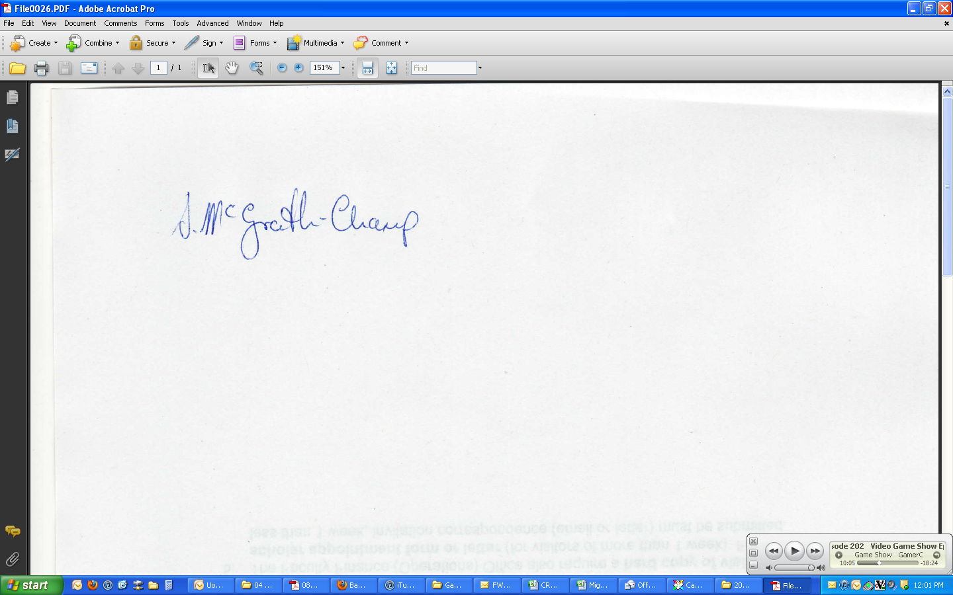 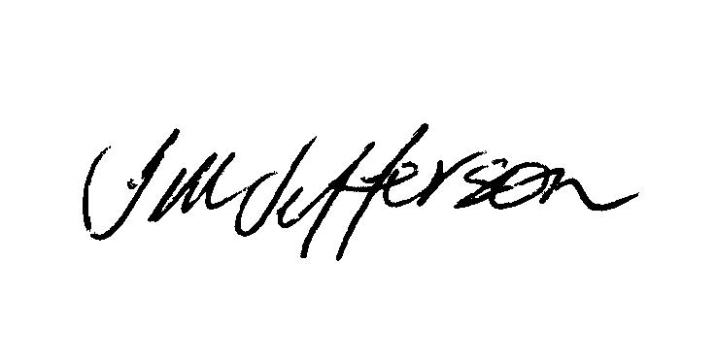



| Susan McGrath-Champ  Associate Professor  University of Sydney Business School  University of Sydney  Tel | +61 2 9351 6437  Email | [susan.mcgrathchamp@sydney.edu.au](mailto:susan.mcgrathchamp@sydney.edu.au)  Web | sydney.edu.au/business  Street Address  Work and Organisational Studies (HO3)  University of Sydney Business School  Sydney, NSW 2006  Uni of Sydney logo | Therese Jefferson Associate Professor  Curtin Graduate School of Business  Curtin University Tel | +61 8 9266 3724  Email | [T.Jefferson@curtin.edu.au](mailto:T.Jefferson@curtin.edu.au)  Web | curtin.edu.au  Street Address I 78 Murray Street Perth WA 6000  Curtin University logo | Linely Lord  Associate Professor  Curtin Graduate School of Business  Curtin University Tel | +61 8 9266 4239 Email | [L.Lord@curtin.edu.au](mailto:L.Lord@curtin.edu.au)  Web | curtin.edu.au  Street Address I 78 Murray Street Perth WA 6000  Curtin University logo |
| --- | --- | --- |

**References:**

Lord, Linley, Therese Jefferson and Judy Eastham (2012) “Women’s participation in mining: What can we learn from EOWA reports?” *Australian Bulletin of Labour* 38(1):68-95

McGrath –Champ, Susan and Therese Jefferson (2013 in production), “Gender and Pay Equity in Professional Services” *Economic and Labour Relations Review*, 24 (1)