The Salvation Ar my

The Salvation Army Submission to Exposure Draft Public Housing Tenants’ Support Bill 2013.

April 2013
For more information, please contact:

Netty Horton
The Salvation Army
Australia Southern Territory
Territorial Social Programme Department
99 Railway Road, Blackburn VIC 3130

Phone: 03 8878 4500
www.salvationarmy.org.au

The Salvation Army Submission to Exposure Draft Public Housing Tenants’ Support Bill 2013.

Introduction
The Salvation Army welcomes the opportunity to make submission on the Exposure Draft – Public Housing Tenants’ Support Bill 2013.
The Salvation Army is one of Australia’s largest providers of social services and programs for the most marginalised and socially excluded individuals. This submission is informed by these experiences and The Salvation Army’s collective knowledge and expertise about the causes, impacts and possible solutions to disadvantage.

The Draft Bill
The Salvation Army welcomes practical and legislative initiatives that seek to reduce homelessness and is cautiously supportive of the draft bill in so far as it will prevent some individuals from needlessly exiting public housing though eviction and continual rotation through homelessness services. However, The Salvation Army also has a number of concerns about the impact of the bill on already vulnerable individuals and provides a number of comments and recommendations below.
The Salvation Army prefaces these by observing that the current failures of public housing are not the result of an individual tenant’s recalcitrance. Many of the issues facing public housing are the historic consequences of the lack of investment and planning across taxation, population and housing policy. These have coalesced with ongoing oscillations of funding responsibility between the Commonwealth and the states and territories.
As one of the country’s largest providers of homelessness and housing services, The Salvation Army relies on public housing as a critical exit point for many clients. Where private rental markets and in many cases community housing providers are unable to accommodate the most complex and vulnerable clients, public housing remains the safety net option for housing.

Concerns with the exposure draft
Poverty and housing stress
The draft bill proposes that the maximum amount allowable for deduction is 35 per cent of the tenant’s allowance.
As 30 per cent or more of household income has historically provided the benchmark against which households are considered to be in housing stress, collection of an amount up to 35per cent creates significant risk. Indeed, in view of the very low threshold criteria against which tenets will be subject to the Scheme, compounded by the extremely low base incomes of tenants, The Salvation Army urges a total waiving of arrears as part of being signed onto the Scheme.
Utility of punitive measures
The Salvation Army supports voluntary, 'opt-in' streams of income management such as Centrepay, particularly where these measures are supported by case management (intensive counselling and support including financial counselling and supported by locally coordinated services).
Punitive measures have not been demonstrated to build the capacities and capabilities of clients to manage their finances in an ongoing manner. Instead, such interventions reinforce State control over the lives of individuals and reinforce the risk of dependency.
While the draft bill suggests that the Scheme will be used as a measure of last resort to manage arrears and evictions, it is unclear what the operational definition of ‘last resort’ is, nor what tenant support services are to be initiated before compulsory deductions commence. Many clients with complex needs require a range of supports to help them sustain tenancies, compounding the residualisation that has occurred in public housing to the point that it creates more disadvantage than ever before.
The Salvation Army seeks assurance that compulsory deductions are only used as a last resort, with difficult and complex clients who will be provided with the support services that they need in order to sustain their tenancy.
Inadequacy of Newstart
The Salvation Army, along with many other charities, NGOs and business peaks have been calling on the government for an increase of $50 per week in the rate of payment of the Newstart Allowance for individuals. Not only would this significantly reduce the discrepancy between payment types, but it would ease both financial hardship and disadvantage for recipients. While 25 per cent of this increase would go straight back into the rental costs for tenants, this critical increase would have a significant impact on the fragile personal economies of many risking eviction through sheer lack of money to pay the rent.

Recommendations
- Compulsory deduction of an amount up to 35 per cent of a household income is onerous and may place households in housing stress. This amount needs to be reduced.
- Given the very low threshold at which compulsory deductions may be activated, consideration should be given to waiving arrears and focussing on the future maintenance of the tenancy.
- Operational clarity need to be provided in relation to the definition of ‘last resort’ and its relationship with the provision of tenancy support services.
- Tenancy support services should be adequately available and provided before compulsory deductions are activated.
- While beyond the scope of this bill, the inadequacy of the Newstart allowance is a significant driver of poverty and disadvantage in Australia. In consideration of this some of the more punitive and rigid aspects of the Scheme could be softened in recognition that there are many at high risk of arrears simply due to this low and inadequate allowance.

If you wish to discuss this submission further, please contact Ms Netty Horton, Territorial Social Programme Director on (03) 8878 4783 or email netty.horton@aus.salvaitonarmy.org

Yours sincerely
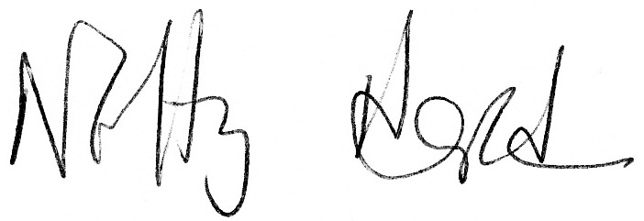
Territorial Social Programme Director

