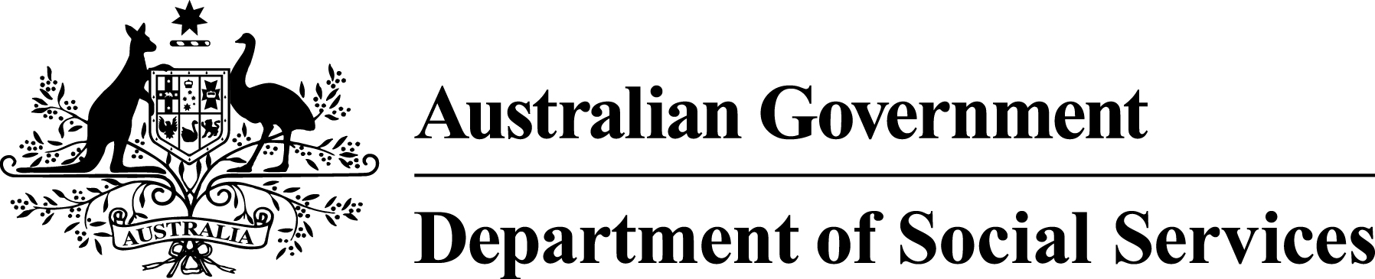

Having a say about using the BSWAT

Information for supported employees

Easy Read version

How to use this document
This information is written in an easy to read way.
We use pictures to explain some ideas.
Some words are written in blue. We explain what these words mean. There is a list of these words starting on page 14.
You can ask for help to read this document. A friend, family member or support person may be able to help you.
This Easy Read document is a summary of another document.
You can find the other document on our website at www.dss.gov.au

What’s in this document?
Getting paid fairly 4
What is the BSWAT? 5
Is the BSWAT fair? 6
What law applies? 7
What will the government do now? 8
Why will it take 3 years? 10
What will happen in the next 3 years? 11
What do you think? 12
Where can you get more information? 13
Word list 14

Getting paid fairly
Recently, the government has been working on some changes to way that people who work in supported employment get paid.
Supported employment is the way that government works with some businesses to create jobs for people with disability.
We want to make sure that people who work in supported employment are getting paid fairly.

What is the BSWAT?
At the moment, we use some different tools to work out how much people in supported employment should be paid.
One of the tools we use is called the ‘Business Services Wage Assessment Tool’.
This is known as the BSWAT.
In Australia at the moment, the BSWAT is used to work out the right amount of pay for about 10,000 people.
The BSWAT may be used in your workplace. Or, your workplace may use another tool.

Is the BSWAT fair?
Earlier this year, an important case about the BSWAT went to court.
Two people – Michael Nojin and Gordon Prior – said that they were not being paid fairly.
So they took their case to court.
In May 2013, this case went to one of the most important courts in Australia – the Full Federal Court.
The judges in the Federal Court decided that using the BSWAT was not a fair way of working out how Mr Nojin and Mr Prior should be paid.
The government is working to make sure that what happened to Mr Nojin and Mr Prior does not happen to you.

What law applies?
The law is the set of rules that we all must follow.
Judges, courts and the government decide on the law.
The law that applies in this case is called the Disability Discrimination Act 1992.
This law applies around Australia. It says that people with disability must be treated fairly.

What will the government do now?
The government agrees that we need to stop using the BSWAT as it currently is.
However, we think that it will take time to get everyone who uses the BSWAT to change over to a new tool.
We think this will take about 3 years.
We have written to the Australian Human Rights Commission to ask for 3 years to make the changes.
The Australian Human Rights Commission looks after any problems or complaints to do with the Disability Discrimination Act.
If the Australian Human Rights Commission says that we can have 3 years to make the changes, it will mean that:
- Some employers will continue to use the BSWAT to work out how much to pay their workers.
- People will not be able to complain that the BSWAT is unfair during this time.

What if the Australian Human Rights Commission says ‘no’?
If the Australian Human Rights Commission says no to our request, it could create problems for employers who use the BSWAT.
It will be very important for employers who use the BSWAT to make sure that they are not breaking the law.
To do this, they will need to:
- quickly change the tool they use to work out how much people should be paid
- start paying higher wages quickly, which they may not be able to afford to do.
If employers do not make these changes quickly, they may not meet the Quality Standards.
The Quality Standards are a set of rules that the government uses to make sure that supported employment services are working well.
The government is asking for 3 years to make sure that these problems do not happen.

Why will it take 3 years?
Here is a summary of the reasons we think it will take 3 years to make these changes.
We need to choose or design a new and better tool for working out how much people get paid. This will take time.
We need to keep talking to people to find out what they think about the changes.
So far, we have talked to about 600 people about the changes.
We would like to talk to more people.
We need to help supported employment businesses learn how to use the new tool.
We need to make sure that these businesses can keep making money and keep employing people.
If we act too quickly it may harm the way these businesses operate.
We need to give these businesses time to adjust to the changes.
We also want to give these businesses time to help supported employees understand the changes.
During this time, some employers will still work out how much to pay people using
the BSWAT.
It’s important that it doesn’t take more than 3 years to make a better tool.

What will happen in the next 3 years?
During the next 3 years, the government will do a lot of work to make sure that the changes are taking place.
Here is a summary of what we will do.
We will organise a group of people to work on making a new tool. This group is called a Taskforce.
We will make sure all areas of government are dealing with this problem.
We will continue giving information to people with disability, their families and carers – and employers and other people who work in this area – about the changes we are making.
We will provide ways for people to contact us and ask questions. Our contact details are on page 13.
The government will continue to work to improve supported employment.
We will provide support and training for people with disability, and their families and carers, to learn about the new tool.
Every 6 months, we will tell the Australian Human Rights Commission about our progress.

What do you think?
We are sharing this information with you so that, if you want to, you can:
- think about the changes
- tell the Human Rights Commission if you agree or disagree with our request for extra time.
If you want to find out more about the request, or to read the full version of this document, please visit the Australian Human Rights Commission website.
It’s important to know that this change will only make a difference to you if your workplace uses the BSWAT.
Your workplace may use a different tool.
The government is working to make sure that what happened to Mr Nojin and Mr Prior does not happen to you.
We think it will take 3 years to fix the problem.
We want to know if you think this is ok.

Where can you get more information?
You can phone us or send us an email.
1800 880 052
bswat@dss.gov.au
There are currently 3 Easy English documents that can provide supported employees with more information.
The future of wage setting in Supported Employment – Easy Read version
This is a document asking people what they think about the changes we are making.
The future of wage assessment in Supported Employment – Easy Read version
This document is a summary of what people told us about the changes.
Vision for Supported Employment – Easy Read version
This document describes the way we want supported employment to be.
You can find these documents on our website at www.dss.gov.au

Word list
Australian Human Rights Commission
This is an organisation that works to protect people’s rights and make sure we are all treated fairly.
Federal Court
The Federal Court is one of the highest courts in Australia. It listens to lots of cases and makes decisions about many laws.
Quality Standards
A set of rules that the government uses to make sure that supported employment services are working well.
Supported employment
Supported employment is the way that government works with some businesses to create jobs for people with disability.

