Footprints in Time 2012 Community Feedback
Adelaide and Port Augusta
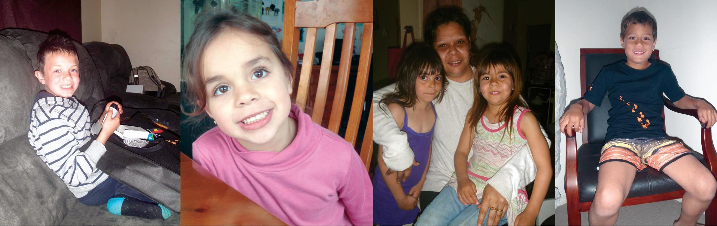
Introduction
This fact sheet gives feedback to the community about Footprints in Time: The Longitudinal Study of Indigenous Children. With the help of 1,283 families like yours, we completed the fourth round of interviews in 2011. Our fourth round of interviews included 87 families from Adelaide and Port Augusta. This fact sheet compares families living in Adelaide and Port Augusta with Footprints in Time families living in other places.
We would like to thank the parents and families who continue to participate in the Footprints in Time study. By allowing us to be part of your child’s life, we will learn what Aboriginal and Torres Strait Islander children need to have the best start in life to grow up strong.

Staying healthy and strong
Across all sites, parents reported that Footprints in Time children are generally in good health. In the fourth round of interviews, 77 per cent of parents rated their child’s health as excellent or very good, 21 per cent as good, and only 2 per cent gave a rating of fair or poor.
Over 40 per cent of Footprints in Time parents said that their child had no health problems since the last interview. For those who did have problems, the most common conditions were eczema and skin problems, asthma, ear problems, and chest infections.
Figure 1: Health problems in the past year
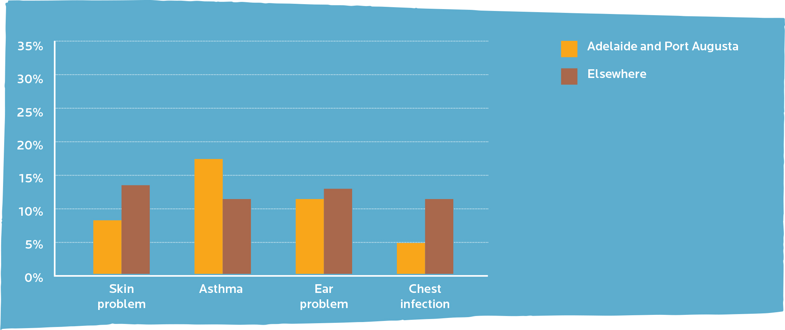

Children in Adelaide and Port Augusta were more likely than children living in other areas to develop asthma, about as likely to develop ear problems, and less likely to develop skin problems and chest infections.
Cultural experiences
Parents in Adelaide and Port Augusta were less likely to take their child to Indigenous cultural events, ceremonies and sorry business than parents located elsewhere. They were also less likely to teach their children traditional practices like finding food and hunting, and traditional arts, like painting and dancing.
Figure 2: Children who have cultural experiences often or very often
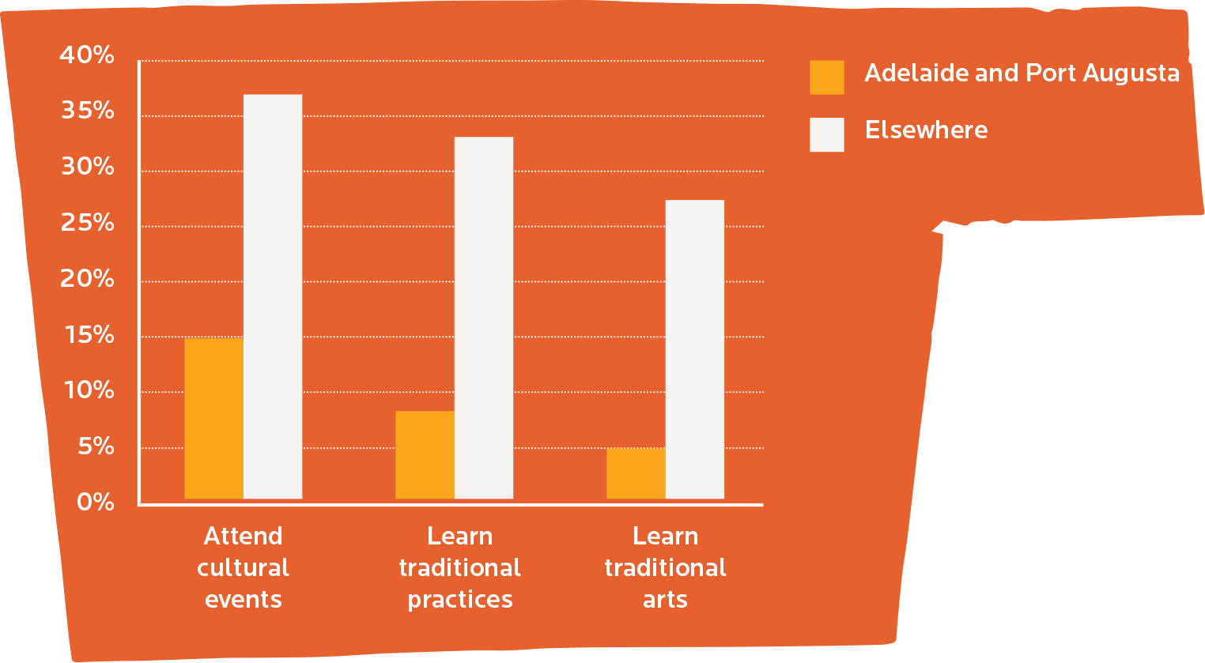

Footprints in Time parents all over Australia were asked the question: “Every parent wants their child to be healthy and happy as they grow up. What else do you want for your child?” Here are some responses:
“Grow up independent and respectful, pride in self and culture, family, friends and community.”
“Be smart, good job, respectful to elders, learn about his culture.”
“Want him to get a good education as he is a really bright child, and become a good working role model for Aboriginal people.”
“A good education with cultures not just reading and writing, to include music, theatre, drama.”
“To know his language and to keep his culture strong.”

Learning and playing
We asked children who were 4 to 5 years old to name pictures of objects. This tells us about some of the words each child knows. The pictures get harder to name as the game goes on and very few children can name all of them.
Out of 50 objects, children in Adelaide and Port Augusta named an average of 22 in English. Children in other regions named about 20 objects in English.
The number of languages a child knows can affect how many objects they can name in English. Another way of looking at the range of words a child knows is looking at how many languages they speak. Some children can name objects in more than one language. About 24 per cent of children living in Adelaide and Port Augusta are learning more than one language. Outside of Adelaide and Port Augusta, 21 per cent of Footprints in Time children are learning more than one language.
Doing activities with parents and family, like reading and telling stories, increases the number of objects children can name. By the time Footprints in Time children are 6 to 7 years old, the average number of objects that children can name on the picture cards increases to 30.
77 per cent of Footprints in Time children are now going to school or preschool.
We asked our older Footprints in Time children (around 6½ to 8 years old) what they thought about school. Over 87 per cent of these children said school was fun and another 8 per cent said school was sometimes fun. About 96 per cent of children said their teacher was nice or sometimes nice to them, and 91 per cent said that other children at school were nice or sometimes nice to them.
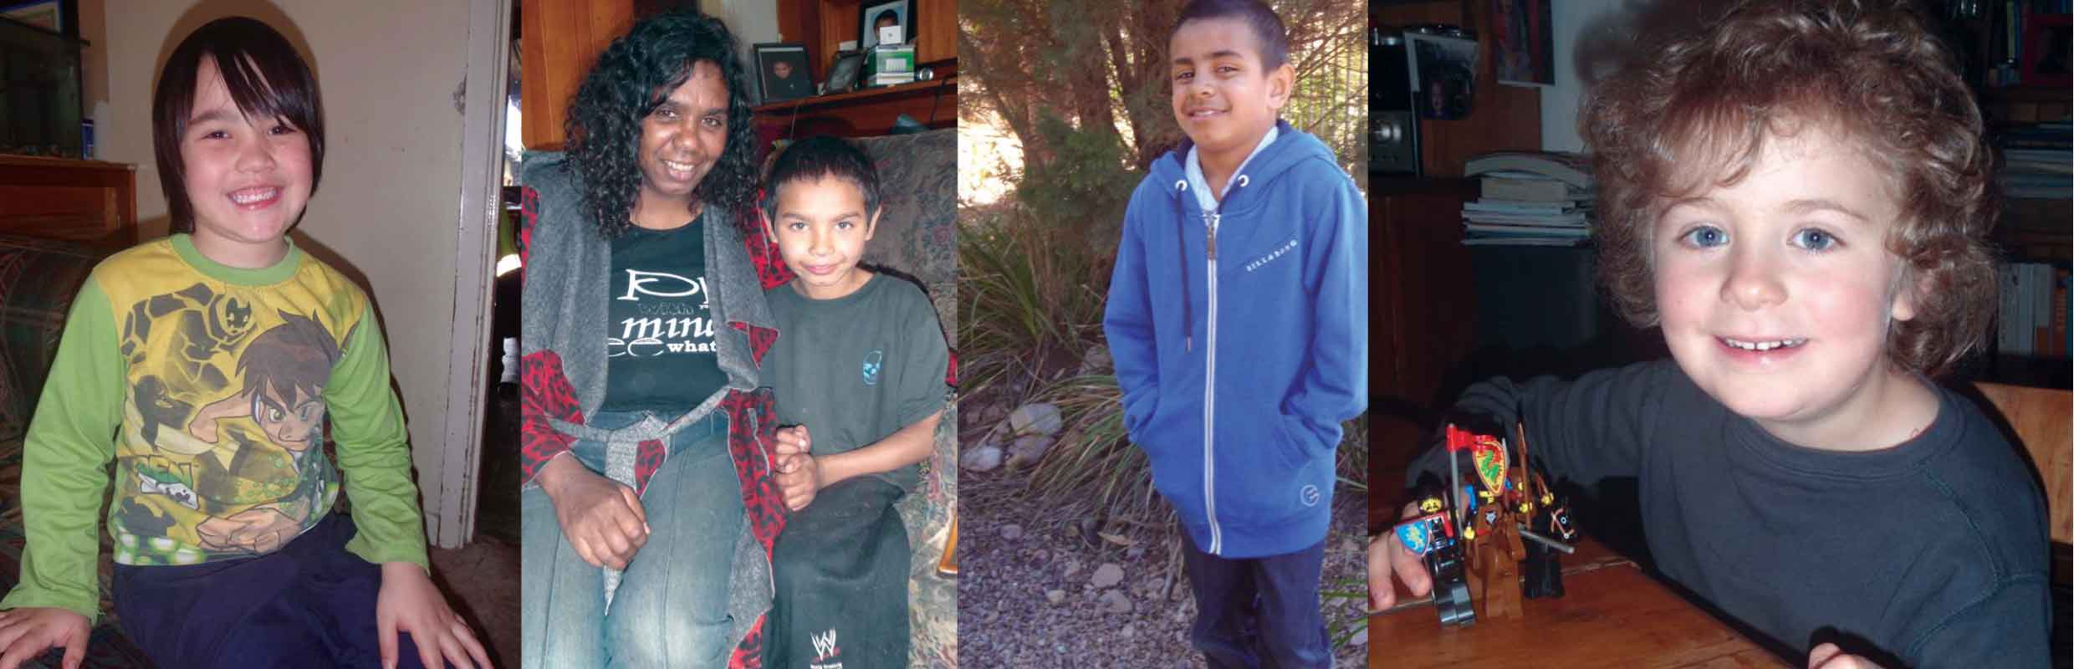

Computer and Internet use
For the first time in 2011, we asked if children used computers and the Internet.
Most children (68 per cent) in Adelaide and Port Augusta use computers to learn and play. This is about the same as other areas. More children in Adelaide and Port Augusta have computers at home than children in the study living elsewhere, but fewer children in Adelaide and Port Augusta use computers at school than children in the study living elsewhere.

Figure 3: Children who use computers
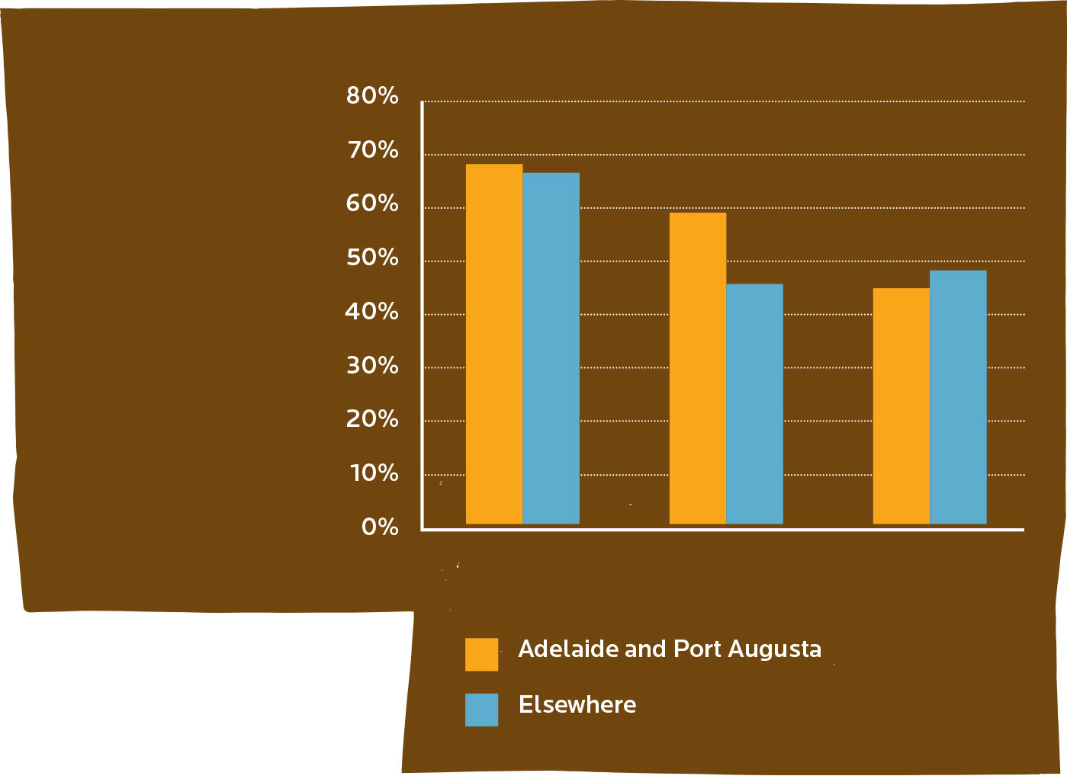

About a third of the children in Adelaide and Port Augusta (36 per cent) use the Internet. This is about the same as in other areas. More families in Adelaide and Port Augusta have the Internet at home compared to Footprints in Time families in other areas, but fewer schools in Adelaide and Port Augusta use the Internet than schools in other areas.
Figure 4: Children who use the Internet
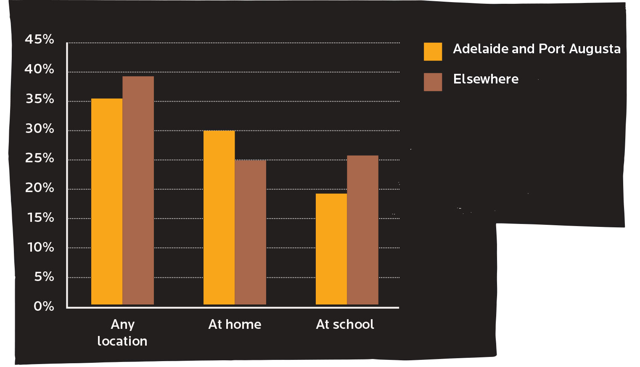

Who uses Footprints in Time?
The data from Footprints in Time is being used to tell governments, policy makers and service providers about the lives of Aboriginal and Torres Strait Islander children and their families. To find out more about Footprints in Time, go to www.fahcsia.gov.au/lsic.
At present, we have over 100 researchers using Footprints in Time data for interesting and important projects. For example, researchers are looking at housing conditions and children’s health, breastfeeding, and links between cultural identity and being ready for school.
Keeping in touch
If you are one of our Footprints in Time families, we need to keep in touch with you. If you have moved or are going to move, please let us know on the free-call number 1800 106 235 or contact your local Research Administration Officer.

