Submission to the Welfare Review Interim Report:

A new System for Better Employment and Social Outcomes

August 2014

The Tenants’ Union of New South Wales (TUNSW) is the peak body representing the interests of tenants in New South Wales. We are a specialist legal practice with expertise in residential tenancy law and policy, and the main resourcing body for a statewide network of Tenants’ Advice and Advocacy Services. Our work brings us into frequent contact with recipients of income support in both the private rental market and the social housing sector. We are particularly interested in the Interim Report’s discussion of Commonwealth Rent Assistance (CRA) and social housing rents.

Indexing rent assistance
We strongly support lifting the maximum rates of CRA and indexing them to real growth in tenants’ housing costs, rather than the more general Consumer Price Index. We note that at the present rates, about 40 per cent of CRA recipients in New South Wales are still in housing stress (paying more than 30 per cent of their income in rent), and 12 per cent are still in housing crisis (paying more than 50 per cent). Our own research indicates that the high cost of renting remains a barrier preventing tenants from exiting the private rental market into homeownership, and that high numbers of tenants are worried about rental affordability.

Figure 1. Worried about paying the rent.
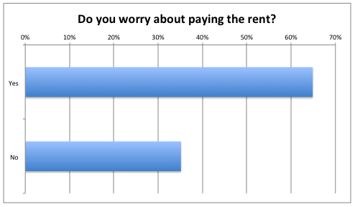
Source: TUNSW (2014).

Impact of public housing on income support recipients
The Interim Report suggests that income-related rents in public housing (and social housing generally) lead to two potentially perverse outcomes: tenants developing a ‘preference’ for social housing over the private market; and a disincentive for social housing tenants to work because rising incomes lead to higher rents.
The Report then suggests a move away from income-related rents in social housing, and looks instead to make CRA the preferred rent subsidy scheme across both the private rental market and the social housing sector.
We discuss each of these ‘outcomes’ below.

Potential outcome #1 – tenants prefer social housing
We reject that a preference by low-income households for social housing is ‘perverse’; on the contrary, it indicates that social housing is doing something that the private rental market is not doing: delivering relatively affordable and secure housing to low-income households.
It may be that there are better ways of delivering affordability than through income-related rents, but we should not resile from the principle that affordable housing is the right of every citizen, and that social housing is one way in which governments can ensure that this right is realised.
We should also be clear: we are certain that a large part of the reason why low-income households may prefer social housing to private rental housing, aside from its affordable rents, is the relative security of social housing. Secure housing, too, is the right of every citizen and it is appropriate that social housing tenants should enjoy and ‘prefer’ the relative security of their housing to the insecurity of private rental housing.

Private rental offers only minimal security of tenure: tenancies are typically subject to an initial fixed term of six or 12 months, and thereafter become periodic agreements, which landlords can, under New South Wales law, terminate without grounds on 90 days’ notice. The sector is also structurally insecure: in one study, 26 per cent of landlords sold up and exited within 12 months entering the market; amongst negatively geared landlords, 50 per cent exited within 12 months.

Tenants’ experience of the problems of the private rental sector are demonstrated in the results of the TUNSW’s ‘Housing Affordability Survey’. We noted above how renters in the private market worried about affordability; they also worry about security and the consequences of asserting their tenancy rights.

Figure 2. Worried about finding an affordable home, if you had to move.
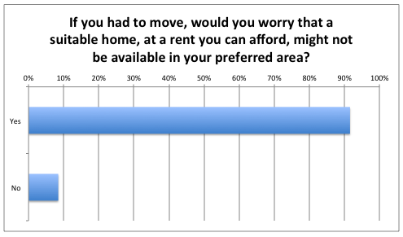
Source: TUNSW (2014).

Figure 3. Declined to assert tenancy rights.
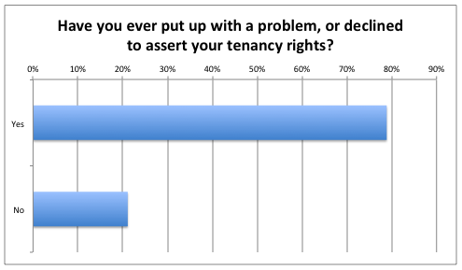
Source: TUNSW (2014).

The proper objective of policy should be to make private rental sector more affordable and secure, not to change the conditions of social housing to make it less ‘preferable’.
Indeed, in recent years conditions in public housing in New South Wales have been deliberately changed to make it less preferable, particularly to tenants on moderate incomes. The results are truly perverse: these changes have increased work disincentives, reduced exits from public housing, and reduced opportunities to house applicants from the waiting list.

Potential outcome #2 – work disincentives
We strongly support initiatives to address work disincentives in social housing.
We agree that income-related rents, which have been an increasingly prominent feature of social housing policy since at least the 1980s, do have a work disincentive effect, as described in the Interim Report. However, we are more concerned about the additional work disincentives created by the Reshaping Public Housing (RPH) reforms of 2005. We consider these to be more damaging – to tenants’ rewards from work, to applicants’ opportunities for housing, and to the financial sustainability of public housing.

The first aspect of the RPH reforms is Housing NSW’s policy of higher rent rates for tenants on so-called ‘moderate incomes’. The policy revised Housing NSW’s system of income-related rents, which provides rebates to eligible tenants so that the rent the tenant pays is about 25 per cent of the tenant’s household income. Under the revised system, tenants whose household income is above the ‘moderate income threshold’ pay, on a sliding scale, 25-30 per cent of their household income. Tenants whose household income is above a second threshold (the ’30 per cent threshold’, at the top of the sliding scale) pay 30 per cent.

Figure 4. Thresholds for moderate income rent rates, from 18 March 2013.
Household | Moderate income threshold | 30 per cent threshold | Ineligible for rental rebate
First adult | $710 pw | $888 pw | $1 325 pw
Additional adult | + $190 pw | + $238 pw | + $350 pw
First child | + $140 pw | + $175 pw | + $265 pw
Additional child | + $95 pw | + $119 pw | + $175 pw

Source: Housing NSW, ‘Tenancy Charges and Account Management Policy Supplement’.

It is important to note that the 25-30 per cent sliding rate applies not just to income in the moderate income range (nor does the 30 per cent rate apply only to income above the 30 per cent threshold). These rates are not marginal rates; they apply to that part of a tenant’s household income below the range too.

This means that earning additional amounts of income in the moderate income range comes at a large cost in terms of additional rent due. If the 25-30 per cent sliding rate was expressed as a marginal rate, it would be, on average, 50 per cent over the moderate income range (45-55 per cent); in other words, on average 50 cents in every additional dollar earned by a tenant in the moderate income range would go to Housing NSW in rent. When it is considered that each additional dollar will also be subject to income tax and other costs associated with work (for example, childcare), a tenant could easily end up with little reward, or even a loss of income, from working. For example, a single person earning $800 per week will be in the middle of the moderate income range and the 32.5 per cent income tax bracket, and therefore face an effective marginal tax rate of 82.5 per cent (from rent and income tax alone). Such a high effective marginal tax rate is a powerful work disincentive.

The moderate income thresholds are set higher than the income thresholds at which most Centrelink payments are reduced to zero, so the effective marginal tax rates generated by Centrelink payment reduction will not stack with those generated by the moderate income rent rates. However, while they do not stack, they do sit side-by-side, so the effect is that public housing tenants face very high effective marginal tax rates for an extended range of incomes – longer than other persons. Many part-time jobs pay incomes in this range, and may present opportunities for earning additional amounts; however, public housing tenants would receive little reward from doing this work.

The intention of this policy was that public housing tenants with opportunities to do such work would move out of public housing and thereby enjoy a lower effective marginal tax rate. This is utterly unrealistic, as it does not take account of the higher cost of private rental and the relative security of public housing. More realistic is that a public housing tenant – reluctantly – will not take up those work opportunities. That this has been the result is indicated by the results of the policy of reviews as to eligibility – the second aspect of the RPH reforms.

Under this aspect of the RPH reforms, Housing NSW signs up new public housing tenants to fixed term agreements subject to review towards the end of their fixed terms. Each review considers the tenant’s household income and their continuing eligibility to remain in public housing. Where a tenant’s household income is above the relevant income threshold (the 30 per cent threshold under the moderate income rents policy – see Figure 4 – with additional adjustments made for people with disability), Housing NSW will proceed to terminate the tenancy.

In fact, very few public housing tenants are found to be ineligible at review: less than two per cent, according to figures provided by Housing NSW to the Auditor-General.

This is not because the thresholds are set too high. On the contrary, the incomes at which tenants become ineligible are insufficient to afford the median rent for appropriately sized dwellings in New South Wales overall. Unaffordability is especially acute in inner and middle Sydney (Figure 5).

Figure 5. Unaffordability of private rental dwellings at thresholds for loss of eligibility for various households.
 | One bedroom dwelling |  |  | Two bedroom dwelling |  |  | Three bedroom dwelling
 | Single | Single (disab) | Couple | Single + child | Single + two children | Couple + child | Single + two children | Couple + two children | Couple + two adults (disab)
Sydney
Inner
Middle
Outer
NSW

Median rent ≤ 30 per cent of threshold (affordable)
Median rent > 30 per cent of threshold (housing stress)
Median rent > 50 per cent of threshold (housing crisis)

Key

Source: TUNSW analysis based on Housing NSW, ‘Tenancy Policy Supplement’; Housing NSW (2014).

This at least partly explains why so few tenants are found to be ineligible: faced with the prospect of losing their homes and renting unaffordably and insecurely in the private market, tenants who might otherwise have increased their income through work have not done so, and have stayed poor in order to stay housed.

We have spoken with public housing tenants who have declined – in all cases, reluctantly – opportunities of work because of this prospect. We have also spoken with public housing tenants who have had to contemplate other undesired courses of action – such as asking a child who has commenced paid work to move out – so that they will pass the review and remain housed.

We note that the operation of the policies for reviews as to continuing eligibility and higher rents for moderate-income tenants has coincided with the reduction of turnover in public housing tenancies.

Figure 6. Exits from public housing.
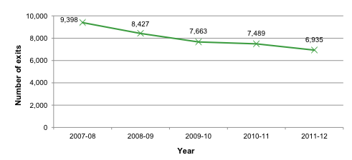
Source: Auditor-General (2013).

We submit that the policies have contributed to the reduction, and so operated to the disadvantage of applicants waiting for social housing too.

The lessons of the experience of the RPH reforms are twofold. For stakeholders in NSW public housing, the first lesson is that the moderate income rent rates and reviews as to continuing eligibility should be immediately abolished. This would cost Housing NSW little (it may even increase rent revenues) and would improve the rewards of work for public housing tenants – and, as tenants become more secure in employment, they may be more inclined to move out into the private market and create opportunities for new social housing allocations.

For the present review, the lesson of the RPH reforms should be that attempts to make public housing ‘less preferable’ can backfire badly, and create worse work disincentives. Furthermore, replacing income-related rents with a CRA-based rent subsidy model will not address the work disincentive created by reviews as to as to continuing eligibility.

Alternatives to income-related rents
All of the above is not to say there is no case for considering alternatives to income-related rents in social housing. We frequently see problems for both tenants and social housing landlords arising from the process by which household incomes are determined, and rental subsidies are calculated. As well as creating work disincentives, income-related rents entail a large and intrusive surveillance of tenants and their households, and are complex to administer. This is particularly so for households whose composition occasionally varies, or whose income fluctuates from time to time.
Replacing income-related rents with a market based system, and applying CRA as an affordability measure, would considerably alter the way social housing is delivered, administered and experienced in New South Wales. Because of the limited eligibility criteria for social housing assistance, CRA would be an inadequate rental subsidy for many tenants in social housing. Additional subsidies would need to be available for tenants who require support to sustain their tenancy. A proposal along these lines was made in the final report of the Henry Review.
There are other possible alternatives. The NSW Aboriginal Housing Office’s system of setting rents according to household complement, but not household income, should be considered. So too should a system of income-related rents subject to adjustments for amenity. Such adjustments could be set according to how well properties are appointed, their size and where they are located, and thereby increase – or decrease – the rent payable.
We note that this alternative, and other proposals involving market rents and CRA, would send to tenants price signals that could encourage greater efficiency in the use of social housing. To actually achieve greater efficiency, however, there would also need to be changes in the way allocations are made. Applicants and tenants would need to be given greater agency and choice as to their dwellings. Indeed, it would make little sense to move to such a system of rents if applicants and tenants could not respond to the price signals sent.

Further discussion on social housing rent reform
The Tenants’ Union of NSW is interested in further discussion about social housing rent setting policies. Such discussions must involve all stakeholders in social housing, and allow consideration of all alternatives.
For further information about the content of this submission, please contact Ned Cutcher, Policy Officer at the Tenants’ Union of NSW, on (02) 8117 3712.

Welfare Rights Service NSW and Shelter NSW (2014) ‘The Impact of Rent Assistance on Housing Affordability for Low-Income Renters – New South Wales’. Accessed at www.shelternsw.org.au/publications/policy-papers/doc_view/400-the-impact-of-rent-assistance-on-housing-affordability-for-low-income-renters-new-south-wales
TUNSW (2014) ‘Affordable Housing Survey, April 2014’. Accessed at www.tenantsunion.org.au/publications/papers-submissions/129-2014-survey-report-affordable-housing-and-the-new-south-wales-rental-market
Wood, Gavin and Ong, Rachel (2010) ‘Factors Shaping the Decision to Become a Landlord and Retain Rental Investments’, AHURI: 28.
Auditor-General of NSW (2013) ‘Making the best use of public housing: Housing NSW, NSW Land and Housing Corporation’, Audit Office of NSW. In 2008, the TUNSW was advised by Housing NSW that of tenants reviewed to date, just 0.8 per cent (that is, 28 individual tenants) were found ineligible.

