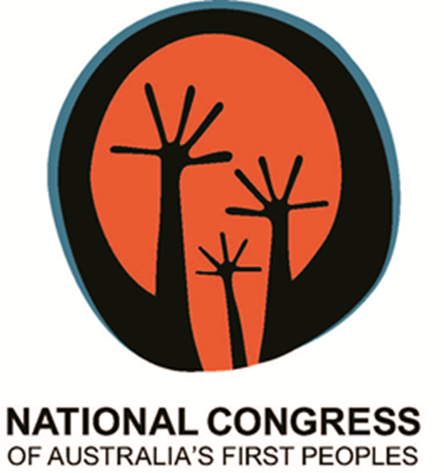

Statement to the
Reference Group on Welfare Reform to the Minister for Social Services

Response to the Interim Report
‘A New System for Better Employment and Social Outcomes’

11 August 2014
The National Congress of Australia’s First Peoples (Congress) welcomes the opportunity to respond to ‘A New System for Better Employment and Social Outcomes’, the Interim Report of the Reference Group on Welfare Reform to the Minister for Social Services (the Reference Group). This statement will remain brief, given the short timeframe for responses to the Interim Report and the continuing consultations of the Reference Group. In the interests of thorough consultation, Congress offers to facilitate a roundtable of Aboriginal and Torres Strait Islander Member Organisations to ensure that First Peoples views are included in the Final Report.

Congress is a national representative body for Aboriginal and Torres Strait Islander Australians. Congress is an independent national voice guided by strong foundations of unity, democracy, culture and our Peoples’ ability to make decisions and control our own lives and communities.

Congress is a leader and advocate for protecting and advancing the wellbeing and empowerment of Aboriginal and Torres Strait Islander Peoples, and for securing our economic, political, environmental, cultural and social future.

Congress has created one of the largest networks of our Peoples in the country, and continues to grow. Our 8200 plus individual members are from urban, regional and remote communities in every State and Territory. Our 190 organisational members, national bodies, peaks and community organisations, contribute their massive membership of tens of thousands of our Peoples to the Congress movement. Owned and controlled by its membership, Congress Co-Chairs and Board are elected, not appointed.

Congress supports the United Nations Declaration on the Rights of Indigenous Peoples which affirms the right of the Aboriginal and Torres Strait Islander Peoples to be self-governing and autonomous, including:

- The right to participate in decision-making in matters that would affect our rights, through representatives chosen by ourselves;
- The requirement for Australia to demonstrate good faith by obtaining free, prior and informed consent before adopting or implementing legislative or administrative measures that may affect our Peoples;
- The right to engage freely in economic activities while maintaining and developing our own political, social and economic systems and institutions.
Congress opposes any legislation or policy which limits or removes the right to self-autonomy from First Peoples. Aboriginal and Torres Strait Islander communities across Australia must be allowed to take responsibility for their own affairs. It is highly concerning that the Interim Report suggests measures that would take further agency away from individuals (i.e. forcing single mothers to seek employment when their children reach a certain age).

The Interim Report fails to acknowledge the importance of culture in the lives of Aboriginal and Torres Strait Islander Peoples. Congress expresses deep concern at the lack of acknowledgement of culture and the role it plays in the everyday lives of Aboriginal people. Imposing laws, policies and programs on communities that do not enable the integration of one’s culture is damaging and hinders opportunities for progress.

Many of the social problems faced by First Peoples today have resulted from past government policies that coerced people from practicing culture (i.e. removal from land, relocation to reservations and missions, Assimilation, the stolen generation policies).
Furthermore, the Interim Report would benefit from an acknowledgement that social welfare policies targeted at Aboriginal and Torres Strait Islander Peoples assist in ameliorating the effects of historical dispossession and discrimination.

Aboriginal and Torres Strait Islander Peoples’ connection and rights to their lands, seas and waters must be respected and protected. Policies that coerce our peoples from their lands and communities to seek employment hundreds of kilometres away, may only repeat past injustices that caused dispossession, discrimination loss of connection to land and culture.

Furthermore, Government must respect the place of customary law in Aboriginal and Torres Strait Islander communities. The use of terms such as ‘law of the land’ and ‘broad social norms’ is an affront to Aboriginal and Torres Strait Islander culture and implies archaic policy making based in de facto assimilationist thought.

The Four Pillars of Welfare Reform

Simpler and sustainable income support system
Congress supports the review of social welfare policies if conducted with the aim of improving the lives of Aboriginal and Torre Strait Islander People and empowering our peoples to seek further education or employment if they so choose. A punitive approach will only exacerbate perceptions of disempowerment and discrimination by government authorities.

The goal of a more efficient welfare system must not result in arbitrary inflexibility and not be at the detriment of Aboriginal and Torres Strait islander culture. Policies must take into account the differences in geographical realities of peoples living in remote, regional or town/city communities.

Strengthening individual and family capability
Congress is supportive of the Interim Report’s focus on empowering our peoples and building capability with the view to self-sufficiency. However, Congress recommends that welfare measures will be better formulated and implemented if Aboriginal and Torres Strait community controlled health and welfare organisations are resourced adequately to apply their expertise.

Congress remains adamant that the mandatory income management system must be replaced by a voluntary system with provision for case by case income management where warranted. Although income management has been extended to include select groups within the broader Australian population, the majority of those affected on welfare are Aboriginal and Torres Strait Islander people and hence the measure continues to discriminate heavily against Aboriginal people.

Processes surrounding income management must be reviewed, especially in regard to the exemption process. It has been identified that once placed on income management, it is very difficult for people to get themselves off the system.

Engaging with employers
Given the lived experiences of many working Aboriginal and Torres Strait Islander Peoples has involved some degree of cross-cultural ignorance or even overt racism, it is integral that efforts to increase the numbers of employed First Peoples are matched with nuanced cross-cultural competence strategies. This may include cross-cultural competence training for employment services, employers and employees. Cross-cultural training cannot simply be a ‘box ticking’ requirement, and training conducted in one region may have little or no relevance in another. For instance a course run in urban Victoria or New South Wales will do little to equip employment agencies working with a remote community in the Northern Territory, Western Australia or Queensland.

Building community capacity
Congress supports overarching strategies to advance First Peoples’ autonomy and sustain the development of Aboriginal Torres Strait Islander People and their communities. Congress endorses the emerging body of evidence that shows it is investment in programs and services, developed in genuine collaboration with our communities and properly funded, that is the key to building capacity and achieving sustained benefit.

The principle of Aboriginal Torres Strait Islander Peoples being in control of our communities, with active support from partners including governments, NGOs and the private sector, will create the conditions that enable First Peoples to break free from the cycle of poverty and welfare dependency.

Congress recommends that welfare reform policies and programs be targeted to each local community’s needs in active partnership and engagement with the community. The diversity of Aboriginal and Torres Strait Islander Peoples, tribes and clans must be recognised, respected and considered when developing and implementing policies.

Geographical attributes, proximity to services, and capacity will also differ by community, requiring approaches to be tailored to a community’s unique circumstances. Reform to welfare policies and implementation of changes must be targeted at empowering First Peoples to actively participate in the decision making processes on issues that affect their particular communities.

Concluding remarks

Congress looks forward to the release of the final report. We are adamant that only with the inclusion of the expertise of Aboriginal and Torres Strait Islander organisations, will the Final Report be able to genuinely address culturally relevant solutions to the welfare problems facing our peoples.

