Submission
McClure Social Security Review 2014

14.8.2014

Dear Sir,

I write this submission as:

a) an individual sole parent, with 31 years’ experience both as a parent and as a paid worker in the community sector.

b) a current member of The Council of Single Mothers and their Children (Vic) and The National Council of Single Mothers and their Children. I am a former Policy Development Officer at ACOSS, and was on the ACOSS Board for approximately four years.

c) the author (under their direction) of the ACOSS submission in 1986 to The Social Security Review’s first issues paper by Bettina Cass: Income Support for Families with Children.

d) a former member (Welfare Member) of the Social Security Appeals Tribunal (1992-1996)

Susan Jennifer Barclay

BA, Dip Soc Stud,
University of Melbourne 1976

1. WHAT SHOULD BE THE GUIDING PRINCIPLES FOR REFORM?

Any Review of income support needs to be based on principles that are important for outcomes.

The Social Security Review in the mid to late 1980s published a comprehensive range of Issues Papers for public discussion and comment.
The First Issues Paper by Bettina Cass (Income Support for Families with Children, AGPS, 1986) in particular spells out the principles upon which any reform should be based. These principles are basic and non-negotiable. They are applicable today as they were in the 1980s.

“The [four] objectives of family income support are:

1. Horizontal Equity - to provide a fair share for all families

2. Vertical Equity - to provide adequate support to low income
families

3. Intra-family Equity - to provide resources to the parent primarily
responsible for children’s care

4. Incentives - to provide family assistance which does not
discourage parents’ workforce participation
and income earning.”

(p 5 Bettina Cass Income Support for Families with Children Social Security Review Issues Paper Number 1, 1986)
The 1986-89 Social Security Review provided a model for much-needed reforms of the social security system, including an extension of the then Family Income Supplement for people in low-paid work, and an increase and then indexation of the Child Payment part of income support payments. (This was later divided into a payment then called Family Tax Benefit A and B under the Howard Government in 1998)

5. No Disadvantage

A fifth and another necessary objective of reform is that no income support recipient should be disadvantaged by changes.

Over the last ten years or more in Australia, we have seen many groups and individuals being disadvantaged. These are in two main categories:

First, there is the very large group (More than 717,000 people as well as their children) whose payments have been indexed inadequately and whose incomes have slowly eroded away since 1996.

This includes all individuals and families now receiving Newstart Allowance, students receiving Youth Allowance, where the rate is even lower.

The base rate of Newstart Allowance is now only $255 per week, compared with a pension rate of $421 per week. This is solely the result of adequate indexation of Age and Disability Pensions, compared with CPI-only indexation of Newstart Allowance.

Even independent international organisations like the OECD has recommended that Australia’s Newstart Allowance should be increased because of its inadequate rate.

Of the advanced OECD countries, Australia has the lowest unemployment payments in the developed world, as the following graphs show: (also p 7 (Chart 5.13)

Unemployment benefits versus poverty line, showing the gap as a percentage of the poverty line over time

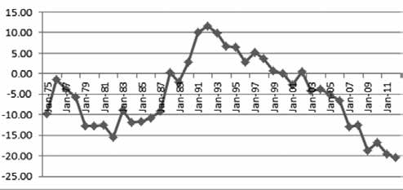

Source: Calculations by The Australia Institute based on Melbourne Institute of Applied Economic and Social Research. Poverty Lines: Australia (various issues), and Australian Government 2104

Advance Australia Fair?
What to do about growing inequality in Australia
Inequality in Australia Report, p 19

Second, there are those who have lost eligibility for payments. These include sole parents and their children whose eligibility for receipt of Parenting Payment, formerly paid at the full pension rate, and who have now been arbitrarily transferred to the now MUCH lower Newstart rate once their children turn eight. (From 2006)

Another group which has lost eligibility is refugees and migrants, who used to be paid ‘Special Benefit’ under similar rules to those of Newstart Allowance.

Recommendation 1.

All changes to social security payments should be consistent with these five objectives:

a. Horizontal Equity a fair share for all families
b. Vertical Equity adequate support to low income families
c. Intra-family Equity payments to go to the primary caregiver
(This objective has now largely been achieved)
d. Incentives assistance which does not discourage parents’ workforce participation and income earning.
e. No Disadvantage Payments need to be increased and then indexed to a formula which is both adequate and consistent.

Recommendation 2.

a) Newstart Allowance should be increased to a level which is equivalent to the pension rate, as it was before 1975.

This may need to be done in stages, with a commitment to further increases, but an immediate increase of at least $60 per week would be essential to start.

This should be accompanied by a public promise and commitment to overcoming poverty in Australia.

Once it reaches the same level as the current pension rate, it should then be indexed to maintain its value, so it does not fall so far below the poverty line as is now the case.

b) All sole parents should immediately be returned to full pension eligibility, as existed prior to 2005.

Sole parents should continue to be eligible for full pension conditions until their youngest child finishes secondary school.

c) An additional payment needs to be directed towards one parent families, who face significantly higher costs (such as housing) than a single person.

A top-up payment (Like the Guardian’s Allowance which existed up until around 1996-2000) would help to recognise these additional needs of one parent families.

d) Effective programs and incentives for work and study participation should be re-instated, to encourage sole parents’ workforce participation, including re-instating affordable child care.

2. AUSTRALIA DOES NOT HAVE A DEBT PROBLEM, BUT IT DOES HAVE A POVERTY PROBLEM

It is unproductive to try to manage the Australian economy with no thought of the far-reaching effect of policies and attitudes of the present Government.

Blaming the victim - calling all people who receive any sort of income support payment a “bludger” is insulting and inaccurate. Whether on Newstart or Youth Allowance, Parenting Payment, Age or Disability Pension, classifying all of these individuals as “bludgers” or “leaners” undermines the confidence of people.

People who are in this group find this attitude unreasonable and unnecessarily punitive. Australia needs to support and value every individual. Every human being has a right to be alive and many contribute in ways that are not valued or acknowledged by the community as a whole. Or, indeed, even noticed.

It is time that we stopped using the word ‘bludger’ which started in 1975, when indexation arrangements for the then unemployment benefit were frozen.

Australians are well aware that our system is fair, reasonable and affordable. Indeed we are doing better than many other OECD countries. Our indicators of spending are very low - Australia can afford to maintain a health care system, an education system and an improved income support system.

As the following chart shows, Australia’s spending on social welfare relative to GDP is sustainable and affordable.

Indeed, many improvements are needed to income support, but in the present context, they are affordable.

Compared with other OECD countries the Australian tax-transfer system is highly redistributive to those with least means. Australia's spending on social security is below the OECD average (Chart 5.13). This reflects a range of factors, including benefit levels that are unrelated to previous earnings, employer rather than public provision of sick leave and other important structural differences from most OECD countries.
Chart 5.13: Social welfare spending as a percentage of GDP in 2001^{(a)}
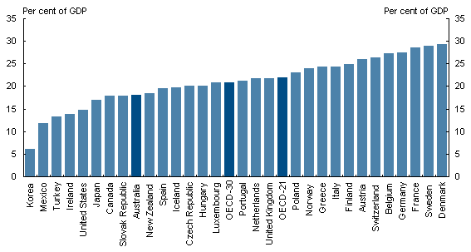
- 1999 data for Turkey for 2000 and 2001 OECD averages. OECD averages exclude countries where data are not available for related time series. OECD-21 exclude Austria, Czech Republic, Hungary, Iceland, Korea, Mexico, Norway, Poland and Slovak Republic.
Source: Whiteford (2007).
OECD Social Indicators

3. COMPARISONS AND CONSEQUENCES

The present system is clearly disadvantaging many people in Australia, especially children.

Poverty rates in Australia have increased, and will increase further under proposed Budget cuts. Already about two and a quarter million people in Australia are below the poverty line.

This 2,265,000 people represents 13% of the population. It includes nearly 575,000 children - or 18% of all Australian children.
Child Poverty rates have increased and are looking like they will also increase further if current trends continue.

Adequate indexation is the key to maintaining adequacy of income support payments. Since around 1996, we have seen Newstart fall in value from nearly the equivalent of the pension, 420 per week, to 255 per week.

The proposal to remove indexation for pensions should be abandoned. This indexation has protected pensioners from severe deprivation and poverty.

Newstart Allowance and Youth Allowance need to be increased to combat the poverty recipients of these allowances already suffer.

CPI only Indexation has reduced the value of Newstart Allowance. It is a measure which is inadequate and incorrectly calculated as the poverty increases in Australia have demonstrated. Many

All income support payments need to be indexed in line with Average Male Weekly Earnings to protect vulnerable Australians from the poverty they now experience.

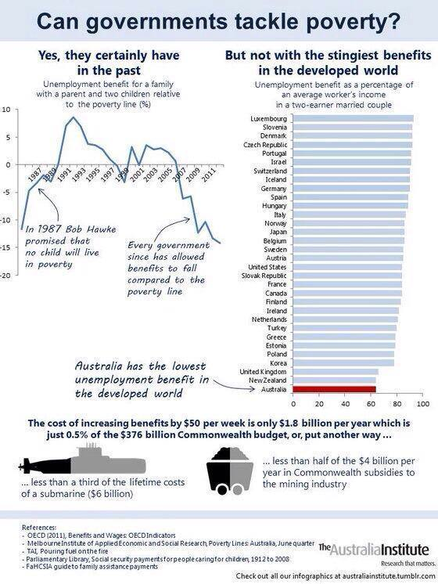

The Australia Institute, 2014

What does poverty mean in Australia now?

Some examples:

It means:

- you have insecure and/or unaffordable housing,

- you cannot afford chidren’s school books or excursions, and sometimes cannot afford to send your children to school at all.

- always having very small amounts left over after paying your bills for the week and NEVER having enough for food,

- always having to say no to your children’s requests for a birthday party, a meal out, or going out with friends.

- panicking when your fridge or washing machine breaks down as you will be unable to finance repairs or replacements.

It means no phone or internet, electricity and gas being cut off. It means eviction and possible homelessness.

You are scared all the time and you cannot plan for the future as the future is as insecure as the present.

You definitely cannot afford little extras. You know that you will not be able to afford to take your children to the doctor unless you can find one who bulk bills.

[The proposed GP and other medical services copayment would, of course, make this situation impossible.]

There is now a great deal of research which has looked into the long-term consequences of poverty for both individuals, and the community as a whole, when children are consigned to poverty for a large proportion of their lives.

It is both unnecessary and undesirable to allow escalating rates of child poverty to continue in Australia.

4. WHY SHOULD CHILD POVERTY BE A FOCUS?

It is self-evident that any civilised society should look after its children, especially when they are disadvantaged by circumstances beyond their control.

All children deserve the best start in life possible, and the best opportunities to develop and learn and take their place in the future.

Several researchers have provided evidence that having a strong safety net, educational opportunities, access to health care etc actually result in positive social outcomes not just for the individual but for society as a whole.

(Wilkinson and Pickett, Joseph Stiglitz, Thomas Piketty)

Changes have been made to the structure of social welfare payments that affect children.

While the present system of Family Payments is much more adequate for children than before the reforms of the 1980s, the income support system for the parents (both two-parent and one-parent families) has failed.

As noted above, lack of adequate indexation is the cause of this.

Recommendation 3.

a) Any change to payments for children must improve their circumstances, not reduce them. They must be consistent with the guiding principles of ADEQUACY and EQUITY.

b) The proposal to cease payment of Family Tax Benefit B when the child turns six is punitive and inappropriate.
It should be abandoned.

c) The Schoolkids Bonus should be retained. Families need all the help they can get to assist with the cost of their children’s education.

[There has long been a recognition through the taxation system of the costs of children. Tax Rebates and Credits have now been replaced by easier to access direct payments.

This is appropriate and should continue]

The following graphs show how low Australia’s social welfare spending is in the context of other OECD countries.

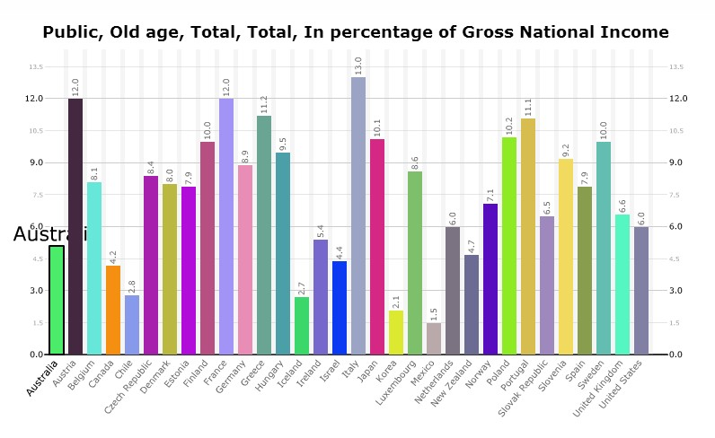
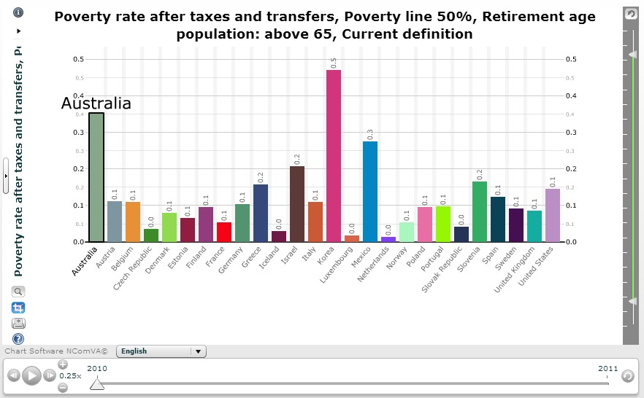

“Only 7 OECD countries spend less than us on social welfare (2010 total social expenditure, not just cash benefits)”

OECD Statistics (glennmurray.com)

5. IT IS TIME TO ABANDON MONETARISM AS AN ECONOMIC MODEL

We now know that economic modelling and theory which has informed the policies of some countries over the last fifty years has been based on a myth.

There is now a great deal of evidence that this is the case.

Wilkinson and Pickett have done detailed studies across a range of OECD countries and have shown that more equal societies are also those where there is better health, better levels of trust and safety, better educational outcomes as well as a range of other variables that we associate with the sort of society we would hope to live in.

Piketty’s contribution in Capital in the Twenty-First Century is the detailed study of economic and historical records over two centuries, as well as the critical examination of the failed and incorrect economic theories which have dominated our thinking in recent decades.

Joseph Stiglitz puts the problem very eloquently:

“Inequality is a choice .... I see us entering a world divided not just between the haves and have-nots, but also between those countries that do nothing about it, and those that do. Some countries will be successful in creating shared prosperity — the only kind of prosperity that I believe is truly sustainable.
Others will let inequality run amok. In these divided societies, the rich will hunker in gated communities, almost completely separated from the poor, whose lives will be almost unfathomable to them, and vice versa. I’ve visited societies that seem to have chosen this path. They are not places in which most of us would want to live, whether in their cloistered enclaves or their desperate shanty towns.” (Stiglitz 2013)

IT IS THE ROLE OF GOVERNMENTS TO HAVE APPROPRIATE TAXATION ARRANGEMENTS FOR REVENUE RAISING, AND RESPONSIBILITIES FOR A SOCIAL SAFETY NET.

These are not individual responsibilities, any more than the building and staffing of a hospital or school.

Australia values its health system, it values equity and fairness. This is evident from the recent outcry and rallies which have come from the widely-perceived unfairness of the proposed 2014 Budget.

Recommendation 4.

a) Adequate Health and Education funding should be restored. The present Government does not have a mandate to destroy Federal - State funding agreements that date back to Federation in 1901.

b) The reforms recommended by Gonski should immediately be introduced.

c) Australia needs a well-functioning income support system to
prevent and alleviate poverty and homelessness across all of Australia.

This includes participation in the global move to combat climate change, which is now being introduced in countries like India and China.

Responsible environmental actions cannot be separated from economic ones. Even conservative bodies like the World Bank and the International Monetary Fund are now recognising this.

The present Government’s position on climate change is both retrograde and counter-productive.

6. TAX REVENUES AND SOCIAL EXPENDITURES

No government can fund any social security programs without a fair and equitable tax base.

This has been neglected in current discussions.

Most of the Australian community are well-informed enough to know that taxation revenues are not equitable.

In particular, wealthy corporations and individuals are taking advantage of a range of measures to avoid or evade tax.

There needs to be a broad discussion of ways of restricting tax avoidance.

For example, even the Sydney Morning Herald ran an article in late June that spelled out how some companies avoided paying tax. Sydney Morning Herald reporter, Michael West, stated that: “Australia's largest coalminer, Glencore, paid almost zero tax over the past three years, despite income of $15 billion, as it radically reduced its tax exposure by taking large, unnecessarily expensive loans from its associates overseas.”

Similar rorts have taken place in corporations like Energy Australia, Google, and many others who do not pay their fair share of tax.

All Australians know that large corporations are subsidised by the taxpayer for the use of fuel.

Yet only one side of the equation is looked at - the expenditure side.

The revenue side is just as important.

Recommendation 5.

a) International agreements need to be sought to prevent corporations using other countries as tax havens.

b) The Capital Gains Tax needs to be increased, as its reduction has distorted investments away from productive to speculative investment. This has had a disastrous effect upon the Housing Sector.

c) Superannuation concessions favour the wealthy. Using superannuation as a way of avoiding tax detracts from the purpose of superannuation.

Concessions on superannuation cost the Government in the same way that direct outlays do. This needs to be recognised in accounting and Budget planning.

d) Many reforms to the Taxation system were brought in in the 1980s and 90s, but they have been weakened and undermined by relaxing of certain provisions, such as the Capital Gains Tax.

7. SOLE PARENTS AND WORKFORCE BARRIERS

It is false to assume that parents do not want to work. Most sole parents can and do work, but they face a range of workforce barriers because of their situation.

These include:
1. There is no possibility of sharing of the tasks of child-rearing, including getting children to and from school. State governments usually have rules that say children should not be left alone until they are 14 to 16 years old, which conflicts with Federal government policies requiring sole parents to work – usually full-time – once their child turns 8.
2. There is only one income at best, and the costs of working have to be deducted from any income earned. This can outweigh the benefits, including financial benefits, of working and can be a major disincentive.
3. Each individual is in the best position to work out their best working arrangement, depending upon their individual circumstances. Full-time work is not necessarily the best option for many sole parents, as they can come home from a day’s work too exhausted to have anything left for their child or children.
4. The sole parent is the only one there - they must put their children first, indeed they want to. But a requirement to work is not the best way to maximise a one-parent family’s work opportunities.
5. Each parent should be offered incentives to work, not punishments for not working. Incentives work better than disincentives.
6. Child care costs can be a particular disincentive for low income working parents, especially sole parents. Cuts to child care funding arrangements for low income earners will cause even greater hardship for working sole parents.

Recommendation 6.

a) Each individual parent is in the best position to make choices about how much she (or he) can work. This is likely to vary according to the age(s) of her child or children and other circumstances, such as whether the child has a learning or other disability, or just needs more encouragement than other children.

Workforce participation is to be encouraged, NOT coerced.
Effective programs (rather than ineffective ones, like many that currently exist) should give support to sole parents in seeking work.

b) Poverty traps can often mean that it is not worth working - if you earn $100, and lose $100 in means-testing of income support payments, costs of working, child care, travel and other costs, it is not possible to make ends meet.

Work should result in an improvement in income. This would help alleviate poverty in one-parent families and would also help each individual sole parent and their child or children.

8. RELATIONSHIPS BETWEEN TAXATION, INCOME SUPPORT AND HOUSING

The housing sector, especially for low-income earners, has been neglected over recent years.

Despite some advances and commitments under the Rudd Government, especially on homelessness and affordable housing, this area of policy needs a great deal more attention.

Consequently, we have unacceptable levels of homelessness in Australia, which are set to increase unless progress is made across areas of Taxation, Income Support and Housing.

We have a ridiculously skewed housing sector, with some house values having been blown out by distorted investments, and not nearly enough attention given to supporting investments in affordable housing.

Senator Scott Ludlam has put this issue very clearly:

“Deliberate government policy over two decades has shaped a market almost unique in the world: a nation of landlords bidding up the price of real estate in the hope of building an asset base for retirement and a nation of renters helping pay off the mortgages of those who got the jump on them.

The twin engines of capital gains tax exemptions and negative gearing, worth $4 billion a year to the Commonwealth budget, have turned human shelters into tax shelters, allowing the suitably diligent to convert their progressively taxed income into lightly taxed assets in the form of rental accommodation."

"these statistics … are all cited by three studies produced by the Australian Institute of Health and Welfare and released today. This is one of the expert bodies that the Abbott government has defunded. Taking the expert bodies out of the picture removes such information as we do have about the degree and the extremity of the housing affordability and homelessness emergency in our country today."

Recommendation 7.

The $500,000 taken from the Federal Housing Budget should be immediately re-instated.

There should also be the re-instatement of the position of Minister for Housing, and an enquiry into housing and homelessness issues should be established.

9. UNEMPLOYMENT STATISTICS ARE INCORRECT AND MISLEADING

Unemployment statistics are misleading. The statistics published by the Australian Bureau of Statistics (ABS) although based on commonly used international definitions, are counter-intuitive and have little meaning for the average person.

Consequently, they are misleading and a considerable under-statement of true rates of unemployment.

“Not only must you not be in employment, but you can’t have done even one hour of paid or unpaid in the four weeks prior to the survey. Nor can you be discouraged by the absence of available jobs either -- you must have applied for something in the previous four weeks -- and you must be available to start immediately.”

… [This] excludes from the formal definition a lot of people who really are unemployed.” (Steve Keen, 11.8.14)

Roy Morgan polls have now begun measuring unemployment in a different way, according to a more meaningful and relevant set of questions.

“The “endorsed international standards” are bunkum and have been ever since they were modified in the 1980s. By then it was obvious that the low unemployment years of the golden age of capitalism had come to an end, and there were two things that could be done about it: we could either have had a good hard look at why advanced market economies were leaving so many people without a job; or we could define the problem away.” (Steve Keen, 11.8.14)

This has been a common perception and worry of researchers and analysts dating back to the 1980s. The graph below illustrates the differences between the two methods of measuring unemployment.

Figure 1: The ABS and Roy Morgan unemployment rates
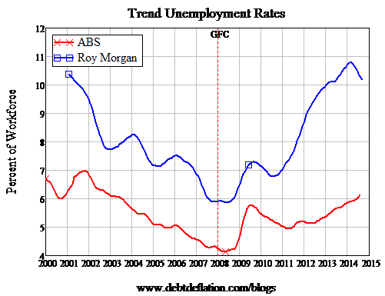

Recommendation 8.

A more accurate method of measuring and reporting unemployment statistics needs to be developed, which could at least be used alongside existing ABS methods.

10. NO FURTHER CUTS TO NEWSTART- NO ADDITIONAL BURDENS ON UNEMPLOYED PEOPLE

Dire poverty is what is presently experienced by those receiving Newstart and Youth Allowance. At present Newstart recipients face a range of intrusive and unrealistic demands imposed by Centrelink implementing Government requirements.

To add to this in any way at all is contrary to commonsense.

Severely restrictive (and hitherto unindexed) income tests on Newstart Allowance make the prospect of benefitting from part-time or casual work, which may be all that a person can get, an impossibility.

Proposals to further punish unemployed people, including sole parents, are inappropriate and unnecessary.

Many people do not have the option of sleeping in family homes, or in friends’ houses, and proposals like six months of living on no income at all will cause a serious increase in homelessness rates, as well as a range of other extreme and unfathomable consequences.

Further demands - like job search when a person has no income at all are simply impossible and unreasonable.

Existing work participation requirements are stringent enough and do not need to be made any more onerous.

More resources need to be directed towards the support of disadvantaged jobseekers and those who have been unemployed in the long-term.

Some very effective programs to assist this group of disadvantaged job-seekers have already closed due to losing their funding.

These programs should be re-instated, and more established.

There are some programs which do not adequately address the needs of long-term unemployed people.

The views of unemployed people themselves need to be taken into consideration when determining which programs are worth supporting, as they have the most relevant experience of what is useful and appropriate and what is a waste of their time and effort.

There seems to be a great deal of ‘recycling’ people who are unemployed, with referrals to short-term resume-writing courses and the like, which are then repeated by another agency some time later. So courses duplicate one another and no actual help is made available for the person.

‘Work for the dole’ has been trialled both here and overseas and has been shown to be completely without benefit to either the individual or society in general. The idea should be consigned to the rubbish bin.

Recommendation 9.

a) There should be no further cuts to payments for unemployed people. The proposed six month wait for receiving payments is inappropriate and should be abandoned.

b) Funding for programs that are effective and helpful for long-term and disadvantaged job-seekers needs to be retained and strengthened.

c) Proposals for ‘Work for the dole’ should be immediately abandoned.

11. INCOME MANAGEMENT

Income Management has been shown to be unnecessary, demeaning and expensive.

It should NOT continue under any circumstances and should be immediately abolished.

In its place, all funds allocated to administrative costs of Income Management, approximately $3,500 per person per annum (Eva Cox, 9.7.2014), should be re-allocated to income support recipients in the form of an increase to their payment.

This would take the inadequate base rate of $13,000 per year to $17,500 per year (at current rates). This would indeed be of assistance in poverty alleviation. This, of course, would also be of immediate assistance in balancing the budgets of individuals and families.

If the Government has funds to allocate to income management, it should be redirected to individuals receiving the payments.

For a few people, if further help is needed, an effective and accessible financial counselling service should be utilized to assist with budget planning. There is currently a large network of Financial Counselling services across the country.

Where drug, alcohol or gambling addiction exists (probably about .001% of those on income management), the usual avenues for help and counselling could be accessed.

To apply income management to a group as a whole is punitive. It is a gratuitous humiliation of people and their right to choose for themselves.

It is also of NO value to either the individual or the community as a whole, as it does not help people learn to manage for themselves and for the future.

People who have difficulty budgeting need:

(1) A more adequate payment, not one where half or sixty per cent of their income goes towards paying rent.

(2) Access to support services.

Taking away the freedom of the individual undermines people’s confidence and self-esteem.

The impact of enforced income management on people in the Northern Territory is devastating and ongoing.

“Once again, negative stigmatising of the people was as one, promoting aspects of dysfunction without providing background or explanation of situations and ensuring the most sensationalised
elements of disadvantage were promoted. Measures imposed were not targeted at areas of need but were simply imposed on all as blanket measures.

The oppressive restrictions were imposed on communities irrespective of whether they were perceived to be well managed and achieving their goals or whether they were struggling and in need of help. They were punished without distinction.

Their individual worth was of no consequence. The intention of such measures had never been designed to assist in specific circumstances involving particular individuals or communities but as a
means of taking back control from all.” (Michelle Harris, ‘Concerned Australians’, 28.6.2014)

These are applicable not only to Aboriginal people in the Northern Territory, but apply to all individuals treated in the same manner.

Recommendation 10.

a) Income Management should be completely abolished immediately.

b) Referrals for Financial Counselling (or other individual or group counselling) should be made available in place of Income Management

c) All funds directed towards Income Management should be paid instead in the form of increases to Newstart’s low rate of payment

d) The so-called ‘Northern Territory Intervention’ should be abolished and replaced by a self-determining self-help group run by and for Aboriginal people and communities. This group should be responsible for policies affecting their community.

12. POVERTY TRAPS

Poverty traps are sometimes seen as a consequence of a targeted income support system.

A poverty trap exists where a person receiving government income support undertakes paid work to try to improve their standard of living, or indeed to just make ends meet, but finds that she or he is little better off, no better off or even worse off than before.

Some changes have taken place in recent years. There has been a relaxation of some income test taper rates for some groups, for example.

The ‘sudden death’ poverty trap which existed when the threshold for eligibility for a pensioner concession card, and its attendant benefits, has been improved by the issuing of the card for all persons receiving a part-pension, even at a very low rate. The existence of a Seniors Health Card for those not receiving government income support is also helpful.

However, the poverty traps that currently exist for those on Newstart Allowance remain extreme, with the ‘free area’ for income earned remaining at a very low level, not having been indexed for inflation for forty years.

This is a ludicrous situation and needs immediate attention for those now receiving Newstart Allowance, many of whom face an effective tax rate of over 130%. The exact rate would depend upon an individual’s circumstances.

It is a basic principle that a person should be better off financially from participation in paid work. This should be self-evident.

Recommendation 11.

a) There should be an immediate increase to the free area for income earned for those receiving Newstart Allowance so that it is the same level as those receiving a pension. (Approximately $160 per fortnight), plus an additional free area for each dependent child.

This should then be indexed according to an adequate indexation formula, so that its value is maintained.

b) The other costs of working need to be recognised as they contribute to a stacking of income tests which result in effective tax rates of over 100%.

A formula for income tests which takes into account costs of child care, for example, needs to be introduced.

13. CHILD SUPPORT

The present child support system is widely acknowledged to be a bureaucratic mess, with apparently billions of dollars in child support collected which has not been paid to the custodial parent.
There are no measures which enforce collection of child support for non-custodial parents who are unwilling to pay.

The child support system needs reform, but as that is the subject of another enquiry, the matter is not the subject of this submission.

14. SUMMARY OF RECOMMENDATIONS

Recommendation 1.

All changes to social security payments should be consistent with these five objectives:

a. Horizontal Equity a fair share for all families
b. Vertical Equity adequate support to low income families
c. Intra-family Equity payments to go to the primary caregiver
(This objective has now largely been achieved)
d. Incentives assistance which does not discourage parents’ workforce participation and income earning.
e. No Disadvantage Payments need to be increased and then indexed to a formula which is both adequate and consistent.

Recommendation 2.

a) Newstart Allowance should be increased to a level which is equivalent to the pension rate, as it was before 1975.

This may need to be done in stages, with a commitment to further increases, but an immediate increase of at least $60 per week would be essential to start.

This should be accompanied by a public promise and commitment to overcoming poverty in Australia.

Once it reaches the same level as the current pension rate, it should then be indexed to maintain its value, so it does not fall so far below the poverty line as is now the case.

b) All sole parents should immediately be returned to full pension eligibility, as existed prior to 2005.

Sole parents should continue to be eligible for full pension conditions until their youngest child finishes secondary school.

c) An additional payment needs to be directed towards one parent families, who face significantly higher costs (such as housing) than a single person.

A top-up payment (Like the Guardian’s Allowance which existed up until around 1996-2000) would help to recognise these additional needs of one parent families.

d) Effective programs and incentives for work and study participation should be re-instated, to encourage sole parents’ workforce participation, including re-instating affordable child care.

Recommendation 3.

a) Any change to payments for children must improve their circumstances, not reduce them. They must be consistent with the guiding principles of ADEQUACY and EQUITY.

b) The proposal to cease payment of Family Tax Benefit B when the child turns six is punitive and inappropriate.
It should be abandoned.

c) The Schoolkids Bonus should be retained. Families need all the help they can get to assist with the cost of their children’s education.

[There has long been a recognition through the taxation system of the costs of children. Tax Rebates and Credits have now been replaced by easier to access direct payments.

This is appropriate and should continue]

Recommendation 4.

a) Adequate Health and Education funding should be restored. The present Government does not have a mandate to destroy Federal - State funding agreements that date back to Federation in 1901.

b) The reforms recommended by Gonski should immediately be introduced.

c) Australia needs a well-functioning income support system to
prevent and alleviate poverty and homelessness across all of Australia.

This includes participation in the global move to combat climate change, which is now being introduced in countries like India and China.

Responsible environmental actions cannot be separated from economic ones. Even conservative bodies like the World Bank and the International Monetary Fund are now recognising this.

The present Government’s position on climate change is both retrograde and counter-productive.

Recommendation 5.

a) International agreements need to be sought to prevent corporations using other countries as tax havens.

b) The Capital Gains Tax needs to be increased, as its reduction has distorted investments away from productive to speculative investment. This has had a disastrous effect upon the Housing Sector.

c) Superannuation concessions favour the wealthy. Using superannuation as a way of avoiding tax detracts from the purpose of superannuation.

Concessions on superannuation cost the Government in the same way that direct outlays do. This needs to be recognised in accounting and Budget planning.

d) Many reforms to the Taxation system were brought in in the 1980s and 90s, but they have been weakened and undermined by relaxing of certain provisions, such as the Capital Gains Tax.

Recommendation 6.

a) Each individual parent is in the best position to make choices about how much she (or he) can work. This is likely to vary according to the age(s) of her child or children and other circumstances, such as whether the child has a learning or other disability, or just needs more encouragement than other children.

Workforce participation is to be encouraged, NOT coerced.
Effective programs (rather than ineffective ones, like many that currently exist) should give support to sole parents in seeking work.

b) Poverty traps can often mean that it is not worth working - if you earn $100, and lose $100 in means-testing of income support payments, costs of working, child care, travel and other costs, it is not possible to make ends meet.

Work should result in an improvement in income. This would help alleviate poverty in one-parent families and would also help each individual sole parent and their child or children.

Recommendation 7.

The $500,000 taken from the Federal Housing Budget should be immediately re-instated.

There should also be the re-instatement of the position of Minister for Housing, and an enquiry into housing and homelessness should be established.

Recommendation 8.

A more accurate method of measuring and reporting unemployment statistics needs to be developed, which could at least be used alongside existing ABS methods.

Recommendation 9.

a) There should be no further cuts to payments for unemployed people. The proposed six month wait for receiving payments is inappropriate and should be abandoned.

b) Funding for programs that are effective and helpful for long-term and disadvantaged job-seekers needs to be retained and strengthened.

c) Proposals for ‘Work for the dole’ should be immediately abandoned.

Recommendation 10.

a) Income Management should be completely abolished immediately.

b) Referrals for Financial Counselling (or other individual or group counselling) should be made available in place of Income Management

c) All funds directed towards Income Management should be paid instead in the form of increases to Newstart’s low rate of payment

d) The so-called ‘Northern Territory Intervention’ should be abolished and replaced by a self-determining self-help group run by and for Aboriginal people and communities. This group should be responsible for policies affecting their community.

Recommendation 11.

a) There should be an immediate increase to the free area for income earned for those receiving Newstart Allowance so that it is the same level as those receiving a pension. (Approximately $160 per fortnight), plus an additional free area for each dependent child.

This should then be indexed according to an adequate indexation formula, so that its value is maintained.

b) The other costs of working need to be recognised as they contribute to a stacking of income tests which result in effective tax rates of over 100%.

A formula for income tests which takes into account costs of child care, for example, needs to be introduced.

REFERENCES:

Bettina Cass
Income Support for Families with Children Social Security Review Issues Paper Number 1, AGPS, 1986

ACOSS
Assistance For Families
ACOSS Submission to the Social Security Review, February 1897
ACOSS Paper No. 4

Poverty in Australia: ACOSS Paper 194, revised 2013
First published in 2012 by the Australian Council of Social Service
Locked Bag 4777 Strawberry Hills, NSW, 2012 Australia Email: info@acoss.org.au Website: www.acoss.org.au
ISSN: 1326 7124 ISBN: 978 0 85871 082 5

Helen Hodgson
AN HISTORICAL ANALYSIS OF FAMILY PAYMENTS IN AUSTRALIA: ARE THEY FAIR OR SIMPLE?
AN ANALYSIS OF TRANSFER PAYMENTS TO AUSTRALIAN FAMILIES APPLYING THE CRITERIA OF EQUITY AND SIMPLICITY
Journal of the Australasian Tax Teachers Association 2005 Vol.1 No.2 , 318

Advance Australia Fair?
What to do about growing inequality in Australia
Bob Douglas, Sharon Friel, Richard Denniss and
David Morawetz
Published May 2014 by Australia21 in collaboration with The Australia Institute
ABN 25 096 242 010

ABC News
OECD warns of rising poverty in Australia as GFC fallout continues
By business editor Peter Ryan
Updated 20 Mar 2014

Piketty, Thomas Capital in the 21st Century, Cambridge,
Belknap, Harvard University Press, 2014

Peter Whiteford
The budget, fairness and class warfare
Inside Story 5 August 2014

Peter Whiteford
Is Australia’s welfare system unsustainable?
Inside Story 10 February 2014

Eva Cox
When job seekers outnumber jobs 5 to 1, punitive policy is harmful
The Conversation, 9 July 2014

Joseph Stiglitz
The Price of Inequality
4 August 2013

Richard Wilkinson and Kate Pickett
The Spirit Level: Why Equality is Better for Everyone
4 November 2010

Michael West
Glencore tax bill on $15b income: zip, zilch, zero
June 27, 2014
Sydney Morning Herald

Richard Eccleston
The Howard Government, Capital Taxation and the Limits of Redistribution?
Australian Journal of Political Science, June 2007
Australian Journal of Political Science, Vol. 42, No. 2, June, pp. 351–364

Ian McAuley, University of Canberra
Taxes and the housing bubble – how we ruined a rational tax system
Published in D!ssent Number 14, Autumn/Winter 2004
University of Canberra

glennmurray.com.au
Abbott’s war on the rest of us – And why there’s no need
April 22, 2014
Just my ramblings

Poverty, Social Exclusion and Disadvantage in Australia
Ben Phillips, Riyana Miranti, Yogi Vidyattama and Rebecca Cassells
NATSEM, University of Canberra 2013

Eva Cox
An 800,000-plus jobs gap between ‘welfare to work’ and reality
The Conversation, 3 January 2014

Senator Scott Ludlam Housing
16.7.2014
http://scott-ludlam.greensmps.org.au/content/speeches-parliament/250000-australians-are-waiting-public-housing-greens-have-plan

Debt: the big lie on which Abbott built a budget
Kenneth Davidson
The Age 23/5/2014

Michele Harris, ‘concerned Australians’
Striking the Wrong Note
Sixth Anniversary of the Northern Territory Intervention
‘concerned Australians’
NEW LEGISLATION IGNORES ABORIGINAL VIEWS, 28.6.2014

Steve Keen
The truth about Australia's unemployment rate 'shocker'
Business Spectator, 11.8.14

Emma Davidson
Why we should listen to women on income management
The Drum 16 September 2011

Ian McAuley
ICAC Exposes Australia's Lazy Rent-Seeker Economy
New Matilda, 13 August 2014-08-14

Matt Wade
Miserly Newstart keeps unemployed further away from jobs
The Age, May 23, 2014

Ben Eltham
Work For The Dole Doesn't Work And Never Has
New Matilda 28 Jul 2014

Susan Barclay
ACOSS Discussion Paper: Alleviating Poverty Traps for Families with Children
ACOSS, January 1991

