Fixing the income tax and welfare system

Below I will present the simplest form of taxation and welfare system that you can imagine. It is absolutely fair and absolutely efficient. It allows the welfare system to do what it does best and the taxation system to just collect revenue. It produces a progressive income tax system without creating poverty traps and anomalies. It is an ideal system based on two radical ideas, welfare for all and flat rate tax.

What is wrong with the current system?

Where would you start? The current arrangement has a welfare system that includes taxation elements and a taxation system that has welfare elements. Combined together we get incredible complexity and bureaucracy. We have a system where taxpayers are constantly encouraged to rearrange their personal affairs to avoid tax or gain benefits. Some beneficiaries are in poverty traps where effective marginal taxes are so high that they have a disincentive to enter the workforce. Other taxpayers are able to rort the system to their advantage.

Currently in Australia, income tax and welfare payments are intertwined and pulling and pushing welfare recipients towards certain behaviours, often to the detriment of the economy and the individuals themselves. The tax system hands out welfare in the form of a tax-free threshold and the welfare system withdraws welfare like a tax at a fairly high rate as people earn money. Medicare
levy exemptions .are also withdrawn and marginal tax rates cut in. You can add to this all the state­ based welfare housing and transport concessions which are targeted at those on welfare and foregone when a person joins the workforce.

I argue that the current tax and welfare system in Australia actually pushes people into welfare because effective marginal tax rates (welfare withdrawal+ marginal tax) are often over 70% and close to 100% at times. Disability pensions, particularly, have become a real trap. A person who has qualified for a disability pension risks so much ifthey try to re-enter the workforce. That's why
822,000 people have sought refuge in these pensions. I contend that these people have made an economic decision based on a very rational assessment of situation

Here is a common example of the Effective Marginal Taxes met by an ordinary household trying to escape poverty.

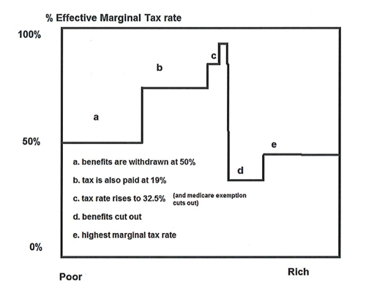

These unfair Effective Marginal Rates (EMR) of income tax create poverty traps by penalising the poor for extra income earned. For some that means they get no advantage and possibly go backwards when earning additional income.

The poverty trap

The current system does nothing to get people out of a welfare mentality. Imagine that a person is in
a trap. The walls are slippery and the EMR represents the slope of the walls. Here is what it looks like:

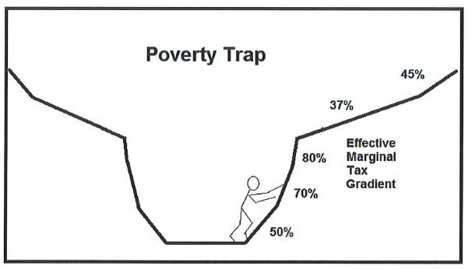

A person with few resources has to work hard to get past the very high effective marginal tax rates near the bottom. Welfare payments are like gravity pulling people down. Strangely the going gets easier at higher income levels, as above $100,000 a family finally gets to keep more than 60% of what it earns.

These anomalies and many more make the current system so horrendously unfair to the working poor who are battling and working long hours and yet look back to see their efforts have achieved so little.

Most people accept the current system. The concept of an effective marginal tax rate is a difficult one to work with, and even welfare advocates rarely mention it. It seems to be the secret that no one wants to talk about.

The current system and this year's budget

In the Sydney Morning Herald of 22 May 2014 a table illustrates the situation faced by a family with two adults and two children. The table shows their respective incomes before and after the budget. I have reproduced the table below. It is when you compare net incomes vertically that the true injustice is revealed.

Working couple,two dependants (aged 8&12),SMH, 22 May 2015,Page 4. I have added an additional column that derives the effective marginal rate of tax in each range. I do this by comparing the change in disposable income as a percentage of the difference in private income.

Earned  Income | couple, two dependants (8&12) |  | After budget
 | Now | Budget  +I- | Disposable income | EMR tax
0 | 43547 | -4534 | 39013
20000 | 52631 | -4534 | 48097 | 55%
40000 | 58120 | -5791 | 52329 | 79%
60000 | 64736 | -6350 | 58386 | 70%
100000 | 82973 | -6213 | 76760 | 54%
140000 | 100920 | -3367 | 97553 | 48%
200000 | 132453 | 0 | 132453 | 42%

To explain, income from $20,000 to $40,000 is effectively taxed at a marginal rate of 79%. The family earned $20,000 but their disposable income went up by a mere $4232 ($52,329-$48,097). The other
$15,768 goes to or stays with the government. $15,768 is 79% of $20,000. And this does not include the loss of health concessions and State-based transport concessions etc.

No rational person on $20 per hour would want to work forty hours a week to achieve just $6.40 per hour. And an extra hour earns them just $4.20. Yet millions do it. Unfortunately, the 2014-15 budget only makes things worse in this regard. The budget designed to get people working again penalises them at an even higher rate than before.

What is proposed in this alternative system?

The proposed system has two features.

- The welfare system would calculate and pay everyone a living income that varies according to the individual's circumstances like dependent children, assets, age, disability and so on.
- The tax system would tax all regular income and welfare income at around 45 cents in the dollar.

This seems intuitively wrong, but it actually produces net incomes that are fairly similar to our current welfare and tax systems, while eliminating the poverty traps, anomalies and special cases that plague us now.

Who gains and who loses?

The gainers from this system are low-income earners, naturally, because they are the ones most affected by high effective marginal rates. The main losers are the upper-middle income earners who currently have a 37 cent marginal rate. This is unfortunate but is partly explained by the anomalous favouring of this group by the current tax table, whereby this group has a far smaller step up and a

broader income range than the lower income bands. As you can see this group has been favoured by having a mere 4.5 percentage point higher marginal tax than the band below it.

$180,001 and over | $54,547 plus 45c for every $1 over $180,000
$80,001 - $180,000 | $17,547 plus 37c for each $1 over $80,000
$37,001 - $80,000 | $3,572 plus 32.5c for each $1 over $37,000
$18,201- $37,000 | 19c for each $1 over $18,200
$0- $18,200 | Nil

This chart shows disposable income of the new and old scheme compared for the existing and proposed systems.

Disposable income

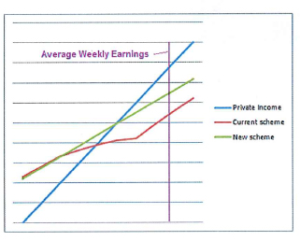
Note, in this example, how for low incomes disposable income hardly rises at all under the
current scheme as income rises.

Note also that above average earnings you can see how the two methods start to converge once
all benefits are withdrawn.

What this illustrates is how unrewarding it is to work and earn additional income when you are relatively poor.

Why do low-income earners benefit?

A graph shows a comparison with the current system based on a family with two children. The proposed change would definitely benefit low-income workers but that is only a result of the fact that the current system hits them so hard. It can be shown that low-income workers are little better off than the unemployed who have secured a disability pension. By my estimate, they may be working a forty hour week to gain as little as $3.45 per hour.

In the graph for a two-income family with two children, the blue line represents their net income under the proposed system and the red line shows net income under the current system. You can see that the main group that benefits is the low income group. These are the people who feel the frustration of working hard for little gain. Apart from addressing this injustice, you may be surprised to see that this radical system has an outcome that is quite close in many respects to the current system.

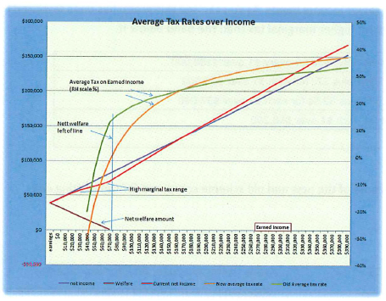

For example, a family with two $85,000 incomes would pay exactly the same tax as now. Very high income earners would be worse off, and this may need to be addressed.

What would determine the living income?

Many factors could be taken into account to determine the best and most appropriate living income, such as assets, home ownership, age, child's age, dependent student, disability etc.- in fact, all of the factors now built into some but not all parts of the welfare system.

Base the welfare payments on the same factors used today, but gross them up to a taxable amount and then tax them and all income at the same flat rate.

An individual's payment would take account of factors such as,

- Age
- Children
- Household type (single person, couple, couple with children, sole parent)
- Rent payments
- Time since earning taxable income (if of working age)
- Undergoing study
- Living at home
- Assets
- +any other relevant factor

Derive the tax rate

Make the flat tax rate sufficient to raise revenue as today, recognizing that there would be a trade­
off between the flat tax rate and the generosity of the welfare payments. This would starkly display

a government's dilemma when setting welfare payments. My calculations suggest a rate of 43%-45% would be suitable. In order to have a 40% flat marginal tax and still raise as much revenue as today there may need to be a 20% reduction in the base welfare payments. A 42% flat tax would imply a 10% reduction in base welfare payments. My modelling techniques are quite limited and the actual trade-offs may be better or worse. There may also be some dynamic effects which I believe would permit a lower flat tax as workforce participation rises.

What are some examples?

For example, let us say that in calculating the living income the welfare system may assess (for illustration purposes only) that the first adult in a household is worth $30,000 before tax. A partner is worth $22,000 before tax. Two children are worth $18,000 combined.

In our first example shown in the table below, such a family with no assets with two children is guaranteed an income of $70,000 less tax of 45%, the government having taken back $31,500 in tax, leaving them $38,500 to live on. This is slightly less than they are to get after the latest budget. This family will get a payment from Centrelink for about $1,540 each and every fortnight until their circumstances change (regardless of income.) Suppose then one adult gets a job, earning $20,000. After tax, they clear an additional $11,000. Now their family income is $90,000, less tax of $40,500, leaving them with $49,500 to live on. (This slightly higher than the current budget would give them.)

[Note that the marginal tax rate is 45 cents in EVERY dollar, including welfare dollar.]

Suppose the same family gets an even better job with an income of $100,000, they still get their welfare payment. But now the welfare has been balanced completely as their overall tax becomes equivalent to and then exceeds their net welfare payment. At $100,000 (just $50,000 each) they are self-sufficient and effectively paying around 7% income tax. Further income continues to be assessed at 45% marginal tax until by the time they both earn $180,000 they are paying 34% average tax.

Comparative table

Here is a table with our examples of our family with two children

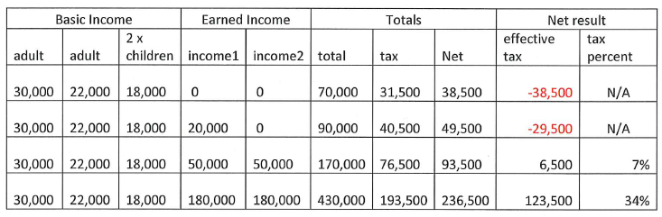

Progressive Tax

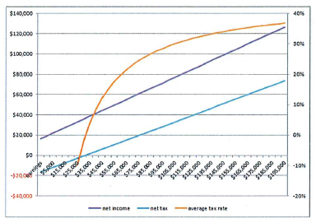

As you can see, this tax/welfare system is progressive. Average taxes rise as income rises. It also retains horizontal equity because everyone is still getting their welfare payment each month, which is based on their individual circumstances (dependent children, assets etc.) There is no need to phase out the welfare payments as income rises. Taxed welfare payments are the means by which the tax system becomes progressive. When a person becomes unemployed they do not need to go to Centrelink. They continue to get their welfare payments determined by their circumstances which rarely change. They only need to notify a change of circumstance to Centrelink when a child is born, a child leaves home, a partnership (marriage or de facto) breaks up or their assets change significantly.

This revolutionary system removes many layers of red tape. It removes poverty traps. It removes circumstances where, because effective marginal tax rates may be extremely high, there is reduced incentive to work. It removes the need for spouse rebates and other complexities in the tax rules. It removes the stigma of welfare and 'going on the dole.' With everyone on the dole the only way up is by getting a job!

The ideal tax and welfare system explained.

Why welfare for all?

The concept of welfare payments for everyone seems alarming at first, until you consider the way the system works now. For example, consider the tax-free threshold which applies to all taxpayers equally as a form of welfare for all. The proposed welfare payment would be related to the taxpayer's actual circumstances instead of applying to all taxpayers regardless of their need.

To illustrate this, consider two people, each with an income of $18,200. Currently neither pays tax. Suppose that one person is 18 years old and living at home, while the other is a 35-year-old second income earner in a family with three children. Which one has the greater capacity to pay tax? Under the new system, the 18-yr-old may qualify for a gross welfare payment of, say, $10,000, and when combined with their earned income would clear them $15,510 after tax. They actually pay 15% tax. The other person, being the second income earner in a two adult household with children may

qualify for a gross welfare payment of say, $22000. After tax on the combined income they will clear
$22,110. You can see that the welfare payment approach is likely to be much fairer and less anomalous than the tax-free threshold.

Consider two families whose family incomes are each $200,000. One family has no school-age children while the other family has three children at school. Currently they both pay the same tax, but under this system, while they would still pay the same tax, their welfare payments would differentiate between them. The welfare payment approach provides for horizontal equity as well as vertical equity.

Why a flat tax?

A tax system should just collect revenue and not try to be a quasi-welfare system. A flat tax makes collecting tax and accounting for tax extremely simple and efficient, reducing administrative expenses. It removes many anomalies associated with additional income, income splitting, hiding investments under a spouse's name etc. It also makes the treatment of child care and other work­ related expenses very fair, as tax deductions would now be the same for all, regardless of income. The current tax system has tried to provide such fairness by using a variety of rebates and concessions in special circumstance and income ranges, but the calculation of these is often baffling and themselves likely to produce anomalies.

A flat tax means that everyone can justly say that they are paying their fair share of tax. Likewise, the welfare payment also applies to all. No one can accuse another of receiving an undeserved welfare payment. In this way, the proposed system removes class warfare from the tax and welfare systems.

Issues

This approach is radical, but in line with government desire to remove red tape and give incentives to those out of work to get back into the workforce. As an added benefit, it provides a vehicle to deliver true horizontal equity into the tax and welfare systems.

Is the 45% marginal tax rate reasonable?

I chose 45% because I believe that it would still raise enough net revenue, but a lower rate would be desirable. I also recognise that 45% marginal tax seems high compared with 0 to 20% marginal tax faced by a low-income earner today but that is not the true situation. Firstly, these people will generally be better off. Moreover, the income tax marginal tax rates are never the full picture. The effective marginal tax rate must consider what a person would get if they had no income- they would qualify for benefits. When the rate at which benefits are withdrawn is added to the rate at which tax is taken, the effective marginal tax for low-income earners is actually closer to 70% or 80% and often more. Such people should be congratulated that they bother to work. They are willing to work for forty hours to receive just eight to ten hours' income! Some, committed to unemployment, value their time more highly and just earn nothing while sacrificing very little. They make a very rational decision to not work.

What is the overall cost to revenue of the proposed living income system?

I am afraid that I haven't got the resources to fully cost such a system precisely. While I know that such a system is ideal, some fine tuning would be required to calculate the appropriate living income regime and the best marginal tax rate. In setting these values I suggest that, except for Newstart for singles, the current benefits are actually somewhat generous for able-bodied people. I suggest that most people are capable of finding some work some time and the only reason that they do not is the prohibitive penalties they face if they do find work. The current system, rather than encouraging them to work, makes it so much easier not to try.

My best effort, based on some assumed rates, calculating net revenue raised by such an income tax arrangement is as follows.

Household  Income | Living Income Payments | Total Income Tax Revenue | Net Income Tax Revenue
$billion | $billion | $billion | $billion
803 | 192 | 361 | 169

I estimate that the proposed living income payments would amount to $192bil. and tax received would amount to $361bil. The net revenue raised would be $169bil. Some of my data is out of date and my assumptions are very broad brush, but I think that this is enough net revenue to say that the
system could work.

How do we calculate the living income?

Currently we already do this for welfare recipients. But for the population as a whole what is practical? There are many factors that should be taken into account, as mentioned earlier. Paying
rent may increase the necessary living income but should home ownership reduce the living Income? Maybe, but then, what about the cost of a mortgage? Other assets might need to be valued but who is qualified to do that? Franked shares? Disabilities? Carers? The formulae to account for all these separate circumstances would entail a lot of work and intrusive questioning. However, I think that
these problems are surmountable.

To simplify the system people could make simple declarations that placed them into broad categories. Without detailed information they would then automatically qualify for standard living incomes within these categories. If they thought that they were special cases they could ask for a more detailed assessment which entitled them to a more precise calculation. In addition, there would be periodic checks and penalties for false information. For those shy of being assessed, if a wealthy person did not want to participate they could opt out and forego their living income.

Would there be a risk that the system might encourage a lot of people to actually stop working and get the welfare payment alone?

Not likely,I think, when you consider people still work despite the current disincentives of very high effective marginal tax rates. It may however make employees more mobile and more willing to try job swaps and search for new employment. It also gives them the option to take career breaks to do special training courses. This may benefit the economy creating a better trained, more mobile workforce.

To counter any incentive to just forego work, there would need to be quarterly negative adjustments to the living income when an able person cannot demonstrate earned income and is not engaged in education. That would be very important to guarantee a motivation to find work. Compared to the current system there would be much greater incentive to participate in the workforce, as the current system's high EMTRs are a considerable deterrent. A factor in assessing a person's payment would
be whether that person had recently paid tax from earnings. The longer the period since a person contributed tax from earnings the less they would be paid in welfare. In this way, there is also a reward for declaring income.

Having found work and retained it for sufficient time, their living income would be restored (but without back-payments) and so they would have a double incentive to get back to work. Most importantly, the lower rate of effective marginal tax lowers the attraction of just giving up work and going on the dole, as there would be a lot more to lose than is the case now.

Currently, the dedicated unemployed person has to meet a test to prove that they looked for work and didn't get any. This proposed system would reverse the situation and an unemployed person would be determined to get work to ensure that they avoided the quarterly reduction. This is a
carrot and a stick combined together and should ensure a better result. How far would the quarterly reductions to the living income go for able persons? In the end, we cannot have people completely abandoned by the system so there must be a minimum below which the living income would not be reduced. A working-age able-bodied person would face a sliding payment that sees them receive
less and less if they remain out of the workforce. Their payment would be restored once they regain employment, giving them a double incentive to get back to work. While disabled people would be exempt from the sliding welfare payment, they would still retain a far greater incentive to gain work than at present.

A person undergoing training would also be exempt from the drop in payment and a person performing voluntary work in the community may also be exempted from the reduction.

Similarities to current system

Look again at the average effective tax lines shown in the graph.

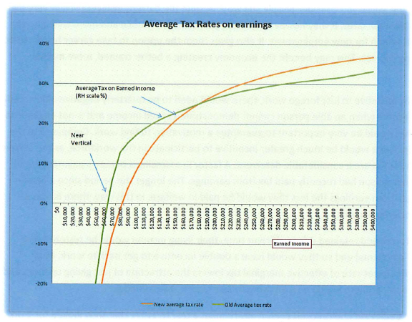

Consider how similar the lines are. There are several reasons why this proposed system should be
actually quite similar to the existing system.

- Implicit in the current system is the principle that people should pay tax in greater proportion as their income rises. The proposed system also achieves this.
- Another principle in both systems is that Australian society will look after the disadvantaged and provide a minimum income for those who cannot work.
- Another principle is that families need extra tax relief for children.
- These and many other factors are built into the current system, but in layer upon layer of complex rebates, entitlements, allowances and concessions, some giving and some taking away.
- The proposed system meets all these needs without the complexity and the traps that
complexity brings.

Now consider the differences between the average tax rates in the graph. One curve is smooth without irregularities showing perfect consistency while the other is irregular and has a distinct kink that exposes the imperfection of the underlying system that creates it. The current system is actually trying to achieve in an imperfect way what my ideal tax and welfare system would achieve naturally.

The proposed system has simplicity and achieves the required result. The question should be, if a simple model achieves an approximation to an extremely complex one then isn't the simple model possibly the ideal that the complex system is trying to achieve?

Debating the new system

Advantages

The advantages of the scheme are huge:

• The welfare system just takes care of peoples' welfare
• The tax system just collects tax
• Horizontal and vertical equity is achieved and maintained for all income ranges

By keeping the roles of the two systems distinct we achieve some brilliant results

• No more poverty traps- everyone has the same incentive to work
• Horizontal equity is achieved between taxpayers according to their circumstances via the living income
• Wealth can be used as a reduction factor for calculating living income and flows into their after-tax income, so we have a small proxy for a wealth tax, which is sorely needed
• No more dole, no more pensions and no more complex rules and penalties
• Absolute transparency and fairness when adjusting the budget

Disadvantages

- Some groups may be disadvantaged under the new system and complain.

If some people are disadvantaged by comparison to the current system then one has to ask, what is special about them? lfthere is something special about them, then this can be built into the living income calculation. If not, they should have no complaint. Transitional arrangements could be devised.

- Some may object that the very wealthy will only pay the same marginal tax as everyone else.

This is academic. We know that truly wealthy people will have arrangements to minimise their tax. More importantly since holding assets will result in a lower living income payment the truly wealthy will receive a lower welfare payment. It must also be recognised that high­ income taxpayers pay the bulk of the net tax raised so why should they be expected to pay at a higher marginal rate? The system is already progressive.

- Tax revenues will no longer grow through bracket creep.

If the purpose of a progressive tax system is to provide governments with an easy way to grow revenues then it is a travesty.

- Lower reduction rate than present welfare payments may cause a budgeting problem.

This is the biggest obstacle. While it is true that welfare payments will recaptured by tax at a lower rate than is currently the case, and that may be a cost to the budget, it is absolutely necessary so everyone has an incentive to earn income for themselves. At the moment, the incentive to work is often close to zero. We could expect that with incentive restored those who have previously sort refuge in disability pensions, for instance, will suddenly find that doing a few hours of part-time work at the local school library or delivering pamphlets starts to be more attractive. And they don't have someone taking 80 cents from every dollar that they earn.

Arguments

When I first conceived this plan and tested it, I couldn't believe what I saw. Surely there was a logical flaw, surely I was making some fundamental mistake. Nothing could be this simple. However, I found that any argument raised against this system could always be countered logically. Here are some examples of potential challenges and their responses.

C. Your system taxes everyone at 45%. That is a very high tax rate!

R. It is lower than the effective marginal rate now faced by those on low incomes and no more than those on high incomes. It could possibly be lower if more people on full benefits start earning income as is expected.

C. Your system pays welfare to everyone. For the rich, that is unnecessary and is unwarranted.

R. No it isn't unwarranted. High income earners pay more tax and they may have children to feed and clothe, etc. Why should we hit them twice?

C. At present low-income earners enjoy a tax-free threshold near $20,000. You are taking that away from them.

R. Actually, everybody gets the tax-free threshold, but what low-income earners get in the new system is more targeted to the individual's situation.

C. The marginal rate of 45% is a disincentive to work.

R. Look at the current effective marginal rates, sometimes close to 100% in certain income ranges. The current system has real disincentives to work.

C. With everyone getting a welfare payment Centrelink will be bogged down in paperwork.

R. This would not be the case. Centre/ink will only need to be concerned about when a household changes circumstances and they will not need to worry about income. Only births, deaths and separations in most cases.

C. Some people may be worse off under this system and they will make it politically impossible to implement.

R. If such people are a special case then that can be built into the base welfare payment. If they are not special then they have no reason to complain.

Conclusion

As stated earlier, a flat tax system combined with taxable welfare payments for all produces an ideal result, which because of its simplicity is technically far superior to the current tax and welfare arrangements.

The proposed system represents a radical and brave way to revolutionise tax and welfare but the results would be amazing. Eliminating the welfare system, removing poverty traps, encouraging everybody to participate in the workforce. These seem utopian, but are actually quite practical. The big hurdle is a possible but not proven cost to revenue, especially in the first couple of years when people still retain a welfare mentality. Once that mentality is overcome the big benefits start to flow.

David Pearce

