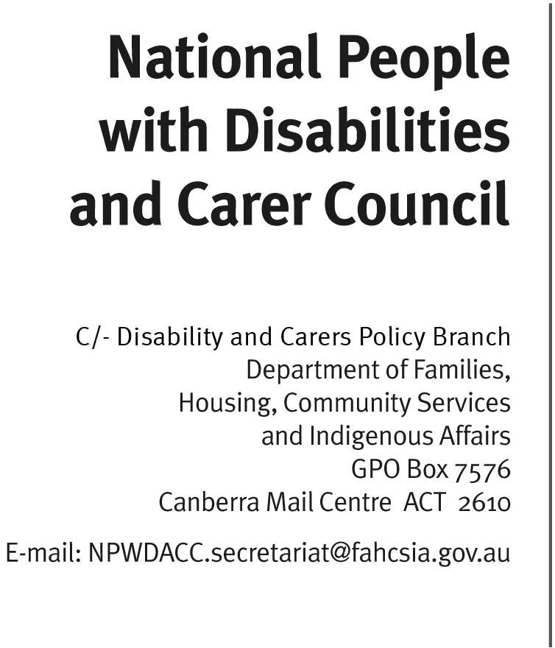

Mr Ian Holland
Committee Secretary
Standing Committee on Community Affairs – Legislation Committee
PO Box 6100
Parliament House
Canberra ACT 2600
Email: community.affairs.sen@aph.gov.au

Senate Community Affairs inquiry into Aged Care

Dear Mr Holland

The National People with Disabilities and Carer Council (Council) provides advice
to the Australian Government on issues affecting people with disability, their families and carers and services in Australia. Council appreciates the opportunity to provide a submission to the Senate Community Affairs inquiry into Aged Care.

A major focus for the Council over 2012 and 2013 has been to provide advice on the development and implementation of the DisabilityCare Australia scheme (previously known as the National Disability Insurance Scheme) and as such Council is particularly interested in the interface between the scheme and the Aged Care system. For the purposes of this submission the Council wishes to focus on the
Aged Care (Living Longer, Living Better) Bill 2013.

Council’s advice is in line with its advice to Inquiry into the National Disability Insurance Scheme Bill 2012 earlier this year. This advice focused on the inequities that may arise as a result of DisabilityCare Australia’s age requirement where people who acquire disability after the age of 65 will not be eligible for support under the scheme, which may result in a lower level of support in the aged care system.

Council is of the view that the supports available from the aged care system:
- are more severely rationed with a relatively low average funding package;
- provide a more restricted suite of options, with key gaps including assistive technology;
- are less focused on community participation and more on personal care and in-home support; and
- entail means-tested payment of fees.

Council is supportive of the reforms under the Living Longer Living Better aged care reform package that aims ‘to provide older Australians with more choice, control and easier access to services,’ and this is more closely aligned with the focus on greater individual choice and control for people with disability under the DisabilityCare Australia scheme and the United Nations Convention on the Rights of Persons with Disabilities.

However, despite these reforms Council is concerned about the home care and aged care systems’ narrower focus on personal care and in-home support and particularly that there is limited criteria to support greater community participation of people with disability over the age of 65, such as:
- support to participate in work. For example, currently under the Disability Employment Support (DES) program a person with disability who wishes to continue working after they turn 65 loses the support they previously had;
- access to customised aids and equipment through the various state and territory government schemes and through the new home care packages. For example, this may mean that older people may not have wheelchairs customised to their personal requirements nor will they have access to electric wheelchairs/scooters which for some people may allow opportunity for greater community participation; and
- funding supports that enable independent travel, including through personal transport-related aids and equipment.
(noting that people to be supported under Disability Care Australia will have access to appropriate aids and equipment as set out in the recently released COAG endorsed Principles).

Council recommends that urgent reform is required to improve the provision of disability-related support services to people in the aged care system. In particular, services that support the independence and full participation of older people - such as mobility and orientation training for people who are losing their vision and assistive technology – should be made available through aged care funding mechanisms. Improved access to such services may also potentially reduce the need of older people for intensive personal support.

Council also recommends that joint meetings should be established between the standing national disability and carer advisory body, currently the Council, and the equivalent aged care advisory body, currently the Aged Care Reform Implementation Council, on a periodic basis to discuss interface issues, areas for collaboration and co-funding arrangements, including sharing support costs and care of those whose needs cannot be met outside DisabilityCare Australia.

In addition, it would also be beneficial to link the National Disability and Carer Alliance and the National Aged Care Alliance in the same way.

Council considers it essential that attention be paid to these issues so that the aged care reforms ultimately ensure a more equitable delivery of services and support for older people with disability to participate more fully in the community.

Yours sincerely

Dr Rhonda Galbally AO
Chair

10 May 2013

NDIS - Principles to Determine the Responsibilities of the NDIS and Other Service Systems, April 2013

