PORTFOLIO SUPPLEMENTARY

additional ESTIMATES

STATEMENTS 2013‑14

**APPROPRIATION BILL (NO. 5) 2013‑14**  
  
**APPROPRIATION BILL (NO. 6) 2013‑14**

Social SERVICES pORTFOLIO

Explanations of SUPPLEMENTARY

additional estimates 2013‑14

© Commonwealth of Australia 2014

ISBN (print) 978-1-925007-47-3ISBN (PDF) 978-1-925007-49-7ISBN (.docx) 978-1-925007-48-0

This publication is available for your use under a [Creative Commons BY Attribution 3.0 Australia](http://creativecommons.org/licenses/by/3.0/au/deed.en) licence, with the exception of the Commonwealth Coat of Arms, the Department of Social Services logo, photographs, images, signatures and where otherwise stated. The full licence terms are available from <http://creativecommons.org/licenses/by/3.0/au/legalcode>.

CC by_grey

Use of Department of Social Services material under a [Creative Commons BY Attribution 3.0 Australia](http://creativecommons.org/licenses/by/3.0/au/deed.en) licence requires you to attribute the work (but not in any way that suggests that the Department of Social Services endorses you or your use of the work).

**Department of Social Services material used ‘as supplied’**

Provided you have not modified or transformed the Department of Social Services’ material in any way including, for example, by changing the Department of Social Services’ text; calculating percentage changes; graphing or charting data; or deriving new statistics from published Department of Social Services statistics — then Department of Social Services prefers the following attribution:

*Source: The Australian Government Department of Social Services.*

**Derivative material**

If you have modified or transformed Department of Social Services material, or derived new material from those of the Department of Social Services in any way, then Department of Social Services prefers the following attribution:

*Based on The Australian Government Department of Social Services data.*

**Use of the Coat of Arms**

The terms under which the Coat of Arms can be used are set out on the It’s an Honour website (see [www.itsanhonour.gov.au](http://www.itsanhonour.gov.au)).

**Other Uses**

Inquiries regarding this licence and any other use of this document are welcome at:

*Steve Jennaway, Chief Finance Officer, Department of Social Services, 1300 653 227.*

Printed by CanPrint Communications Pty Ltd

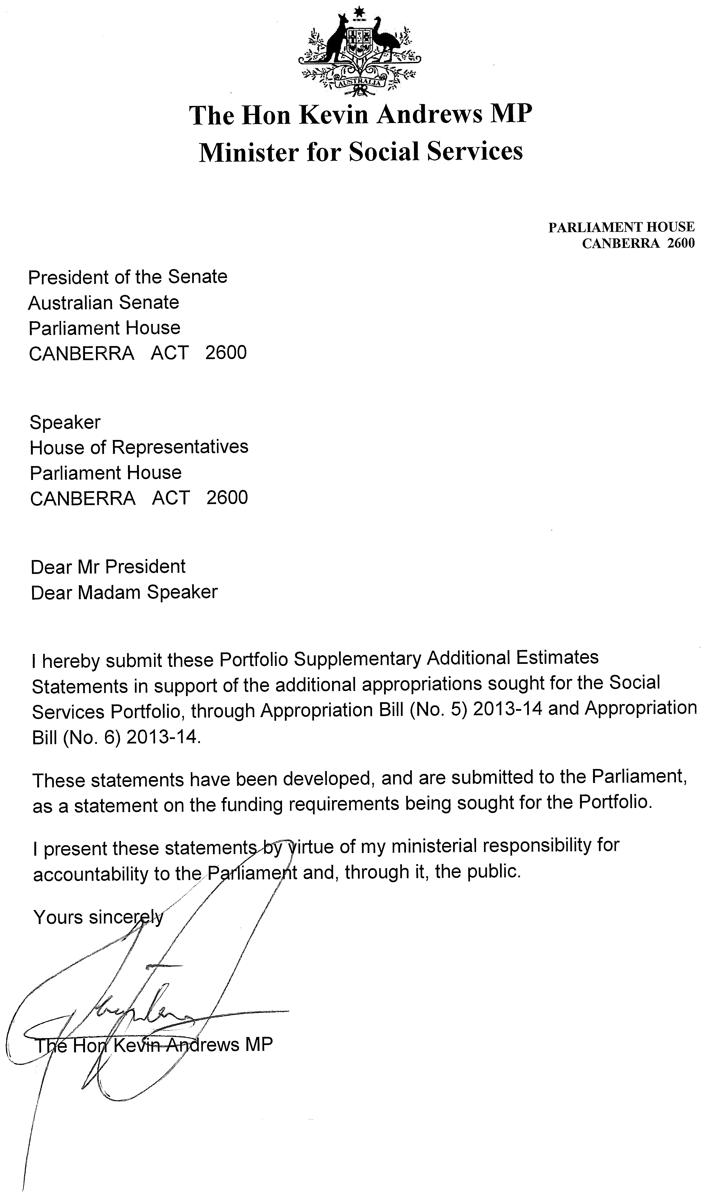

#### Abbreviations and conventions

The following notations may be used:

NEC/nec not elsewhere classified

‑ nil

.. not zero, but rounded to zero

na not applicable (unless otherwise specified)

nfp not for publication

$m $ million

Figures in tables and in the text may be rounded. Figures in text are generally rounded to one decimal place, whereas figures in tables are generally rounded to the nearest thousand. Discrepancies in tables between totals and sums of components are due to rounding.

#### Enquiries

Should you have any enquiries regarding this publication please contact the Steve Jennaway, Chief Finance Officer, Department of Social Services on 1300 653 227.

A copy of this document can be located on the Australian Government Budget website at: [www.budget.gov.au](http://www.budget.gov.au/).

User Guide  
to the  
Portfolio Supplementary Additional Estimates

Statements

# User Guide

The purpose of the 2013–14 Portfolio Supplementary Additional Estimates Statements (SAES), is to inform Senators, Members of Parliament and the public of the proposed allocation of additional resources to Government outcomes by agencies within the portfolio.

The SAES facilitate understanding of the proposed appropriations in Appropriation Bill (No. 5) 2013–14 and Appropriation Bill (No. 6) 2013–14. In this sense the SAES is declared by the Appropriation Acts to be a ‘relevant document’ to the interpretation of the Acts according to section 15AB of the *Acts Interpretation Act 1901*.

Appropriation Bill (No. 5), which follows on from Appropriation Bill (No. 1) tabled at Budget and Appropriation Bill (No. 3) tabled at Additional Estimates, will provide additional expenditure authority for the ordinary annual services of government in respect of the 2013–14 financial year. Appropriation Bill (No. 6), which follows on from Appropriation Bill (No. 2) tabled at Budget and Appropriation Bill (No. 4) tabled at Additional Estimates, will provide additional expenditure authority in respect of the 2013–14 financial year for capital works and services, payments to or for the States, Territories and local government authorities, and new administered outcomes not authorised by specific legislation.

Social Services Portfolio  
Supplementary Additional Estimates Statements

Department of Social Services 1

National Disability Insurance Agency 13

# Department of Social Services

Overview of additional appropriations 3

Agency Measures table 4

Additional Estimates and variations 7

Breakdown of Additional Estimates by appropriation bill 12

# Department of Social Services

## Overview of additional appropriations

The Department of Social Services is seeking additional appropriations of $6.3 million through Appropriation Bill (No. 5) 2013–14. These variations are due to additional measures announced since the Portfolio Additional Estimates Statements 2013–14.

Further information may be found in the 2014–15 Department of Social Services Portfolio Budget Statements.

### Agency Measures table

Table 1.1 summarises new Government measures taken since the 2013–14 Portfolio Additional Estimates. The table is split into revenue, expense and capital measures, with the affected program identified.

### Table 1.1 Agency 2013-14 Supplementary Additional Estimates Measures



### Table 1.1 Agency 2013-14 Supplementary Additional Estimates Measures (continued)

### 

### Table 1.1 Agency 2013-14 Supplementary Additional Estimates Measures (continued)

### Additional Estimates and variations

The following table details the changes to the resourcing for the Department of Social Services at Supplementary Additional Estimates, by outcome. The table also details the Additional Estimates and variations resulting from new measures and any other variations (if applicable) since the 2013–14 Portfolio Additional Estimates in Appropriation Bills (No. 5 and No. 6).

Table 1.2 Supplementary additional estimates and variations to outcomes from measures and other variations



Table 1.2 Supplementary additional estimates and variations to outcomes from measures and other variations (continued)

****

Table 1.2 Supplementary additional estimates and variations to outcomes from measures and other variations (continued)

****

Table 1.2 Supplementary additional estimates and variations to outcomes from measures and other variations (continued)

****

Table 1.2 Supplementary additional estimates and variations to outcomes from measures and other variations (continued)

****

### Breakdown of additional estimates by appropriation bill

The following tables detail the Additional Estimates sought for the Department of Social Services through Appropriation Bill No. 5.

Table 1.3 Appropriation Bill (No.5) 2013‑14



# National Disability Insurance Agency

Overview of additional appropriations 15

Additional Estimates and variations 16

Breakdown of Additional Estimates by appropriation bill 17

# National Disability Insurance Agency

## Overview of additional appropriations

The additional appropriation provided to the National Disability Insurance Agency (the Agency) has resulted from a re-profiling of participants in Western Australia and Northern Territory. The 2013-14 funding will be used to engage and train additional staff for the following new trial site offices opening on 1 July 2014:

Perth Hills in Western Australia; and

Barkley region in the Northern Territory.

The additional funding will ensure that the Agency is well placed to assist new participants when opening these trial sites.

Total funding including from Appropriation Bill 5 is also included in the 2014-15 Social Services Portfolio Budget Statements.

### Additional Estimates and variations

The following table details the changes to the resourcing for the Agency at Supplementary Additional Estimates, by outcome. The table details the variations since the 2013‑14 Additional Estimates in Appropriation Bill No. 5.

Table 1.1 Supplementary additional estimates and variations to outcomes from measures and other variations



### Breakdown of additional estimates by appropriation bill

The following table details the Additional Estimates sought for the Agency through Appropriation Bill No. 5.

Table 1.2 Appropriation Bill (No.5) 2013‑14

