Department of families, housing, community services and indigenous affairs

Evaluation of the Community Stores Licensing Program

Final report



CULTURAL & INDIGENOUS RESEARCH
CENTRE AUSTRALIA

May 2011

Head Office (Sydney): Level 1, 93 Norton St, Leichhardt NSW 2040
Melbourne Office: Level 14, Como Centre, 644 Chapel St, South Yarra VIC 3141
ABN: 30 065 353 951
TABLE OF CONTENTS

1. INTRODUCTION 1
1.1 OBJECTIVES 1
1.2 Methodology 2
1.2.1 Data analysis of store assessment data 2
1.2.2 Site visits 5
1.2.3 In-depth interviews with stakeholders 6
2. contextual background 7
2.1 overview of licensed stores 7
2.2 The Licensing process 7
2.3 legislation 7
2.4 Community stores projects 9
3. Findings – outcomes of community stores licensing 11
3.1 Food security 11
3.2 Quality AND RANGE OF FOOD 12
3.2.1 Data analysis 12
3.2.2 Qualitative research 14
3.3 pROMOTION OF BETTER NUTRITION 15
3.3.1 Qualitative research 17
3.4 rETAIL MANAGEMENT 17
3.4.1 Data analysis 17
3.4.2 Qualitative research 19
3.5 fINANCIAL MANAGEMENT 22
3.5.1 Data analysis 22
3.5.2 Qualitative research 24
3.6 bUSINESS STRUCTURE AND GOVERNANCE PRACTICES 26
3.6.1 Qualitative Research 27
3.7 INCOME MANAGEMENT 29
4. research Findings – process 33
4.1 OVERVIEW 33
4.2 ASSESSMENT AND LICENSING 33
4.3 Case management 34
5. cONCLUSIONS 36
Appendix 1 38

INTRODUCTION

As part of the Northern Territory National Emergency Response (NTNER), the Australian Government established a licensing regime for community stores in the Northern Territory (NT). The licensing regime for community stores applies to stores in all of the prescribed areas of the NT. This covers stores on Aboriginal Land Rights Act land, Community Living Areas land and town camps. As well, there are several stores outside these prescribed communities that play an important role in assisting food security because of their proximity to these remote communities, and in October 2008, the legislative licensing requirements were applied to a number of these station stores and privately owned stores.

The original NTNER Act, passed in 2007 (‘the Act’), identifies three main areas that are taken into account when determining whether a licence should be issued. These are:
- The store’s capacity to meet the requirements of the Income Management regime
- The quality, quantity and range of groceries and consumer items, including healthy food and drink, available and promoted at the community store
- The financial structure, retail practices and governance practices of the store.

Legislation passed on 21 June 2010 to reinstate the Racial Discrimination Act 1975, included an explicit food security objective for stores licensing. This more recent legislation builds on the original legislation in terms of emphasising the importance of ensuring food security through store licensing, and expands the focus on governance, community consultation, options for intervening when a store does not meet licensing requirements, and the assessable matters that can be taken into account when reviewing licensing. Section 2.2 provides more details on the legislation changes.

The Cultural and Indigenous Research Centre Australia (CIRCA) was commissioned by the Department of Families, Housing, Community Services and Indigenous Affairs (FaHCSIA) to conduct an evaluation of the Community Stores Licensing Program. This evaluation was conducted between January and March 2011.

OBJECTIVES

The Department required a program performance evaluation that assessed the implementation of stores licensing against the legislation. More specifically, the objectives of the evaluation were as follows:

- Assess outcomes of the licensing regime on store operations - Identify the extent to which store improvements have been made with regards to financial management, governance, range of nutritional food available, and in enabling stores to participate in the Income Management regime
- Assess effectiveness of the process - Explore the effectiveness of the assessment, licensing and capacity building components of the scheme, and document the strengths and weaknesses of each approach, as well as the relationship between these different aspects of the program
- Assess outcomes of the licensing regime on food security - Identify the impact of the licensing scheme on food security as defined in the Act (including the impact over time).

Methodology

A range of research methods were used to conduct this evaluation. In summary, the evaluation included analysis of data from a randomly selected sample of stores, including assessment forms, in-depth interviews with key stakeholders (both government and non-government) and site visits to five communities to gather feedback from store managers, store committees, stakeholders and community members. The diagram below summarises the approach. The remainder of this section provides details on each method.

Data analysis of store assessment data
↓
Primary research
↓ |  | ↓
15 in-depth interviews with stakeholders:  Relatively even split across Government staff, store owners/managers and community representatives |  | 5 site visits:  Including consultations with stakeholders (4-5 interviews per community), community members and store committee members (through in-depth interviews or small groups)
↓
Reporting and Analysis

Data analysis of store assessment data

The data analysis included a review of assessment forms for a sample of community stores. A sample of 32 stores was selected, using the following criteria:
- Location/Shire
- Population size of the community
- Distance to a regional centre
- Licence type (e.g. ALPA, Outback Stores, Independent, etc)

These criteria were used to ensure the sample included stores from a range of locations, in terms of coverage across the NT, as well as community size and level of remoteness. Each store management model was also included.

The graphs below summarise the profile of all 91 stores that had a licence (as at December 2010), and the sample selected for data analysis. As can be seen, the sample selected was representative of the total population of licensed stores.

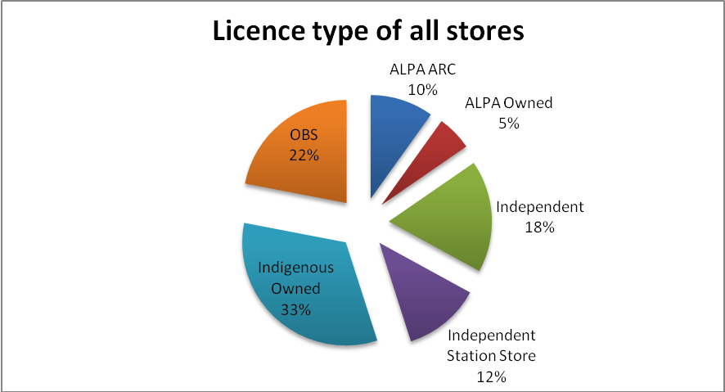

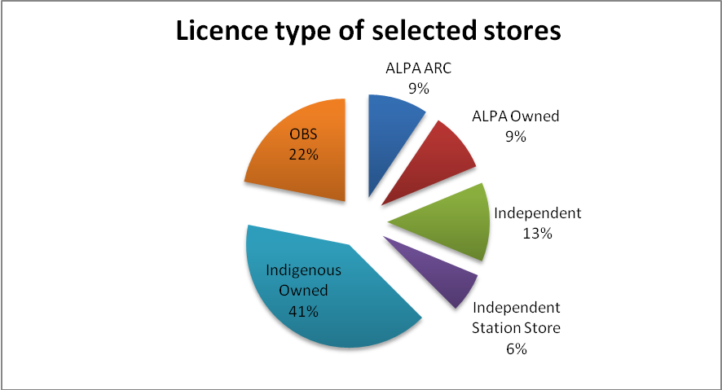

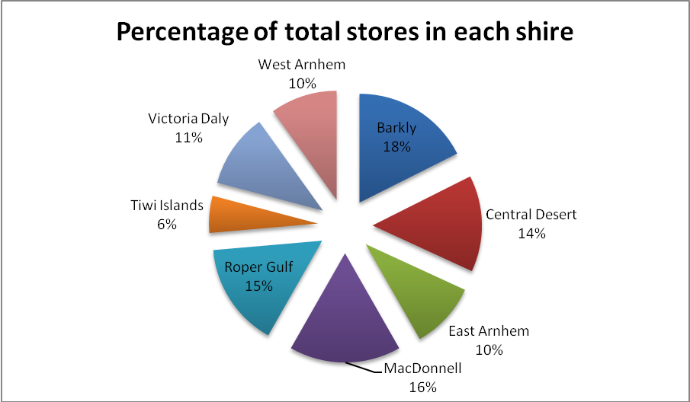

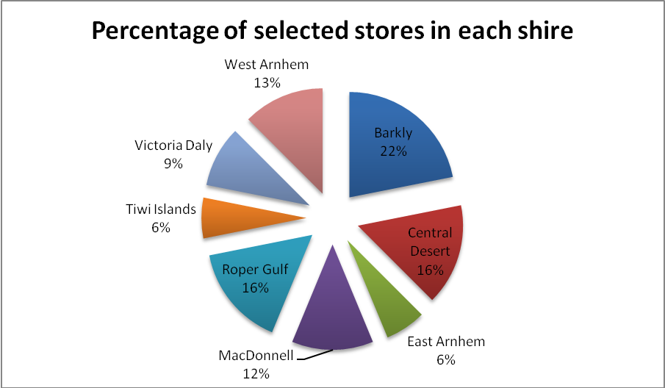

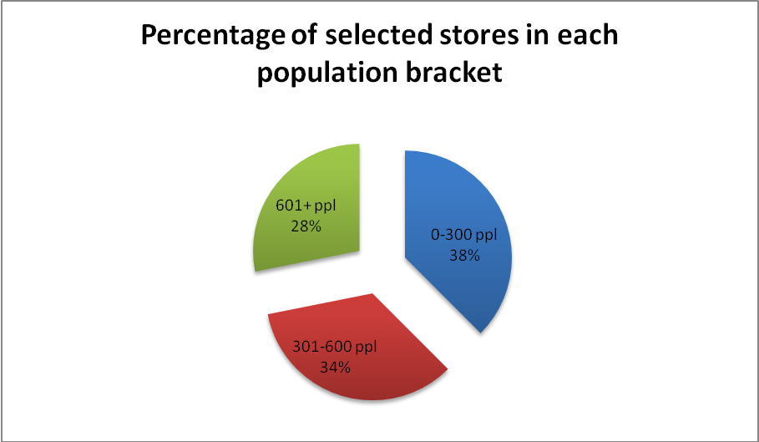
Source: ABS Census of Population and Housing 2006

Assessment reports for the sample of stores were analysed in order to review the impact of stores licensing. It should be noted that there were a number of challenges in conducting this analysis:
- The assessment report templates have changed several times since the introduction of the legislation in 2007, which makes it difficult to measure changes over time. In particular, the assessment tool changed significantly as a result of the revised legislation in July 2010, making comparisons difficult. In this latter time period the reports utilise the Risk Assessment Tool (RAT).
- For the earlier time periods, limited assessment reports were available because corporate licenses were provided for Outback Stores (OBS) and ALPA. This means that early assessment forms were not available for many of these stores

Therefore, two time periods were used in the analysis. The first time period covers the period between 30/04/2009 and 24/03/2010. The second time period covers from July 2010 to December 2010. These time periods were used because they provided the most complete data sets.

During the first time period, assessment reports were available for 20 stores. For the second time period, assessment reports were available for 22 stores. Appendix 1 provides a list of the stores included in both time periods.

The reports gathered information on each of the assessable matters, and the results from this analysis are included in section three. Care is needed when reviewing the data, due to small sample sizes. However, the consistency in the findings of the data analysis and the qualitative research provide evidence with regard to the impact of stores licensing.

Site visits
Site visits were made to five communities in the NT to conduct consultations with store managers, store committee members, stakeholders and community members. These sites were chosen to provide a mix in terms of ownership model, location and community size: the site visits included Indigenous owned stores (2), OBS managed stores (2) and one ALPA store; and included larger and smaller communities from a range of Shires across the NT. To protect individual privacy in small communities, the communities are referred to as communities A, B, C, D, and E. Approximately three to eight committee members, two to seven community members, and four to five stakeholders were consulted in each location.

The consultations with stakeholders in each community included store managers in each location, as well as a range of other relevant stakeholders, including
- Government Business Managers in all five locations
- School Principal
- Nurse and Nurse Manager
- Educator
- Community Liaison Officer & Staff Cultural Mentor
- Nurse
- Aboriginal Health Worker,
- Trainer/Consultant, School Nutrition Program
- Shire Council staff member
- Manager, Women’s Association
- Youth Services Officer
- School Transport Officer / nutrition program worker
- Shire Council staff member

In-depth interviews with stakeholders
A range of stakeholders were consulted as part of the evaluation, as follows:

FAHCSIA Staff
- Director, Stores Licensing
- Licensing team manager, Community Stores licensing
- Case management team manager
- Alice Springs team manager
- Case managers for each site visit

FaHCSIA NT Executive
- Manager, NT State Office
- Deputy State Manager

FaHCSIA Policy
- Food Security Policy staff

External Stakeholders
- Outback Stores
- ALPA
- ORIC
- ASIC
- Burdon Torzillo
- Remote Retail Services

contextual background

overview of licensed stores

As at December 2010 there were 91 licensed community stores. This comprised of 30 Indigenous owned stores, 20 stores managed by Outback Stores (OBS), 16 Independent stores, 11 Independent station stores, 9 ALPA managed and community or Shire owned stores (managed by ALPA Australian Retail Consultants) and 5 ALPA owned and managed stores.

It is worth noting that Outback Stores is a wholly-owned Commonwealth Company, subject to the Corporations Act 2001 and the Commonwealth Authorities and Companies Act 1997 (the CAC Act). Outback Stores is managed by its governing Board with the Commonwealth as its sole shareholder. With the transfer to the Commonwealth (prior to this Outback Stores was part of Indigenous Business Australia), OBS a new constitution, which includes a new objective for the company ‘to improve access to affordable, healthy food for Indigenous communities, particularly in remote areas, through providing food supply and store management and support services’. The main difference with regards to this change is that Outback Stores assists stores that are not viable in the long term, whereas prior to this only potentially viable stores were managed by Outback Stores.

The Arnhem Land Progress Aboriginal Corporation (ALPA) was established in 1972, and is an Aboriginal-owned benevolent organisation which provides benefits to its members from the successful operation of community retail stores. There are five member stores in Arnhem Land (five stores owned by ALPA), and there are also 11 community owned stores managed by ALPA’s consultancy service, Australian Retail Consultants.

The Licensing process

The following points summarise the licensing process:
- Store assessment against legislated assessable matters is conducted (see below for details on the assessable matters)
- A licence is granted (3, 6 or 12 months) or otherwise.
- Feedback on the assessment and licensing process is provided to store owners and managers
- Case management is provided to assist stores in attaining/maintaining a licence and funding support provided where appropriate
- Ongoing monitoring including site visits conducted and further feedback provided to store owners and managers
- Stores are reassessed in line with the conditions of their licence

legislation

This evaluation was conducted from January until March 2011, and the goal of the evaluation was to assess the impact and effectiveness of community store licensing against the assessable matters since the introduction of the NTER legislation on 22 August 2007.

The assessable matters, as listed in the 2007 legislation, can be summarised as follows:

‘The community store’s capacity to participate in, and (if applicable) the community store’s record of compliance with:
- the requirements of the income management regime
- the quality, quantity and range of groceries and consumer items, including healthy food and drink, available and promoted at the community store
- the financial structure, retail practices and governance practices of the community store.

It should be noted that this legislation was revised on 27 June 2010, and there were several changes to the legislation that are relevant for this evaluation.

Firstly, food security was defined and identified in the legislation, as follows:

‘For the purposes of this Act, food security means a reasonable ongoing level of access to a range of food, drink and grocery items that is reasonably priced, safe and of sufficient quantity and quality to meet nutritional and related household needs.’

The revised legislation (July 2010) also expanded the assessable matters, as follows

- ‘whether the community store makes, or will make, available a sufficient quantity and range of safe and good quality food, drink and grocery items to meet the nutritional and related household needs of each Indigenous community it services or may service;
- the capacity of the manager to promote, and the manager’s promotion of, better nutritional outcomes through methods including, but not limited to:
  - stock placement and store layout; and
  - nutritional displays and demonstrations;
- the quality of the retail management practices of the manager in relation to matters including, but not limited to, the following:
  - stock management;
  - adequacy of stock storage;
  - stock pricing methodology;
  - sustainable management of store infrastructure;
  - point of sale management;
  - the practices of the store in relation to maintaining cleanliness and hygiene;
  - the practices of the store in relation to ensuring the safety of its customers and employees;
  - freight arrangements;
- whether the financial practices of the owner and manager of the community store support the sustainable operation of the store including, but not limited to, in relation to the following:
  - financial accounting practices;
  - budgeting procedures;
  - creditor and debtor management;
  - cash and assets management;
  - procurement practices;
  - insurance arrangements;
  - management of employment arrangements;
- the character of the manager, employees and other persons associated with carrying on the business of the community store, including, but not limited to, whether the manager, employees or other persons have a criminal history;
- the business structure and governance practices of the community store;
- the community store’s capacity to participate in, and (if applicable) the community store’s record of compliance with the requirements of, the income management regime;
- matters relating to food security specified by the Minister under subsection 125(2);
- any other matter relating to food security that the Secretary considers relevant.’

Another significant change was the requirement that licenses be granted to the store owners rather than store managers. For ALPA stores and Outback managed stores, since July 2010 licenses have been granted to store owners (often an Indigenous community organisation/corporation), whereas under the previous legislation a corporate licence was granted to OBS and ALPA ARC. Several stakeholders commented on this change, and the impact of this on corporate stores, as well as independent stores owned by Indigenous community organisations.

The other important change in the legislation that had a significant impact at the time of the evaluation was the inclusion in the July 2010 legislation of ‘Division 4—Requirement to register under the Corporations (Aboriginal and Torres Strait Islander) Act 2006’ (the CATSI Act). This specifies that the ‘Secretary may require registration under the Corporations (Aboriginal and Torres Strait Islander) Act 2006’.

At the time when this evaluation was conducted, several community stores had recently transitioned from the Northern Territory Associations Act (2005) to the CATSI Act (2006).

The CATSI Act is the set of laws that establishes the Office of the Registrar of Indigenous Corporations (ORIC) and allows Aboriginal and Torres Strait Islander groups to form corporations. The Act guides how Indigenous corporations are run. The CATSI Act started on 1 July 2007.

ORIC has been set up to help the Registrar administer the CATSI Act and to support and regulate corporations for Indigenous people throughout Australia. The Registrar's office supports and regulates the corporations that are incorporated under the Act. It does this in a variety of ways: by advising them on how to incorporate, by training directors, members and key staff in good corporate governance, by making sure they comply with the law and by intervening when needed. Several stakeholders noted that ORIC utilises its regulatory powers more so than the Commissioner who administers the NT Associations Act, and that ORIC is better resourced to support Indigenous corporations, and to monitor and regulate these corporations.

In the consultations, many stakeholders highlighted this significant change in the operation of community stores in the NT. ORIC identified that approximately 20 NT stores had transitioned across (as at February 2011).

The two major implications of the transition identified in the research included:
- Greater transparency with regards to financial reporting as a result of the transition. For example, audited financial statements must be submitted to ORIC each year, and this financial information is accessible online
- The provision of governance training by ORIC to the board of directors (often referred to as store committee members)

Community stores projects

It is also important to note that a number of programs were being implemented by community stores licensing while the evaluation consultations were being conducted. The two main projects were
- The Aboriginal Benefits Account (ABA) Stores Infrastructure Project - This project provides funding to improve the infrastructure of a number of NT stores (approximately 18). For some stores a new store building will be provided, while for others this includes significant improvements/upgrades to the store infrastructure. A round of consultations was being conducted for the ABA project during the time when this evaluation was being conducted. Staff from the stores licensing team and the ABA infrastructure project team are involved in the implementation of the ABA project
- Storebiz – This program is being rolled out in 10 stores (Kintore, Laramba, Aputula, Mt Liebig, Bulla, Peppimenarti, Haasts Bluff, Milikapiti, Areyonga and Timber Creek). This program aims to improve both retail management and governance practices. The project includes assistance with conducting a store diagnostic, and developing a business plan, as well as providing governance training and a mentor for the development of good governance practices

Findings – outcomes of community stores licensing

Food security

Food security was defined and identified in the legislation (July 2010), as follows:

‘For the purposes of this Act, food security means a reasonable ongoing level of access to a range of food, drink and grocery items that is reasonably priced, safe and of sufficient quantity and quality to meet nutritional and related household needs.’

Overall, this evaluation indicates that stores licensing has had a positive impact on food security, especially with regards to the quality, quantity and range of healthy food available. Data analysis and feedback from stakeholders and community members indicates that generally, the range of healthy food available in remote communities has improved since the introduction of stores licensing. The evaluation also suggests retail management practices have improved, which appears to have had a positive impact on the quality of food available, and also the security of food supplies for communities.

‘I have been told that generally the standard of stores has improved, there are some good independent stores. If you were drawing a line in the sand comparing it to four or five years ago, the standard has lifted.’ (Stakeholder)

Interestingly, at the time of the fieldwork there was considerable flooding in central Australia, and while this impacted on the amount of food available in the stores at the time, several stakeholders commented that historically when experiencing similar weather conditions the shelves would be bare.

The market basket survey is conducted annually by the NT Department of Health and Families, and this first started in 1998. The results from the 2009 survey identified several improvements to the quality and range of food available, as follows
- In 2009 the average number of fresh fruit choices in remote stores was 10, which is higher than any other year
- The average number of fresh vegetable choices in remote stores was 17, again higher than any other year
- The percentage of fresh fruit and vegetables rated as ‘good quality’ has increased from 66% in 2000 to 90% in 2009
- 96% of items in the food basket were available or usually available in remote stores surveyed (46% of stores had 100% of goods).
- 49% of stores stated they had a nutrition policy (this information was not reported in previous years)
- 71% of stores surveyed had a store committee (this information was not reported in previous years)

It should be noted that it is not possible to attribute these improvements to stores licensing alone, but the results from the qualitative research and data analysis suggest that licensing has contributed to these improvements to some extent.

Information on price was difficult to assess, primarily because in most cases community members and stakeholders felt that prices were high. However, the mark-up policies identified in the research indicated that for most stores a lower mark-up is used for healthy foods in comparison to unhealthy foods to encourage consumption of nutritious foods.

Quality AND RANGE OF FOOD

Data analysis
To assess changes over time, the assessment forms from two time periods were assessed (from 30/04/2009 to 24/03/2010, in comparison to the more recent assessment forms from July to December 2010). As the assessment forms changed over this time period, the analysis includes a comparison of the overall criteria which was the basis of the earlier assessment forms, and specific questions on range included in the more recent assessments. For the earlier time period, the results are based on 20 stores, and the 2010 time period includes 22 stores.

The graph below includes results from July to December 2010 for a range of measures regarding quality and range of food. The graph also includes results for the earlier time period, with results from the overall assessment for this criterion (Criteria A) as well as the individual responses for a number of categories within this criterion. It should be noted that Criteria Point A for quality and range of food was defined as ‘Stores should ensure that there are sufficient resources to guarantee the accessibility and availability of goods required for healthy living, including healthy food, and that these goods are displayed and sold in a way that is culturally and socially acceptable within the community’.

As the following graph shows, for the last six months of 2010, the percentage of stores offering a good range of meat, fresh fruit and vegetables is high (around 90%), and this is higher than the proportion meeting Criteria A overall in 2009/2010. While the questions are not directly comparable, the results do suggest there have been improvements in the range of healthy food available.

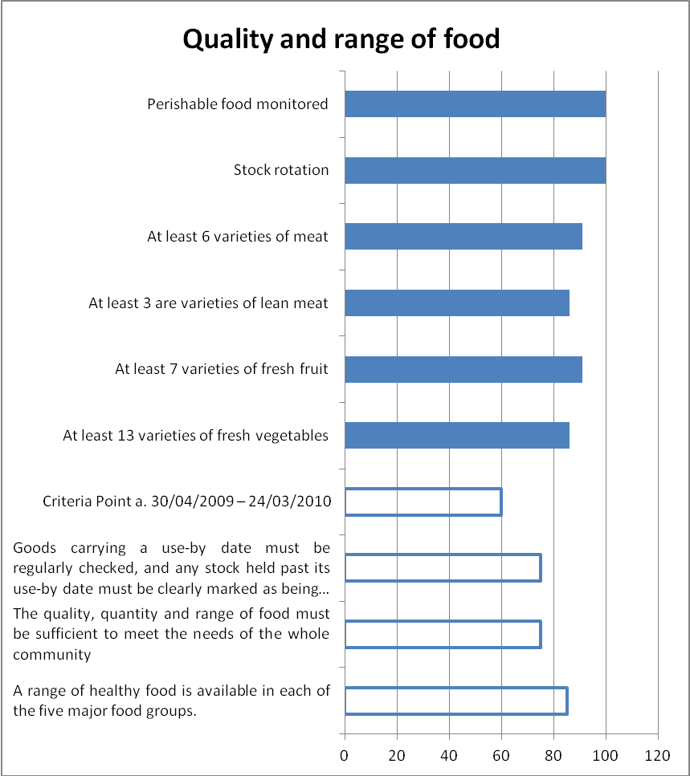
July to Dec 2010
30/04/09 to 24/03/10

The following table provides more detailed results for the July-December 2010 time period across a range of measures with regards to quality and quantity of food. This is based on 22 assessment forms.

Criteria Point | Yes | No | Not Answered | Percentage Yes
Available food
At least 3 varieties of salad vegetables | 21 | 1 | 0 | 95%
At least 13 varieties of fresh vegetables | 19 | 3 | 0 | 86%
At least 8 varieties of fresh vegetables (for those who answered no to previous question) | 2 | 1 | 19 | Only one not met
At least 6 varieties of frozen vegetables | 15 | 7 | 0 | 68%
At least 7 varieties of tinned vegetables and legumes | 20 | 2 | 0 | 91%
At least 7 varieties of fresh fruit | 20 | 2 | 0 | 91%
At least 4 varieties of fresh fruit (for those who answered no to previous question) | 2 | 0 | 20 | 100%
At least two tinned fruit cans in 100% natural juice with no added sugar (not in syrup) | 18 | 4 | 0 | 82%
At least two varieties of dried fruit (mixed pack acceptable) | 21 | 1 | 0 | 95%
At least 6 varieties of meat | 20 | 2 | 0 | 91%
At least 3 are varieties of lean meats | 19 | 2 | 1 | 86%
At least 1 variety of lean meat (for those who answered no to previous question) | 2 | 0 | 20 | 100%
Stock rotation | 22 | 0 | 0 | 100%
Perishable food monitored  Daily – 21  Weekly -  During re-stocking - | 22 | 0 | 0 | 100%

In summary, the key points to note are:
- The vast majority of stores sold at least 13 varieties of fresh vegetables, and all except one who completed these questions sold at least 8 varieties
- 91% sold at least 7 varieties of fresh fruit, and all had at least 4 varieties of fresh fruit
- 91% sold at least 6 varieties of meat, and for 86% at least three of these were varieties of lean meat
- Just over 90% offered at least 3 salad vegetables, 7 tinned vegetables and 2 dried fruits

Qualitative research
The results from the data analysis were supported throughout the qualitative research. In the vast majority of consultations with community members and stakeholders, it was suggested that there has been a substantial improvement to the quality and range of food available in community stores since the introduction of stores licensing. Some of the noted changes included:
- More stock / greater variety of stock
- More fruit and vegetables
- Greater variety and better quality meat
- More healthy food available at takeaway stores
- More fresh milk and dairy products available
- Improved food quality because of the provision of funding for more fridges, so that more perishable items can be stored/provided

While in the majority of cases the consultations indicated an improvement in food quality, there were some community members who felt that the quality of food available in some instances was poor – such as fruit and vegetables, as well as other packaged material. The main criticism was that the food was sometimes ‘old’ stock which impaired quality. However, this was not consistently noted across the research, and is also most likely a reflection of the challenges of the provision of food supplies in remote communities e.g. such as impact of climate on perishables and slow stock movement.

There was a definite sense from the research that quality and range of food available in the Outback Stores and ALPA stores was less impacted by store licensing, as offering high quality, healthy food are guiding policies for these stores. Therefore, it is difficult to assess whether the quality and range of food in these stores has been impacted by licensing. Stakeholders felt that the impact of stores licensing is likely to be more relevant for independent stores that do not always have procedures and policies in place with regards to quality and range of foods.

Takeaway food provided by stores was felt to be a key area where changes had been made to the quality and variety of food available. For example, in Community E the takeaway store provides stews and other substantial meals now, whereas in the past mostly fried food was provided. The research also indicates that some stores are able to utilise their takeaway as a means of moving fruit, vegetables and other perishables that are close to reaching their use by date. At the store in Community C funds from store profits had been used to purchase a new oven which improved the quality as more oven-cooked rather than deep fried food was provided. Improvements in the takeaway were also identified in Community A. However, it is worth noting that the improvements for these takeaways was not attributed to community stores licensing, but appeared to be driven by the motivation and capacity of the store managers, or the change of store management to Outback Stores.

While the evaluation identified examples of improvements to takeaways, there were also a number of instances where stakeholders and community members felt the quality of the food provided by takeaway stores was poor.

The research suggests that while the impact on the quality of food in community stores had improved, there are opportunities to enhance the quality of food provided by takeaways, especially given that takeaways are often an important source of food for community members.

In addition, there were concerns identified in a large number of interviews across all locations about ‘rogue’ traders who have found ways of getting around the licensing system. For example, in one location there was concern about local takeaway stores that were perceived to let standards drop outside of assessment periods by stocking less healthy food and selling prohibited items on BasicsCards e.g. tobacco.

pROMOTION OF BETTER NUTRITION

To assess changes over time, the assessment forms from two time periods were assessed (from 30/04/2009 to 24/03/2010, in comparison to the more recent assessment forms from July to December 2010). For the earlier time period, criteria point b for promotion of better nutrition was defined as ‘Healthy living, in particular healthy eating, should be supported and promoted by the store’. This rating has been compared with the results from July to December 2010 with regards to health promotion.

As the following graph shows, for the last six months of 2010, almost all stores have purchasing options for fruit and vegetables that promotes consumption, and for over 80% of stores, the store layout promotes healthy choices and a nutritionist is accessed to help promote the sale of healthy foods. In comparison, in 2009/2010, less than half of the stores fully met the criteria on health promotion.

While the questions are not directly comparable, the results do suggest there have been improvements in the promotion of better nutrition

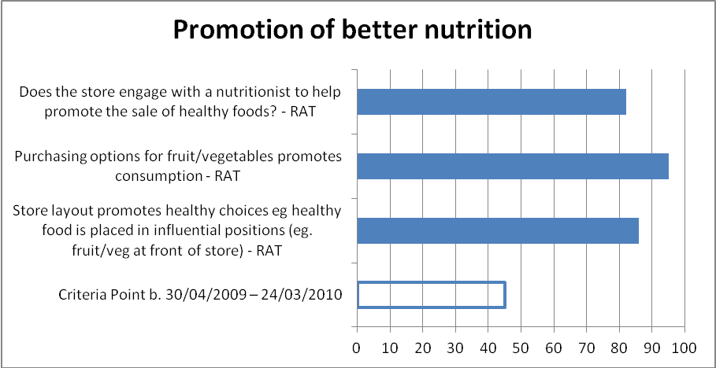

The following table provides more detailed results for the July-December 2010 time period across a range of measures with regards to quality and quantity of food. This is based on 22 assessment forms.

Criteria Point | Yes | No | Not Answered | Percentage Yes
Store layout
Store layout promotes healthy choices eg healthy food is placed in influential positions (eg. fruit/veg at front of store) | 19 | 2 | 1 | 86%
Healthy food is well displayed in the store | 20 | 1 | 1 | 91%
Pieces of fresh fruit and/or other healthy snacks placed at point of sale | 15 | 5 | 2 | 68%
Purchasing options for fruit/vegetables promotes consumption | 21 | 0 | 1 | 95%
Tobacco and tobacco products are hidden from view | 16 | 5 | 1 | 73%
Nutrition
Does the store engage with a nutritionist to help promote the sale of healthy foods? | 18 | 4 | 0 | 82%

In summary, the results indicate that for the sample of stores selected, the vast majority promote healthy choices through layout, displays, and purchasing options. As well, 82% engage with a nutritionist.

Qualitative research
Based on the qualitative research, it was difficult to assess the impact of stores licensing on the promotion of better nutrition. However, the sense from stakeholders was that this had improved over time. The research identified a number of examples, as follows:
- Fruit and vegetables sales in Community B had gone up by 28% in dollar value in the last year (reported by the store manager). The store finds opportunities to sell fruit and vegetables by providing it in different forms to customers to increase its appeal, such as by creating soup packs and packaging pre-cut fruit and vegetables. Boiled eggs are cooked every day and these are popular with community members
- In Community A and Community B the fruit and vegetable displays are located prominently at the front of the store, close to the registers to encourage community members to purchase these items
- In Community B, the store manager has organised larger packs of meat to assist with the provision of food for the school nutrition program, and has also assisted with filling shopping lists, as well as liaising with the trainer for the school nutrition program.
‘The store management is approachable now, they will work with the community, help out with the nutrition programs, that’s different.’ (Stakeholder)
- The store in Community E was reported to sell less junk food and stock more fruit and vegetables. The store also offers ‘tastings’ of new types of fruit that are ordered to encourage community members to eat a greater variety of fruit and vegetables. The takeaway store also offers more healthy food, and employs a chef who is a qualified nutritionist. Fresh fruit and vegetables from the store that do not sell are utilised in takeaway meals. The store also displays promotional information such as ‘Go for 2&5’ (fruit and vegetable campaign) posters.

However, once again it is important to note that ALPA and Outback Stores have their own organisational requirements regarding the provision of nutritional food, so it is difficult to ascertain the impact of licensing in this regard. In some instances the nutritional policies of ALPA and Outback Stores go above and beyond the licensing requirements. For example, all ALPA and Outback Stores have a nutritionist attached to the store as part of their store policies.

rETAIL MANAGEMENT

Data analysis
To assess changes over time, the assessment forms from two time periods were assessed (from 30/04/2009 to 24/03/2010, in comparison to the more recent assessment forms from July to December 2010). For the earlier time period, the criteria point for retail management was defined as ‘The store should, as far as possible, follow best practice retail processes and procedures’. This rating has been compared with the results from July to December 2010 with regards to retail management.

As the following graph shows, for the last six months of 2010, a large majority of the sampled stores demonstrated good retail management practices (and in some cases it was 100% for those sampled), and this had increased when compared with the number who fully met this criterion in 2009/2010.

While the questions are not directly comparable, the results do suggest there have been improvements in the retail management practices for community stores.

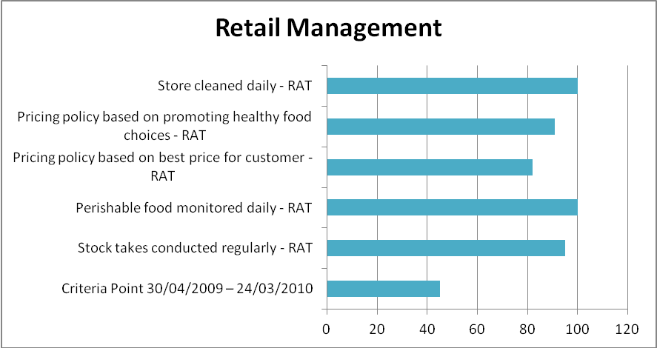

The following table provides more detailed results for the July-December 2010 time period across a range of measures with regards to retail management. This is based on 22 assessment forms.

Criteria Point | Yes | No | Not Answered | Percentage Yes
Compliance with legislation/regulations – certificate of registration sighted | 20 | 1 | 1 | 91%
Ordering based on visual stock levels | 20 | 2 | 0 | 91%
Ordering based on sales data | 2 | 20 | 0 | 9%
Stock regularly checked on delivery against invoice | 21 | 1 | 0 | 95%
Stock takes conducted regularly  Weekly – 1  Monthly – 1  Quarterly – 8  Bi-annually – 1  Annually – 10 |  |  |  | 95%
Fridge temperature monitored | 19 | 2 | 1 | 86%
Perishable food monitored  Daily – 22  Weekly - 0  During re-stocking – 0 | 22 | 0 | 0 | 100%
Stock rotation | 22 | 0 | 0 | 100%
Pricing policy based on best price for customer | 18 | 3 | 1 | 82%
Pricing policy based on promoting healthy food choices | 20 | 1 | 1 | 91%
Items individually priced | 10 | 9 | 3 | 45%
Price on shelving | 21 | 1 | 0 | 95%
Prices on item match POS price file | 12 | 5 | 5 | 55%
Regular preventative servicing |  |  |  | 73%
Store cleaned  Daily – 22  Weekly -  Monthly - | 22 | 0 | 0 | 100%
Environmental health inspection reports provided | 12 | 10 | 0 | 55%

In summary, the key points to note are:
- The vast majority of stores are compliant with legislation
- 95% check stock against invoice on delivery
- Almost all stores monitor fridge temperatures and also monitor perishable food daily
- All stores are cleaned daily
- Almost all stores had prices on shelves

The results also suggest there are opportunities to improve the use of the POS systems. For only 9 stores the prices on items matched the POS price file, and the majority of stores orders are based on visual stock levels rather than sales data.

Qualitative research
The overall impact of community stores licensing on retail management has been significant. Most stakeholders and community members commented that since stores licensing was introduced the retail operations - including stock management, storage, shelving, pricing, point of sale and freight management - have all improved.

‘Now it’s like a real store, with aisles you can walk down, a range of products, prices, proper clean shelving, fridges for fresh food and meat; they used to just have a freezer, it wasn’t like a shop at all’. (Stakeholder)

Improvements in stock storage were identified in all the locations visited. Major improvements had occurred in refrigeration which allowed a larger quantity and range of fresh food to be stored and displayed. Most stores had also improved the display of goods by either increasing the amount of shelving available and/or re-arranging shelving so that products were more easily accessible to consumers. Stores licensing has funded a considerable number of Improvements to store infrastructure, and this was highly valued. For example, In Community B, where the store is awaiting refurbishment through the ABA project, a large freezer container had been installed outside the store to provide additional storage for meat and bread. It is worth noting though that in one community, there were concerns that relying on government funding would reduce the degree of community support for the store. This community support was seen to be contingent on the community retaining some measure of self-sufficiency in the running of, and financial responsibility for, the store. While funding infrastructure is an important function of community stores licensing, in this case it was felt that there is a danger of this being conceived by community members as a ‘hand-out.’

‘It’s the community’s store. If we get fridges and stuff from the government, it helps but people will lose faith in the store.’

Overall, effective stock management was seen as a feature of all the stores visited, ensuring a continuous supply of most products, including fresh fruit and vegetables. Stakeholders in Community D had been impressed with stock management in the aftermath of the Queensland floods when the store continued to supply good quality fresh food despite the obvious challenges.

While freight management is a challenge for many stores in remote locations, most stores visited were receiving regular weekly deliveries. For example, in Community E while the barge delivered food once a fortnight, this was supplemented by a charter flight once a week.

In Community B, these regular deliveries had been severely challenged by the recent increase in flood events which had seen many deliveries cancelled or postponed. However, both stakeholders and community members commented that a wider range of goods, including fresh food, is now available on a regular basis. Stakeholders, community members and store managers noted that prior to licensing it was common for store shelves to be virtually empty prior to a delivery. Store managers recognised the importance of reliable freight provision and this was a priority in their approach to stock management. Errors in delivery appeared to be an issue which was being more proactively dealt with since licensing with store managers more prepared to negotiate the return of goods rather than having valuable but unnecessary stock sitting in storage.

Community store licensing has had a major impact on infrastructure in some stores, for example, in Community E and Community A, where infrastructure had been improved. In Community E stores licensing had funded the purchase of a forklift and truck, and this was viewed positively, especially as it had a big impact on their ability to manage stock, including unloading from the barge. In Community C the store now has plans for expansion which includes increased storage space and expansion of shelving. Community B is awaiting a refurbishment (through ABA) and this was a point of considerable discussion as both the store manager, stakeholders and community members looked forward to the impending improvements such as new refrigeration, a takeaway, increased storage spaces and a petrol bowser. Many people interviewed commented on the role of the store as a gathering place and this was noted as an important consideration in infrastructure planning with provision for places to sit and eat being an important element in any store planning.

Maintenance of store infrastructure is an ongoing challenge and this was particularly noted in relation to repairs of refrigerators. The main challenge was accessing trained and reliable repair staff in a timely manner given the remote locations involved. This was an area where community stores licensing appeared to have limited impact as store managers continued to struggle with this issue.

Point of sale management had been positively impacted by stores licensing with improvements in operating systems and software, provision of receipts, effective processing of BasicsCard as well as the provision of shopping trolleys, baskets and bags. The elimination of book-up was noted as a significant positive by stakeholders, community members and the store committees for whom it was a source of pride. Store managers saw income management as an important factor in the success of community stores licensing as it provided a guarantee of significant funds being spent on food.

A major change identified by stakeholders and community members was the introduction of consistent pricing in stores and labelling on shelves to clearly indicate the prices of goods. This was seen as a significant improvement which enabled customers to make informed decisions when shopping.

‘It used to be that products just sat on the shelves and you never knew what they would cost, that could be a big shock.’ (Community member)

Overall, stakeholders and community members identified improved retail management of stores as achieving a better quality and wider range of produce in the stores. However, there were concerns raised about the high price of food. Comments about pricing varied across communities and while some complained of the high price of meat, others noted that fruit and vegetables were more expensive. Stakeholders commented that basics such as Weet-bix, flour, bread and powdered milk are often still expensive. Both ALPA and Outback Stores have healthy food policies and ALPA has an approach which inflates prices for unhealthy items like Coke and reduces mark-up on water and fresh fruit and vegetables to keep these prices low. Community E also had a similar mark-up policy where healthy foods had a lower mark-up in comparison to unhealthy foods.

Store practices in relation to cleanliness and hygiene were frequently commented upon with major improvements noted as a result of stores licensing. Most stakeholders, community members and committee members noted changes in the stores approach to cleanliness; shelving and floors were cleaned regularly and the overall impression was of a clean environment as opposed to previous impressions that stores were ‘dirty’ and ‘unhealthy’. Some stakeholders commented that the areas outside stores where people are eating needed to be kept cleaner with rubbish removed more frequently. It was also noted that there were fewer dogs around the stores and inside the stores since licensing. This appeared to be the result of improved fencing and gates but also a willingness by store managers and store committees to make an effort to keep the dogs away from stores. However, it was also felt that there was room for improvement on this issue and required constant vigilance given the large number of dogs in communities.

‘The condition of the store is dramatically better, it used to be covered in mouse poo and everything was dirty especially on the shelves, and they were selling dirty old clothes – now it’s more like a mainstream store.’ (stakeholder)

Increased employment of Indigenous staff was also seen as a positive improvement by both stakeholders and community members. While ALPA stores have a comprehensive training program, allocating time for staff training was identified as a challenge for some of the other stores.

‘You’ve got Indigenous people working in the stores now and being trained, that’s a big change.’ (stakeholder)

In Community E, for example, staff had completed Certificate I in Retail Management, and there were plans to commence Certificate II in 2011. However, the research suggests this focus on training was driven by the staff and management, rather than community store licensing.

Several comments were made by stakeholders and committee members in relation to a preference for a couple to work in the store. This was primarily because two staff provided increased capacity for provision of packaged fresh food. In one location, the appointment of a single store manager meant that there was limited time for the preparation of sandwiches and salads which had been provided previously when a couple had been employed.

It is important to keep in mind when reviewing this section that overall it was felt that for ALPA and Outback Stores, the quality of retail management had not been impacted by stores licensing, because these stores have clear policies and procedures that encourage good retail management processes.

fINANCIAL MANAGEMENT

Data analysis
Information on financial management was collected in the most recent time period (July to December 2010), and this included a range of operating ratios, such as gross profit ratio, net profit ratio, liquidity ratio, current ratio, and solvency ratio. The following graphs include the results for each store included in the sample (ranging from 19 to 22), and this is plotted against the recommended ratio (based on the community stores licensing recommendation).

As can be seen, for the gross profit ratio, just over half of the stores in the sample are above or equal to the recommended ratio, although there are a significant minority (7) that are below the recommended ratio. The financial challenges are further highlighted when reviewing the net profit ratio, as most stores are either below this ratio, or equal to this ratio.

For the liquidity ratio, current ratio and solvency ratio, the majority of stores are either equal to the recommended minimum ratio or above it.

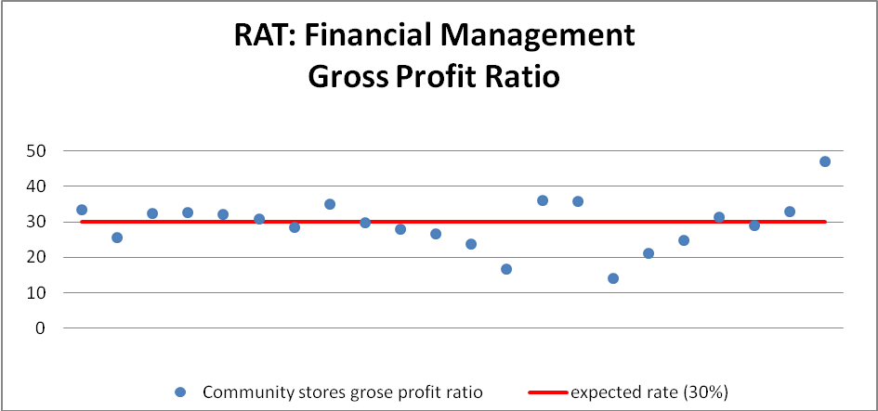
n=22

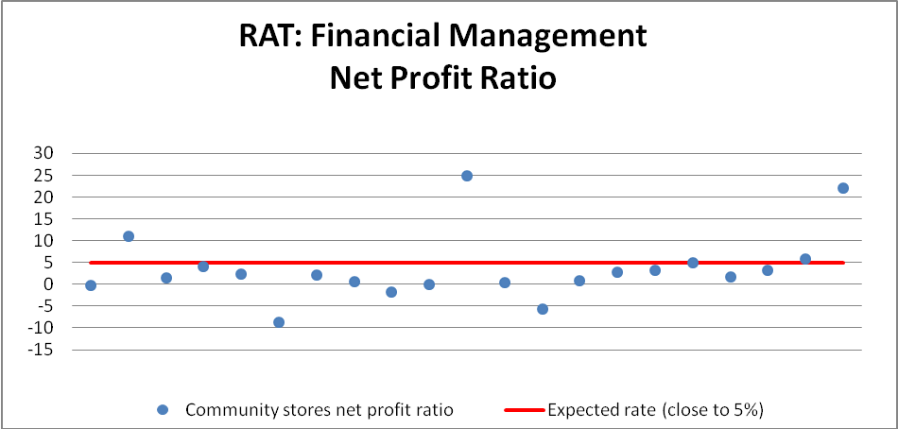
n=21

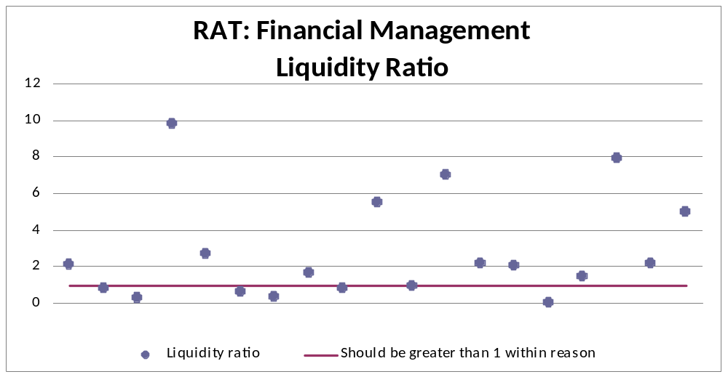
n=19

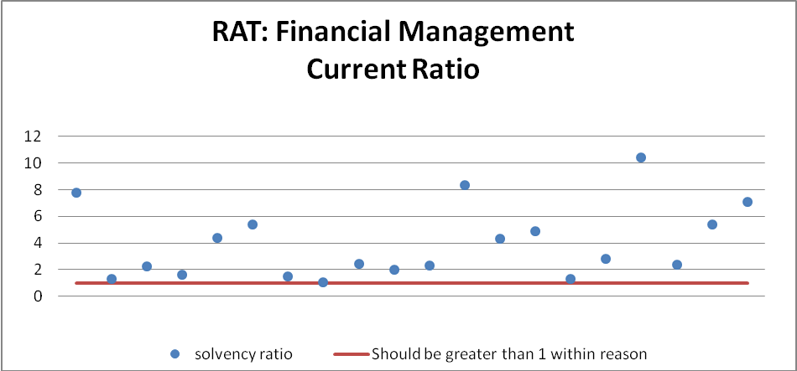
n=20

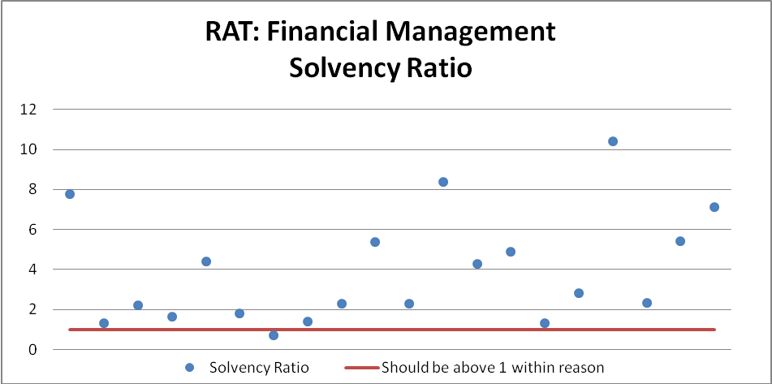
n=20

It should be noted that it was not possible to make comparisons between the earlier assessment data, and the results from July to December 2010 because the financial information recorded was vastly different. In summary though, it is worth noting that during the earlier time period (2009/2010), the criterion included in the assessment forms for financial management was that ‘the financial structure of the store should be transparent and be able to be assessed independently of other businesses in the community. All financial transactions must be clearly and unambiguously identified and appropriately approved’. The results from the data analysis found that 12 fully met this criterion, 4 substantially met this criterion, and two had significant deficiencies. Based on this, two-thirds of the sample fully met this criterion.

Qualitative research
The most significant improvement in financial management attributed to stores licensing has been the abolition of book-up. This positive improvement was identified consistently by stakeholders, store managers and community members throughout the research. It was felt that ‘almost overnight’ the debilitating cycle of debt from book-up for stores and community members was removed. Indeed, many stakeholders felt that the removal of book-up, with no adverse effects, was the most significant positive impact that licensing has had on community stores. It was felt the continued support of community stores licensing through assessments is integral in ensuring book-up does not resume.

‘Getting rid of that [book-up] was a big thing for us, it’s about breaking habits for the community and the workers but it is easy to slip back into old ways.’ (Store manager)

‘Used to hear a lot about rip-offs and corruption, it seems much better now.’ (Stakeholder)

Another significant change to financial management as a result of community stores licensing is an improvement in financial transparency. In part this may be a result of the requirement through the assessment process to disclose financial records. As well, the RAT collects information on a range of ratios including gross profit ratio, net profit ratio, liquidity ratio, etc, which provides feedback to community stores licensing on the viability of the store. Stores licensing staff see this as an important warning system with regards to the financial viability of stores.

The research suggests that in some cases increased financial transparency has had a positive impact on the eradication of poor financial management practices. For example, in one of the site visits, it was suggested that compliance with the financial terms of licensing placed pressure on previous managers engaging in poor financial management practices, as they were suspected by stakeholders to have been engaging in dishonest financial practices. In this case the managers left, as they were not willing to meet the standards of the licensing assessments. They were subsequently replaced by managers who were and continue to be committed to meeting the requirements of the licensing regime.

‘With all the stuff they [the old managers] were up to, they couldn’t handle the conditions of the new licenses.’ - Stakeholder

It should also be noted that at the time of the research, a number of stores were transferring from the NT Associations Act to the CATSI Act (see section 2.2 for an explanation of this change). This transition to the CATSI Act is included in the July 2010 NTER legislation. It was noted that financial transparency has improved as result of this change, especially as audited financial reports must be submitted annually. The research indicates that stores licensing has been supporting stores that have transitioned across to the CATSI Act. For example, the stores licensing team has worked with stores to support their annual general meetings, and has worked with ORIC to assist stores with providing their audited financial statements by establishing a panel of auditors who were committed to providing these statements by the due date. It was noted that the level of compliance for Outback Stores improved from around 5 stores of 17 submitting audited statements in 2009 to 15 of the 17 stores providing their audited financial statements by the due date in 2010.

As part of stores licensing, there is an expectation that the store committee meets regularly, and that financial reports are submitted to the store committee/board of directors. Stores licensing have developed a resource kit for stores that provides assistance in presenting financial information in a simpler and more visual format, so that it can be more easily understood. Outback Stores also use a similar tool called ‘Money stories’. In the store in Community C, policy and business plan documents have been developed that use simple language supported by images and illustrations.

The positive impact community stores licensing has had on the financial management of stores is not exclusively due to the assessment and licensing components. The introduction of retail consultants in certain communities has yielded encouraging results. This investment in the governance mentor model is addressing a legitimate need within remote communities for specialised assistance in the governance and financial management of stores. This approach has assisted the store in Community C, through the presence of a governance mentor to work with the store committee to encourage greater control over the financial management of the store. This has resulted in the store financing community initiatives such as the sports carnival.

While community stores licensing has generally had a positive impact on financial management, there are instances where community stores licensing has had little impact on financial management. For example, stores operating under ALPA or Outback Stores. This is attributed to the fact that these stores have their own formal financial management practices in place.

A significant challenge highlighted in the research was the impact of unqualified or ‘unscrupulous’ accountants on good financial management practices. Several stakeholders spoke negatively of the impact of these accountants on independent stores, including a lack of transparency, and they were labelled the ‘gatekeepers’ with regards to financial information. It was suggested that there needs to be systems in place to identify and address poor accounting practices as a result of the use of unqualified or ‘unscrupulous’ accountants. One stakeholder felt this was a critical underpinning for sustainable improvements to community stores.

bUSINESS STRUCTURE AND GOVERNANCE PRACTICES

Information on governance practices was collected in the most recent time period (July to December 2010). As the following table highlights (and the qualitative research supports), good governance is an area that requires further development. The sample includes 22 stores.

For the purposes of licensing assessment, stores are expected to have store committees or boards where this is a requirement of the rules or constitution of the entity that owns the store. Generally this applies to stores where the owner is incorporated under the NT Associations Act and the CATSI Act, but not for privately owned stores such as Pty Ltd companies, partnerships, sole traders or Shire owned stores. The table below shows the number of store owners (from the sample of n=22) that are required by their rules or constitution to have a store committee or board, and the number that are not required to have a store committee or board. As can be seen, for the sample we were looking at, the majority (73%) were required to have a store committee or board.

Requirement | Yes | No | Percentage Yes
Store requires a committee | 16 | 6 | 73%

For the 16 that were required to have a store committee or board, analysis was conducted on governance data collected in the RAT. While 81% of the sample had an independent relationship between the store committee and accountant/auditor, without any conflict of interest, and 81% of the committees met regularly (at least quarterly and in some cases monthly), a range of other measures of good governance had lower levels of compliance. For example:
- 56% of the stores were recorded as having a clear understanding of roles and responsibilities between owner, manager and store committee
- 63% of store committees were provided with financial reports

Positively, 69% held the AGM within the applicable statutory time-frame, and 63% indicated that store committee members had participated in governance training.

Criteria Point | Yes | No | Not Answered | Percentage Yes
Regular committee meetings  Weekly – 0  Bi-monthly – 1  Monthly – 4  Quarterly – 8  Bi-annually – 0  Annually – 0 | 13 | 1 | 2 | 81%
AGM was held within the applicable statutory time-frame | 11 | 3 | 2 | 69%
Relationship between store committee and accountant/auditor is independent, without any conflict of interest? | 13 | 1 | 2 | 81%
Is there a clear understanding of roles and responsibilities between owner, manager and store committee? | 9 | 5 | 2 | 56%
Store committee has participated in governance training | 10 | 4 | 2 | 63%
Financial reports provided to store committee | 10 | 3 | 3 | 63%

It should be noted that it was not possible to make comparisons between the earlier assessment data, and the results from July to December 2010 because the governance information recorded was vastly different. In summary though, it is worth noting that during the earlier time period (2009/2010), the criteria included in the assessment forms for governance was that ‘the store must be operated within a clear governance structure that provides transparency in all decision making affecting the management of the store and limits the opportunity for fraud, corruption or impropriety’. The results from the data analysis found that 12 fully met this criterion, four substantially met this criterion, and two had significant deficiencies. Based on this, two-thirds of the sample fully met this criterion. While not directly comparable, the analysis suggests that there have not been significant improvements in good governance practices in recent times. However, care needs to be taken in interpreting these results given the small sample size.

Qualitative Research
Governance was viewed as an integral component with regards to sustainable improvement of community stores over time, and this was an area that was felt to have received considerable focus in recent times. This is in part because of the contextual changes identified in section 2.2 with regards to the transition to the CATSI Act from the NT Associations Act, and the NTER legislation changes in June 2010 that require the licence be granted to the board of directors/store committee rather than the store manager. As well, the StoreBiz program is targeting governance.

It is clear that governance is an important area of need, but one that is challenging to address. The evaluation indicates that resources have been dedicated by stores licensing, especially in more recent times, to assist good governance practices. However, stakeholders noted that while there has been considerable focus on governance in the last six months, prior to this the primary focus of licensing has been on food security and retail management practices, and that because of this it is not possible to identify the impact of community stores licensing on governance. As well, improvements to governance are difficult to measure, and are also only likely to be realised in the longer term. Some stakeholders felt that at this stage licensing has not influenced governance. Therefore, while the evaluation provides a few examples where governance has improved, overall we believe this is an area that should be a focus in the long term.

In assessing the impact of licensing on governance, the evaluation provided the following feedback on improvements:
- A few stakeholders felt that overall governance had improved, and that communities tended to be more focused on ensuring the store is well-run and viable. This was felt to occur because licensing has ‘shone a spot light on governance’ which encouraged a focus on governance in communities
‘When a store manager is not performing, I’ve seen the committee exercise power to get rid of him, that wouldn’t have happened before licensing.’

- ORIC noted that the number of complaints received regarding governance had dropped, although this was felt to be more related to the removal of book-up, as this was identified as a key source for complaints in the past. The removal of book-up was linked to improvements in governance, because it removed the cycle of debt for the store and community members
- In cases where liquidators/administrators have been appointed, it was felt there has been an improvement in governance through this process, in conjunction with the support provided by community stores

The evaluation indicates that the impact on governance to date has been mixed. In the research, a number of examples were provided where governance had dramatically improved:
- The store in Community C was consistently identified as a positive example of improved governance practices. The change in management and governance practices was seen to have been facilitated by stores licensing. The store now works very closely with a retail consultant, and this consultant is acting as a governance mentor. The research indicates that the store committee is highly engaged, and actively involved in decision making for the store, including but not limited to decisions regarding how store profits are used.

‘Nothing would have happened if it wasn’t for community stores licensing, because it had FAHCSIA’s attention an administrator was appointed.” (Stakeholder)

- There were two stores in particular that were often identified by stakeholders as good examples where governance had improved, as the committee’s awareness of their role in making decisions for both stores had improved significantly. While support provided by case managers was identified as assisting the improvements to governance, the research found that a wide range of factors contributed, for example changes in store management, involvement of external retail consultants, and involvement of GBMs.
- In Community B, committee members were aware that the store makes a profit, and were connected to this and the decision making roles in determining what happens with this profit. The meetings also followed a consistent agenda

‘We have our say now, talking about the store, talking about bringing the prices down a bit.’ (Committee member)

Importantly, the evaluation indicates a significant need with regards to improving governance of community stores. This is of most relevance to Outback Stores, and many independent stores. Facilitating good governance was not perceived to be a responsibility of Outback Stores, as this was viewed as a conflict of interest (although a few stakeholders disputed this rationale). The site visits indicate that there are considerable gaps in the level of engagement of store committee members in the Outback Stores model, and this is a key area that requires focus. Outback Stores noted that it is often hard to ‘get traction’ with owners, and that this is always a challenge in communities. The evaluation indicates that this should be a priority for FaHCSIA, in comparison to the monitoring of Outback Stores more generally. ORIC also mentioned that they continue to receive complaints regarding governance with Outback Stores.

For example, in Community A it was not clear who was on the store committee, and even some committee members were unsure if they were still on the committee. The store manager noted that there are only a couple of committee members that are engaged with the governance of the store. While not conclusive, the research suggests meetings are not happening regularly, and that a quorum is not often reached. It was suggested that the lack of engagement may also be due to the lack of profits, as the store has a significant debt that needs to be repaid. Based on the consultations, it was suggested that engagement may be higher where the committee is involved in decisions on how profits should be spent in the community.

Good governance includes the engagement of the committee in decision making, but also the engagement of the community more broadly with the store committee/board of directors. The evaluation provided examples where the store committee were engaged in the running of the store, but in almost all cases open lines of communication, feedback and engagement with the community were limited. In several of the site visits, community members talked about the governance of the store happening behind closed doors, with limited awareness among community members that they could have an influence on the operation of the store. As well, the processes for applying for funds were not clearly understood by community members. While store committee members identified clear processes, where applications need to be made in writing, there appeared to be limited awareness of this process among community members. It appears there are few open meetings with community members regarding the store. It is important that initiatives addressing governance practices also focus on the engagement of the store committee members with the community more broadly.

The transition to ORIC was also felt to improve governance to some extent, through the delivery of training, and because of the greater transparency of financial reports.

Some stakeholders and committee members commented on the governance training provided by ORIC. Generally, there were concerns with the appropriateness of regionally based governance training, as this requires committee members to travel from the community. This was also viewed to be very expensive. It was noted that training needs to be ongoing, as it is very difficult for training alone to improve governance conditions, and that opportunities for mentoring, and assistance from the stores team could help improve governance. There was also reference to governance training conducted by the Fred Hollows Foundation and as part of StoreBiz that was run in the community, and this was viewed more favourably in comparison to training where people had to travel to a regional centre.

INCOME MANAGEMENT

To assess changes over time, the assessment forms from two time periods were assessed (from 30/04/2009 to 24/03/2010, in comparison to the more recent assessment forms from July to December 2010). For the earlier time period, ‘Criteria Point a’ for income management was defined as ‘the ability of the store to receive, manage, control and report on income management funds. This will include an assessment of relevant processes and procedures of the store, including actions taken by the owners, managers and staff, and will, in particular, include an assessment of point of sale and other IT systems, the ability to automatically accept Centrelink data (without the need for re-keying of data) and the ability of store staff to verify the identity of customers.’ The other criteria of relevance from this time period (criteria b) is defined as ‘It is important that the operation of the store support the income management regime and, in particular, supports community members’ efforts to manage their income.’ These ratings have been compared with the results from July to December 2010 with regards to income management.

As the following graphs show, there is a high level of compliance with income management among the sample, and this has improved in the last 12 months.



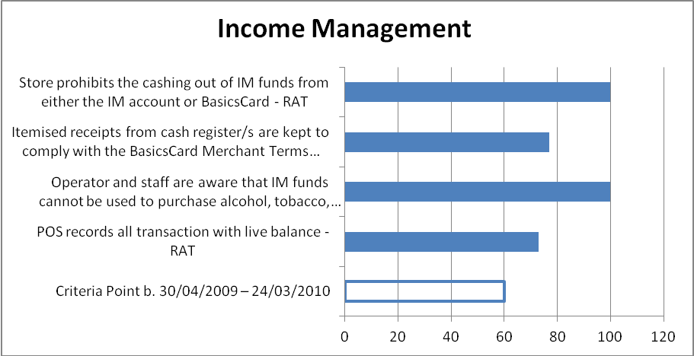

The following table provides more detailed results for the July-December 2010 time period across a range of measures with regards to income management. This is based on 22 assessment forms.

Criteria Point | Yes | No | Not Answered | Percentage Yes
POS System Used
Cash registers are networked and can access and update IM client accounts in real time | 17 | 4 | 1 | 77%
Store has a detailed and up-to-date procedure manual on processing IM funds | 21 | 1 | 0 | 95%
Store has a StoreCard used by IM customers | 7 | 14 | 1 | 32%
Where manual IM system used, Store ensures balances are updated after each transaction | 5 | 0 | 17 | 23%
Ability to report to Centrelink on IM within 48 hrs of receiving a request
Store is currently compliant with Centrelink reporting requirements |  |  |  | 82%
Store has in place back-up of IM account balances onto an external hard drive or memory stick | 15 | 4 | 3 | 68%
Ability to report to each customer, on request, their IM account balance
POS download with customer identity card | 4 | 18 | 0 | 18%
POS download, sales deducted for each transaction | 12 | 10 | 0 | 55%
Electronic IM system (Blaze), Sale recorded creating a live balance | 3 | 19 | 0 | 14%
Centrelink download spreadsheet, sales deducted manually | 2 | 20 | 0 | 9%
Ability to ensure that no person draws more than their available funds from their IM account
POS records all transaction with live balance | 16 | 6 | 0 | 73%
Immediate update of IM balance after each transaction for hardcopy or Blaze | 2 | 20 | 0 | 9%
Manual procedure for processing IM funds | 4 | 18 | 0 | 18%
Ability and willingness to prevent IM funds being used to purchase prohibited items
POS system prevents IM funds being spent to acquire prohibited items |  |  |  | 41%
Operator and staff are aware that IM funds cannot be used to purchase alcohol, tobacco, gambling services or pornography | 22 | 0 | 0 | 100%
There are signs in the store indicating that IM funds cannot be used to purchase alcohol, tobacco, gambling services or pornography | 13 | 6 | 3 | 59%
Receipts
Signed itemised receipts from cash register/s are kept to comply with the Schedule 5 Contract | 16 | 3 | 3 | 73%
Itemised receipts from cash register/s are kept to comply with the BasicsCard Merchant Terms and Conditions | 17 | 4 | 1 | 77%
How and when customers can use their IM funds
Store charges customers to use IM funds or BasicsCard | 2 | 20 | 0 | 9%
Minimum spending amounts are applied to Basics card customers | 6 | 16 | 0 | 27%
Trading hour restrictions are applied for IM customers | 3 | 19 | 0 | 14%
Cashing out
Store allows the cashing out of IM funds from either the IM account or BasicsCard |  |  |  | 0%

research Findings – process

OVERVIEW

As already noted throughout this report, many of the policies adopted by the licensing program were felt to be unnecessary for the ALPA and Outback Store sites as these stores are self-regulated and have their own policies and procedures that cover many of the areas relevant to store licensing. This is also the case for the assessment and case management processes, which were in large part viewed to be unnecessary for ALPA and Outback Stores. Indeed, some store managers went one step further to describe them as ‘painful’

‘It’s amazing the number of people who want to count the number of fruit and vegetables we have here.’

These stores tended to strongly adhere to the principles of the provision of fresh, healthy food as part of their businesses. In addition, ALPA and Outback Stores have considerable experience in managing retail stores in remote Indigenous communities, with procedures that monitor the quality of food and retail management practices. Given this, quarterly visits to these stores by case managers were considered excessive.

The remainder of this section details feedback gathered from store managers and stakeholders, as community members were generally unaware of the licensing processes.

ASSESSMENT AND LICENSING

Generally, it was difficult for store managers to differentiate between the assessment and licensing processes, as they were perceived to be one in the same i.e. an assessment is conducted and then a licence is provided if successful. For this reason the two have been combined into one reporting section.

Many viewed the assessment process as a helpful process that can be used to identify any issues, and for Independent stores it was felt to be a particularly important tool to ensure the store is safeguarded against poor practices.

‘Assessment is a good process, it keeps the stores performing; the stores are so much better than they used to be.’

There was a sense that there is a need for greater flexibility in the assessment process in order to make allowances based on the nature of the store and size of the community. For example, a few store managers felt that some of the items that they are expected to stock as part of the assessment are not appropriate because these products were rarely purchased by community members, meaning this stock was often thrown out when it reached its use by date (e.g. dried peas, legumes, wholemeal pasta and biscuits, and diet jams, soft drinks and cordials). In addition, there are financial implications to the provision of such items as they must be bought in bulk, although one store manager noted that they sometimes visit a regional supermarket prior to assessment and buy a few of the relevant items, rather than buying these in bulk. It was felt that the assessment process should be cognisant of these issues, so that stores are not continually assessed on these items. This could be achieved through making a store exempt from providing a particular item, once a history of unsuccessful sale attempts is established. However, it should also be noted that in a few cases perceptions of what is required were incorrect or out of date, as a few items identified by store managers (diet jam and wholemeal past) are not required, or were taken off the list in 2010. It is therefore important that any changes are highlighted with store managers to address these misconceptions.
‘There is an expectation we will have dried peas, legumes, people don’t eat that stuff around here, it is a waste of money, but 90% of the stuff they tick off. Diet jam and diet cordial will be on the shelf for 12 months.’ (Store Manager)

Another example from the Community D ALPA store further illustrates the need for flexibility. The store has a policy where they mark-up junk food at a higher rate than the rate recommended by the licensing team and conversely fresh food (fruit and vegetables) has a lower mark-up. The aim of this is to encourage community members to purchase more healthy food options. Apparently the Community D store is consistently marked against this as part of their monitoring, though they have explained to staff the reasoning behind the pricing.

There was some cynicism about the assessment process with comments that there are ‘loopholes’ with regards to being granted a licence. It was suggested that some store managers / owners (only relevant to independent stores) ensure they meet the assessment criteria during the assessment visits only, and that these standards lapse as part of the general running of the store. While it is not a requirement that notice is given for monitoring visits, there was a perception held by stakeholders that generally notice is given for visits from community stores staff, which provides an opportunity for stores to improve their practices in response to these visits. It is worth noting that the legislation sets out the requirement that seven days notice is given for formal assessment visits, but this is not a requirement for monitoring visits.

Another issue that was raised consistently throughout the research was that the licensing process offered little incentive for non-compliant stores to improve as licenses were rarely revoked and there were no real consequences of non-compliance, such as fines. This gave the impression to some that the licence was largely pointless except for in extreme situations. One stakeholder noted that as far as they were aware, there were only two cases where a licence had not been granted. Several stakeholders felt that the stores licensing had conflicting aims, as its objective was to ensure food security, as well as regulate community stores. Some also suggested this enabled ‘rogue traders’ to continue operating.

Case management

There were mixed views with regards to case management, and often the perception of this capacity building component was dependent on the relationship between the store manager and the case manager. Case load was also identified as having an impact on the effectiveness of case management, given the resource-intensive nature of this component.

Stores that were positive described case management as a supportive process that offered interactive and ongoing support. There was a sense that many of the case managers work very hard to cultivate positive working relationships with store managers and committees.

‘They are different from other government mobs that you only hear from when there is a problem.’

For example, in Community E, the store managers and store committee found the case manager very helpful in terms of providing advice and assistance when legal advice was required. The case manager was also critical in helping the store access funding for store machinery, such as a forklift and truck. This was viewed very positively, because this store is not a large, profitable store. Feedback suggests that the store relied on their case manager for advice and support, and the case manager was often the first person they would contact if they had a question or concern.

‘The best thing is if we have a query, we won’t get “she’ll be right” answer. She’ll find out the answer or give you someone else to talk to.’ (Store Manager)

Governance is a key area where case managers can offer assistance, particularly with regard to Outback Stores, who have a policy of independence from the store committee. However, enhancing governance practices is resource intensive, and requires a long term commitment.

Once again, independent stores were considered to be the most likely to benefit from case management, as they were more likely to require ongoing support as they did not have corporate backing as in the cases of ALPA and Outback Stores.

On the other hand, there was limited interest in case management among ALPA stores. This was because ALPA staff felt that they had less needs compared to independent stores with regards to improving their capacity. As well, it was felt that case managers did not have the required experience/qualifications to provide advice to ALPA given the level of expertise of ALPA in remote retail management.

cONCLUSIONS

In summary, in terms of the impact of stores licensing on the assessable matters identified in the legislation, the evaluation suggests that:
- Overall stores licensing has had a positive impact on food security, in terms of ongoing access to food that is safe and of sufficient quality and quantity to meet household needs. While this cannot solely be attributed to stores licensing, the qualitative research and data analysis suggest that licensing has contributed to these improvements
- However, there are still significant concerns among community members about the high cost of food in remote community stores
- There were also concerns raised about the quality of food sold by takeaway stores. While there were examples of improvements, some stakeholders felt licensing has less of an impact on takeaway stores, which is important given that in many communities takeaway food is an important source of food
- The evaluation indicates that there have been improvements in retail management practices over time. Most stakeholders and community members commented that since stores licensing was introduced the retail operations - including stock management, storage, shelving, pricing, point of sale and freight management - have all improved
- The most significant improvement in financial management attributed to stores licensing has been the abolition of book-up. This positive improvement was identified consistently by stakeholders, store managers and community members throughout the research. Indeed many stakeholders felt that the removal of book-up, with no adverse effects, was the most significant positive impact that licensing has had on community stores. It was felt the continued support of community stores licensing through assessments is integral in ensuring book-up does not resume
- The evaluation also indicates that the level of transparency with regards to financial reporting has improved. This in part may be due to licensing requirements, but the transition of stores from the NT Associations Act to the CATSI Act is having a significant impact
- The impact of stores licensing on governance is difficult to assess. Good governance practices were seen as critical for sustainable store improvements, and this is an area that has received considerable focus in recent times. However, this is also an area where there are significant challenges in order to drive improvements, especially given the need for long-term and resource intensive support in some cases. Based on the evaluation, we do not believe licensing has had a substantial impact on good governance practices of community stores
- The research indicates that there may be a limitation to the Outback Stores model with regards to good governance, because this is not identified as a responsibility of Outback Stores’ managers
- The evaluation found that there is a high level of compliance with the income management requirements

The evaluation indicates that sustainability will be enhanced through improvements to those practices that underpin good community stores, such as skilled and experienced managers, good governance practices, and good financial management practices (including using qualified accountants and having high quality book-keeping practices). This is significant given that in many cases it was difficult to assess the impact of stores licensing on these areas. As well, a few stakeholders commented that these are the areas where licensing needs to make significant changes, in order to contribute to sustainable change, and to avoid licensing becoming a ‘tick and flick assessment that only looks at the surface’. It was suggested that licensing could be enhanced if there are requirements with regards to management skills and qualifications, accountancy practices and governance practices.

The evaluation reviewed the process for store licensing. Based on the consultations conducted:
- The process of assessment and licensing was felt to be effective, and this was perceived to be of benefit to independent stores
- There was a preference for more flexibility in the assessment process, in order to make allowances based on the nature of the store and the size of the community (for example, in terms of the list of items that should be offered)
- There were concerns that ‘rogue traders’ may be able to ‘work the system’, as they are able to meet assessment requirements at the time of the assessment, but then let standards lapse at other times. This could be addressed through unannounced visits, but it is a requirement of the legislation that seven days notice be given prior to the assessment being conducted. Interestingly, results from the evaluation suggest that to date licensing has been effective in ‘weeding out’ a lot of the ‘unscrupulous’ and/or incompetent managers, but that there are still a few ‘poor managers’ that remain. A few stakeholders that were concerned about the ‘rogue traders’ felt that stores licensing knows about these ‘unscrupulous’ store managers, but are not willing to take on the ‘harder cases’
- Several stakeholders felt that stores licensing has conflicting aims, as the objectives include ensuring food security, as well as regulating community stores. Some also suggested this enabled ‘rogue traders’ to continue operating, and that there is a need for a ‘tougher’ regulatory body
- The effectiveness of case management varied, depending on the relationships between case managers and store managers, and the level of need of store management. The qualitative research indicated that several independent stores valued the support and advice provided by the case managers. On the other hand, corporate retail managers (ALPA and Outback Stores) were less reliant on the support from case managers, as they did not feel that case managers could assist given the level of expertise in retail management within these organisations

A key finding from the evaluation was that ALPA and Outback Stores are less likely to be influenced by stores licensing, because the policies and practices of these organisations reflect the good practice principles of retail management that licensing encourages. Therefore, the research suggests that the impact of stores licensing on these stores was limited, and the need for ongoing contact through assessments, monitoring and case management is also limited. However, the evaluation did indicate that there is a considerable need for assistance with regards to the governance practices of Outback Stores.

It is also important to keep in mind the need for a licensing regime that is sustainable, and that ensures that the remote community stores do not go back to the ‘bad old days’.

‘Before the licensing you used to get some bad people, they jacked up the prices, moved funds out for personal advantage, it was scam after scam.’ (Stakeholder)

Appendix 1

List of stores included in the data analysis

Store | Location | Type | 30/04/2009 to 24/03/2010 | RAT
Alawa Store known locally as Waliburru Community Store | Minyerri - Roper Gulf | ALPA Consultancy store | Yes | Yes
Warrabri Bakery | Ali Curung - Barkly | Independent | Yes | Yes
Gunbalanya Service Station | Gunbalanya - West Arnhem | Independent | Yes | Yes
Lajamanu Community Store | Lajamanu - Central Desert | Indigenous owned | Yes | Yes
Numbulwar General Store | Numbulwar - Roper Gulf | ALPA ARC | Yes | Yes
Nganmarriyanga Community Store | Palumpa - Victoria Daly | ALPA ARC | Yes | Yes
Neutral Junction Station Store | Tara - Barkly | Independent Station Store | Yes | Yes
Aherrenge Community Store | Ampilatwatja - Barkly | Indigenous owned | Yes | Yes
Janyima Store | Bulla - Victoria Daly | Indigenous owned | Yes | Yes
Waite River Station Store | Engawala - Barkly | Independent Station Store | Yes | Yes
Aputula Social Club Store | Aputula (Finke) - MacDonnell | Indigenous owned | Yes | Yes
Kintore Store (Pulikutjarra Aboriginal Corporation) | Kintore - MacDonnell | Indigenous owned | Yes | Yes
Milikapiti community store | Milikapiti - Tiwi Islands | Indigenous owned | Yes | Yes
Nguiu Store | Wurrumiyanga - Tiwi Islands | Indigenous owned | Yes | Yes
Peppimenarti Store | Peppimenarti - Victoria Daly | Indigenous owned | Yes | Yes
Urapunga Community Store | Rittarangu - Roper Gulf | Independent | Yes | Yes
Mt Liebig Store | Mt Liebig - Central Desert | Indigenous owned | Yes | No
Midlands Caravan Park | Elliot - Barkly | Independent | Yes | No
Maningrida Progress Association Store and Hasty Tasty Takeaway | Maningrida - West Arnhem | Indigenous owned | Yes | No
Adjurmarrarl Supermarket (Gunbalunya Council Store) | Gunbalanya - West Arnhem | ALPA ARC | Yes | No
Wirliyajarrayi Store | Willowra - Central Desert | OBS | No | Yes
Warte Alparayetye Community Store | Alpurrululam - Barkly | Indigenous owned | No | Yes
Areyonga Store | Areyonga - MacDonnell | Indigenous owned | No | Yes
Wuduluk Store | Beswick - Roper Gulf | OBS | No | Yes
Jilkminggan Store | Jilkminggan - Roper Gulf | OBS | No | Yes
Nyirripi Community Store | Nyirripi - Central Desert | OBS | No | Yes

Gross profit ratio is the ratio of gross profit to net sales expressed as a percentage. Net profit ratio is the ratio of net profit (after taxes) to net sales. A liquidity ratio measures a company's ability to pay its bills. The denominator of a liquidity ratio is the company's current liabilities, i.e. obligations that the company must meet soon, usually within one year. The numerator of a liquidity ratio is part or all of current assets. The current ratio is a common liquidity ratio, and this compares current assets to current liabilities, and includes assets and liabilities of equal longevity. The solvency ratio measures the size of a company's after-tax income, excluding non-cash depreciation expenses, as compared to the firm's total debt obligations.

