Growing the NDIS Market and Workforce
Supporting the market to deliver innovative, people-centred services so that participants can achieve their goals.
2019

Copyright notice — 2019
This document Growing the NDIS Market and Workforce is licensed under the Creative Commons Attribution 4.0 International Licence
Licence URL: https://creativecommons.org/licenses/by/4.0/legalcode
Please attribute: © Commonwealth of Australia (Department of Social Services) 2019
Notice:
  - If you create a derivative of this document, the Department of Social Services requests the following notice be placed on your derivative: Based on Commonwealth of Australia (Department of Social Services) data.
  - Inquiries regarding this licence or any other use of this document are welcome. Please contact: Branch Manager, Communication and Media Branch, Department of Social Services. Phone: 1300 653 227.
Email: communications@dss.gov.au
Notice identifying other material or rights in this publication:
  - Australian Commonwealth Coat of Arms — not Licensed under Creative Commons,
see https://www.pmc.gov.au/government/its-honour
  - Certain images and photographs (as marked) — not licensed under Creative Commons

Contents
Introduction 4
Vision — The NDIS market in the long-term 5
In the short-term — Assistance to transition 5
Key priorities and scope 5
Monitoring progress and success 5
Priorities 1 & 2 — NDIS providers 6
Priority 1 — Optimise the NDIS market and provide information to support investment 6
1.1. Improving financial settings for service delivery 6
1.2. Providing better information to support investment 6
1.3. Improving IT systems and payment platforms 6
1.4. Nationally consistent regulation of the NDIS market 6
1.5. Addressing thin markets in regional and remote areas, and for participants with different needs 6
Priority 2 — Invest to build capable NDIS providers 6
2.1. Practical resources and advice to build provider capabilities in local markets 6
2.2. Targeted funding to develop market and provider capacity and capability 6
2.3. Growing a diverse range of NDIS providers 6
Priorities 3 & 4 — NDIS workforce 6
Priority 3 — Fostering a capable NDIS workforce 6
3.1. Developing workforce capabilities 6
3.2. Improving formal qualifications for the sector 6
Priority 4 — Grow the NDIS Workforce 6
4.1. Growing awareness of job opportunities and improving perceptions 6
4.2. Mobilising a suitable NDIS workforce 6
4.3. Growing a workforce that reflects diverse needs 6
4.4. Jobs Compact 6
Monitoring market effectiveness 6
Glossary 6

Introduction
The National Disability Insurance Scheme (NDIS) is one of the most important social reforms in Australian history, delivering choice and control for people with disability and driving economic improvements by creating new business and employment opportunities.
Under the Scheme, NDIS providers will deliver innovative, person-centred services, enabling participants to choose the best services to meet their individual needs.
To assist providers to deliver these services, the NDIS is expected to be one of the largest job creation opportunities in Australian history, with up to an additional 90,000 full time equivalent employees (FTE) needed over the next five years. This will include a mix of highly skilled positions and a large number of roles that do not require formal qualifications.
Through this growth, the NDIS also provides a unique opportunity to build a diverse workforce, which reflects the needs of all NDIS participants.
The NDIS provides an increase in funding for disability services, from $8 billion dollars in 2015–16 to $22.5 billion at full Scheme. This funding will enable support to be delivered to 460,000 Australians with disability. The NDIS has reached a major milestone with more than 250,000 Australians now receiving support under the world-leading Scheme. This includes approximately 78,000 people receiving life-changing support for the first time under the NDIS.
As a result of the reforms to how disability supports are delivered and the increased funding, the NDIS is expected to deliver large economic benefits. Government modelling suggests the NDIS will improve outcomes for NDIS participants while reducing total expected government expenditure associated with NDIS participants (including disability support, healthcare and other mainstream services) from $680 billion to $310 billion in net present value terms over 40 years.
Figure 1 — NDIS workforce growth required
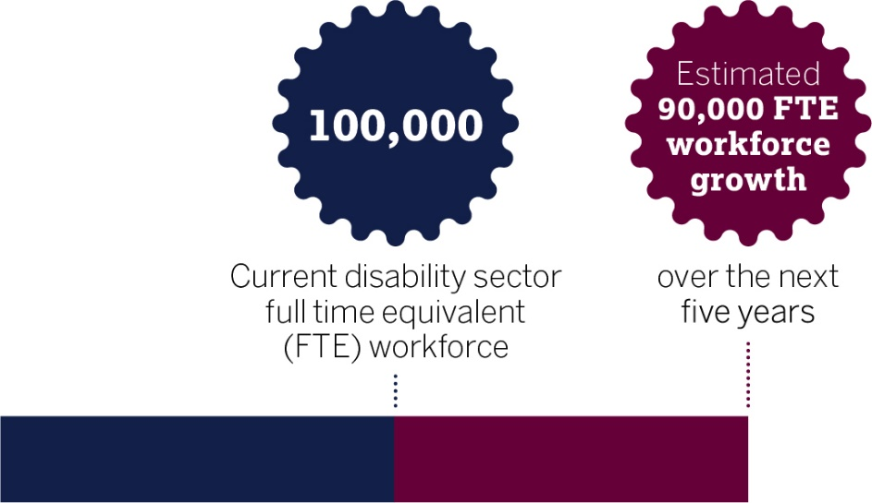

Vision — The NDIS market in the long-term
In a mature and well-functioning market, NDIS providers will deliver innovative services to Scheme participants, to invest in their workforce, and to offer attractive jobs and career progression options. In the long-term, the needs of the sector will become more apparent, allowing mainstream employment and training services to deliver the skills and training services the sector requires.
As such, the Australian Government’s (the Government) primary role in the long-term is to ensure appropriate market settings, including for thin markets, and to provide market oversight. The Government is continuing to build the market infrastructure required to underpin a well-functioning NDIS market. This includes further refining market settings, reducing barriers and improving information to support investment.

In the short-term — Assistance to transition
Given the scale and pace of reforms to the disability support sector, the Government recognises the need to support business and workforce development while the market transitions and matures.
Significant changes from providers in the disability service sector are still required for the sector to adapt to a market-based model of the NDIS. In light of this, the Growing the NDIS Market and Workforce Strategy (the Strategy) outlines the Government’s approach to NDIS market and workforce development taking into account the market infrastructure and information-sharing needs of an efficient NDIS market in the long-term as well as the additional support necessary during the transition.

Key priorities and scope
This Strategy outlines the Government’s key priorities to assist an efficient and effective NDIS market and workforce to grow. It is organised under four priorities. The first two priorities are focused on NDIS providers, and a further two focused on growing and fostering a capable workforce (see figure 2 below).
The Government is also working with state and territory governments to support the development of the NDIS market and workforce. For example, education and skills services are being refined to improve formal qualifications and training pathways for current and potential NDIS workers.
Taking into account some similarities in the workforce across aged care, healthcare and disability services, the Government is also working across sectors to remove barriers, find synergies, and enable and promote attractive career paths across the broader health and care workforce.

Monitoring progress and success
It is vital that governments are able to assess the effectiveness of the NDIS market, and the impact of policies and programs, in meeting the objectives of the Scheme. The progress of individual policy initiatives outlined in the Strategy and their impact on the NDIS market and workforce will be monitored through specific implementation and evaluation plans.
The Government has also implemented a new Key Performance Indicator Framework (KPI Framework) in consultation with states and territories and the National Disability Insurance Agency (NDIA). The KPI Framework will extend beyond the initiatives in the Strategy and provide a holistic view of how the market is performing. Further information about the KPI Framework is outlined under ‘Monitoring market effectiveness’ [page 13].
Figure 2 — Key priorities and initiatives of the Government
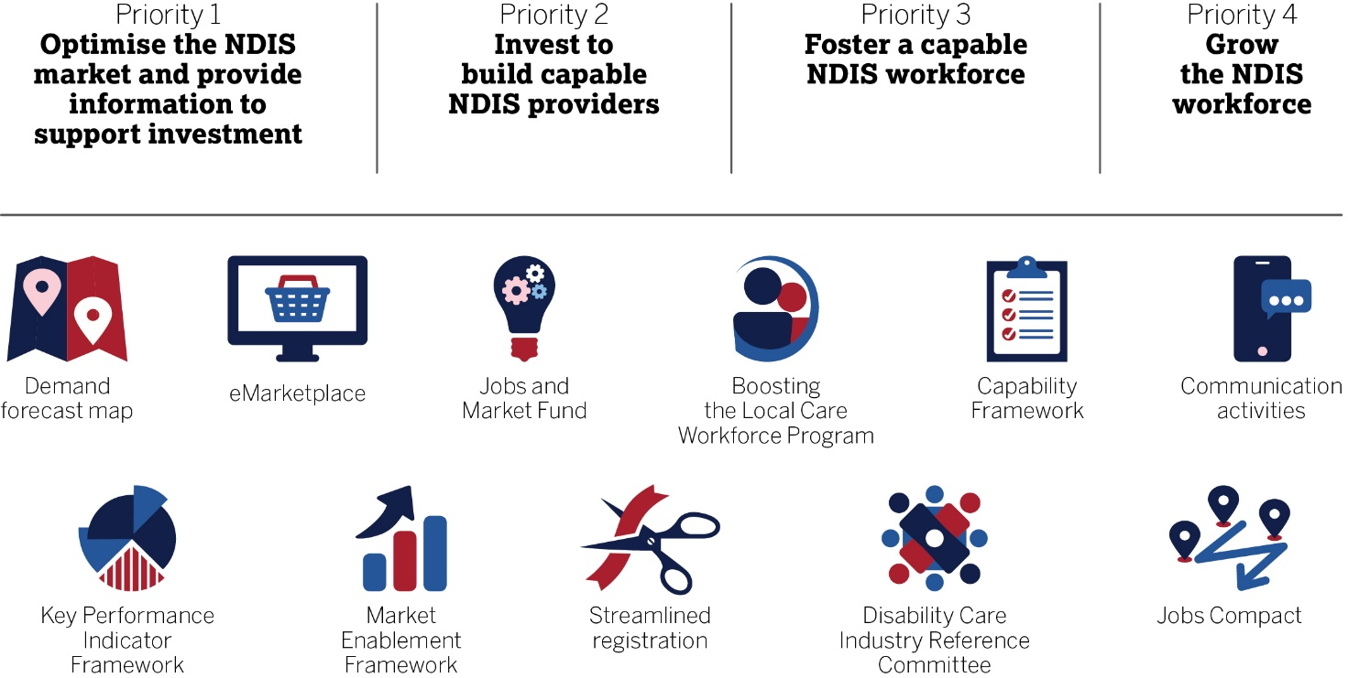

Priorities 1 & 2 — NDIS providers
The vision for the NDIS is for a disability support system where participants are empowered as consumers to select services and supports appropriate to their individual needs.
This can only be achieved if the NDIS market is effective, with market settings capable of sustaining businesses and workers to provide innovative, person-centred services, enabling participants to choose supports to best meet their needs.
Initiatives to build the right settings for NDIS providers and to deliver improved market information are outlined in Priority 1 — Optimise the NDIS market and provide information to support investment.
In the short-term, recognising the significant nature of the reforms as well as the pace of growth required, the Government is also assisting providers with business development, and to help ensure Indigenous and culturally and linguistically diverse (CALD) providers enter and remain in the NDIS market. These actions are outlined in Priority 2 — Invest to build capable NDIS providers.

— Optimise the NDIS market and provide information to support investment

Improving financial settings for service delivery
In the long-term, and where competitive market segments emerge, prices based on the interaction of demand and supply are fundamental to an efficient and effective market. As the market matures, the Government is balancing fiscal sustainability with the need for appropriate price settings that will enable the provision of quality services. If prices are set too high, taxpayers may pay more than necessary, and this will reduce the purchasing power of participants. If prices are set too low, providers will be unable to attract workers and meet participant demand. This would forfeit some of the economic benefits associated with the NDIS by increasing the fiscal cost of delivering the NDIS.
The Independent Pricing Review Report (IPR) released in 2018 identified areas to improve NDIS pricing arrangements. The NDIA accepted all the 25 recommendations from the review, to deliver immediate financial benefits to providers.
The first set of IPR recommendations were successfully implemented in July 2018, including:
- Permanently increasing price caps for a range of services where previous prices were determined to be too low.
- Temporarily increasing price limits for most supports.
- Introducing new flexible arrangements for provider travel and appointment cancellations.
- Allowing for more flexible group community participation supports.
The IPR also recommended more flexible pricing by expert panels determining prices for participants with complex needs and in rural areas. These price increases have been reflected in participant budgets.
The implementation of these price adjustments is expected to improve the ability of the NDIS to attract and sustain providers, improving overall industry profit margins by two to four per cent, with even higher margin improvements expected in rural, remote and very remote areas.
The NDIA has provided an update on sector analysis and consultation on proposed reforms relating to therapy supports and complexity. Further industry consultations are being conducted, and the NDIA has proposed to publish a draft price list for therapy services in early 2019, with implementation to follow as soon as practical afterwards.
In the long-term, the Government is also considering pathways to price deregulation. In the interim, and while the sector transitions, the Government will explore ways to improve price settings, like benchmarking prices to mature markets where similar services are delivered. The NDIA has established a Pricing Reference Group, including independent experts, to assist the NDIA with this work.
The Government has announced the response to the review of the Specialist Disability Accommodation (SDA) Pricing and Payments Framework. The changes will:
- Allow SDA to be put in plans regardless of whether a property is available.
- Remove the requirement to exhaust all other options before a participant can be eligible for SDA.
- Establish an SDA Reference Group for ongoing consultation with participants and providers.
A second tranche of reforms will be implemented later in 2019, with an aim of giving participants more choice and making it easier for families to live together.

Providing better information to support investment
Greater access to market data will facilitate competition and innovation in the delivery of NDIS services. If organisations have more information about the services that are in demand, they can better tailor their offerings, improving the quality and responsiveness of services they offer. This also reduces cost for providers while improving competition.
The Government will provide the sector with more market information. As a first step, the Department of Social Services (DSS) and the NDIA will release more detailed market demand information that will better inform service provision and workforce requirements.
DSS will release quarterly demand forecasts by postcode, including, but not limited to:
- support needs by service type
- aggregated participant profile
- workforce by occupation type.
This information will be available on a new website as part of the Boosting the Local Care Workforce program (BLCW program), which will also host a range of practical resources and market information for the sector. Providers using the website will be connected to tailored information that is relevant to their circumstances and location. Providers will also be able to explore detailed demand data by postcode (an illustrative example of proposed demand data is provided in Figure 3). The website will be launched alongside this Strategy.
Figure 3 — Illustrative example of the demand forecast map
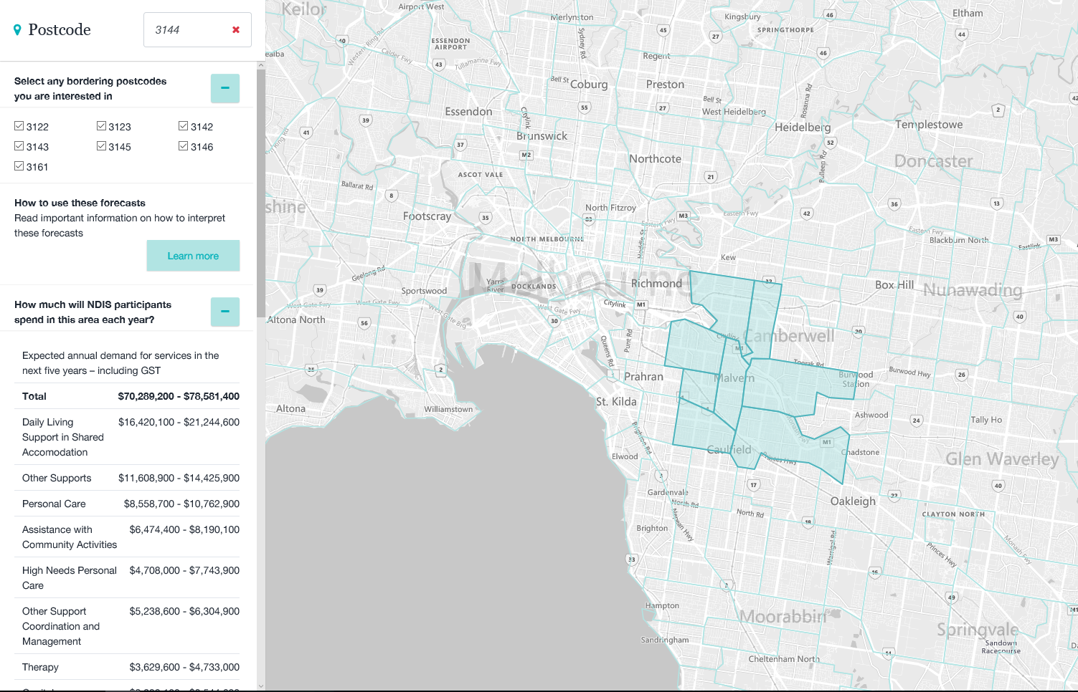

Improving IT systems and payment platforms
Efficient administrative arrangements are important to the functioning of the NDIS. The NDIA is improving participant and provider interactions with payment platforms to:
- Better connect providers and participants through improvements to the search functionality, so that providers can be easily found and engaged by participants.
- Establish a dedicated National Provider Payments Team to work with providers to resolve specific claiming issues while broader improvements are made to the payments system.
- Improve quoting and claiming processes for low-cost Assistive Technology, as well as other improvements to the portal.
- Engage with providers to build the NDIA’s understanding of business needs and increase awareness about the purpose of the NDIS.
These changes will lay the foundations for the development of eMarketplaces. An eMarketplace is a platform that can support information discovery, encourage innovation, and build community capacity. The Government is exploring options for industry to lead the development of eMarketplaces. EMarketplaces will make it easier for participants to connect with and pay providers, and will empower participants as informed consumers.

Nationally consistent regulation of the NDIS market
In February 2017, the Council of Australian Governments endorsed a national NDIS Quality and Safeguarding Framework. The NDIS Quality and Safeguards Commission (NDIS Commission) is responsible for implementing the Government’s responsibilities under that framework.
The NDIS Commission is an independent regulator that works with people with disability, providers and the community to deliver nationally consistent, responsive and effective regulation of the NDIS market.
The NDIS Commission brings together several quality and safeguarding functions under an integrated regulatory model, combining a complaints function with industry regulation, and setting practice standards and competencies. The NDIS Commission will have a system-focus, improving the quality and safety of NDIS services and supports, while also being responsive to an evolving market.
The NDIS Commission will introduce a new nationally consistent system of registration and regulation for NDIS providers, which will set a single national standard for the quality and safety of NDIS services.
Registration requirements will be proportionate to the size and scale of the provider, as well as the risk and complexity of the supports and services they deliver. This will allow the regulatory system to be risk-responsive.
A nationally consistent worker screening check will be implemented by states and territories as part of the NDIS Quality and Safeguards Framework. This nationally consistent approach will allow workers with a clearance to work across any state or territory, and workers who pose a risk of harm to persons with disability will be excluded from risk assessed positions in the NDIS nationally. A single national system will contribute to simpler hiring processes for providers and self-managed participants, who will be able to verify workers’ clearance using the database held by the NDIS Commission.

Addressing thin markets in regional and remote areas, and for participants with different needs
There are cases where the NDIS market is not yet well developed, particularly in regional and remote areas.
Undersupply is also evident for some participant cohorts,
such as participants with complex needs, Indigenous participants, and those from CALD backgrounds.
To address undersupply, new and innovative approaches are required. The NDIA is implementing the Market Enablement Framework (MEF), released November 2018, to identify and respond to market risks, including thin markets.
The MEF is an operational framework for monitoring, analysing and responding to market risks including undersupply. The Framework will:
- Guide the NDIA in determining whether an intervention is required to ensure participants receive supports, and if so, how to intervene.
- Complement pricing adjustments that will benefit service provision in remote areas, such as permitting price quoting and new flexible travel arrangements for providers in regional and remote areas.
The Government recognises that a wide range of targeted market design mechanisms and interventions are required in regional and remote markets where demand is limited. Expert research and consultation on thin market design and intervention options has been commissioned by DSS and the NDIA and is due to conclude in May 2019. This work has been commissioned to:
- Review thin market identification, design and intervention approaches adopted in public sector markets in Australia and internationally.
- Consult with stakeholders to identify current and potential thin market problems, barriers to growth, challenges facing different types of organisations, and effective responses to thin markets and rural and remote service delivery.
- Develop an expanded suite of options for market design, including guidance on pilots to trial implementation in rural and remote areas.
Where there are interactions or overlaps between similar services in these areas, such as aged care or health care, the Government will consider coordinated approaches to tackle design and intervention options.

— Invest to build capable NDIS providers
Significant structural changes are required in order for the sector to adapt to a market-based model and businesses need to drive this change. The Government is investing in the NDIS market through the BLCW Program and the Jobs and Market Fund (JMF) to assist providers to transition to the NDIS, and to support continued market growth.
The Government is investing in initiatives to increase the diversity of NDIS providers. This will target appropriate services for Aboriginal and Torres Strait Islander people and people from CALD backgrounds living with disability. It will further enhance the significant employment and economic opportunities to Indigenous and CALD businesses under the NDIS. This will complement other government initiatives that aim to develop a diverse NDIS workforce — see Section 4.3 for more information.

Practical resources and advice to build provider capabilities in local markets
The Government is investing $33 million from 2017–18 to 2019–20 through the BLCW program to develop the immediate capacity of both disability and aged care service providers to operate effectively and expand their workforces.
Under the BLCW program, Regional Coordinators and Specialist Coordinators have been deployed in key locations across Australia to support existing providers and businesses entering the disability market.
Regional Coordinators are working with NDIS and aged care providers at the local level to:
- Help them transition to the NDIS operating model.
- Improve workforce planning and business capability.
- Link them with government employment and other relevant services.
Regional Coordinators are currently establishing links with local-level coordinators across federal, state and territory agencies, to gain further local knowledge and identify opportunities that exist through these networks.
Specialist Coordinators will provide a national approach to address specific issues with an initial focus on:
- financial skills
- Indigenous business
- workforce planning
- specialist disability accommodation
- supporting participants with high-needs
- market development in remote areas
- allied health professionals
- career pathways for care workers.
Specialist Coordinators are currently engaging with key stakeholders to analyse risks and issues, recommend responses, identify areas of market underutilisation and unmet demand, and inform provider assistance.
Figure 4 — Boosting the Local Care Workforce program
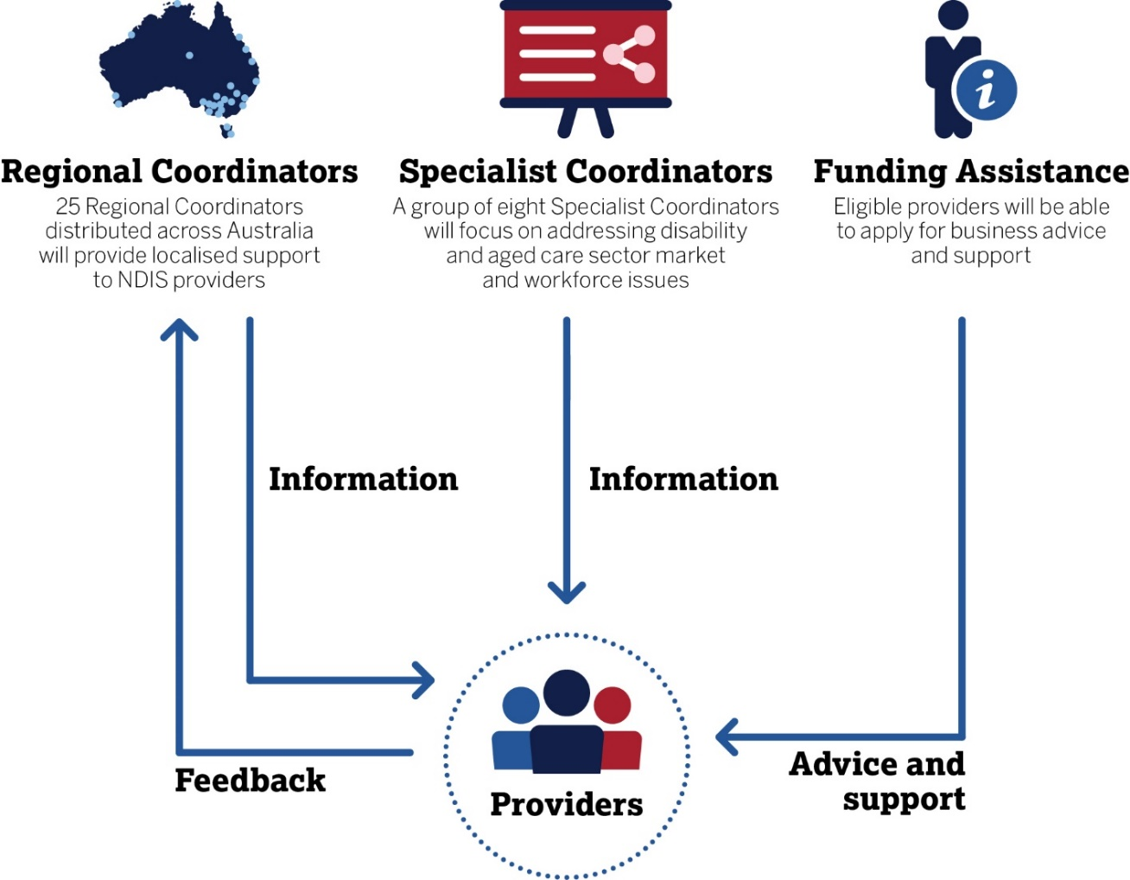

Targeted funding to develop market and provider capacity and capability
The Jobs and Market Fund
The Government has committed $45 million for a Jobs and Market Fund (JMF) to fund targeted projects to grow the provider market and workforce in capacity and capability to meet the needs of NDIS participants. Most JMF expenditure will be through grant rounds, with procurements conducted where appropriate to secure services such as market demand forecasts and analysis.
The JMF will build on the Sector Development Fund (SDF), which provided more than $112 million to projects to prepare NDIS providers, participants and the workforce for the transition to the NDIS.
Whereas the BLCW Program will provide direct support to individual providers, JMF program outcomes will address collective market and workforce needs.
JMF projects contribute to the following outcomes:
- Providers: increased capacity and capability of NDIS providers.
- Workforce: increased number and capability of NDIS workers.
- Participants: increased capacity of NDIS participants to influence the growth of the market to meet their needs.
- Target markets: development of under-supplied markets — by region, participant cohort, or support type.
- Evidence: increased evidence base for market and workforce growth.
- Other outcome areas nominated for specific grant opportunities.
Individual grant opportunities (rounds) may include additional outcome areas or be targeted to address particular outcome areas. The next grant rounds will be informed by analysis of the needs of thin markets, such as under-supplied rural and remote regions, and Indigenous service provision.
Examples of projects that may be funded under the JMF include:
- Initiatives to support Indigenous organisations to provide NDIS services.
- Projects to develop new delivery models for rural and remote communities.
- Development of frameworks and resources to assist providers to train NDIS workers.
- Information and programs that link jobseekers with NDIS career opportunities.
Information about future grant opportunities will be made available at the Community Grants Hub.
Support for NDIS Providers Program
The Government has committed $17.6 million over four years starting from 2018–19 to assist NDIS service providers to meet their obligations in providing safe and quality services and support to people with disability participating in the NDIS.
The Support for NDIS Providers Program is a new four year grants program managed by the NDIS Commission. This Program will support a national information and education program to develop and grow a quality market in the NDIS, emphasising compliance obligations through the lens of people with disability accessing NDIS supports and services.
The Support for NDIS Providers Program is designed to:
- Drive a nationally consistent, responsive and effective regulation of the NDIS market.
- Support registered NDIS providers to meet the conditions of registration and operate in accordance with registration obligations.
- Maintain and stimulate strong and diverse markets for NDIS supports and services, including in rural and remote areas of Australia, for activities that have limited supply, and those supporting Aboriginal and Torres Strait islander and CALD participants.
- Stimulate continuous improvement amongst NDIS providers to deliver progressively higher standards in quality and safety of NDIS supports and services for NDIS participants.
The initial focus of the program is to fund targeted initiatives that support providers transitioning to the new arrangements and to address specific areas of the new provider obligations. The program complements other Australian Government programs designed to develop and strengthen the NDIS market. It will provide practical support to retain and attract high quality providers to the NDIS market, including benefits to small local providers, those facing the challenges of operating in rural and remote Australia, or in areas where there are limited choices for NDIS participants. Current and future grant opportunities will be advertised on the NDIS Commission’s website and GrantConnect website.

Growing a diverse range of NDIS providers
Culturally appropriate services are fundamental to Aboriginal and Torres Strait Islander and CALD people living with disability being able to exercise choice and self-determination within the NDIS. The NDIS also presents significant employment and economic opportunities for Indigenous and CALD businesses.
The Government is investing in a number of initiatives that aim to grow the diversity of providers offering services under the NDIS.
Enabling growth of Indigenous business in the NDIS
The Government is working with the National Aboriginal Community Controlled Health Organisation (NACCHO) to increase the accessibility of the NDIS for Aboriginal and Torres Strait Islander peoples across the country.
This project will identify the barriers preventing Aboriginal Community Controlled Health Organisations (ACCHOs) from effectively delivering NDIS services, and will produce tailored toolkits and resources to combat these barriers.
Another element of the project is to design and test alternative or modified service delivery models that will enable ACCHOs, and other Indigenous controlled organisations to deliver NDIS services in ways that meets the needs of Aboriginal and Torres Strait Islander participants in local communities.
The Government’s long-term plan is to work with Indigenous organisations to ensure the lessons from this project, and other relevant projects, inform systemic improvements so that Indigenous organisations, businesses and communities can thrive under the Scheme.
An NDIS focus for Indigenous Business and Employment Hubs
The Government is seeking to maximise specific sector development investments such as the BLCW program, to assist NDIS providers navigate to other relevant government programs, where further assistance may be available for NDIS providers.
For instance, Indigenous NDIS businesses, with assistance from Regional Coordinators under the BLCW Program, may be able to leverage the Indigenous Business Sector Strategy 2018–2028 (IBSS).
The IBSS aims to assist Indigenous Australians to build sustainable businesses. The IBSS includes the establishment of Indigenous Business Hubs in major cities across Australia to provide a single point for Indigenous businesses to access advice and support.
The IBSS will also provide financial assistance to eligible businesses through grants and loans. The Government is working to ensure IBSS initiatives are coordinated with NDIS programs and opportunities where relevant.
Enabling growth in CALD capability and opportunities for NDIS providers
The Government will engage with providers and organisations experienced in delivering services to CALD participants. This will include humanitarian settlement service providers, migrant resource centres, and peak body forums, to create greater awareness of opportunities for delivering specialist services under the NDIS.
A priority investment for the JMF includes developing resources and practices to support organisations to provide culturally appropriate services to CALD participants. These commitments will complement the NDIA’s Cultural and Linguistic Diversity Strategy 2018 and the NDIA’s Aboriginal and Torres Strait Islander Engagement Strategy 2017.
These strategies are designed to enhance cultural competency with the NDIA’s partners in the community, who deliver services such as Early Childhood Early Intervention Services and Local Area Coordination as well as organisations delivering Information, Linkages and Capacity Building activities.
The NDIA is working with Translation and Interpretation Services National to promote the availability of language services to NDIS service providers and participants.

Priorities 3 & 4 — NDIS workforce
The NDIS presents one of the largest job creation opportunities in Australian history. The Productivity Commission estimates the disability care workforce will need to approximately double from the 2014–15 level to meet the demand created by the NDIS. This means that one in five jobs created in Australia over the transition period will need to be disability care jobs.
Approximately 71 per cent of newly created jobs are expected to be support worker roles, 12 per cent allied health service roles, 11 per cent case and social worker roles and 6 per cent managerial roles.4 As such, most NDIS roles require the right capabilities and experience rather than formal qualifications.
The Government’s long-term vision is for a capable and adaptable NDIS workforce, with workers pursuing attractive career pathways. This vision will require a mature market of diverse and strong providers delivering effective on-the-job capability development for workers, along with appropriate and accessible formal training pathways.
In the short-term, this requires Government investment in supporting providers to develop their workforce, coordination to improve formal qualifications, and better collaboration between existing initiatives, including employment services.
As the aged care workforce will almost treble by 2050, the Government is also working across sectors to remove barriers, find synergies, and enable and promote attractive career paths across the broader health and care workforce.
Priorities 3 and 4 below set out the Government’s approach to grow the NDIS workforce.
Figure 5 — NDIS workforce as representation of broader workforce growth

— Fostering a capable NDIS workforce
The success of the NDIS can be measured, in part, by the satisfaction of participants in the services they receive. This will require NDIS providers and workers to be responsive to the needs of participants and deliver person-centred services.

Developing workforce capabilities
The rapid growth of the NDIS workforce has resulted in rising demand for workers with relevant skills and experience.
A new Code of Conduct and NDIS practice standards will set the expectations for the manner in which supports and services under the NDIS will be delivered. The Code and Practice standards require NDIS providers and support workers to have the skills necessary to deliver the supports that they are providing.
To help grow a capable workforce that delivers supports and services that maximise the health and wellbeing of NDIS participants, the Government, through the NDIS Commission, will be developing an NDIS Capability Framework. The Capability Framework, which will be developed over a three-year period coinciding with full scheme, will set out the behaviours and core capabilities to be demonstrated by providers and workers when delivering services, depending on their role.
The Capability Framework will consist of a core ‘capability set’ that describes expectations of capabilities that will apply to all forms of NDIS service delivery. The Capability Framework will also include a complementary ‘capability set’, which will outline additional expectations for groups of workers where more specialised supports and services are being delivered. In addition, a range of guidance documents and tools will be developed to assist in transforming the Capability Framework into work practices.
This will include:
- Tools to support workers and employers to turn the framework into good work practice.
- Assessment tools and materials for workforce development and change management.
- Strategies to improve existing training programs, resources and modes of delivery.
During the development phase, the Government will work closely with state and territory governments as well as NDIS providers, participants, workers, and technical experts to create a framework that complements workforce capability frameworks that might exist in other jurisdictions or sectors. The Capability Framework will be an important resource for NDIS providers in workforce planning and development.
In the long-term, it is expected that the education and training sectors will be able to use the Capability Framework to inform the development of future education and training products.

Improving formal qualifications for the sector
As the NDIS grows, formal training will need to be responsive to the changing needs of the sector and be adaptable to new and existing workers.
Working with states and territories to create a pathway to education and training
State and territory governments currently manage the delivery of Vocational Education and Training (VET) in their jurisdictions and provide two thirds of the funding that supports the system. Each state and territory currently offers subsidised training for disability related courses.
In partnership with states and territories, the Government is supporting the growth of apprenticeships and traineeships. Through the Skilling Australians Fund, states and territories are able to develop projects that will boost the number of apprenticeships and traineeships in key areas, including health, ageing and community services, which includes disability care. Employers are also able to receive support through the Australian Apprenticeship Incentives Program, which provides incentives to encourage employers to take on apprentices.
Getting fundamental education and training right
Ongoing reforms to the VET system have improved how training qualifications are developed and updated. These reforms have focused on enhancing the role that industry plays in the development of training packages, partly in response to feedback from employers that VET training was not keeping pace with emerging needs. The reforms ensure that the VET system remains relevant and responds flexibly to national and state priorities and emerging areas of skills need.
The recent Joint Standing Committee on NDIS Market Readiness highlighted that there is a need to address education and training currently available to the NDIS workforce, particularly for caring and support roles.
The Government is exploring ways to support skills development for the NDIS workforce. The Government is working with states and territories through the Council of Australian Governments Industry and Skills Council, which has tasked skills officials to work alongside disability officials on developing and supporting a consistent approach to skills development for the NDIS.
Further, the Australian Industry Skills Committee has formed a Disability Care Industry Reference Committee (IRC) to explore and address skills needed in the NDIS, and the disability sector more broadly. This follows the recent establishment of the Aged Services Industry Reference Committee. The Disability Care IRC will be responsible for:
- Updating national training package qualifications, skill sets and units of competency.
- Exploring approaches to career structuring and progression in the disability sector.
Work is underway to update the Health and Community Services Training Packages, including Aboriginal and Torres Strait Islander Health Worker Training Packages. This will include the evaluation of units of competency, skillsets and qualifications and will take place in consultation with the sector.
As the NDIS matures, the education and training sector will continue to respond and take appropriate action to address emerging skills needs in products, including qualifications.

— Grow the NDIS Workforce
The scale at which the workforce needs to grow in a short period is significant. It is estimated that the NDIS workforce will need to increase by up to 90,000 full-time equivalent (FTE) employees over the next five years.
This is a challenge for both governments and the sector. Current constraints on workforce growth include low public awareness of NDIS job opportunities, misperceptions about working in the sector, and competition from similar sectors. There is also the challenge of simultaneously growing a diverse and inclusive workforce that reflects the needs of all NDIS participants.
Improved market settings will strengthen the ability of NDIS providers to offer attractive employment opportunities. To complement this, and assist provider efforts to attract suitable and diverse workers, the Government is focusing a number of existing initiatives on the NDIS workforce, and trialling new ways to promote and attract workers to the sector.
Although state and territory initiatives fall outside the scope of this strategy, the Government is working to coordinate NDIS workforce initiatives with the significant work already being undertaken by states and territories to grow their NDIS workforces.

Growing awareness of job opportunities and improving perceptions
The Government is currently working to build public awareness of the employment opportunities in the NDIS. Research funded by the Government identified that approximately half of the people considered suitable to work in the NDIS had very low awareness of the opportunities available.
Actions to raise awareness will focus on promoting disability sector roles and employment pathways into the sector on key government education and job websites. This will be supported by targeted communication activities to encourage people to work in the NDIS.
The Government will continue to update the My-Skills website, and the national directory of VET courses and training, to provide information on pathways into NDIS careers. This will include stories on the health and community service page that promote working in the disability sector as well as links to relevant training. The website will also promote opportunities on VET pathways into allied health jobs, to address the perception that allied health careers are only achievable through university courses.
The jobactive website, which acts as a key government hub to link employers and job seekers, will host a page that provides a range of information on NDIS roles and resources to assist NDIS providers and workers. This will include guidance tools for providers to advertise jobs on the website as well as tips for job seekers looking for a career in the disability and aged care sectors. Related vacancies advertised from other recruitment websites will link to the jobactive website. The Government is preparing to launch these tools and resources in early 2019.

Mobilising a suitable NDIS workforce
Leveraging existing government programs
Employment services play an integral role in the development of the NDIS workforce. Since the commencement of the NDIS, nearly 11,500 jobactive participants and more than 2,400 Disability Employment Service (DES) participants have gained employment with NDIS providers. The Government will continue to leverage these programs, including the Community Development Program (CDP), and use targeted actions to connect suitable jobseekers to NDIS jobs. These actions will assist in aligning the needs of the sector with the supports available through employment services.
The Government has conducted highly successful provider forums and networking events to grow the relationship between NDIS businesses and jobactive to maximise employment outcomes.
To build on this initiative, the Department of Jobs and Small Business will roll out a range of engagement activities in 10 select regions across Australia over the next two years (2019 and 2020). These regions will be selected on the basis of identified workforce shortages and strong local engagement. The engagement activities may include:
- Targeted information sessions between NDIS businesses and employment service providers.
- Job expos to promote job opportunities within the disability services and care sector.
- Workshops identifying local issues and solutions.
The Government will work with stakeholders to design and coordinate funding from existing programs, and deliver place-based pre-employment projects to assist suitable job seekers overcome some of the early barriers to employment. This includes prioritising NDIS jobs for the Launch into Work program.
Further, beyond 2020 a new employment services model will build on what is working well in the current system and implement improvements to better meet the needs of job seekers and employers. The new employment services model will make greater use of technology, and will be designed to drive quality and ensure greater responsiveness to growth industries, such as the NDIS.
Reforms to the existing CDP will support 6,000 jobs in remote Australia through the Jobs Creation Package (JCP). The JCP will grow the size and capacity of the remote labour market and support the development of more local businesses, including NDIS service providers. CDP participants in JCP positions will have access to real wages and entitlements such as superannuation. Employers will receive up to $26,769 over two years to help expand their business and hire new staff in remote Australia. This includes a subsidy of up to $21,769 and retention bonuses of up to $5,000.
Regional and Remote Areas
The Regional Employment Trials announced in the 2018–19 Budget encourage regional stakeholders to design and implement local solutions to unemployment in their regions. Under the program, trial regions will receive $1 million in grant funding, with local stakeholders able to apply for individual grants of between $7,500 and $200,000 for employment-related projects such as mentoring programs and the upskilling of local unemployed people to become more job ready. This may include a focus on meeting the workforce needs of local NDIS businesses and training job seekers to move into NDIS jobs, where the Regional Development Australia Committee has identified this as a local priority.
Where there can be synergies, the Government will also leverage the Stronger Rural Health Strategy (Rural Health Strategy) to address NDIS workforce shortages in rural and remote areas. The Rural Health Strategy aims to grow the health workforce, including nurses and allied health workers, across the country according to community need. Recognising these sectors face similar challenges in growing the health and care workforce, particularly in rural and remote areas, the Government will harmonise efforts and leverage existing activities where possible.

Growing a workforce that reflects diverse needs
Part of offering genuine choice and control is building a workforce that represents the different needs and interests of participants including age, gender, language and culture. Current information indicates that the majority of the disability care workforce is female, over the age of 45 years, holds a certificate-level qualification, and is from an English speaking background. This does not reflect the diversity of participants.
An NDIS workforce that meets diverse needs will be supported through initiatives targeted at particular groups that may otherwise be underrepresented in the workforce. This includes people with a disability, young workers, people of CALD backgrounds and Indigenous Australians.
The Government is projecting that a further 10,000 job seekers with disability will be placed into sustainable employment over the coming years with NDIS businesses. This will be achieved through the recent reforms to DES, which are expected to increase the overall number of employment outcomes under the program. This will not only contribute to growth of the NDIS workforce, but also improve participation rates for people with disability.
The Government will leverage existing programs such as the Try, Test and Learn Fund to support cohorts that are underrepresented in the labour force into NDIS Jobs. The Try, Test and Learn Fund is trialling new and innovative approaches to assist particularly vulnerable Australians onto a path towards sustainable independence. The fund focuses on priority groups identified through analysis of the Priority Investment Approach data set. Select projects have been identified to benefit the growth of a diverse NDIS workforce, including:
- A community-led work readiness project designed to match unemployed young people with employment opportunities within the community sector through training, mentoring and work experience.
- A project that would trial ways to support CALD refugee women into in-home care roles.
The Government is also considering a number of projects that would support informal carers into formal accredited or non-accredited training, employment or potentially starting their own business in the aged and disability care sectors.
Increasing the Indigenous Workforce
The roll out of the NDIS will not only improve social and economic outcomes for the expected 28,000 Aboriginal and Torres Strait Islander participants, but also for Aboriginal and Torres Strait Islander job seekers. The Government is investing in a number of new initiatives, as well as streamlining existing ones, to improve employment outcomes of Indigenous workers into NDIS roles.
Through the SDF, the Government funded a number of projects targeted to address barriers to the recruitment and retention of staff for remote and Indigenous communities.
Recognising that disability service options in remote Indigenous communities are limited, the NDIA engaged a Registered Training Organisation to develop an accredited Remote Disability Worker training package.
The Government is also working with Indigenous Allied Health Australia (IAHA) to inform ways to build and diversify the Indigenous allied health workforce, so that NDIS participants living in rural and remote areas have access to culturally responsive services. IAHA is working with communities to develop a service delivery model that aims to provide practical career pathways tailored to community needs, sustainable employment and better health outcomes.

Jobs Compact
The Government will establish Jobs Compacts to ensure workforce initiatives are coordinated and leverage off each other where possible. The Department of Jobs and Small Business will lead this work in selected metro and regional areas.
Through the Jobs Compacts, location-specific action plans will be established. These plans will outline the agreed priority workforce challenges and opportunities, as well as the actions that will be implemented to address the priorities and the roles and responsibilities of participating agencies. The nature of the plans will reflect the relative maturity and particular needs of the NDIS market in each locality. The selection of regions will be informed by a combination of regional workforce intelligence and labour market analysis.
Stakeholders who will be invited to participate in the development of action plans include, but is not limited to:
- Commonwealth Departments (including DSS, the Department of Health, the Department of the Prime Minister and Cabinet, and the Department of Education)
- State and territory governments
- NDIA Local Area Coordination and Early Childhood Early Intervention (ECEI) partners
- BLCW Regional and Specialist Coordinators
- Department of Jobs Employment Facilitators
- Local employment service providers from jobactive, DES and the CDP
- Primary Health Networks
- TAFEs and other Registered Training Organisations.
Actions undertaken as part of the Jobs Compact will complement other initiatives outlined in this strategy including the BLCW program and the employment engagement activities.

Monitoring market effectiveness
The aim of the Strategy is to support the market to deliver innovative, people-centred services so that participants can achieve their goals. This aim will be achieved if the NDIS market is operating efficiently and effectively.
To monitor the NDIS market, the Government has developed and implemented a new Key Performance Indicator (KPI) Framework in consultation with the NDIA and states and territories. The KPI Framework will measure the effectiveness of the NDIS market at a granular level. Fifteen metrics will draw from available data sources to provide, when considered holistically, indications of relative market effectiveness by comparing performance between NDIS districts and registration groups, and performance over time.
This information will help inform areas where governments may need to intervene to maintain the effectiveness of the market, and make sure that participants are receiving quality services to achieve their goals.

Glossary
ACCHOs
Aboriginal Community Controlled Health Organisations
Australian Government
Refers to the Commonwealth Government
(also referred to as the Government in this document)
BLCW Program
The Boosting the Local Care Workforce Program
CALD
Culturally and linguistically diverse
COAG
Council of Australian Governments
DES
Disability Employment Services
DSS
Department of Social Services
FTE
Full-time equivalent
IAHA
Indigenous Allied Health Australia
IBSS
Indigenous Business Sector Strategy 2018–2028
IT
Information Technology
IRC
Industry Reference Committee
JMF
Jobs and Market Fund
jobactive
jobactive is the mainstream Employment Service program run by the Department of Jobs and Small Business
MEF
Market Enablement Framework
NDIA
National Disability Insurance Agency. The Australian Government organisation administering the NDIS.
NDIS
National Disability Insurance Scheme.
Also referenced as ‘the Scheme’.
NDIS Commission
NDIS Quality and Safeguards Commission
SDA
Specialist Disability Accommodation
SDF
Sector Development Fund
VET
Vocational Education and Training

Growing the NDIS Market and Workforce 2019
dss.gov.au

The scale of job creation is expected to exceed previous major national projects, including: National Broadband Network required 25,000 FTE 2017–2025; BER School Building Program 22,971 FTE 2009–10; Snowy Hydro Scheme 22,500 FTE 1950-70; China Free Trade Agreement 5,400 FTE 2014-2035.
Productivity Commission, National Disability Insurance Scheme (NDIS) Costs, Study Report, October 2017, p. 319.
Productivity Commission, National Disability Insurance Scheme (NDIS) Costs, Study Report, October 2017, p. 319.
Research conducted By the Department of Social Services and Alphabeta using focus groups, February 2019

