A review of
Child Protection
Income Management in Western Australia

Experiences and perceptions of those involved in Child Protection Income Management
Final Report
February 2014

CONTENTS
CONTENTS 2
Glossary 4
Executive summary 10
Income management in Western Australia 10
Child Protection income management in Western Australia 10
Methodology 11
Summary of process findings 12
Summary of impact findings 13
Conclusions 14
1. Introduction 15
1.1 Aim 15
1.2 Background 15
1.3 Governance 17
1.4 Review questions 18
1.5 Structure of the report 19
2. Income management overview 20
2.1 What is income management? 20
2.2 Income management in Western Australia 21
2.3 Financial management support services 23
2.4 Incentive payments 23
3. Methodology 24
Introduction 24
3.1 Ethics 24
3.2 Case file analysis 24
3.3 Interviews with Child Protection Income Management recipients 26
3.4 Interviews with intermediaries and stakeholders 27
3.5 Client confidentiality 28
3.6 Australian Department of Human Services (Human Services) data 28
3.7 Participation rate of financial counselling and money management services 28
3.8 Participation by other organisations 29
3.9 Data limitations 29
4. Review findings—process 31
Introduction 31
4.1 Referral process—Government of Western Australia Department for Child Protection and Family Support (Child Protection) 31
4.2 Process—Australian Government Department of Human Services (Human Services) 37
4.3 Relationship between agencies 41
4.4 Financial counselling and money management 42
4.5 Summary 44
5. Review findings—impact 46
Introduction 46
5.1 Meeting priority needs 46
5.2 Strengthening financial capability and skills 53
5.3 Other issues underlying financial mismanagement 57
5.4 Individual and community perceptions 66
5.6 Summary 70
6. Conclusion 72
Appendix A—Original review research questions 73
Process questions: 73
Outcome questions: 74
Appendix B—Review communication products 75
References 89

FIGURES
Figure 2.1 Application of Income Management in Western Australia 21
Figure 2.2 Australian Government funding for the income management trial and
related services in Western Australia 22
Figure 3.1 Sampling frame and final sample 27
Figure 4.1 Trend of recipients on Child Protection Income Management and Voluntary Income Management—Western Australia 32
Figure 4.2 Issues which lead to individuals from case files review being referred to income management 35
Figure 5.1 Positive and negative comments from Child Support Income Management recipients interviewed 68

Glossary

Term | Definition
Approved money management course | An approved money management course is one that has been deemed by the Australian Department of Social Services to cover the 10 subject areas listed below, based on the Financial Literacy Competency Standards from the Financial Services Training Package (FNS04).  - Develop and use a personal budget:  - Budgeting  - Money planning (money decisions and prioritising)  - Saving and spending (spending leaks, shopping tips, needs versus wants)  - Develop and use a savings plan:  - Goal-setting  - Introduction to banking (opening accounts, account types, fees, different ways to pay)  - Develop understanding of debt and consumer credit:  - Credit and credit cards  - What is debt?  - The cost of credit  - Money loans  - Consumer rights and responsibilities  Completion of an approved money management course, along with an established savings pattern, is prerequisite to receiving $1 in matched savings for every $1 saved up to $500.
Auto income management | Auto income management is used when recipients identified as eligible for income management have not responded to contacts from Human Services to arrange how to allocate their income-managed funds. Under auto income management recipients have 50 per cent of their income support funds withheld until they make contact with Human Services, with the remaining 50 per cent being paid in the normal way (that is, into a bank account or by cheque).
BasicsCard | The BasicsCard is a Personal Identification Number protected card that allows holders to spend income-managed money at approved businesses using the EFTPOS system. The card can be used to buy most things—excluded goods and services include alcohol, pornography, tobacco and tobacco products, gambling products, gambling services, home-brew kits and home-brew concentrate.
Case file | A case file is a file held by Child Protection to document its interactions with clients and may include:  - planning documents such as a Case Plan, Cultural Plan, Behaviour Management Plan, Safety Plan, Educational Support Plan  - documents recording reviews of, or changes to, a child’s Case Plan  - supervision records regarding the management of the case  - records of case discussion on significant changes to the child’s situation/case plan  - case transfer notes  - referrals to clinical/treatment services  - Duty of Care Unit Notifications  - carer assessments and reviews.
Case manager | The case manager leads a team of case workers and has overall responsibility for the case and ensuring ongoing support to the Child Protection client. The case manager liaises with the client and ensures that the client’s experiences and opinions are represented in the case management meetings. The case manager also retains original copies of the case management files.
Case plan | A case plan is the casework document that outlines the outcomes, goals and tasks needed to reduce the risk of maltreatment.
Case worker | Case workers are Child Protection staff who are responsible for investigating serious concerns about the welfare and safety of children and young people. They make recommendations for action appropriate to the situation and also provide community education and information that promotes child safety in family, community and residential settings.
Child Protection | The Western Australian Government Department for Child Protection and Family Support.
Child Protection clients | Child Protection clients are children and young people whose safety and wellbeing the Western Australian Government Department for Child Protection and Family Support seeks to protect. In this report, parents and carers of Child Protection clients may also be referred to as clients. These parents and carers are either current or former income-managed recipients.
Child Protection staff | Child Protection staff investigate serious concerns about the welfare and safety of children and young people, and make recommendations for action appropriate to the situation.
District | Child Protection delivers services through eight districts in Metropolitan Perth and nine districts in Country Western Australia. The trial of Child Protection Income Management does not cover all districts in Western Australia (see also Perth Metropolitan Region and Kimberley Region).
FaHCSIA | The former Australian Government Department of Families, Housing, Community Services and Indigenous Affairs, FaHCSIA, ceased to exist on 18 September 2013, when the Australian Government Department of Social Services (Social Services) was established.
Financial Management Program | The Australian Government Financial Management Program provides services that are voluntary, free and confidential to people experiencing personal financial difficulties. Program services include the Community Development Financial Institutions (CDFI) Pilot Project; emergency relief; financial counselling; money management information and education; information about saving for retirement; research into problem gambling and its impacts; and the Home Energy Saver Scheme. For more information go to http://www.fahcsia.gov.au/our-responsibilities/communities-and-vulnerable-people/programs-services/financial-management-program.
Human Services | The Australian Government Department of Human Services.
Humbugging | The term refers primarily to the practice of demanding money from relatives, often violently. Humbugging typically takes the form of demands for cash, with wives and the elderly being particular targets.
Incentive payments | An incentive payment of $250 is made to a recipient on a Voluntary Income Management agreement on completion of each consecutive 26-week period. A recipient cannot accrue more than one qualifying period at a time.
Interactions | A duty interaction enables the Child Protection duty officer to assess the information received and ascertain what, if any, further information and assessment is needed and whether Child Protection has an ongoing role in the child’s safety, wellbeing and/or protection.  A duty officer can undertake the following tasks during a duty interaction:  - clarify information with the referrer  - check department records in Assist and Objective (data collection programs)  - ascertain the person/s with parental responsibility.
Intermediaries | Intermediaries are staff from Child Protection, Human Services, financial counselling services and money management services who are involved in the implementation and administration of Child Protection Income Management. Intermediaries are also court officials and representatives of legal aid and law enforcement, welfare sector and community organisations who took part in the review.
Kimberley Region | The East and West Kimberley Districts of country Western Australia
Kitty, extras | Kitty is the term used by staff and recipients for unallocated income-managed funds, referred to by Human Services as their Income Management Account. These funds can be accessed in one-off payments to purchase specific goods or make a regular payment such as rent or utility bills.
Matched Savings Program | The Matched Savings Program gives recipients on compulsory income management an incentive to develop a savings pattern and build functional financial capability. A recipient is eligible to receive $1 in matched savings of up to $500 for every $1 saved, provided they have completed an approved money management course and have established a savings pattern.
Neglect | The Children and Community Services Act 2004 (WA) is the legislative basis of Child Protection’s mandate to assess and respond to child abuse and/or neglect. It states that neglect occurs when a child is not provided with:  - adequate food or shelter; or  - effective medical, therapeutic or remedial treatment; and/or  - care, nurturance or supervision  to a severe and/or persistent extent where the health or development of the child is significantly impaired or placed at serious risk.
Notifications | Notification must be given of any incident that results in, or is likely to result in, a child experiencing significant loss, harm or injury that may result in a potential viable legal claim for a child. Some initial assessment has to be undertaken to determine which incidents need to be notified but, broadly speaking, notification should occur within five working days of Child Protection becoming aware of the incident.  Incidents that may need to be notified include, but are not limited to, accidental injury requiring significant medical treatment, a car accident, death of a parent or significant other, a standard care issue that does not include a safety or wellbeing concern, and a victim of crime or serious bullying issue. Refer to the Duty of Care Unit for further detail.
Recipient | A person receiving welfare payments paid by the Australian Government though Human Services is referred to as a recipient.  The majority of recipients referred to in this report are having their payments income-managed through either Child Protection Income Management or Voluntary Income Management.
Perth Metropolitan Region | The eight districts in the Perth Metropolitan region and the adjacent Peel District in Country Western Australia.
Safety and Wellbeing Assessment (SWA) | In the case process a SWA is where available information is analysed to identify whether a child is in immediate danger of moderate or serious harm and whether the child is at risk of significant harm in the future if joint work is not undertaken with the family.  The purpose of a SWA is to clarify if:  - the child has suffered significant harm, or is likely to suffer harm as a result of abuse and/or neglect  - the child’s parents have not protected, or are unlikely to protect, the child from harm or further harm of that kind  - a safety plan is required.
Social Services | The Australian Government Department of Social Services
Triangulation | Triangulation is a data validation technique involving cross-verification of data from more than two sources and the application and combination of several research methodologies in the study of the same phenomenon. The purpose of triangulation is to increase the credibility and validity of the results.  - It can be employed in both quantitative (validation) and qualitative (inquiry) studies.  - It is a method-appropriate strategy of founding, which increases the credibility of qualitative analyses.  - It becomes an alternative to traditional criteria like reliability and validity.  - It is the preferred line in the social sciences.  - By combining multiple observers, theories, methods, and empirical materials, researchers can hope to overcome the weakness or intrinsic biases and the problems that come from single-method, single-observer and single-theory studies.
Trigger payment | Under Child Protection Income Management, to be assessed as eligible for income management, a recipient, or their partner, must be receiving a Category H welfare payment, the trigger payment, which includes:  - social security benefit  - social security pension  - a payment under the ABSTUDY scheme that includes an amount identified as living allowance  - service pension  - income support supplement  - defence force income support allowance.
Unified Government Gateway | This system allows Human Services staff to:  - search for a recipient who is also a Child Protection client  - view the recipient’s current Rent Assistance details  - update the recipient’s Rent Assistance details  - view the recipient’s current Centrepay details  - update the recipient’s Centrepay payment deduction details.
Voluntary Income Management | If a recipient volunteers for Income Management, 50 per cent of their payments and 100 per cent of any advance and lump-sum payments will be income managed. The rest of their payments will be paid to them in the usual way. The income-managed money can be used to pay for essentials such as rent, bills and food for the family.  If a recipient chooses to have their payments income managed, they have to remain on Income Management for a minimum of 13 weeks, after which time they can choose how long they want this to continue. When they decide that they no longer want to be income managed, they need to contact Human Services to cancel their Voluntary Income Management agreement.
Wellbeing | Wellbeing includes ‘care, development, health and safety of a child’, as defined in the Children and Community Services Act 2004 (WA).

Executive summary
The aim of this review is to assess whether Child Protection Income Management operating in Western Australia is achieving its goals of:
- ensuring that the priority needs of the individual, their children and other dependants are met
- strengthening recipients’ financial capability and skills to reduce the risk of hardship and crisis
- promoting socially responsible behaviour, particularly in relation to children
- reducing the amount of funds available to be spent on excluded goods, including alcohol, tobacco, pornographic material and gambling.
The review was conducted by the Evaluation Hub in the Australian Government Department of Social Services (Social Services) with the assistance of the Government of Western Australia’s Department for Child Protection and Family Support (Child Protection) and the Australian Government Department of Human Services (Human Services).
Ethics clearance for the review was received from the Social Services Human Research Ethics Committee.

Income management in Western Australia
In Western Australia, income management has been introduced incrementally on a trial basis since November 2008 in the Perth metropolitan and the East and West Kimberley regions.
Income management is a budgeting tool to help recipients meet ongoing needs for themselves and their family. It works by allocating a proportion of certain welfare payments to spending on priority items such as food, housing, clothing and utilities.
Western Australia has two streams of income management:
- Voluntary Income management—when a welfare recipient chooses to have their welfare payments income-managed. The percentage managed is 50 per cent.
- Child Protection Income Management—Child Protection staff refer their clients who are also recipients of welfare payments to Human Services to have the recipient’s welfare payments compulsorily income managed to ensure that necessities are provided for the child/ren. The percentage managed is 70 per cent.

Child Protection income management in Western Australia
Income management is an additional tool available to Child Protection staff to assist in the management of child abuse and neglect. It is used where the family is experiencing financial difficulties in addition to other issues.
Income-managed funds are transferred to an income management account. Funds from this account may only be spent on priority items such as:
- food
- clothing
- health items
- education and training
- child care
- housing
- household utilities
- public transport
- acquisition, repair, maintenance or operation of motor vehicles (used wholly or partly for purposes in connection with any of the above needs).
The BasicsCard, which operates as a debit card, utilises funds transferred from the Income Management account. It can be used at participating stores for the purchase of items such as food, clothing, petrol, health and hygiene products, furniture, linen and toys.
Additional features of income management include:
- matched savings incentives to help those subject to compulsory income management to budget and save. Those who complete an approved money management course and have a pattern of savings over at least 13 weeks may receive a contribution from the Australian Government of up to $500
- access by those subject to compulsory income management to financial counselling and money management services
- access by voluntary recipients in income management to an incentive of $250 for every six months that they remain in the scheme.
Income-managed funds cannot be used to purchase excluded goods, which are:
- alcoholic beverages
- tobacco products
- pornographic material
- home brew concentrates and home brew kits
- gambling services.

Methodology
The review used a mixed methods approach that allowed for triangulation of data from multiple sources. The review largely consisted of case file analysis and interviews with Child Protection Income Management recipients and staff involved in the implementation of income management. These staff are collectively referred to as ‘intermediaries’ throughout the report. Interviews were conducted in the Perth metropolitan and the Kimberley regions, where income management has been rolled out since November 2008. Interviews were also conducted with government and non-government stakeholders in the Goldfields region of Western Australia, where income management was not available at the time of the review.
The main source of quantitative data was a review and analysis of 92 case files of current and previous Child Protection Income Management recipients in Western Australia. This was supplemented, where possible, by administrative data from Human Services.
Qualitative data were gathered through a series of interviews and focus groups, involving:
- 32 child protection clients who were also recipients of welfare payments and who had been referred to income management
- 111 Child Protection staff
- 19 Human Services staff
- 13 representatives of financial counselling and money management services
- 23 government and non-government stakeholders in the Goldfields region
- 4 representatives from other interested organisations.
In addition, 13 of the 32 child protection recipients interviewed gave permission for the reviewers to consult their child protection files and speak with their case workers, allowing the review to link recipient attitudes and experiences of income management with information from case files and case workers.
Because of the data limitations it is not possible to extrapolate and generalise the findings. The qualitative data gave insight into the implementation process and evidence of some positive implications for some income-managed recipients, which may guide future implementation of income management.

Summary of process findings
The review of case files, while these were limited in number, indicates that Child Protection Income Management is being targeted appropriately in the trial sites. Child Protection staff reported that they initially felt troubled by the compulsory nature of Child Protection Income Management. Over time, however, they came to see Child Protection Income Management as a useful tool that could help improve the lives of recipients and their children. Human Services staff reported that recipients without children of their own, but living in households with parents or carers subject to Child Protection Income Management, were also referred to income management to improve outcomes for children.
Child Protection staff noted that, even though they preferred recipients to volunteer for income management, the high cost of living in Perth meant that the 50 per cent of welfare payments managed under Voluntary Income Management was not always sufficient to meet the priority needs of recipients and their children. The differential access to additional payments was also seen as an extra incentive to volunteer for income management rather than be referred to Child Protection Income Management. In the Kimberley region, staff thought the payment of royalties could increase the financial harassment that income management had played some role in reducing. Child Protection staff also reported some degree of misuse of the BasicsCard.
Collaboration between Child Protection and Human Services generally worked well, but Child Protection staff reported that claims of hardship from recipients could be better assessed if Human Services provided more information on when recipients commenced income management and how their income-managed funds were allocated.
In late 2012 a disincentive for Child Protection staff to refer recipients to income management was removed—that is, the requirement to keep case files open even when there were no remaining safety concerns for the child.
According to some Human Services staff, the administration of income management could be improved in the Kimberley region by providing a dedicated income management team to increase privacy and provide a more specialised service. Staff noted, however, that care should be taken to ensure against Human Services staff becoming de facto Child Protection case managers. Human Services staff also reported that targeting of income-managed funds directly to schools had a positive impact on children’s experiences of school.
Providing a ‘warm referral’ from Human Services to money management service providers was reported as one way to increase uptake of these services by recipients on Child Protection Income Management who otherwise did not appear interested in the services. Human Services staff also suggested that financial counselling and money management services should be made compulsory to ensure that more recipients took up these services.

Summary of impact findings
The qualitative evidence collected for this review indicates that income management helped recipients meet their own and their children’s priority needs. Intermediaries reported income management as a useful tool to assist recipients experiencing housing problems and potential homelessness through regular allocations to landlords. Income management was seen to assist vulnerable young people (who were not parents) by helping them manage their lives and affording them safety and housing. Income management afforded older vulnerable people protection from financial harassment, especially in the Kimberley region.
Recipients reported both positive and negative impacts of being on income management. It restricted places, where recipients could shop, which was reported as problematic, especially in the Kimberley region where recipients also reported problems using the BasicsCard for transport. The inability to use BasicsCard at entertainment venues was also seen as a negative. On the positive side, recipients reported that income management provided them with more money for food; helped them provide clothing and access to schooling for their children; and restricted the use of cigarettes and alcohol, which was seen as a positive outcome for the community.
The evidence collected for this review suggests that income management’s role in strengthening recipients’ financial capability and skills is less clear than its reported ability to help recipients meet priority needs. Intermediaries reported that creditors excused some recipient debt because of regular debt payments made through income management. This debt reduction led to improved credit ratings for recipients. This had positive and negative outcomes. One negative outcome was that recipients could then build up more debt through a better credit rating. Intermediaries suggested that income management could cause dependency for some recipients, evidenced by their inability to budget without it, and that income management worked best when recipients were assisted directly by financial counsellors. It remained unclear whether income management provided recipients with financial management skills, or whether the allocation of funds by Human Services was the sole driver of improved financial outcomes for recipients.
Income management was also seen by Child Protection staff to support recipients facing other issues in conjunction with financial mismanagement. Intermediaries reported that income management allowed recipients to address other issues (such as substance use) as their housing situation stabilised. Stabilised housing and regular supply of utilities also facilitated family reunification, and in some cases income management allowed recipients to leave abusive relationships. Furthermore, income management was documented in case files as a useful tool for young parents who found themselves overwhelmed by the responsibilities of parenthood.
In a similar vein, case file analysis revealed that income management gave opportunities to parents who had themselves been in the child protection system as children. These opportunities included being able to stabilise their own situation and to access other support programs. Recipients who were debilitated by overwhelming debt were also found to benefit from income management, according to recordings in their case files.
Intermediaries also reported that income management could be both disempowering and empowering depending on its application and the availability of support services. Intermediaries also reported that income management resulted in shame for some recipients when using the BasicsCard and suggested that it could be rebranded to distance it from the Northern Territory Emergency Response. At a community level, they reported that income management restricted cash flow, and contributed to a reduction of substance and alcohol use and violence in the Kimberley region. The intermediaries felt that this was positive, as there are a growing proportion of children with foetal alcohol syndrome disorder in the Kimberley region.

Conclusions
This review relies mainly on qualitative data that provides rich descriptions of the perceptions and experiences of income management of both recipients and intermediaries. As with all qualitative studies, care should be taken in drawing conclusions, as the findings cannot be generalised; nor can those who were involved in the review be seen as a representative sample of recipients or intermediaries.
The review was intended to include analysis of similar child protection cases in a control site elsewhere in Western Australia where income management is not available. Changes in the trial sites could then be compared to changes in the control sites to allow a limited analysis of whether changes is the trial sites can be attributed to income management. In the end, the review team was not given access to the necessary case files, so analysis of changes in the trial sites against any changes over the same period in a control site was not possible.
The data available in the child protection case files in the trial sites were not as detailed as the review team expected. Furthermore, fewer case files were in scope for the review than anticipated. The original questions proposed for the review were therefore revised.
Overall, the review found that Child Protection Income Management was effectively implemented in Western Australia, with appropriate targeting and referral, and productive collaboration between Human Services and Child Protection. While there was some initial reluctance among Child Protection staff to refer their clients to income management, most interviewed for the review recognised its usefulness in helping families and meeting the needs of children.
The review also identified some issues with the operation of Child Protection Income Management, including misuse of the BasicsCard and problems with using it for transport, and the impact of royalty and lump-sum payments to recipients. The review also found that the take-up of money management services was low, but noted that some service providers and other intermediaries were exploring innovative ways to improve engagement.
In terms of impacts, intermediaries interviewed for the review overwhelmingly reported that income management had assisted recipients to meet their priority needs and those of their children. In particular, income management was seen as helping to stabilise housing by reducing housing debt and ensuring that rent and utilities were paid.
Recipients on Child Protection Income Management were almost all angry at the initial referral and complained of lack of money for outings and treats for the family. Over time, many recipients acknowledged that income management had helped improve their ability to meet their basic needs. About a third of interviewed recipients on Child Protection Income Management wanted to remain on it, and a further third wanted to go off once their income-managed period was over but retain the opportunity to return to it in future if they needed to. The remaining third wanted nothing more to do with income management.
In relation to the ability of Child Protection Income Management to promote socially responsible behaviour, the findings were more varied. Intermediaries thought that income management was effective in helping to reduce financial harassment or humbugging and in reducing the amount of money available for alcohol and drugs. However, families generally experienced multiple problems and needed a holistic approach to support them, with income management being only one component in a raft of support mechanisms.

1. Introduction

1.1 Aim
The aim of this review is to assess the effectiveness of Child Protection Income Management operating in Western Australia. Income management was introduced incrementally on a trial basis in the Perth metropolitan region and the Kimberley region from November 2008. Income management is a budgeting tool designed to reduce financial stress, hardship and deprivation by directing welfare payments to the priority needs of welfare recipients and their families.
The trial is an Australian Government initiative, jointly implemented by the Australian Government Department of Human Services (Human Services) and the Government of Western Australia’s Department for Child Protection and Family Support (Child Protection). The Australian Government Department of Social Services (Social Services) has policy responsibility for all income management.
Income management is used in some cases of child neglect associated with financial hardship and mismanagement. In assessing the effectiveness of Child Protection Income Management, this review considers whether income management goals are being achieved. The goals of income management are to:
- ensure that the priority needs of the individual recipient, their children and other dependents are met
- strengthen recipients' financial capability and skills to reduce the risk of hardship and crisis
- promote socially responsible behaviour, particularly in relation to children
- reduce the amount of funds available to be spent on excluded goods, including alcohol, tobacco, pornographic material and gambling (FaHCSIA, 2012).
This review consists of two distinct components:
- a process component that assesses the effectiveness of different elements of Child Protection Income Management administration, including reforms introduced in July 2010
- an impact component that assesses whether Child Protection Income Management met its goals and whether outcomes varied by individual and family circumstances, or by location.
This report presents a series of findings from the review, addressing key process and impact questions, listed in Section 1.4.

1.2 Background
On 1 July 2010 the Australian Government introduced a new welfare reform phase—known as the New Income Management model (New IM). The government’s plan was that over time, and drawing on evidence from implementation in the Northern Territory, income management might progressively be rolled out more broadly across Australia. Under New IM, welfare recipients are referred to income management through four different options: Child Protection, Vulnerable, Disengaged Youth/Long‐term Welfare Payment Recipient, and Voluntary.
In Western Australia, two income management options are being trialled: recipients are income managed because they volunteer (Voluntary Income Management) or income management can be applied on a case-by-case basis, following an assessment by Child Protection workers, to address neglect of children. There are specific referral criteria provisions for a review of the decision. The policy framework in Western Australia was developed as a casework tool to address child neglect. It also recognises that the tool should be used as part of a range of strategies.
Under Child Protection Income Management, 70 per cent of a recipient’s fortnightly welfare payments, and 100 per cent of advance or lump sum payments, are set aside in an income management account to be spent on the priority needs of the recipient and their family. Child Protection workers can determine whether the period a recipient spends on Child Protection Income Management continues for anywhere between three and 12 months, with possible extension after a review.
As at 22 February 2013, there were 336 recipients on compulsory Child Protection Income Management in Western Australia: 69 per cent in the Perth Metropolitan region and 31 per cent in the Kimberley region. Aboriginal and/or Torres Strait Islander recipients made up 63 per cent of the total, and non-Indigenous recipients made up the remaining 37 per cent.
A further 1,154 recipients in the Perth metropolitan region and the Kimberley region were participating in Voluntary Income Management, some of whom may also be parents or carers who chose to volunteer for income management after discussions with their child protection case worker. Others may have transitioned to Voluntary Income Management after a period on compulsory Child Protection Income Management.
Other than the compulsory nature of Child Protection Income Management, the main differences between this option and Voluntary Income Management are as follows:
- Only 50 per cent of a recipient’s welfare payments are income managed under Voluntary Income Management, compared to 70 per cent under Child Protection Income Management.
- Voluntary Income Management recipients are eligible for an incentive payment of $250 for every 26 continuous weeks they remain on it. This incentive payment is not available to Child Protection Income Management recipients.
- Child Protection Income Management recipients may be eligible for a matched savings payment of up to $500 if they meet relevant criteria. The matched savings payment is not available to Voluntary Income Management recipients.
- A recipient can cease Voluntary Income Management at any time after the first 13 weeks, whereas a Child Protection Income Management recipient can only cease it when the Child Protection case worker assesses that it is no longer needed.

Previous review of the income management trial in Western Australia
In 2009, the former FaHCSIA commissioned ORIMA Research to conduct a review of the income management trials in Western Australia.
The ORIMA evaluation generally found that income management had a positive effect (ORIMA, 2010). The majority of both the Voluntary Income Management and Child Protection Income Management recipients surveyed thought that income management had improved their lives and the lives of their children. Survey respondents also reported that their families had eaten more food, which included more fresh foods; that they were able to save regularly; and that there was less drinking and violence in their communities.
The ORIMA evaluation also identified several areas for program improvement, including:
- improving staff training and communications
- increasing awareness on the part of income-managed recipients of the program’s operation and benefits
- increasing the take-up of financial management services
- increasing the availability of approved merchants for the BasicsCard (see Glossary).
This review seeks to build on the ORIMA evaluation by focusing specifically on Child Protection Income Management. The ORIMA report covered both Voluntary Income Management and Child Protection Income Management. The sample size for child protection recipients (36 of a total of 88 income management recipients surveyed) was too small to allow detailed quantitative analysis of the cohort.
This review draws on new sources of data, including an analysis of Child Protection case files, to help build a more in-depth picture of the experience of Child Protection Income Management in Western Australia. It also considers changes to Child Protection Income Management introduced in response to the earlier ORIMA evaluation.
In Western Australia, there are two income management options: recipients are income managed because they volunteer (Voluntary Income Management) or income management can be applied on a case-by-case basis, following an assessment by Child Protection workers, to address neglect of children. There are specific referral criteria provisions for a review of the decision. The policy framework in Western Australia was developed as a casework tool to address child neglect. It also recognises that the tool should be used as part of a range of strategies.

1.3 Governance
This review was conducted by staff in the Evaluation Hub of the Australian Government Department of Social Services, with the assistance of the West Australian Government Department for Child Protection (Child Protection) and Family Support, and the Australian Government Department of Human Services.
Advice on the review was obtained from:
- the Australian Institute of Family Studies (AIFS), which was engaged by Social Services to provide professional advice on the review methodology, data collection techniques and interpretation of findings. AIFS also helped conduct some of the fieldwork and assist with some analysis
- a non-government External Advisory Committee, comprising experts in child protection policy and research, which endorsed the research design for the review, provided advice on specific aspects of the methodology and provided feedback on the draft report
- Child Protection to develop the application for ethics approval, the methodology, and access to Western Australian qualitative and quantitative data. Child Protection also coordinated access to its staff, especially Aboriginal Practice Leaders working with the Aboriginal Engagement and Coordination unit to help ensure the appropriateness of letters, communication tools and community engagement.
The advisors from AIFS were Dr Daryl Higgins, Deputy Director (Research), and Kelly Hand, Senior Research Fellow and Manager, Project Evaluation and Qualitative Research.
The members of the External Advisory Committee are experts in child protection policy and research:
- Professor Matthew Gray (chair), Director, Centre for Aboriginal Economic Policy Research, Australian National University
- Professor Fiona Arney, Chair of Child Protection and Director, Australian Centre for Child Protection, University of South Australia
- Dr Adam Tomison, Director, Australian Institute of Criminology
- Associate Professor Judith Cashmore AO, Faculty of Law, University of Sydney.
Ethics clearance for the review was received from the former FaHCSIA Human Research Ethics Committee, which is registered with the National Health and Medical Research Council.

1.4 Review questions
The review consists of two distinct components: a process component and an impact component. This report addresses the key review questions identified for each component. The questions are a modified version of the original questions included in the ethics proposal. There were three main reasons for the modifications:
- The original process questions were narrowly focused on measuring recipient numbers. The questions were re-cast to focus more on the effectiveness of the operation of Child Protection Income Management.
- Many of the original questions sought to compare any differences found between recipients referred to Child Protection Income Management and recipients who volunteered for Voluntary Income Management. These questions have been removed, as the administrative data does not support this analysis. Administrative data only records that a recipient is a Voluntary Income Management recipient; it does not identify whether the recipient is also a parent or carer whose child or children are the subject of concerns being investigated and/or case managed by Child Protection workers.
- The impact questions needed to be more closely aligned with the overall aims of income management.
Appendix A includes a list of the original questions included in the ethics proposal and explains where the questions have been addressed within this report and which questions cannot be answered due to data limitations.

Process questions
- How effectively have the 2010 income management policy changes been administered and implemented?
- How have referral and review processes supported the appropriate targeting of income management and monitoring of outcomes?
- How effective has the BasicsCard been in supporting recipients to direct their money to meeting high priority needs, with a particular focus on child wellbeing?
- How do large, lump sum payments interact with the operation of income management?
- To what extent have service delivery practices and/or gaps impacted on the effectiveness of Child Protection Income Management?

Impact questions
- What are the impacts of Child Protection Income Management on recipients and their families?
- To what extent does participation in income management help families to direct their money to meet high-priority needs, with a particular focus on child wellbeing?
- To what extent has Child Protection Income Management contributed to improvements in financial management skills and capacity?
- How effective has Child Protection Income Management been in reducing violence and child neglect?
- To what extent has Child Protection Income Management contributed to unintended consequences (either positive or negative)?

1.5 Structure of the report
This section provides a brief overview of the structure of the remainder of the report.
Chapter 2 provides an overview of Child Protection Income Management and how it operates in Western Australia. It also provides information about the changes introduced in July 2010.
Chapter 3 describes the methodology used for the review. It provides details about the case file review of Child Protection clients and interviews with Child Protection Income Management recipients and staff involved in the implementation and operation of income management.
Chapter 4 presents findings of the process component of the review. It covers referral and review processes, the operation of the BasicsCard, the challenges posed by lump sum, reconciliation and royalty payments, and financial counselling and money management services.
Chapter 5 presents findings of the impact component of the review. It assesses the ability of Child Protection Income Management to meet priority needs, strengthen financial capability and skills, and improve child wellbeing. It also considers individual and community perceptions of Child Protection Income Management, as well as any unintended consequences.
Chapter 6 brings together the findings from Chapters 4 and 5 and draws out the overall themes emerging from the review.

2. Income management overview

2.1 What is income management?
Income management is a budgeting tool which seeks to reduce financial stress, hardship and deprivation by directing welfare payments to the priority needs of income-managed recipients and their families. It thereby ensures that welfare payments are spent in the best interests of children and families.
In Western Australia welfare recipients can have their payments income managed through two streams:
- Child Protection Income Management, where recipients are compulsorily referred by Child Protection case workers to Human Services for income management
- Voluntary Income Management, where recipients volunteer for income management.
Income management changes the way a recipient’s welfare payments are delivered, but it does not change the amount of payment (see figure 2.1). Human Services assists income-managed recipients to identify their expenses and allocate their income-managed funds to meet their priority needs. Recipients can spend their income-managed funds in several ways, by asking Human Services to:
- put income-managed funds onto their BasicsCard to enable them to pay for essential items (food, clothing, health and hygiene products or petrol) using the EFTPOS network
- make one-off or regular payments from their income-managed account for payments or bills (rent, utility bills and regular payments to the community stores)
- make one-off payments to stores
- direct funds to other priority needs, which may include car maintenance or purchasing a fridge or furniture.
Income-managed funds cannot be used to purchase excluded goods, including alcohol, tobacco, pornographic material or gambling goods and services. There is no restriction on how the portion of the recipient’s payments that is not income managed is used.
Under Child Protection Income Management 70 per cent of a recipient’s welfare payment is income managed and the remaining 30 per cent is paid in the usual way.
Under Voluntary Income Management 50 per cent of a recipient’s welfare payment is income managed. When Voluntary Income Management was introduced in Western Australia, 70 per cent of a recipient’s welfare payments was income managed. This was reduced to 50 per cent in July 2010 to align it with Voluntary Income Management in the Northern Territory.
Under both Child Protection Income Management and Voluntary Income Management, 100 per cent of social security advance or lump-sum payments are income managed.

Figure 2.1: Application of income management in Western Australia
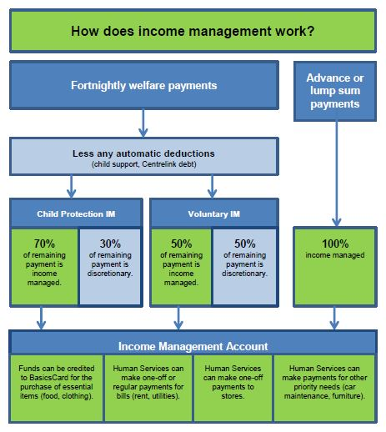

2.2 Income management in Western Australia
In February 2008 the State Coroner of Western Australia released a report recommending that income management be introduced in Western Australia as an additional case management tool for the Department for Child Protection and Family Support to address child neglect.
Income management in Western Australia was introduced by the Social Security and Other Legislation Amendment (Welfare Payment Reform) Act 2007 (Cth).
Since 2008, Child Protection Income Management and Voluntary Income Management have been implemented progressively in the Perth metropolitan region, and the East and West Kimberley districts (referred to collectively here as the Kimberley region) and the Peel district of Country Western Australia. It has also been extended to the Laverton Shire and the Ngaanyatjarra Lands (including Kiwirrkurra) under a different measure from 15 April 2013.
Child Protection policy allows its workers to consider referring their clients to Human Services for income management, on a case-by-case basis in the following circumstances:
- where parents’ use of their available resources is contributing to neglect of the child/children
- as part of a reunification plan, to enable the child to return home safely
- to assist at-risk young people’s use of available financial resources (especially those leaving care) to achieve independence and safeguard their wellbeing
- where a pregnant woman’s (or the child’s father’s) use of available financial resources is likely to result in the child being at risk of significant harm due to neglect when born.
Within a child protection client’s case plan, income management may be one of a number of strategies Child Protection uses to improve child wellbeing and safety. Other strategies may include referral to psychiatric or psychological counselling, drug and alcohol programs, parent support services, StrongFamilies services and respite services.
Income management is only an option for Child Protection clients who are welfare recipients as income management only applies to welfare payments delivered by Human Services, not to other forms of income, such as wages. The Child Protection clients referred to in this review are therefore all recipients of welfare payments unless otherwise stated.

Funding
The Australian Government initially provided $18.9 million over two years in 2007–08 and 2008–09 for a trial of the Child Protection Income Management and the Voluntary Income Management streams in Western Australia. This funding also included additional funding for Financial Management Support services. The Australian Government provided an additional $13.2 million in 2009–10 and $11.8 million in 2010–11 for the trial.
In 2011 the Australian Government announced it would invest an extra $17.9 million to continue the trial in its existing locations; to extend the trial to the Peel District; and to provide Financial Management Support services in Western Australia in the 2011–12 financial year. In the 2012–13 Budget, the Australian Government announced that the Western Australian trial would be extended until 30 June 2013, at an additional cost of $13.5 million. To continue the trial, $11.8 million was allocated in the 2013–14 Budget.

Figure 2.2: Australian Government funding for the income management trial and related services in Western Australia
Year | Funding
2007–08 and 2008–09 | $18.9 million
2009–10 | $13.2 million
2010–11 | $11.8 million
2011–12 | $17.9 million
2012–13 | $13.5 million
2013–14 | $11.8 million

2.3 Financial management support services
The Financial Management Program aims to build financial resilience and wellbeing for those most at risk of financial disadvantage and social exclusion. The program funds a range of service strategies, including money management and Commonwealth financial counselling services that are free, community based, voluntary and confidential. These services support income-managed recipients and their families to improve their immediate and longer term money management skills by providing financial management training and advice to address crisis situations.
The services encourage recipients to take control of their financial wellbeing by delivering budgeting and tailored money management education (e.g., on responsible spending, bill payment options, savings, reducing debt, increasing asset purchases, and planning for the medium and long term). The use of these services by income-managed recipients is encouraged by Human Services.

2.4 Incentive payments
When New Income Management in the Northern Territory was introduced in July 2010, the Australian Government reduced the income-managed portion of West Australian Voluntary Income Management recipients’ welfare payments from 70 per cent to 50 per cent of their fortnightly payments. The Australian Government also introduced two new payment schemes.
- The Matched Savings Payment Scheme (available only to recipients who are income managed under a compulsory option such as Child Protection Income Management) is intended as an incentive to encourage recipients to develop a savings pattern and increase their capacity to manage money. This is a one-off payment of up to $500 matched for every dollar a recipient saves in their personal savings account.
To be eligible for a Matched Savings Scheme payment recipients must:
  - have completed an approved money management course
  - show that they have been saving for at least 13 weeks, with the savings not coming from income-managed funds
  - have saved the same amount of money in their personal savings account that they want to receive through the scheme.

- Voluntary Income Management recipients are eligible for an incentive payment of $250 for every 26 continuous weeks they remain on Voluntary Income Management.
When a recipient qualifies, Matched Savings Scheme Payments and Voluntary Income Management Incentive Payments are automatically paid into their income management account.

3. Methodology

Introduction
This chapter describes the methodological approach of this review. Three main forms of data were collected specifically for the review:
- in-depth interviews with Child Protection clients who are, or were, having their welfare payments income managed
- interviews and focus groups held with intermediaries involved in the implementation and administration of Child Protection Income Management and a small number of stakeholders in the Goldfields region of Western Australia, where income management was not available at the time, to obtain a comparative perspective
- a systematic analysis of a sample of case files of current and former Child Protection clients who are, or were, having their welfare payments income managed.
These three datasets were supplemented by existing data from Human Services on the overall population of recipients on Child Protection Income Management, and their patterns of movement on and off it.
Qualitative methods were employed in the primary fieldwork components of the research, including all recipient and intermediary focus groups and interviews. Both qualitative and quantitative information was obtained from the case file review.

3.1 Ethics
The review team applied to the former FaHCSIA Human Research Ethics Committee for ethical approval and was advised on 12 April 2012 that the Ethics Committee was satisfied that the review met the requirements of the National Health and Medical Research Council’s National Statement on the Ethical Conduct of Human Research and related guidelines.
The review team sought approval from the Ethics Committee on 29 November 2012 to supplement the data obtained from Child Protection case files with variables capturing income management commencement and cessation dates from the Human Services datasets. The Ethics Committee approved this request on 5 December 2012.

3.2 Case file analysis
A key aspect of the methodology was a systematic review and analysis of a sample of case files of current and former Child Protection clients who at some point had their welfare payments income managed. The case file component of the review draws on the methodology and practices employed by the 2007 Evaluation of the Family Court of Australia’s Magellan case management model (Higgins, 2007).

Sample
A sample was selected for the case file analysis from the Human Services database. The database contained all Child Protection Income Management recipients (n=647) who had not opted out of being contacted for research purposes and whose contact details were available.
The stratified sample comprised 156 current and previous Child Protection Income Management recipients. The sample was stratified on the following variables:
- recipients in the Child Protection Income Management stream (current and previous)
- location (Perth metropolitan region or Kimberley region)
- Indigenous indicator (identifying as Aboriginal and/or Torres Strait Islander is voluntary; therefore, the actual number of Aboriginal and/or Torres Strait Islander persons may be underestimated in the Human Services administrative data)
- age
- gender.
After a review of the 156 recipients in the original sample, only 92 of the files in the sample remained in scope. The 64 case files out of scope were Child Protection cases referred to income management that were ineligible as the recipients had no trigger payments (see Glossary). Other case files which were out of scope were those where the client was deceased or incarcerated. The final sample of 92 recipients included 30 in the Kimberley region and 62 in the Perth metropolitan region.
The purpose of selecting case files of clients who were formerly (but no longer) on Child Protection Income Management (n=47) was to determine:
- whether those who came off income management did so because their case plan goals had been achieved
- whether those who came off income management were taken off for reasons such as resource constraints or moving out of the area.
Recipients who had previously had their welfare payments income managed were selected also to determine if intermediary practices and recipient experiences had changed over the time that Child Protection Income Management has been operating in Western Australia (based on the assumption that those who had ceased income management would disproportionately be recipients who had their welfare payments income managed in earlier stages of the trial).
The review would have also benefited from a third group—a comparison group—comprising families involved with the Child Protection system with similar characteristics and issues to those included in the study but living in locations without income management. However, the review team was not able to access case files for such Child Protection clients. The absence of a comparison group was mainly due to time and resource constraints; including one would have enabled the review team to assess the extent to which these Child Protection clients were able to address parenting and financial management issues in the absence of Child Protection Income Management and, if possible, gauge short and medium-term outcomes for children whose parents are not income-managed recipients.

Data collected and analysed
To facilitate the collection and analysis of case file data, the Australian Institute of Family Studies designed a database to extract mainly qualitative information contained in the case files. Case file analysis was conducted in June 2012 and November 2012, collecting the following information:
- demographic information (family structure, age of parents and/or primary carers and children, region, remoteness, Aboriginal and/or Torres Strait Islander status, cultural and linguistically diverse status)
- primary child protection concern and other presenting issues—including financial difficulties and other indicators of financial vulnerability
- outcomes of safety and wellbeing assessments—substantiations
- numbers and nature of notifications before, during and after periods on Child Protection Income Management
- care plan implemented and assistance provided
- referrals—including to financial management service providers
- reasons for being put on Child Protection Income Management
- Child Protection workers’ impressions of impact of Child Protection Income Management on family (if noted).

3.3 Interviews with Child Protection Income Management recipients
Semi-structured interviews were conducted with recipients who are or who have been income managed in the Perth metropolitan region and in two towns in the Kimberley region, Broome and Kununurra. Interviews with recipients were audio-recorded where recipients agreed. All audio recorded interviews were transcribed. The transcriptions were de-identified and kept in a safe at the Social Services national office.
Coding the interview transcriptions, using a number of themes, was done separately by two review team members before discussing the themes together and agreeing on the coding.

Sampling and recruitment
A flexible approach was taken in the recruitment of income-managed recipients, especially those who were resident in the remote Kimberley region.
An information and communication campaign to raise awareness about the review and promote participation in interviews was developed. Factsheets were produced containing general information about the review for recruitment purposes, to be distributed to intermediaries and stakeholder groups in May 2012. All communication products were developed with the support of the Social Services Communications and Media Branch and Child Protection Aboriginal Engagement Officers (Appendix B).
All 647 recipients in the original sample were sent a letter giving them the opportunity to opt out of the study. The letter contained information about the review and advice on opting out of it, whether through a toll-free telephone number, email or returning the opt-out slip in a reply-paid envelope. Recipients had two weeks in which they could opt out of the review. Six recipients opted out.
An opt-in postcard was designed by the review team and supplied to intermediaries in Child Protection, Human Services and financial counselling services, as well as to money management service providers’ offices for distribution to Child Protection Income Management recipients across the Perth metropolitan and Kimberley region between 8 and 11 May 2012. The postcard provided information about the study and made it clear that participation was voluntary and confidential. Recipients were encouraged to drop the cards into a secure box (provided at each service where the postcard was available) or return them postage paid, email, or call on a toll-free 1800 hotline.
Twelve Child Protection Income Management recipients volunteered, completing the opt-in postcards. However, when contacted only three agreed to participate in interviews.
The 92 Child Protection Income Management recipients selected for the case file review were invited to participate in the interviews. Different methods were used to contact recipients in different regions.
The 62 recipients from the case file review within the Perth metropolitan region were sent text messages inviting them to take part in the study. Interviews were scheduled either face to face or by phone; 21 recipients were interviewed face to face and 11 by phone. Fieldwork was conducted between 22 May and 31 August 2012. In total, 24 interviews were completed in the Perth metropolitan region (interviewed by telephone n=11; additional Child Protection Income Management recipients who were referred to the evaluation team by intermediaries n=10; opt-in postcard process n=3).
The 30 Kimberley region recipients from the case file review were contacted by engaging the use of Child Protection Aboriginal Practice Leaders (APLs). APLs were provided with a list of the clients for recruiting and were asked to assist in arranging appointments and to be available for introducing the interviewers to clients. In addition to recruiting recipients, APLs were also actively promoting the research. Eight interviews were arranged. No interviews were obtained from non-Indigenous recipients. It should be noted that the proportion of non-Indigenous Child Protection Income Management recipients is very low in the Kimberley region. Fieldwork was conducted between 14 and 22 May and between 10 and 14 September 2012. Figure 3.1 below gives the characteristics and size of the sampling frame and final sample.

Figure 3.1: Sampling frame and final sample
Characteristics | Location | Total  population  (n=647) | Target  sample | Actual interviews  conducted  (n=32)
Current Child Protection Income Management recipients | Perth Metropolitan | 148 |  | 18
 | Kimberley Region | 66 |  | 4
 | All | 214 | 20–40 | 22
Former Child Protection Income Management recipients | Perth Metropolitan | 225 |  | 6
 | Kimberley Region | 208 |  | 4
 | All | 433 | 20–40 | 10

Payments to recipient for participating in this review
Each recipient who took part in the study received a $30 Woolworths or Coles voucher at the completion of the interview to recognise their time, travel and knowledge. The vouchers did not include alcohol, tobacco or phone cards.

3.4 Interviews with intermediaries and stakeholders
A total of 149 intermediaries participated in the review, either individually or in focus groups, from the following organisations:
- 111 Child Protection staff (case workers and team leaders involved with Child Protection Income Management attending interviews or focus groups in Child Protection offices)
- 19 Human Services staff (team leaders, customer service advisers, income management co-ordination officers and other staff regularly involved with Child Protection Income Management)
- 13 financial service providers (financial counselling or money management providers)
- 27 legal aid staff, court officials and staff from law enforcement and other welfare sector bodies and community organisations.
Most of the interviews and focus groups were conducted in person (n=31). However, others were conducted by telephone (n=9) (either individually or in a teleconference). Interviews were conducted by both Social Services and AIFS researchers.

Participation process
Prior to the fieldwork period, each of the participating agencies were sent letters about the review and factsheets from FaHCSIA. The factsheets, distributed by each agency, provided general information about the review and a general idea of the areas of their work the researchers would be asking questions about. The factsheets were designed to encourage intermediaries to participate in the review, give them time to think about this area of their work before they were interviewed and ensure they were able to provide informed consent if they wished to participate.
In the weeks preceding fieldwork with intermediaries, management of participating agencies were able to alert prospective interviewees to the study through their regular communication channels, including staff emails and newsletters. Although management from those agencies helped to identify relevant staff, all interviews were treated as strictly confidential.

3.5 Client confidentiality
To ensure client confidentiality the Child Protection case file database was password protected and housed on an encrypted laptop. The laptops were set up so that no access to the internet or any other programs were allowed. The laptops were stored in a Class B container in a locked office at Child Protection when not in use.
To further ensure client confidentiality, when undertaking case file analysis within Child Protection, two review team members were submitted to the same confidentiality and data protocols as Child Protection staff (including undergoing security clearances) in May 2012.
For confidentiality, recipients interviewed for this review are not geographically identified.

3.6 Australian Department of Human Services (Human Services) data
The review team used two Human Services datasets to inform the review. The first contained the contact details and basic demographics of Child Protection Income Management recipients and was used for sampling purposes. The second were weekly datasets containing detailed information for each recipient, whether currently income managed or income managed between 5 March 2010 and 16 November 2012. As well as basic client and demographic information, this database included information on:
- transitions on and off income management (Child Protection Income Management and Voluntary Income Management)
- duration of being on income management (Child Protection Income Management and Voluntary Income Management)—total length of time and any extensions
- number of episodes on income management (Child Protection Income Management and Voluntary Income Management).

3.7 Participation rate of financial counselling and money management services
The review sought the view of service providers employed at agencies funded to provide financial counselling and money management services in areas of Western Australia where Child Protection Income Management has been implemented. The 15 agencies were identified by the Social Services state office. However, as the agencies are funded by Social Services, the interviews were organised and undertaken by AIFS.
An email was sent to representatives of the agencies by the Social Services state office team in August 2012. The AIFS research team then undertook additional emails and phone calls to key staff nominated by the Social Services state office to seek their participation. Of the 15 agencies contacted, two replied that they did not want to take part, seven participated in interviews and six did not engage with the study. Of the two types of services being explored (money management and financial counselling), one agency provided money management services only, three provided financial counselling only, and two provided both. One of the services was located in the Kimberley region, and the others were located in Perth. There was a mix of individual (n=3) and group interviews (n=3), with a total of 13 people participating in these interviews.

3.8 Participation by other organisations
Invitations were sent to the following non-government organisations to obtain feedback about income management and any increase or decrease in services since the start of the income management trial:
- Anglicare
- Uniting Care
- Yorgum Aboriginal Corporation
- Australian Red Cross
- Smith Family
- Relationships Australia
- Women’s Health Care Association
- Ngala Community Services
- Wanslea Family Services
- Centrecare
- Western Australian Council on Social Services (WACOSS)
Only two of these organisations responded.

3.9 Data limitations

Case files
The review team initially hoped to access around 600 case files. An original sample was drawn from Human Services that contained all Child Protection Income Management recipients (n=647) who did not opt out from being contacted for research purposes whose contact details were available.
This number was reduced to 156 due to difficulty matching the Human Services data and the Child Protection data (and resourcing issues within Child Protection), particularly matching names and addresses.
Of the 156 cases selected, a further 64 were unavailable because recipients were deceased, incarcerated or had been referred to income management but were apparently ineligible because of the lack of trigger payments.
Because of the reduced number (n=92) of case files, some analyses were not attempted because of low sample numbers and issues of privacy for the Child Protection recipients.

Human Services data
Administrative data only records whether a person is a Voluntary Income Management recipient; it does not identify whether the recipient is also engaged with the child protection system.
Financial counselling and money management services
Approximately half of the services approached agreed to participate in the review. The small number of services participating is a limitation.

An initial review of a subsample of the case files led to refinement of the review questions
The case file data analysed in this review was collected for the purposes of administering child protection rather than analysing the effect of income management on child protection outcomes in Western Australia. A subsample of case files was reviewed to see if the data in the case files would allow the original review questions to be answered. Following this review, the original review questions were refined so the remaining case files in the sample could be analysed consistently. Interesting themes emerged in the case file analysis, which informed the interviews and focus group discussions. The original questions submitted in the ethics application are at Appendix A. The refined questions are outlined in Section 1.4.

4. Review findings—process

Introduction
This review includes a process component which looks at the effectiveness of different elements of program administration and the extent to which reforms to Child Protection Income Management introduced in July 2010 have been effectively implemented. The 2010 reforms reduced the portion of welfare payments subject to income management for recipients in Voluntary Income Management in Western Australia from 70 per cent to 50 per cent to align with Voluntary Income Management in the Northern Territory.
The data in this chapter reported by staff from Child Protection and Human Services is drawn from interviews and focus groups for each organisation conducted in the Perth metropolitan region and the Kimberley region. In addition, the chapter draws on interviews with staff from financial counselling and money management services in both the Perth metropolitan region and the Kimberley region. Where possible, the analysis highlights similarities and differences in the administration of Child Protection Income Management in the Perth metropolitan region and the Kimberley region.
This chapter looks at the referral process to income management including the role of both Child Protection and Human Services; the relationships between agencies; and the role of financial counselling and money management services. The chapter combines data on the take-up of income management and the case file reviews with data from interviews with recipients and intermediaries. When these three datasets are assembled, it is possible to build up a picture of how effectively the program is being used and to identify potential issues with, or gaps in, service delivery practices.

4.1 Referral process—Government of Western Australia Department for Child Protection and Family Support (Child Protection)
As outlined in Chapter 2, the Social Security and Other Legislation Amendment (Welfare Payment Reform) Act 2007 (Cth) provides the authority for Child Protection staff to refer recipients to income management in cases where the poor use of financial resources is contributing to child neglect. A referral to income management is made to Human Services through the Unified Government Gateway system to request income management of a portion of a recipient’s welfare payments.
The decision to refer a recipient to Child Protection Income Management must be based on the referral criteria, as outlined in Child Protection’s Casework Practice Manual, and endorsed by a team leader. The child protection worker must inform the recipient about the reasons for being referred to Child Protection Income Management; the duration of the time the recipient will participate in income management (which can be three, six, nine or 12 months); and the process through which a recipient can seek a review of the decision.
Recipients can seek a review of Child Protection’s decision to place them on Child Protection Income Management. Recipients can also seek a review of the duration of, and any extensions to, the period of income management. Anecdotally, staff suggested that the number of recipients requesting a review has been very low, but an analysis of this issue is outside the scope of this review.
Child Protection staff have a number of different tools available to them to assist families who enter the Child Protection system. Some of the services they can refer parents and carers to are:
- StrongFamilies Program
- Family and Domestic Violence
- Best Beginnings—0 to 2 years
- Parent Support—0 to 18 years
- Bereavement Assistance Program
- Income Management
- State Concession Card.
In crisis situations they can refer to:
- Crisis Care Helpline
- Family and Parenting Helplines
- Domestic Violence Helplines
- Emergency Services
- Crisis Accommodation and Homelessness Services.
Figure 4.1 shows the rate of participation in both Child Protection and Voluntary Income Management since both were introduced in November 2008.

Figure 4.1: Trend of recipient numbers on Child Protection Income Management and Voluntary Income Management—Western Australia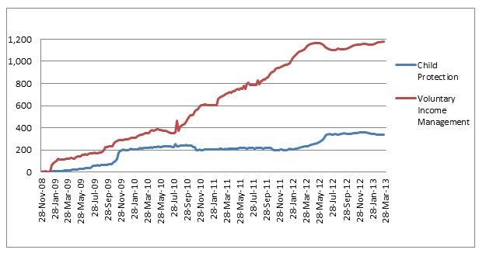The initial rate of take-up for Voluntary Income Management and referral to Child Protection Income Management was relatively slow. The ORIMA report found that there were some initial delays in the take-up of income management in Western Australia (ORIMA, 2010). The report further found that there was a lack of understanding of the income management system and how it works, a finding in common with this review. Some Child Protection staff members interviewed, as well as recipients, also showed a lack of understanding of some of the details of the income management program. This appeared to be due to the rate of staff turnover in Child Protection. There was also initial resistance to the program because it was associated with the income management model introduced in the Northern Territory Emergency Response (commonly referred to as ‘the intervention’).
The slow initial rate of referral to Child Protection Income Management may also have been partly due to staff concerns about its compulsory nature. Most Child Protection staff interviewed for this review said they encouraged recipients to take up Voluntary Income Management before referring them to Child Protection Income Management. This could also partially explain the higher take-up of Voluntary Income Management compared to Child Protection Income Management, at least after the introduction of the July 2010 changes that reduced the proportion of Voluntary Income Management recipients’ welfare payments that are income managed from 70 per cent to 50 per cent in Western Australia, to align it with Voluntary Income Management in the Northern Territory.
At this time, additional payments were also introduced: Matched Savings Scheme payments for recipients on Child Protection Income Management and an Incentive Payment for recipients who remain on Voluntary Income Management for 26 continuous weeks. Human Services staff noted that the different eligibility criteria for additional payments between the two income management streams may have been an extra incentive for recipients to volunteer for income management.
I think it's something that, just in my recent experience, is where people are wanting to go down that path of Voluntary Income Management, as opposed to compulsory [Child Protection Income Management]. (Human Services staff member, Kimberley region)
The rate of take-up of Voluntary Income Management increased significantly from July 2010, most likely due to changes made to both streams of income management. These changes were seen by Child Protection staff to increase the incentive to participate in Voluntary Income Management rather than be referred to Child Protection Income Management.
We've also been really clear about trying to encourage clients to use Voluntary Income Management as well, so they become a party to that decision. And if we're not able to achieve that through supporting them to go through that process [Voluntary Income Management], and we think it's still important, then we would do it [refer the client to compulsory income management]. (Child Protection staff member, Kimberley region)
Over time, many Child Protection staff reported that they came to see Child Protection Income Management as a useful tool which could help improve the lives of individuals and their children.
We've always tried to let staff know it's a tool, like a number of other tools that they've got in their kit bag. (Child Protection staff member, Kimberley region)
While some staff members reported feeling troubled by the compulsory nature of Child Protection Income Management, these staff also said they would use it when they felt it would help.
I must admit part of me is strong on human rights and all that sort of stuff and wants to say, no, no, no. But the child protection side of me is saying yes. (Child Protection staff member, Kimberley region)
There were some mixed views about the reduction in the rate of payments which are income managed under Voluntary Income Management. The change from 70 per cent to 50 per cent may have increased the incentive for recipients to volunteer for income management rather than be referred to Child Protection Income Management. However, some staff in the Perth metropolitan region felt that income-managing only 50 per cent of eligible payments was not adequate to help recipients in Perth, given the high cost of living in Western Australia,
One of the issues that comes up is voluntary [income management] being fifty-fifty. What we are finding is that for some of our clients, well a lot of them, the fifty per cent that is income managed doesn’t actually cover the bills. (Child Protection staff member, Perth metropolitan region)
Child protection staff were concerned that because of the different rates being income-managed, some recipients who wanted to participate in Voluntary Income Management end up being referred to Child Protection Income Management due to high cost of living expenses.
I guess we want to be able to engage with them as well, if we can give that opportunity for them to do that [take up Voluntary Income Management]. The problem is sometimes they then take themselves off, so it kind of defeats the purpose in the end and we have to put them on compulsory [Child Protection Income Management]. The rent is so high that fifty per cent may just cover the rent, but doesn’t cover the electricity, the gas and all the other things that go with it. (Child Protection staff member, Perth metropolitan region)
One of the issues identified by staff that may have impacted on referrals to Child Protection Income Management prior to December 2012 was the policy requirement to keep case files open while a client was on income management. Staff suggested they were deterred from referring clients (meeting the referral criteria), where Child Protection’s involvement with the family was ceasing and the case would otherwise be closed. In these cases, sufficient safety for the child had been achieved and there was no further active role for Child Protection. In such situations, Child Protection would not normally keep a case open where the only reason to do so was to meet this income management requirement.
We don't want to keep cases open just to have open cases. Because we've got legislation on the number of cases workers can hold. To have somebody having an open case just because of income management [is a problem in terms of caseloads]. (Child Protection staff member, Kimberley region)
This issue was addressed in late 2012, when practice guidelines were amended to include the option that, where income management is the only reason for a case remaining open, child protection workers may close the case, with the duty officer as the designated contact point for Human Services, and the recipient can remain on Child Protection Income Management until the designated end date. This is particularly useful where Child Protection Income Management is having positive effects on the child and the family needs to establish or maintain ongoing stability.
An increase to the rate of referral to Child Protection Income Management was experienced between March and June 2012. Anecdotal feedback suggested the fieldwork undertaken at the same time period, which involved visits from the review team and a number of information products to support the review, contributed to the increase in referrals by bringing staff attention to the use of income management as a useful tool to consider. However, there may have been other contributing factors. The commencement of Operation SHARP (Safely Home with A Responsible Person), a program which aimed to keep children off the streets at night in the first week of June 2012, for example, may have caused an increase in Child Protection Income Management recipients towards the end of June.

Targeting
Child Protection staff can use income management in a variety of circumstances:
- child neglect cases, where poor use of financial resources is a contributing factor
- concerns for unborn children, where poor use of financial resources is likely to result in the child being at risk of significant harm due to neglect when born
- multiple presentations for financial assistance, where an individual or family presents to Child Protection multiple times within a short period
- young individuals, where there is a concern for the welfare of a young individual receiving welfare payments while living with their family
- reunification cases, where poor use of financial resources is a barrier to reunifying parents with children who have been removed and placed in foster/kinship/residential care, as it is likely to result in neglect of the child
- young individuals in care, to assist a young individual leaving care to live independently
- a person (who receives an eligible welfare payments payment) staying in the home of a parent /carer on Child Protection Income Management, where their use of financial resources contributes to child neglect or undermines the safety goals for the child or family member on Child Protection Income Management.
The review of 92 child protection case files found that Child Protection Income Management was being targeted appropriately. In the sample of case files, the most common reason for referring recipients to income management was financial difficulties which could result in risk of homelessness, unpaid debts or children not attending school for financial reasons. In some cases, referral was due to factors other than financial issues—however, financial issues were generally seen as compounding factors.
Figure 4.2 shows the major issues associated with income management referrals for individuals in the case file review. In all cases, income management was considered likely to assist in addressing the issue.

Figure 4.2: Percentage of individuals from case file review with certain issue types at time of being referred to income management
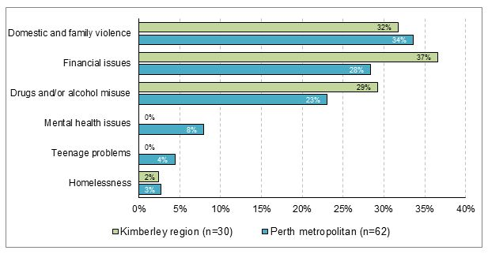
In the Perth metropolitan region, the most frequent primary issues noted in the case file sample were domestic and family violence, financial issues and drug and/or alcohol use. Although only 3 per cent of the case files in the Perth metropolitan region had homelessness as the primary issue, staff commented that those with financial issues could all be seen as under threat of homelessness, as financial issues frequently involved debts and difficulty paying rent. The issues in both the Perth metropolitan and Kimberley region were similar, although mental health was not one of the primary referral reasons recorded in the Kimberley region case files in the sample.
Some Child Protection staff explained how they gave careful thought to referring a recipient to income management. Some staff felt that if the removal of the child was inevitable, it was too late to use income management as a tool. All agreed that if the recipient was not having financial issues they would not be referred.
We’re very much supportive, we’re not one to put every single client on income management, we think very carefully about it, it’s not automatic. I think it’s something we have to see will have a benefit for the child in order to do it. (Child Protection staff member, Perth metropolitan region)
Some Child Protection staff said that if the issues were too overwhelming they did not attempt to place the recipient on income management, and some said they did not even think about income management in those situations. Others said they carefully considered whether income management might exacerbate problems for vulnerable family members,
I suppose because we've got such a high level of family violence, we've also always been really mindful of not actually re-victimising the mother or putting her in a position where she is likely to be further at risk if income management was applied to the family, and that meant that dad was going to take that out on her. (Child Protection staff member, Kimberley region)
A number of Child Protection staff found that a solution to this problem was to refer all adult members of the household to income management. In this way all adult household members have their income restricted and contribute to the household expenses, supply of food and necessities.
Also we're now looking at all adults in the home going on income management. So that reduces the amount of [discretionary] money they've got. We've got houses where there could be half a dozen adults in there. If you just put the mum on it, then the others have still got [money]. Plus they're better off because they've got this food in the house for them to eat. (Child Protection staff member, Kimberley region)
In the Kimberley region, Human Services staff attend to recipients referred by Child Protection who are family or community members without children of their own but who are living in the home of a recipient on Child Protection Income Management with children. Any recipient staying in the house of someone on it (whether they have children or not) can be placed on Child Protection Income Management by Child Protection if they are contributing to neglect of children. This practice aims to stop other household members eating the food bought on the BasicsCard, or to encourage contribution to paying household bills. This practice also limits the amount of money in the household available for buying goods on the prohibited list. This adaptation of the use of the program reflects the more complex household structure in the Kimberley region.
I think targeting not just the caregivers in the household but targeting the whole household [is important] because it's that accumulated harm from everyone around them that is increasing the risk to the kids and not getting their needs met. (Child Protection staff member, Kimberley region)
Staff also differed in their ideas about the appropriate timing of income management referrals. Some staff, often operating within particular Child Protection offices, expressed a preference for using income management as an early intervention tool, while others thought it was only appropriate if children were being assessed to be taken into care,
Sometimes we do it, we let them go too far … like basically too far into debt and then we put [them] on and it’s almost like too late by then, because then they are getting evicted or something like that, and then we’re like, ‘oh, we’ll put you on income management now’, when really we should have done it earlier … and then that’s too late because they’ve lost their house or whatever. (Child Protection staff member, Perth metropolitan region)
A number of Child Protection staff interviewed for the review reported finding that income management provides a level of protection for vulnerable individuals. Despite a slow rate of referrals early in the trial, staff members who were interviewed said they were increasingly using income management as they saw the value of Child Protection Income Management in stabilising the recipient’s financial situation. Most staff members interviewed preferred recipients volunteering for income management. Child Protection staff refer recipients to Child Protection Income Management if the recipient does not volunteer.
Income management has been used in the early stages of interactions, particularly with vulnerable teenagers, and late in the process when the child was in the process of being taken into care. It has been used with individual recipients only and also trialled with all adult recipients in the household who have an impact on the welfare of the children in the household. Child Protection staff members who took part in the review are eager to learn from each other and use Child Protection Income Management to best support recipients in the interests of the children in their care.

4.2 Process—Australian Government Department of Human Services (Human Services)

Initial interviews
The guidelines for recipients referred to Child Protection Income Management by Child Protection state that recipients must attend an initial interview with Human Services to discuss options for the allocation of their income-managed funds. If the recipient does not attend the initial interview, which can be conducted either in person or by telephone, Human Services staff attempt to contact the recipient to reschedule the appointment. In practice, staff can try to contact the recipient up to three times to reschedule. If the recipient cannot be contacted, or does not attend the rescheduled appointment, Auto Income Management (see Glossary) is applied.
Child Protection staff who had made a referral to Child Protection Income Management generally reported discussing the recommendation with the recipient before the referral was made. However, this was seen as not always being possible, particularly for recipients who are difficult to engage. For some recipients, the letter from Human Services inviting them to attend an interview can be the first time they become aware of the referral to income management. This can result in the recipient being angry when they are interviewed by Human Services staff:
Usually, they're a little bit angry or aggressive because they're not happy and the first thing is, ‘we've been looking after our kids’. We just say, look, we don't know why you're on income management. However, let's move on and take it to your case manager at Child Protection. But usually they initially can be quite angry. Particularly things like, I can't use it at KFC [Kentucky Fried Chicken]. I can't use it at McDonalds, my BasicsCard, so, they’re the issues that hit them. (Human Services staff member, Perth metropolitan region)
Human Services staff and managers noted that there were some aspects of the way they were working with income management recipients that could be improved. Privacy, particularly where the initial interview occurs in an open cubicle, was seen as an issue for both staff and recipients. Many recipients experienced feelings of shame and stigma during this initial interview and were embarrassed to talk about their circumstances.
Also, if you're talking about personal things, people don't want to bandy it about to every CSA [Human Services staff member]... you shouldn't have to … [know] why I'm on income management, at least the whole office doesn't [have to] know. (Human Services staff member, Perth metropolitan region)
Human Services staff described different models for working with recipients on Child Protection Income Management in the different offices. Staff interviewed in the Perth metropolitan region thought their approach, where Child Protection Income Management recipients are referred to a specialist team, was preferable to the approach in the Kimberley region, where all front-of-house staff engaged with income-managed recipients. This was because staff felt that using a specialist team meant they were able to provide consistent, high-quality advice and they got to know the recipients better. Human Services staff observed that this meant recipients did not need to retell their story at every visit and also allowed staff to work with them using detailed knowledge of their individual circumstances.
People cannot ‘shop around’ Centrelink [Human Services] offices. There is consistency of interviews … reduces the client ‘bulldusting’. (Human Services staff member, Perth metropolitan region)
Another staff member explained:
The way we work reduces [recipient] aggression as their story is known, and the client has a rapport with the staff. (Human Services staff member, Perth metropolitan region)
In the longer term, some Human Services staff reported negative consequences of having a more personalised relationship between staff and recipients. There was some concern that having an ongoing relationship with one Human Services staff member could lead to recipients seeing them as their default case worker.
You can build up a good relationship with these [recipients]. They do know you and they do trust you and they—not that you have all these miracle answers for them—but they'll come in and even if they just want to talk about it and I can send them to a welfare agency, whatever, but they'll say, well, ‘we always see [XX]. I really don't want to see anyone else.’ … you do build up that relationship with your [recipients]. (Human Services staff member, Perth metropolitan region)
Human Services staff members and one manager expressed concern that they are not trained as Child Protection case workers but felt that they are taking over that role, as the income-managed recipient’s Child Protection case workers often change.
You've got a [recipient] on Income Management for a 12-month period and up to three or four case workers, in 12 months. If the whole concept is to get a [recipient] back to the point where their kids are not neglected, you would need, in my opinion, the ability for one case worker to work with that family. (Human Services staff member, Perth metropolitan region)
Human Services staff acknowledged that the Child Protection staff turnover is:
Huge … because they're overloaded. (Human Services staff member, Perth metropolitan region)
In the Kimberley region, all Human Services staff deal with income management referrals as there is no dedicated income management team due to of lack of office resources.

Allocation of funds
The guidelines for the allocation of income-managed funds outline a clear process for Human Services staff to follow. During the initial interview the recipient and staff member assess which priority needs should be met using the recipient’s income-managed funds. (These needs are identified and prioritised by the Child Protection case manager and included in the referral.) The needs of children are given the highest priority. Income-managed recipients will make the decision about how much of their money is allocated to each expense, provided Human Services is satisfied that their needs are being met.
For most recipients, rent is the first expense to be allocated. Other regular expenses might be power bills, rates and school expenses. Human Services can send money to the nominated accounts as requested. Recipients can also allocate an amount to their BasicsCard for food and other items to use at approved stores. The BasicsCard is used as a debit card through an EFTPOS system at approved stores and businesses.
Any remaining unallocated money from income-managed funds is referred to by income-managed recipients as ‘kitty’ (see Glossary). Funds accumulated in the kitty may be accessed at any stage and used for lump sum expenditures.
Human Services staff reported seeing a positive impact on children’s experiences of school through the allocation of money to schools for breakfast club, excursions and uniforms, noting that this could only be done with the agreement of the recipient. Human Services staff reported that some recipients were resistant to allocating some of their income-managed funds to schools.

BasicsCard
Most of the Child Protection staff interviewed across all districts in the Perth metropolitan region expressed concern about how the BasicsCard could be misused. Child Protection staff members talked about some recipients using the BasicsCard to buy gift cards, petrol and goods for resale at a discount.
I read one case file where they were buying, spending all their BasicsCard on petrol … after hearing the mum's version of the story, she was unable to use any money to buy food, clothing and stuff for the children, so we put them on income management so she had a card, he had one … And then she had some kind of control over, and then I was starting to get reports that he was using, you know, buying fuel for people and getting cash back, and I think it was eighty per cent, so he was getting eighty per cent return on what he would spend for people. But tracking it through Centrelink [Human Services], he used that at Woolworths and Big W, and all those kinds of places so he was probably even buying some clothing and stuff for friends and they were paying him. (Child Protection staff member, Perth metropolitan region)
This practice, aimed at obtaining cash, effectively leaves the income-managed seller with less.
Human Services staff in the Kimberley region highlighted more problems with BasicsCard than their counterparts in the Perth metropolitan region. Some of the concerns in the Kimberley region were about the BasicsCards going astray, being lost or stolen, gambled or the card traded for cash.
You'll see a third or fourth re-issue [of a BasicsCard] in the last three months and no matter what you say, it's just as important as your key-card, they still continue to lose it. When I have that discussion, because I say, well, where's your Basics Card? So and so took it, or I left it at home for my kids. So, that's what they do. (Human Services staff member, Kimberley region)

Royalties from private enterprises
Royalties are paid to Aboriginal communities as compensation for the use of their land by private companies for mining, exploration or other uses. Although the money is increasingly being used for sustainable community development, it may also be distributed to individuals within the community. As royalties are not paid through Human Services, they are not subject to income management.
Most Child Protection staff in the Kimberley region reported that the most difficult time for them to manage recipients was when the community received royalty payments from private companies. This was a time of frustration for staff members as they saw recipients who had been doing well on income management go ‘off the rails’ because of the large amount of money coming into the community. This practice also encourages financial harassment.
Our Aboriginal practice leader refers to it [receipt of royalties] as finger money, so the nannas will have a bit of finger money that they can give to each respective grandchild, but those kids hit them up and it's not little bits. They want bigger bits of money ... (Child Protection staff member, Kimberley region)

Reconciliation moneys, schoolkids bonus and baby bonus—extras income managed
Other payments such as the Baby Bonus, reconciliation of Family Tax Benefits and the Schoolkids Bonus were also seen as an area of difficulty by Human Services staff. These payments are 100 per cent income managed, and the guidelines state that Human Services staff will discuss the allocation of these funds with recipients so they can consider any outstanding debts and other priority needs. Staff indicated that recipients could spend all of their ‘bonuses’ without having an interview, by accessing their income management account online and transferring the bonus payment to their BasicsCard, which could then be spent at approved retailers. Many of the Child Protection staff interviewed expressed frustration and disappointment about this practice.
My biggest concern—we've got income management [recipients] who have large, large debts with Homeswest, fines, Synergy, Alinta. We've just paid them, some of these [recipients], $4000 or $5000, $6000 and there is no policy in place from [Social Services] to say that money has to go towards outstanding bills. So, they've basically got the money, whacked it on their BasicsCard. In a matter of three days, it's gone. (Child Protection staff member, Perth metropolitan region)
Some Child Protection staff felt that, although it is efficient and convenient for recipients to be able to access their accounts online, this access allows those who are astute to access the lump sums before they are allocated and transfer the money to BasicsCard. They are then able to spend the money on large items from stores like Big W and sell the goods or gift vouchers for cash. Human Services staff interviewed for the review were happy for the recipients to use some of the money for their own purposes but felt that some should be used to pay off debt.
Only five of the 32 Child Protection Income Management recipients interviewed for the review were unhappy that 100 per cent of their ‘extras’ went into the income management account. Twenty-seven of the 32 interviewed wanted to make known their dissatisfaction with some elements of the BasicsCard (discussed in Section 5.1). However, this sample is not representative as this cohort agreed to be interviewed; those not interviewed might have responded differently.

Guidelines on monitoring and reviews
Information about recipients on Child Protection Income Management is shared between Human Services and Child Protection through a monitoring and review process. Human Services initiates a mid-point and final review with Child Protection case workers and consults on the ongoing impact and appropriateness of income management for each recipient and whether the recipient’s income management will be extended.
Where a case requires periodic review by a Child Protection case worker, and workload is an issue in respect of Child Protection workload management policy, the case may be placed on the monitored list if appropriate. Where Child Protection is not providing any services other than the referral to Child Protection Income Management, the case should be closed while the recipient remains on Child Protection Income Management until the end date, and the duty officer is the Child Protection contact point for reviews.
This review did not specifically address the monitoring and review process outlined above.

4.3 Relationship between agencies
Human Services staff commented that the relationship with Child Protection case workers was generally good, although some felt there was a lack of understanding among case workers about the referral system, possibly due to high staff turnover.
It has hiccups. I think Child Protection has a lack—their case workers are not trained in how to use the Unified Government Gateway [see Glossary]… as in, what the requirement is to put them on income management. I get a lot of calls … from case workers, asking for step-by-step instructions on how to put them on income management, or if that [recipient] meets the requirements for income management. It's their policies—they're the ones who should know that. (Human Services staff member, Perth metropolitan region)
The referral system was seen by managers to be most efficient in those Child Protection offices that gave the responsibility to one staff member to enter the client data through the Unified Government Gateway and maintain ongoing contact with Human Services.
Child Protection staff throughout the Perth metropolitan region found the Human Services team very helpful:
Since income management we’ve had probably less red tape, so more ability to talk about our mutual clients, share the goal … they’re more inclined to give more information. (Child Protection staff member, Perth metropolitan region)
Three-quarters of the Child Protection staff thought that improvements in the early referral stages could be made by Human Services informing them when their recipients’ payments start to become income managed and how the payments are allocated. This would help when recipients came back to Child Protection case workers saying they had no money available. The case file review showed that it was common for recipients to claim they had no money in the first month after being referred to income management.
Yeah, and then we can have an open and honest discussion at any stage [with the client] so it’s transparent from the beginning, rather than them, I guess, getting on the back foot once again while we’re going to have to check that out to see whether they’re telling us the truth. (Child Protection staff member, Perth metropolitan region)
Financial counselling staff felt that a team approach should be taken when allocating payments. They felt that bringing together Child Protection, Human Services, financial counselling or money management services and the Child Protection Income Management recipient when making decisions about allocating income-managed funds would result in a better outcome for the recipient.

4.4 Financial counselling and money management
At the initial income management interview, Human Services offers all income-managed recipients referral to a Financial Management Program Service—except where the recipient is already seeing a financial counsellor or money management service. Human Services also provides a referral to an approved money management course for Child Protection Income Management recipients who wish to qualify for the matched savings scheme.
Social Services requires that all money management providers in the Northern Territory and Western Australia who deliver services in locations where income management applies have MoneyBusiness as their approved money management course and part of their core service.
MoneyBusiness is an Australian Government initiative that aims to build the money management skills and confidence of Indigenous Australians and assist in building a stronger savings culture. It is located in specific sites in the Northern Territory and Western Australia. The program trains Indigenous people to work with their local community to develop skills to make the best possible money management decisions, better understand money matters, manage debt, save for the future and make better deals for themselves and their families when they shop.
Some financial counselling and emergency relief service providers in these locations also deliver MoneyBusiness as an approved money management course. The course has three components: registration, course reading materials and face-to-face sessions.
There is no obligation for the recipient to accept a referral or attend a meeting with a financial management program provider. Where the recipient does not take up the initial referral, Human Services will give them general information about how the services can help, as well as information about local service providers and how to make an appointment.
Human Services staff interviewed for the review indicated that recipients under Child Protection Income Management often did not appear interested in taking up the offer of additional services, and it was difficult to persuade them of the benefits.
I've heard comments from [recipients]—I know how to manage, I don't need someone to tell me what to do with my money. So you can understand how they must feel, but at the same time, it's beneficial for them anyway, or their kids. (Human Services staff member, Kimberley region)
This finding is in keeping with the income management evaluations in the Northern Territory (AIFS, 2010; Bray et al, 2012).

Source of referrals to financial counsellors and money management services for Child Protection Income Management recipients
Of the six financial counselling and money management services taking part in the review, half reported having had Child Protection Income Management recipients attend as a result of referrals from Human Services or Child Protection. One service, which saw many Child Protection Income Management recipients, reported these referrals as coming primarily from Child Protection. The other two services reported they had each had two or three Child Protection Income Management recipients attend their service as a result of referrals from Human Services.
Many noted that the referral portal, attached to the individual Human Services file and accessible by the money management staff, was a positive development as it enabled easier follow-up contact with recipients. While the portal provides opportunities for financial counselling and money management services to follow up with potential recipients, the follow-up process does not always result in recipients attending interviews.
Well, one of the things we get referrals through the website. We try to look up every now and then when I remember to do it, and that gives me basic information about people. I think there should be a facility on there for me to just advise whether the people attended the interview or not. Not to go into detail because of confidentiality, but I think there should be a feedback to the income management people that, yes, that person is still actively participating or they didn't bother to attend the interview. I think it will help them in their future dealings if they know that. (Financial counsellor)
Most providers said it was difficult to get recipients to engage with their service, and many recipients who made an appointment did not show up.
People don't have to come and see me, so at times they will—the income management people actually ring here and make an appointment, but the people don't turn up. There's nothing that any of us can do to make them turn up. (Financial counsellor)
Service providers’ general interpretation was that recipients:
- perceived they had no problem budgeting
- had multiple issues they were dealing with, which made it difficult for them to engage
- felt obliged to agree to take up financial counselling or money management services even though they did not actually want them.
Financial management services staff members explained:
We make an appointment for them to come and see us, but, quite often, I think they say yes to an appointment because they've been referred to our service. Somewhere along the line, I think that's just they feel they have to say yes, but they don't actually turn up on the day. You can try contacting them again and you get nowhere, so the clients just—I don't know—they feel like that's what they're supposed to be doing as part of the Child Protection Income Management. (Financial counsellor)

Suggestions for improving the take-up of financial services
Some staff and managers from Human Services had suggestions for how to improve the take-up of financial counselling and money management services. Most wanted financial counselling tied to income management, with many thinking it should be made compulsory.
Not many take it up, it should be compulsory. There is a trial of financial counsellor ‘onsite’ or close at hand for easy introduction [short face-to-face meeting] with a 75 per cent success rate. (Human Services staff member, Perth metropolitan region)
In the above-mentioned trial, the counselling service spends some time during each week within the Human Services building and is available to meet the recipients and explain the services offered. This is referred to as a ‘warm’ referral—a way to make the initial contact easier for the income-managed recipient.
Staff noted that where referrals did lead to successful engagement it usually involved a ‘warm’ referral of some kind. In the case of one service, the service provider would provide taxi vouchers or bus tickets to allow recipients to travel to the service, or they would conduct initial appointments at the recipients’ homes.
When they were just given our name, if they didn't know about us, they tended not to come whereas once we've had a chat to them on the phone—and we do different things. The first time, we might say to them, we'll taxi you here and then we'll go online to show you how to get back home, so that they don't have to worry about the difficulty of finding somewhere new. That's all in our budget and we manage quite well with that. (Financial counselling service manager)
In the Kimberley region, respondents noted that staff and services needed to explore different initiatives for improving the take-up of financial services by recipients.
We've tried to encourage them [money management services] to access clients in different ways because often that Centrelink [Human Services] referral, people don't necessarily follow it up … if we're running a program for men, [we] ask the money management crew to come to that because that's a captive group of guys that they can talk to about their services and it's not necessarily being seen to go and see the money management people, the money management people are coming to a group that you're already involved in. So we've tried some of that stuff as well, trying to link them into other ways. I don't know how many clients have picked up those referrals. I think some have and some haven't. (Child Protection staff member, Kimberley region)
Staff across the different agencies who were interviewed for this review are supportive of financial counselling and/or money management training for income-managed recipients. Human Services staff members are working with money management and financial counselling services to try to improve the take-up of the services by trialling different methods to facilitate contact with recipients. The majority of the intermediaries interviewed suggested that these services should be compulsorily linked to income management.

4.5 Summary
The review of case files, while limited in number, indicates that Child Protection Income Management is being targeted appropriately in the trial sites. Child Protection staff reported that they initially felt troubled by the compulsory nature of Child Protection Income Management. Over time, however, they came to see Child Protection Income Management as a useful tool that could help improve the lives of recipients and their children. Human Services staff reported that recipients without children of their own, but living in households with parents or carers subject to Child Protection Income Management, were also referred to income management to improve outcomes for children.
Child Protection staff noted that, even though they preferred recipients to volunteer for income management, the high cost of living in Perth meant that the 50 per cent of welfare payments income managed under Voluntary Income Management was not always sufficient to meet the priority needs of recipients and their children. The differential access to additional payments was also seen as an extra incentive to volunteer for income management rather than being referred to Child Protection Income Management. In the Kimberley region, staff thought the payment of royalties could increase financial harassment, which income management had played some role in reducing. Child Protection staff also reported some degree of misuse of the BasicsCard.
Collaboration between Child Protection and Human Services generally worked well, but Child Protection staff reported that claims of hardship from recipients could be better assessed if more information was provided by Human Services on when recipients commenced income management and how recipients’ income-managed funds were allocated. In late 2012, a disincentive for Child Protection staff to refer recipients to income management was removed—that is, the requirement to keep case files open even when there were no remaining safety concerns for the child.
According to some Human Services staff, the administration of income management could be improved in the Kimberley region by providing a dedicated income management team to increase privacy and provide a more specialised service. Staff noted, however, that care should be taken to ensure that Human Services staff do not become de facto Child Protection case managers. Human Services staff also reported that targeting of income-managed funds directly to schools had a positive impact on children’s experience of school.
Providing a ‘warm referral’ from Human Services to money management service providers was reported as one way to increase uptake by recipients on Child Protection Income Management who otherwise did not appear interested in the services. Human Services staff also suggested that financial counselling and money management services should be made compulsory to ensure that more recipients took up these services.

5. Review findings—impact

Introduction
One component of this review looks at the impact of income management on the lives of recipients and their children, analysing the data collected from the case file review supplemented with feedback from intermediary and recipient interviews.
The data in this chapter are drawn from interviews and focus groups with staff from Child Protection and Human Services conducted in the Perth metropolitan region and the Kimberley region. Data are also drawn from individual interviews with recipients, staff from Money Management and Financial Counselling Services, representatives from the peak organisation and one other non-government organisation and a focus group of interested community members in the Western Australian Goldfields region.
This chapter looks at the extent to which income management helps recipients meet their priority needs, helps strengthen their financial capability and supports recipients who are addressing other issues in conjunction with financial mismanagement. The chapter concludes by presenting individual and community perceptions of Child Protection Income Management, and presents perceptions of the overall effect on child and family wellbeing of referral to income management.

5.1 Meeting priority needs
This review focused on how income management assists in meeting the priority needs of children as set out in the Child Protection referral form: food, clothing, school attendance, suitable housing, and medical attention.
In Income Management: an overview the authors’ state:
Income management draws most directly on what is broadly known as the ‘new paternalism’ approach to welfare policy. According to this approach, governments are seen as having an active role to play in the reshaping of citizens’ behaviour—and in particular, those citizens who are income support recipients and who are especially disadvantaged. (Buckmaster et al, 2012)
During the interviews and focus groups, the issue of paternalism was raised by a small number of Child Protection staff. When a Child Protection staff member who had been working in the area for a long period was asked:
Is the measure paternalistic? (Researcher)
The response was:
Yes, but the stakes are so high, who [cares], if it is going to stop that family from being on the street. That’s the reality. It means food for the kids—it is the least intrusive intervention ... the people doing the work can see it is constructive. (StrongFamilies staff member, Perth metropolitan region)
This attitude was common among staff working with income management. They had reservations but liked having income management as a tool, and felt it was making a difference to children.
Human Services and Child Protection staff in the Perth metropolitan region were asked about what they saw income management being able to contribute to the lives of individuals and what impacts, if any, they had observed. These impacts are grouped by subject area below.

Housing
All Child Protection and Human Services staff working in the Perth metropolitan region identified housing attainment and affordability as a major issue in the region. Staff reported the amount of available public housing and private rental properties to be insufficient to meet demand. They also spoke about the Department of Housing (formerly Homeswest) having a ‘three strikes and you’re out’ policy resulting in eviction after three complaints or issues were raised. Staff in the Perth metropolitan region saw income management as a very useful tool to assist recipients experiencing housing problems and potential homelessness. Human Services staff and financial counsellors spoke about being able to negotiate with the Department of Housing to make regular allocations to pay rent and payments towards outstanding loans and indicated that regular payments were regarded positively by the Department of Housing and private rental agents.
Income management really helps with housing organisations like ‘Homeswest’ and ‘three strikes and you’re out’ policy. Centrelink [Human Services] is proactively working to stop families being evicted using income management. (Human Services staff member, Perth metropolitan region)
By being able to stabilise housing and debt problems, Child Protection staff felt that individuals were then able to start to address the underlying problems, such as drug and alcohol addiction, domestic and family violence, mental health issues, and humbugging (see Glossary), all of which had led to child neglect.
Well, we’ve used it for when a client is at the point of eviction with Homeswest, and you just get a whole bunch of utilities and housing debts, so I’ve put two on the past two months where they had accumulated debts of over $14,000, so I did for those ones, and so it stopped them from getting evicted from Homeswest, and gave us a chance to get them transferred to other places and things [programs]. (Child Protection staff member, Perth metropolitan region)
Child Protection staff in the Kimberley region explained that housing issues there are different to those experienced in the Perth metropolitan region. Housing problems experienced by the Kimberley region recipients appear to be created by family overcrowding and visiting relatives.
It's quite a transient population, so typically what happens is that families move for all sorts of reasons, funeral or wet season or whatever, and they will travel into, perhaps, Kununurra and then be with family and then stay and then it may be months before they move on back to their usual place of residence. That can be families from [the Northern Territory] or families from sort of other remote regions within East Kimberley or beyond. So it's quite a transient group. (Child Protection staff member, Kimberley region)
Child Protection staff in the Kimberley region were concerned that the transient lifestyle of some recipients made establishing good financial habits problematic.
Because you get some who are put onto the child protection [income management] and they're not even in a house, and things like that, and they drift. You find they drift from housing—to house to house, and when we are trying to contribute to the household, it's hard to say to them, oh, you've got to contribute to the household, if you know they're drifters. (Child Protection staff member, Kimberley region)
Housing debts were reported by financial counselling and money management services as being a big problem for many welfare recipients who attended their services. Child Protection staff said that recommencing payments for rent and other outstanding debts through income management was something that was seen as useful to prevent evictions.
Being able to see people who previously maybe never had a house being able to maintain a household, paying the rent and things, and it not being out of control. Because we've got families who move into houses, and because they've never had those bills before, that $100 a week builds up and gets out of control. But with the income management, I've seen a few people where they've been able to maintain a household now for a couple of years, not getting behind. (Child Protection staff member, Kimberley region)
Of the 32 income-managed recipients interviewed for this review, one recipient who was homeless now had a house to live in and 25 per cent said they were now able to pay rent and keep up with their utilities. Some had built up a credit with utility providers.
At first it was hard, but then I realised that my bills got paid on it and I had no [unpaid] bills. (Recipient)

Housing and reunification
Financial counsellors commented that for Child Protection Income Management recipients in particular, addressing housing debt, and hence achieving housing stability, was often an important factor in being able to have their children returned to their care.
Quite often they're clients who have to demonstrate financial capability so they can get their children back. So they have to work with me for, say, through a period of about three months or so. I haven't got any at the moment. I haven't had any for a while, but that's the normal referrals. (Financial counsellor)
Another counsellor spoke about the advantage of having stable accommodation with working utilities when working toward reunification of families.
Yeah, but you're also still ensuring that their rent is paid so that if they get their kids back, their kids have got somewhere to go and also the lights will be on and the gas heater will be working. So, you know, that all sort of helps. (Financial counsellor)

Utility bills and outstanding debt
Financial counselling and money management service providers saw income management as primarily being able to assist recipients pay for basic bills and expenses.
First of all you want to cover their rent and then you want to cover the utilities and if there's anything left over, then, okay, that goes on the BasicsCard and they can get some food, but predominantly you want to cover the big three: the rent, the electricity and the gas, and that would usually knock out half their money anyway. (Financial counsellor)
Intermediaries reported that many recipients using the financial counselling and money management services are facing large amounts of debt. Income management can assist these individuals by allocating money to start to pay off their debts. Creditors may also be more likely to negotiate on payment schedules or waive some of the debt if recipients can demonstrate they have committed to addressing these debts through income management. For example, this can assist in preventing recipients from having their utilities disconnected.
[Income management] stops them getting disconnected … if they aren't very good money managers and they'd have their gas disconnected or their electricity disconnected—if they're on money management, at least they know that that's not going to happen because there's money enough to go—to be paid regularly to stop that happening. (Financial counsellor)
Financial counsellors spoke about managing debts and being aware of opportunities for recipients using their services to have some of their debts written off, and for them to be able to advocate for recipients around their debts.
There could be debts that are very close to the statute of limitations where, as long as there's lack of communication or lack of acknowledging the debt, they could be a few weeks away and, again, that's detrimental to the Centrelink [Human Services] client if Centrelink [Human Services] start making payments to that type of debt. (Financial counsellor)
This counsellor went on to say:
Because some of the things, income management can't do what a financial counsellor needs to do. Say if they've got, maybe, a Telstra debt that's gone to a debt collection agency and we realise that it's a financial hardship that wasn't looked at before, we can talk Telstra into bringing back the debt and reducing the debt. We can do that with our other things, so it means that the client hasn't got as much to pay out. (Financial counsellor, manager)
Child Protection and money management staff spoke about participation in income management as a bargaining tool to maintain utilities and have some debt excused.
Another thing that I find income management is good for is, even Voluntary Income Management, is for, we use it as a bargaining tool, trying to keep people’s utilities on. I use it as a bargaining tool for especially people on their last legs as far as keeping on their gas or power on, used their HUGS [Hardship Utilities Grant Scheme]. They can use it annually up to an amount of $420 dollars, it changes pretty regularly. A lot of our clients [recipients] will use that, and be back within their 12-months period. (Child Protection staff member, Perth metropolitan region)

Issues caused by an improved credit rating
Every Child Protection staff member interviewed had grave concerns for income-managed recipients who are being caught up with companies who rent furniture, whitegoods, TV and computer equipment. This issue could become worse after recipients were referred to income management, because they now had a better credit rating, were able to sign up to new hire contracts.
I’ve got a family that’s hired everything from a hire firm. I just… it’s horrendous that a private enterprise could prey on these vulnerable people like that, apart from anything else. Making a lot of money out of people that don’t have any. (Child Protection staff member, Perth metropolitan region)
One recipient applied for, and got, a loan for a car and rented furniture and whitegoods after being referred to income management. This added to the debt already accumulated, which was part of the reason for the referral. Child Protection case workers were concerned that being on income management gives the recipient a good credit rating and that in some cases this can lead to further loans and greater debt.
You can see an area there where people are causing themselves more harm by having access to these loan companies. I guess essentially income management shows you’ve got a good credit rating in some respects, because you’re paying off regularly, and small, gives this false image of people doing really well, and able to manage when they can’t, so it’s a really difficult area for me that I’m really struggling with at the moment. And I don’t know quite where to go with it at the moment. (Child Protection staff member, Perth metropolitan region)
However, as a good credit rating also helps homeless recipients to gain a rental property, it was seen as very positive for recipients who had left a family violence situation.

Food and clothing
Of the 32 income-managed recipients interviewed, 10 commented on having more food and clothing for their children. Ten spoke about having food everyday instead of running out of money for food, and six talked about learning to shop for food. Six talked about learning to cook and one was also teaching her children to cook.
For food yes [it is good], but it is hard to pay for sideshows and excursions for kids. (Recipient)
Many recipients and staff commented on being able to have money for food every day since being income managed.
Yep, so able to save, having money there all the time for food, whereas before, when they weren’t on income management, they never had money there in the fortnight for food. They were always using the ER [emergency relief] services constantly. (Money management provider)
When asked if they noticed changes in income-managed families, staff from both Human Services and Child Protection gave overwhelming support and said they saw children’s health and wellbeing change in a surprisingly short period.
They'll come back in six, 12 months later and they look like different kids and the mums look different. (Human Services staff member, Perth metropolitan region)

School attendance
Human Services and Child Protection staff in the Perth metropolitan region spoke about the potential for income management to positively impact on children’s experience of school because funds could be allocated to schools to ensure the children are fed, fees and excursions paid for and school clothes provided.
I guess that's the best thing about income management. That you can make sure that a certain amount of money gets allocated to the school or to the service so that the kids can access it instead of it going straight to mum's account and getting wasted on whatever. (Child Protection staff member, Perth metropolitan region)
Staff from Human Services felt that recipients were reassured that their children’s school needs were being covered by the allocation of funds to schools.
They've [recipients] said, it's a peace of mind knowing that I don't have to worry about all that other stuff because I know Centrelink [Human Services] is looking after it for me. I know I can send my kids to school. They're going to go to school because they know they're going to get fed. (Human Services staff member, Perth metropolitan region)
Other staff spoke about the benefit of this program to the children.
We are allocating funds direct to the school. So, normally they'll get to school, they can go and pick their lunch, based on the list. They're going to get fed. So, you've got these kids who have got a positive turnaround in attendance and parents know their kids are going to go to school. That one issue of looking after the finances has been done. (Human Services staff member, Perth metropolitan region)
A major concern of the Human Services staff interviewed in the Kimberley region was the supervision of children. Children appeared to move between residences and carers. The major concern around this practice is that children are becoming nocturnal through lack of supervision and concern for their own safety and as a result do not go to school. In the Kimberley region, Child Protection is working closely with schools. They use income management by directing funds to ensure children go to school—paying schools directly to enable the children to have uniforms, shoes and food. Child Protection staff explained:
We've also been using income management with the school. If the school reports to us the kids are not coming to school because they haven't got—because quite often the story is, oh well, we can't come to school. We haven't had breakfast, even though they will do the breakfast at the school. Or the kid's coming to school but they've got no money for lunches. So if that's the case, we put them on income management and through Centrelink [Human Services] direct a certain amount of funds to go to the school, so they can use it to pay for uniforms and lunches and that sort of thing. (Child Protection staff member, Kimberley region)
Child Protection staff acknowledged the co-operation of the schools in the process:
I notice that more kids are going to school maybe, but I think that's help from the school as well with their programs. (Child Protection staff member, Kimberley region)
Child Protection staff reported change in the communities in the Kimberley region:
We’ve seen change in the community, people working, kids going to school. (Child Protection staff member, Kimberley region)
They also noted the willingness of the recipients to take the voluntary option when their time on Child Protection Income Management came to end:
But no, I do notice that once the clients do come off child protection then they just go onto voluntary afterwards, which is good. (Child Protection staff member, Kimberley region)
Some of the Kimberley region Human Services staff reported that many members of communities do not know how to manage their money because of low educational attainment. They stressed the importance of finding ways to help the present generation of children attend school to help them escape the problems faced by their parents and grandparents.
Because I mean there is gambling and alcoholism and that in town, they don’t know how to manage their money which none of them have worked and have to pay bills and have learnt to manage money. Some of them have not even completed Year 11 or 10 so they wouldn’t know how to budget with all this money. So it's like a little bit extra to help them manage their money. (Human Services staff member, Kimberley region)

Medical attention
Intermediaries did not comment on access to medical attention. However, the case files recorded referrals from doctors and hospitals to Child Protection because they were concerned about the health and safety of children. One case, which was opened because of a referral from a hospital, recorded:
Client put onto IM [income management] because of 'serious neglect to the children' sores and staph infections. (Case file)
There was a later note by a doctor in this case file:
Children are healthier and are gaining weight, skin is now clear. (Case file—Doctor)
The case file showed that the child’s health improved demonstratively after parents were referred to income management.
Recipients were asked if being income managed helped them access medical help more easily. Only one of the interviewees said it helped:
I’m on income management, voluntary. Love it … it’s nice like today I got my rates, you know, I just paid the orthodontist, paid, money saved there. (Voluntary Income Management recipient)
Some recipients said it stopped them accessing medical services because they were not able to access transport using their BasicsCard.

Issues with BasicsCard use
The most nominated negative aspect of income management for the 32 recipients interviewed for this review involved transport problems. One in three had an issue with not being able to use the BasicsCard for public transport or taxis and/or had an issue with the increased time travelling to shops that accepted the BasicsCard. However, this seems likely to be due to lack of communication or understanding as a number of transport companies are approved for BasicsCard. Smart Rider cards that act as tickets for train and bus travel in Perth are available at newsagents and kiosks and can be purchased and topped up using EFTPOS. Similarly, where a public transport provider has EFTPOS facilities available for the purchase of tickets, they are in scope for BasicsCard approval—and some public transport providers are approved for the BasicsCard.
Similar to findings in the Northern Territory, distance and access to transport was an issue for some recipients in the Kimberley region who lived outside of town and had to use a taxi for grocery shopping. In the Kimberley region, the most discussed problem was about using the BasicsCard for transport.
I need additional transport to get my groceries and don’t have cash for taxis. (Recipient)
Another recipient said she had:
… no money for kids’ activities, bus and train fares or phone credit. (Recipient)
Twenty per cent of recipients interviewed would like to see a larger variety of BasicsCard merchants. There are usually a range of shops that accept the BasicsCard. However, many of the recipients interviewed complained that BasicsCard services were not available at the cheaper shops, or those dealing in bulk buys. To be able to shop at these merchants they needed to arrange a transfer of money, in their name, from their account to the merchant before they could make a transaction, most were not keen on making ‘one-off payments’ through Human Services. Comments made by the recipients suggested they do not have a good understanding of how shops are selected as BasicsCard merchants, and why some merchants were not able, or did not want, to accept BasicsCard.
There is also concern from a number of Human Services and Child Protection staff about use of the BasicsCard causing shame.
I've had a few comments from [recipients] regarding the BasicsCard, where they say that they are embarrassed to have a BasicsCard … there is a stigma attached to it. I think part of that's the media … the media's trying to sensationalise things, obviously, because that gets their [viewers] watching their TVs, … or their program—but yeah, some [recipients] have got a resistance to the idea of a BasicsCard. (Human Services staff member, Perth metropolitan region)
Other Human Services staff felt that the card should be rebranded to distance it from the history of the Northern Territory intervention.
So, again, whether the branding, Basic—which I think's a good name, to be honest, for that particular card—whether that also needs to be looked at, as well, not calling it a BasicsCard, to stop these shutters from coming straight down and the stigma that they feel that they're being subject to, when they're not. It's purely an EFTPOS card with a PIN number attached. (Human Services staff member, Perth metropolitan region)
Child Protection staff from the Kimberley region felt the BasicsCard was seen to be only for Aboriginal recipients.
Like everyone thinks only Aboriginal families have to go on BasicsCard. It's discriminatory because it isn't that, anyone can go on that if you're a long-term state recipient. I think that’s what really needs to be out there in the public so people stop frowning upon Aboriginal people walking round with their cards. (Child Protection staff member, Kimberley region)
The problems with shame and embarrassment did not appear to be as extensive an issue as it is in the Northern Territory (AIFS 2010). One of the 32 recipients in interviews said it made them feel inadequate, but none of them talked about feeling shame.
I think the term ‘income management’ is a thing, a big thing. I tend not to refer to it as income management. I tend to refer to it as having a BasicsCard. Which I think takes a bit of the stigma away from it and everything like that, because just that term. Government is going to manage my money. (Child Protection staff member, Kimberley region)
Recipients interviewed for this review were more focused on problems with the BasicsCard and accessing transport and being able to shop at discount shops than about feelings associated with using the card.

5.2 Strengthening financial capability and skills
All Child Protection staff members were supportive of financial counselling and money management services. However, they felt that recipients, particularly those on Child Protection Income Management, were unlikely to use the services offered. Although the services are usually recommended by the case workers, they are not compulsory. They felt that when a recipient did access financial counselling they were able to help address their debt issues.
That really helped with the debts issue, one of my clients … there was fifteen grand of Homeswest debts plus whatever else there was, and some of it was because she decided not to pay it because they wouldn't pay her back what she thought they owed her… then she refused to pay her rent, which obviously dug her into a massive hole. So, you know, [the Financial Counselling service] in that case was really good, and negotiating between them, and got the debt kind of wiped kind of thing, they used the reconciliation money to do it, so they're really good on that front, because they're helping slow down all the debts and things. (Child Protection staff member, Perth metropolitan region)
The majority of Child Protection staff who were interviewed felt strongly that financial services should be made compulsory. All Child Protection staff felt that income management would not have a lasting effect on the recipient unless they had some understanding of managing their own finances.
I think it almost needs to be [compulsory], because I know some clients, it’s not compulsory … they get that option to do financial counselling, and they’re like no, because they’re all bitter because of being put on income management, but then if they’re taken off … they don’t learn anything from the process … then after they just go back to spending their money and then they sort of don’t learn anything from the process. (Child Protection staff member, Perth metropolitan region)
All Human Services staff interviewed in the Perth metropolitan region acknowledged that many recipients had developed a dependency on income management and felt unable to manage without the assistance it offered them.
People are becoming dependent on the income management ‘service’, and they never want to go off it. (Human Services staff member, Perth metropolitan region)
Some Human Services staff also commented that when Child Protection Income Management ended a lot of recipients tended to fall back into the old patterns of debt:
Some of the compulsory [recipients] who eventually, with DCP [Child Protection], they come off and in the exit interview you'll mention Voluntary Income Management. No, no, no. Total 100 per cent resistance. No, no, I've succeeded I'm now off compulsory income management. I can look after my own money and everything. Within four to five weeks, they're back. They're saying, I'm getting myself into a mess now. I need help here. … They literally come back in and book in for Voluntary. (Human Services staff member, Perth metropolitan region)

Views about the value of income management from the perspective of financial counselling and money management services
Of the six services that took part, all were generally positive about the potential impacts of income management.
All but one of the participating services had very limited contact with Child Protection Income Management recipients. One had no recipients participating in Child Protection Income Management. The other four had only two or three recipients who had been on Child Protection Income Management at some stage. The services reported that Child Protection Income Management seemed to have a positive impact on some of these recipients.
Most services had recipients who were either on Voluntary Income Management when they first attended the service, or who they had referred to Voluntary Income Management while they attended the service. All services participating in the interviews saw Voluntary Income Management as a useful tool.
Services also saw value in Child Protection Income Management. In some cases income management was seen as being necessary to get recipients to engage with improving their financial management. Other services also noted that, while being on Child Protection Income Management had the potential to be disempowering, with the right support it could be turned into an empowering experience for recipients who may be taking control of their finances for the first time in their lives.
This is the most empowering program there is if it's taught properly and the person takes control of it. (Financial counsellor, manager)
It should also be noted that one of the services declined to participate as it does not support income management. Another service declined because it did not have any Child Protection Income Management recipients. Other services may have chosen not to participate for the same reasons; however, there may have been other reasons for not wishing to participate that were not identified.
Service providers reported the most common benefits for both Voluntary Income Management and Child Protection Income Management recipients as the ability to deal with debt; maintaining housing and connections to utilities; and being able to buy food and clothes for themselves and their children. Service providers reported that some recipients were able to save some of their money once debt was cleared.

Developing budgeting skills
Some financial counsellors saw income management as an opportunity for recipients to develop their skills around saving and budgeting. It was also a common observation that recipients who started on Child Protection Income Management found that Voluntary Income Management continued to be a useful tool in managing their money once they were no longer required to be income managed.
They are saving in their residual or their kitty, and they're saving for goals and they're doing really, really well. That actually teaches them long term to know how to save. A lot of my compulsories normally go onto voluntary afterwards—they actually like the way of working. (Financial counsellor, manager)
Another counsellor commented that some recipients only appreciated the changes that income management made to their lives after having a period without income management.
We've had one client actually comment that—they don't really like being on it, because it's—they haven't got any control anymore. They can't put their money where they want to, rather than where it would be most beneficial going. But … once they had come off the income management, they realise that it was a really useful tool for them. So I guess at that point we need to get them in for budgeting. They need to have that reality check that they do need some budgeting and they now need to take control, or they could move onto the Voluntary Income Management, if they need a bit more support. (Financial counsellor, manager)

Changing behaviours
Financial counselling and money management staff saw the services they provided through financial counselling and money management services as the key to income management and an agent of change in the lives of recipients. This was especially important for Child Protection Income Management recipients, who may need additional support to change their behaviours around money.
We needed to look at what it was stemming from … other people that were in the property, not from [the individual recipient] as much. You need to get down to the root of the problem … what's causing it and trying to address that. (Financial counsellor, manager)
Financial counsellors in particular noted that they needed to work carefully with Child Protection Income Management recipients to help them overcome feelings of anger, stigma and shame about being on income management:
Generally, the compulsory income management clients are a little bit reluctant to engage as much as perhaps somebody else because I guess they feel in a way that they've been forced to do this. It's just another Big Brother looking at what they're doing. But there are definitely benefits to being able to look at the whole picture and it's generally the nature of the client that they're going to be a little bit reluctant anyway. But we can look into things a bit more deeply for them. (Financial counsellor, manager)
Some staff spoke about empowering recipients to take control of their lives.
At first they feel really disempowered and then they become incredibly empowered ... I think that what can happen is people can go onto a program like this, feel disempowered and not engage with anybody and end up with the same problem over and over and over and over. What we tend to do is we try to have a look at it, work holistically with the person, with the agency, try and build them up, try and get that level of understanding happening and you've got to try a lot of different techniques. So it does require skilled people and then once they are at that stage, that's when they are empowered. They really desperately need, I think, the expert empathy and understanding and to be able to deal with the client appropriately. (Financial counsellor, manager)
On a practical side, financial counsellors reported that they were able to increase recipients’ knowledge of basic financial issues such as managing bank fees, understanding contracts with phone companies and planning how to use lump sum payments.
They don't recognise that using the wrong ATM is costing them $2 or $2.50. They don't realise that direct debits are costing them $40 plus the agency might be charging them a fee as well. They understand better where there's money going. We show them how to go onto their bank statements, how to go onto their Centrelink [Human Services] so they can keep a better eye on their money. (Financial counsellor, manager)
In other cases, the focus is on working with recipients to increase their money management capacity around budgeting.
They’re not learning. If you think about it, they’re on voluntary, they’re not learning from it. It’s getting done for them; do you know what I mean? Money is being managed for them. They’re not learning from it. It’s getting done for them, whereas if they work with us, they’re learning the different ways of how to save their—how to manage their money. (Money management provider)
Financial counsellors were concerned about the allocation of funds by Human Services.
Yeah, budgeting is also difficult, especially when Centrelink [Human Services]—they do the allocations before the client has come to see a financial counsellor and that can lead to confusion for the client. What I've found is the client may not have full numeracy and literacy skills, so … you've got to start at the beginning. If you don't understand numbers, [money management] is a waste of time and effort, which is probably pretty key—to have some sort of numeracy and literacy assessment prior to offering them a money management course. (Financial counsellor)
Child Protection Income Management recipients interviewed for the review felt they were quite capable money managers and did not require any financial counselling or money management services. Most blamed someone else for them being income managed, such as their partner, neighbour, in-laws or parent/s. The voluntary recipients thought financial counsellors were great and felt they helped them negotiate with utility providers, Telstra and the Department of Housing, and to save money, learn how to budget and in one case get a job. This is contrary to the findings in the Northern Territory, where recipients on Compulsory Income Management are more likely than Voluntary Income Management to enrol in money management courses (Bray et al, 2012). This is likely to be the result of the differences in the application of Income Management in the Northern Territory. Bray et al, 2012 also acknowledge problems with the data.

Income management and the most vulnerable individuals
Financial counsellors reported that a holistic approach was essential as income-managed recipients were in financial crisis and therefore very vulnerable.
One of the benefits of Child Protection, as well as the financial side, is they get support from an agency. That's why we said we would only do it holistically—we wouldn't just do financial counselling because you have to work with the Child Protection clients differently. They're hurting. They've either had their children taken away, trying to get reunification, or they're at risk of having their children taken away … They feel a bit that they're under the microscope. They've been told that they're going onto income management by DCP [Child Protection]. They totally ignore that. They don't always go to their Centrelink [Human Services] interview. Then what happens is they suddenly find they've only got 30 per cent in their bank account and then they're angry. That's why we say to Centrelink [Human Services], if they're angry at Centrelink [Human Services], ring through and let them talk to us because we'll talk to them a bit differently. (Financial counsellor, manager)
Financial counsellors also felt that all the issues facing the recipient needed to be addressed to make a difference in their lives.
You've got to look at the big picture of the person. Yes, we could have sorted out her housing, her power and her gas but it was getting her back into TAFE and getting her into free counselling that were the things that helped her as well. (Manager, financial counselling service)

5.3 Other issues underlying financial mismanagement
A Child Protection staff member reported the underlying issues behind the recipients’ need for repeated financial assistance.
I’m not a social worker but I see a lot of people come through the door for food assistance mainly, classified as unforeseen crisis. We get repeat users, and obviously we want to stop that and get to the core of the problem, usually they’re spending their money on other things, gambling, drugs, alcohol, other things, whatever. Or they’ve got extended family coming around and taking it from them. (Child Protection staff member, Perth metropolitan region)
The overarching issue for recipients being referred to income management by Child Protection is financial difficulty, which can result in:
- threat of homelessness
- unpaid debts
- children not attending school for financial reasons.
The issues underlying these financial difficulties are family violence, substance use, financial harassment (or ‘humbugging’), mental health and problems involving teenagers.
Although homelessness was a major issue spoken about in interviews with Child Protection managers and case workers in the Perth metropolitan region, the most frequent issues noted in the interactions in the case files were family violence and drug and/or alcohol use, as these issues are the most likely to result in being involved with Child Protection. These two issues, combined with financial issues, were the major factors involved in the referral to income management in this sample group. Although only 3 per cent were homeless, those with financial issues could all be seen as under threat of homelessness.
We’ve had quite a few where they’ve been constantly in debt with Homeswest and issues with eviction coming up, and income management basically puts them back on a steady track and gets that paid, and gets them into a process of actually save for (…) a lot of our clients live hand to mouth, and there’s no planning, and when the bills come in, they don’t pay them. (Child Protection staff member, Perth metropolitan region)
Some Child Protection staff said they used income management for cases that had multiple problems and were about to have their children taken into care.
I have seen that there are a lot of people that we are putting on compulsory income management, either there’s a drug issue or something there that is sort of not enabling them to make right choices about their money, or they haven’t had that role model in their life showing them how to budget. (Child Protection staff member, Perth metropolitan region)
Staff from Child Protection, StrongFamilies, Human Services and the peak body identified the cost of housing as a major issue for low-income families in the Perth metropolitan region. The cost of housing brings with it increased risk of homelessness and financial difficulties, which in turn impacts on families who may be dealing with the problems of family violence, drug and/or alcohol addiction, mental health issues and/or gambling and unemployment.
Some services that provide specific financial services took part in this review, many of whom apply a holistic approach to services offered to the clients.
Some non-government services that Child Protection refers individuals to for other services declined to take part in this review (see Chapter 3.7). The review, therefore, focuses on the StrongFamilies program and the experiences of their staff working with clients with multiple problems. They reflect the difficulties prioritising issues and the place of income management in meeting the families’ needs.
StrongFamilies is a Western Australian consent-based program that operates within Child Protection and brings family members and agency workers together to share relevant information, identify goals and develop plans to help meet the family’s needs. Child Protection case workers refer parents, carers and families to StrongFamilies if they have complex and interlinked problems that cannot be solved by one agency alone or by agencies working in isolation.
A StrongFamilies staff member felt that, if there were underlying financial issues within the family, they may prefer financial counselling without income management. Staff members stressed that some families did not have financial issues and did not require income management. Staff members who took part in the interviews said that some families really needed income management and they put forward Voluntary Income Management as the preferred option. One staff member said they would refer to the compulsory Child Protection Income Management, after consultation with the individual being referred, if they felt it was necessary. They gave the example below.
Income management is a very practical tool, it’s pragmatic, it works. There is one family [who] had got themselves into so much debt. Strong Families moved in as they hadn’t been paying their rent. After some initial difficulties with the mother resisting income management, the father signed up for Child Protection Income Management to avoid an eviction. Initially there was conflict and stress between the parents; however, the stress spiked and the family settled and are starting to address their issues of addiction. This family were on the brink of becoming homeless and losing their children. They currently still have their house and children. (StrongFamilies staff member, Perth metropolitan region)
A StrongFamilies staff member explained that once a family became homeless it was likely to be split up and the children more likely to have poor long-term outcomes. The staff member explained that keeping the family together and housed gave young children a better chance because the older children became the more resilient they were. It also gave the family time to work through all their issues and function better.
A big thing for me is trying to prevent homelessness … once the families become homeless you can’t really do anything, children aren’t going to school, and everything becomes secondary. Families fragment and the children’s lives go in a different direction. It is seen as a gift if you have social housing … the government has taken a tough stance … three strikes and you are out. (StrongFamilies staff member, Perth metropolitan region)
Child Protection staff were supportive of the StrongFamilies team and referred their most challenging parents and carers in the child protection system to the program.
I think StrongFamilies have a better relationship with housing than we do. They tend to be able to get good results and it’s because StrongFamilies are willing to go above their heads to ministers and do so quite often, so we don’t really have that stick to threaten them with, a big stick. (Child Protection staff member, Perth metropolitan region)
A Child Protection worker spoke about income-managed recipients who she referred to StrongFamilies.
I think some of them are relieved that the finances are all taken care of. I'm working very closely with a family at the moment through StrongFamilies and they are at the point—when we started, you've got this debt, Homeswest is saying, you're on your second strike, you're on the verge of eviction. Your gas has been cut off, electricity's been cut off, your kids are all in court for crimes. We've been working together for so long and we're now at the point where, you only owe—I know it sounds a lot to some—but you only owe Homeswest $6000. That's it. You've got nothing else owing to them. All your other debts are up to date. The kids are actually turning up to school because they know they're going to get fed because the lunches are there. (Child Protection staff member, Perth metropolitan region)
Financial counsellors acknowledged that there are multiple issues besides financial needs for recipients to address. Financial counselling agencies who offered services that addressed the needs of the recipient, in addition to financial counselling and/or money management services, noted that the ability to provide other services and refer to specialised services made it easier to provide a more seamless approach for the recipient.
I think that's a really good point, because we are lucky here at [service] because we have a range of services. Often you find that the financial issues—it's the chicken and an egg. Sometimes you may find that the reason that they are in financial problems is actually based on family and domestic violence, for example. So when they come in we have got a range of different services that we can also open that up a little bit more. You might find there is a tenancy issue or you might find that there is a disability or—whatever and we can actually assist and refer. There might be drug and alcohol issues. We can refer for that, all sorts of things. (Financial counsellor, manager)
The staff member went on to say:
We are then able to link them into a whole lot of other services that, obviously, the Centrelink [Human Services] Customer Service Officer wouldn't be able to at the time. Our first interview is normally a good one and a half hours—maybe even up to two…We'll find out some of the other things. We'll link them into medical, especially mental health. If the kids come in with us, then we look at the schooling. Why aren't they at school? We might get income management to pay funds direct to the school for their lunches or clothing if that's stopping the child going to school. You can identify a lot of other things that, maybe, they wouldn't come out and tell you, and I think that that's really important. (Financial counsellor, manager)
Many Child Protection staff in the Kimberley region saw income management as a way of restricting cash flow to control the bigger issues of violence and alcohol use. Child Protection staff in the Perth metropolitan region felt that income management created a platform to enable the family to address issues of violence and alcohol use. A Child Protection staff member in the Kimberley region commented:
There is a difference on how we manage because we might have cases that are open to the department that are on income management but that for us, is seen as a tool. So that we know that the alcohol—the money is going into those areas that it needs to go to meet the needs of those kids. Which is what income management is about is just addressing that financial side of things. (Child Protection staff member, Kimberley region)
Child Protection staff in the Kimberley region felt that the Child Protection Income Management helped family members recognise their responsibilities to the family.
Income management helps families define the roles of men and women … helps them recognise responsibilities. [Previously] blokes got the card [bank card] and controlled the money but now women are getting financial control. (Child Protection staff member, Kimberley region)

Family violence
Family violence is a big issue among the recipients in the case file sample (see Chapter 4.1 Figure 4.2). When asked if income management helped recipients experiencing family violence, staff members expressed differing approaches. Some were cautious about adding extra stress to the relationship, while others thought it would reduce stress. No Child Protection staff members who participated in the interviews thought it would result in a cessation of violence, as violence was usually not related only to financial issues. However, they felt violence over money decreased after they referred the family members to income management.
We haven’t had a domestic violence report come in saying they’re fighting over the BasicsCard, or the income management, we haven’t had that. (Child Protection staff member, Perth metropolitan region)
Although some staff were concerned about referring individuals who were in a violent relationship to income management, others saw it as a way to help the ‘victim’.
The cardholder is just that one person, just let us call her the victim, or him the victim, they’re having their own savings matched as well by this policy. I doubt that the partner could touch those savings so you know we always ask clients to think about their own savings and emergency funds. … I’m sure you could negotiate with Centrelink [Human Services] and use it as a means to an end to a safer place, or get your own place. You know domestic violence creates poverty if women choose to leave, which they have to at times, and this may suffice a little bit, you know, for their benefit. (Child Protection staff member, Perth metropolitan region)
Some Child Protection staff concluded that income management and the BasicsCard empowered the victim by providing them with the financial ability to find a safer place for them and their children. Income management also ensures that, if they remain with the perpetrator of the violence, they will have food and housing and the bills will be paid.
Another example is a young mum … she was involved in a domestic violence relationship, met a man on the internet, he flew her up to the Northern Territory to start a relationship … she quickly found that this was not what she actually wanted and had no money and absolutely no way of getting back to Western Australia. She went to Centrelink [Human Services] and asked for a crisis payment. It turned out she didn’t know she had about fifteen hundred dollars in her income management bank, so she was able to use that to fly back to Western Australia for her own safety. (Child Protection staff member, Perth metropolitan region)
It was apparent in the case file review that a high proportion of recipients attempting reunification with their children had left a partner. Although this did not mean they were all leaving a domestic violence situation, some case files mentioned that the recipient was residing in a refuge or requesting help to find a place in a refuge, which suggests they were leaving a violent relationship. Most of these files had ‘family violence’ recorded in the case file notes.
A Child Protection case worker said one recipient was able to get a place for herself and her children in a refuge south of Perth but, because there was no income management in place in the region, she was unable to continue being income managed. This is an issue for these recipients, as abused partners often try to remove themselves from proximity to their abuser. Because income management is not available state wide, the abused partner has to choose between getting out of the region and being able to access income management, which affords a credit rating making obtaining housing more likely.
Family violence is an issue in the Kimberley and Perth metropolitan regions. The Child Protection and Human Services staff members who were interviewed also saw income management as providing a level of safety, or at least providing food and paying for utilities. They also thought that it did restrict alcohol consumption.
The case files showed that in around 30 per cent of the sample of cases of family violence, the perpetrator ended up in prison, leaving their families to make a life without them. In some cases it was the partner who had made the complaints against them that resulted in incarceration. The complainant partners who were left were then able to use income management to make beneficial changes in their lives.

Substance use
Gambling and substance use in communities are of major concern to some Human Services staff in the Kimberley region. These activities take away money which would otherwise be spent on food and clothing for the children and to pay housing and utility bills. Staff related instances of recipients trying to make changes.
Yes, and that's what I've gotten from some of the [recipients] coming in here, you know? So and so came over drunk and then they brought all their friends, and you know, I don’t like alcohol in my house, so it's that thing that they have to deal with as well. They are trying to make a change, and I suppose with the kids and stuff, having the kids at the house and then, you know, relatives coming over and stopping there and drinking and stuff. Then it all happens, and now they have to go on child protection. (Human Services staff member, Kimberley region)
Most staff in the Kimberley region felt the BasicsCard was a good way of restricting access to alcohol and tobacco products.
One thing good about the BasicsCard they can't get alcohol on it, which is really what the people are wanting from their elderlies or wives—the BasicsCard to get alcohol, but there's no alcohol. They can't get alcohol so that's a good thing—and tobacco and cigarettes and all that. That's a good thing because they still have extra money there to buy those things, 30 per cent of that money. (Child Protection staff member, Kimberley region)
Those with drug and alcohol dependencies appear to be the most challenging of income-managed recipients. Unless the recipient is ready to deal with their dependencies, income management appears to have little chance of longer term success. The case file of an income-managed recipient referred to below shows that, although every attempt was made to improve the living conditions for the family by referring them to a number of services for parenting, alcohol and drug dependency and StrongFamilies to resolve their problems, the parents were unable to resolve their substance use issues.
Family is currently open for child support to the Department for Child Protection and other agencies, Parent support, StrongFamilies, Community Health and Homeswest have been involved with the family. [date] Report from doctor that baby failed to thrive and should go into care. Recommendation to go into care immediately. (Case file)
However, Child Protection staff felt that, even if income management only achieved short-term improvement for recipients with substance use issues, it was still worth using Child Protection Income Management.
For me though the biggest is the ones that are substance using, it really does limit the amount of money that’s actually being spent on substances and then decreases the effect on their kids, and I suppose the prime one is the one where she complained every six months about the income management and she had three heroin overdoses in front of the kids where the kids had to resuscitate her, in two years? And, since income management—no incidences. No incidences! (Child Protection staff member, Perth metropolitan region)
In the Kimberley region, Child Protection staff were concerned that damage done by substance use could possibly impact on several generations, hence restricting the ability of future generations of families to manage their lives.
So particularly up here we have probably a high proportionate number of kids in care that have FASD [Foetal Alcohol Spectrum Disorder] and what we're seeing is sort of generational FASD … so parents who have got foetal alcohol syndrome are now having children that have got foetal alcohol syndrome, so often the capacity to be able to work with families becomes a whole lot limited because of their own learning capacities. (Child Protection staff member, Kimberley region)
Income management is more openly used in the Kimberley region as a tool to get recipients involved with Child Protection to look after their children. This may be related to the delivery of Operation CAIN in 2009 and Operation SHARP in 2012 in the Kimberley Region. These operations were outreach programs undertaken by Child Protection and the Western Australian Police to engage with young people who:
- may have been on the streets at night
- may not have been attending school
- may have been considered to be suffering neglect.
The operations provided a basis for returning young people to responsible adults, engaging further with families thereafter, considering the application of income management in the Kimberley Region, and sharing the experiences and understanding of community challenges with police.
Human Services also visits communities in the Kimberley region to support recipients who are on income management and to encourage recipients to take up the voluntary stream of income management. The visits are a community-wide attempt to encourage the use of income management.
I think it's seen at first as a bit of a punitive measure as well and kind of a threat sort of if you don't toe the line you're going to be income managed. So it's seen like at first quite negatively ... once they have gone on it, they do benefit from it. But it's kind of thrown around as a bit of a threat. (Child Protection staff member, Kimberley region)
Income-managed recipients interviewed noted advantages in restricting access to alcohol and cigarettes.
I reckon it’s [income management] good for alcoholics, I didn’t like it. (Recipient)
I have no money for smokes, but I suppose that is a good thing. (Recipient)
Ten per cent of recipients interviewed thought restricting money for cigarettes and alcohol was a good thing and 10 per cent felt restricting money for cigarettes was a bad outcome of income management.
An analysis of the case file sample found that the most common cause for an income-managed recipient in the sample to have further interactions with Child Protection was drug or alcohol related. Eleven of the 92 case file sample had interactions for issues which caused concern for children (some interacted to ask for referrals to other services) after commencing income management. Of the 11, five were for drug/alcohol use, three had violence issues and three had mental health issues.

Impact on people aged 18–23 years
A majority of Child Protection staff members were concerned about vulnerable young recipients. Eighty per cent of the younger cohort (18–23 years) in the case file sample had been in the child protection system as a child and were again in the system for the protection of their children. These recipients tended to have been referred to several different support services.
Child Protection staff members who participated in interviews acknowledged that some young recipients on Child Protection Income Management have been through the child protection system as children themselves. They also said that many children who had been through the system went on to lead happy, productive lives. Staff members explained that if the young person’s experience in care was of multiple placements or instability they did not have role models to help them learn life skills. They may have come from families who did not educate them to be financially aware—or they may be from families who had generations of severe financial mismanagement. A Child Protection staff member commented on the use of income management with young recipient.
So overall, I think it’s, as I said, brilliant … the government is, I guess in a sense, doing that financial parenting really … the families that we work with, they never got that from own parents, as child protection workers we’re almost re-parenting some of these parents and by being able to put them on income management as a child protection worker, I think is definitely beneficial to the child in terms of getting fed, clothed and so forth. (Child Protection staff member, Perth metropolitan region)
A Child Protection staff member found that income management was a useful tool for some young parents, who found they were overwhelmed by the responsibilities of parenthood.
Also young mums that I work with who are not used to managing such large amounts of money, I’ll usually, one particular mum, she was fifteen … I said ‘this is your opportunity to go on voluntarily’, she said ‘no’, I said ‘okay, well if I become concerned or there’s things raised I’ll put you on it’. Hated me at the time for doing it, but afterwards she was able to learn how to save and I think ended up putting away five or six grand or something. She had never had her own parenting, they had never helped her … manage her money, so in effect it was like a government parent, I guess, managing her income for her and helped her to learn. (Child Protection staff member, Perth metropolitan region)
Many Child Protection staff members interviewed also felt that income management could be a good tool for vulnerable recipients in the 18–23 year old group who were not parents themselves. They felt income management could help them manage their lives and afford them safety. They were concerned that this group should be able to access income management.
A StrongFamilies staff member explained that income management afforded safety for this younger group:
It gives safety and support for young people that wasn’t there before, so if the parents can’t get their [act] together, it is good for that as well. (StrongFamilies staff member, Perth metropolitan region)

Impact on people aged 45–70 years
It was apparent in the Kimberley region cohort of the case file sample, as well as from the staff interviews in the Kimberley region, that many older members of the community tend to have large numbers of children living or staying with them. These carers find it difficult to cope with feeding children and getting them to school. They are commonly the victims of harassment by family members. A Child Protection staff member spoke about one Voluntary Income Management recipient:
People other than the parents, because the parents of the children may actually have dependency issues or whatever, so they're not looking after the kids—they're going to the grandmothers, aunties and whatever else. These are families which are choosing to go on the VIM [Voluntary Income Management] so that the parents don't come and harass them to get money and stuff … I know of an example where one of the old girls has been able to use the income management account to be able to save up her money for the Christmas presents for the kids. She's been able to have more of that. She got a fridge out of it. She learned that it was a tool that helped her. (Child Protection staff member, Kimberley region)
Another Child Protection staff member commented that children were the ultimate victims as a result of harassment and humbugging:
But I think it's more of the family and the humbugging and all of that kind of stuff as well, and the kids sort of get left behind. (Child Protection staff member, Kimberley region)
A money management provider explained that the pressure of providing for visiting family members is lessened by having money income managed:
Yeah, it was. She was an elderly lady and she had a young kid in her care. It is helpful for them because there’s a humbug … I think when you’ve got family that come and visit a lot, you need that bit of money in there that’s been put away for food. You can’t use it for anything else but food, if you know what I mean? Which is good. (Money management provider)

Financial harassment—‘humbugging’
Financial harassment was seen as an issue that could be assisted by income management. Human Services staff saw this as a cultural issue with some Aboriginal and Torres Strait Islander families, and some Culturally and Linguistically Diverse (CALD) families. However, harassment of family and community members for money is not confined to Aboriginal and Torres Strait Islander and CALD families. Any vulnerable individual may find themselves the victim of financial harassment. Families with teenage children may also be vulnerable to this kind of harassment. In these families teenagers were reported as harassing the parent/s or grandparent/s for money, sometimes using violence and threats. Teenage children in receipt of payments may also be harassed by family members and other community members.
Income management counteracts ‘humbugging’ for older clients and clients with teenaged children in particular. (Human Services staff member, Perth metropolitan region)
Human Services staff were concerned about the extent of harassment taking place in the Kimberley region and stated that community and family members harass younger and older members for money for drugs and alcohol. They also ‘share’ the food, leaving some grandmothers and aunts unable to feed the children in their care. This is more pronounced in the Kimberley region than in the Perth metropolitan region as members of the communities in the Kimberley live in a more communal environment. Human Services staff see financial harassment as going beyond the traditional practice of sharing, forcing older members to seek help.
I think in the Fitzroy area a lot of the old people do it [volunteer for income management] because they have a lot of the younger ones standing over them for cash. … So we've noticed that since going on voluntary themselves, yeah they were able to get the things that they need. Yeah, for themselves and that's the elderly … It's not the young kids [standing over them] it's the husbands and the grown-up sons and nephews. Well, not always men by the way. (Human Services staff member, Kimberley region)
As in the Perth metropolitan region, in the Kimberley region, Child Protection staff give recipients the option to apply for Voluntary Income Management.
I think it's something that just in my recent experience, is where people are wanting to go down that path of Voluntary Income Management, as opposed to compulsory. There are obviously families that there's nothing that can be done—you know, they won't agree to the voluntary side of things, so DCP [Child Protection] makes their decisions about that. (Human Services staff member, Kimberley region)
Human Services staff are also finding that recipients increasingly want to take up Voluntary Income Management as they see others gaining a form of protection for their money.
I've seen quite a few just in the last month come in and say, I want to—but this is voluntary, this isn't child protection—I want to go on the BasicsCard, because they just refer it to Basic. I want to go on that green card. (Human Services staff member, Kimberley region)
Recipients who are being harassed for money often ask to be put on income management. This enables them to purchase food and save for special items. Other community members see them as having more and this may incur anger from those who used to harass them. In some communities, those who are income managed can be seen as being selfish because they no longer have money to give to family or community members. One recipient said:
I used the money (kitty) to go to Retravision. I bought aircon for the house and a TV. People call me a greedy woman now. I tell them I can’t give them money; it’s on the BasicsCard. (Recipient)
The recipients who use income management as a form of protection, usually Voluntary Income Management, are more likely to stay on it for a long period to ensure they remain protected.
Some of them have been on it for a couple of years, the voluntary ones. (Human Services staff member, Kimberley region)

5.4 Individual and community perceptions

Perceived impact of income management on children suffering neglect
When describing what income management could do for recipients, Human Services staff spoke of the broad policy objectives of Child Protection Income Management. This included talking about meeting the priority needs of children and minimising the risk of harm to children through neglect by limiting parents’ access to funds that would enable them to purchase alcohol and drugs. Human Services staff saw income management as:
A learning tool. If they get it right, then hopefully pass on to the children and that won't keep happening. (Human Services staff member, Perth metropolitan region)
Staff members also highlighted the importance of income management as a stress reliever.
Get them out of debt. Which, in turn relieves stress inside the family. (Human Services staff member, Perth metropolitan region)
One staff member commented that by improving the lives of their parents income management was a way to improve the lives of children:
Happier parents, happier children, I guess. (Human Services staff member, Perth metropolitan region)
A Human Services staff member who had worked in the area for many years noted:
As soon as I heard about it [IM trial] I went and asked for the job [on the Perth Income Management team]. Income management is essential for the kids, rent etc. then down the line. (Human Services staff member, Perth metropolitan region)
Most Child Protection staff found that, at least in the initial stages, income management was beneficial for the children. Some Child Protection staff commented, however, that over time recipients may fall back to past practices by finding ways around the rules for the use of the BasicsCard.
I think initially it does [have an impact on the children], until they become crafty. So, you know, you see all of a sudden, oh yeah, they do have food, and they do have clothing, and they've got bed sheets and all that stuff, I mean, and it starts to dribble away when they find what you can do with your BasicsCard, so it’s also dependent on them actually spending it on the right things when they do, because they can still have the money, but not necessarily still be buying the correct things. (Child Protection staff member, Perth metropolitan region)

Perceptions of recipients who are or have been income managed
Recipients lamented the loss of cash—many linked this to the perceived decrease in the capacity to ‘have fun’ with their children or partners. Trips to the zoo, indoor playground, movies and shows were seen to no longer be options for a family outing. The views of three recipients were:
We are so over going to the park. (Recipient)
You cannot use BasicsCard at the movies. (Recipient)
My kids are always at home, destroying my house! (Recipient)
A number of the recipients interviewed had seen a financial counsellor. This group were on Voluntary Income Management after finishing a period of time on Child Protection Income Management and tended to view income management more positively. Two recipients commented on their improved financial management skills:
Income management works well, don't change it! (Recipient)
I like the idea of Voluntary Income Management. It reduces the stigma and the whole family benefits. (Recipient)
Each recipient was asked about their current thoughts on income management. It was a mixed response, with some saying that life was better with income management—there was less stress, increased skills and confidence and that the Human Services staff were a great support.

Figure 5.1 Positive (green) and negative (red) comments about Child Protection Income Management from the 32 recipients in the interview sample
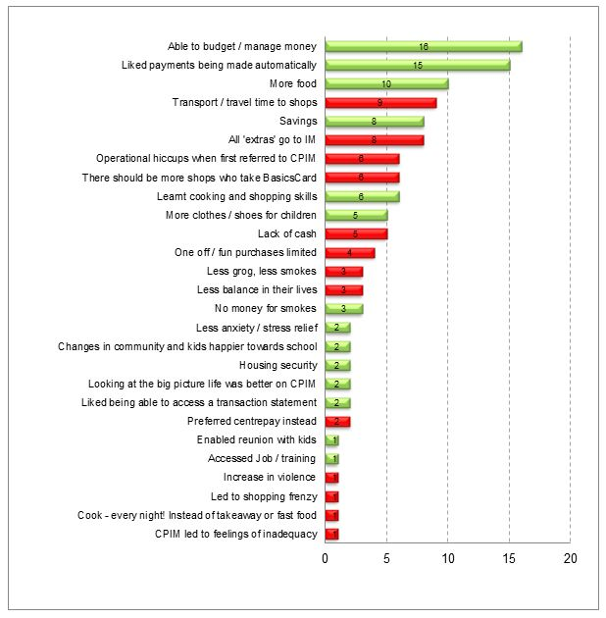
One of the recipients in the sample, who took part in interviews, no longer needed to be income managed as they had full-time employment. A few expressed concern that income management may change or be stopped and they would be forced to leave Child Protection Income Management. Other recipients interviewed did not think that income management had made any positive change to their life or for their families and one said it had made his life worse because of a sense of failure.
Two intermediaries mentioned their clients feeling stigma and shame when using the BasicsCard; however, none of the income-managed recipients interviewed mentioned shame. All who had been referred to Child Protection Income Management were initially angry or resentful. Some of their comments show their thoughts at the time of referral.
Angry because I didn’t know what it would mean. (Recipient)
I was very angry and resentful. (Recipient)
Screw you, but I got used to the idea. (Recipient)
Not impressed, I love my kids! (Recipient)
One spoke about the negative community attitude to income management:
But I suppose overall it's probably not [popular]. Because a lot of people see further government interference in their lives and all that sort of stuff. (Recipient)
When asked about their thoughts around income management and the future, 30 per cent had a strong desire to remain on income management:
I don't ever want to go off it. I’m going to stay on income management. (Recipient)
Thirty per cent wanted an opportunity to try without income management but return if needed:
I want to see if I can manage without it [income management] first. If not, I go on voluntary. (Recipient)
Thirty per cent intended to leave income management and not have anything more to do with it:
I did not like it. My rent came out automatically. I know how to spend my money. I always shopped for food! (Recipient)
There was support for recipients with mental health issues on Child Protection Income Management remaining on it. One parent of an income-managed daughter with mental health issues commented:
People with issues need this kind of help long term, I’m a greenie leftie from way back … don’t take my daughter off income management! (Recipient)

Perceptions of community members in the Goldfields region: a region without income management
Interviews and a focus group were carried out in the Western Australian Goldfields region with Child Protection staff, Human Services staff, police, legal services and community members. A number of the respondents in the focus group had come from areas where Child Protection Income Management was available. Of those who were not familiar with it many were interested to learn how income management could be applied and under what circumstances it would be used to change the outcomes for children. A Child Protection staff member who had worked with income management in the Kimberley region said:
Income management is a guidance mechanism and not about taking away human rights. It should not be an emotional issue, it is about changing behaviours. (Child Protection staff member, Goldfields region)
The majority of the service providers interviewed had previous experience with income management in different regions and they were able to discuss their experiences. They all agreed that it would be a very beneficial tool for them.
We have to normalise income management. (Legal service, Goldfields region)
The big issues in the Goldfields region are substance use, family violence and children feeling unsafe and wandering the streets. Poor language skills leading to low education attainment, which is a major contributing factor to employability, and financial harassment are contributing factors to financial issues, which lead to children being neglected.
I suppose the biggest issue is neglect of kids. A lot of that is alcohol related. So then you've got your domestic violence, kids wandering the streets, kids not going to school, not getting fed regularly or sent to school in dirty uniforms or no uniforms or without breakfast … but yeah, mainly just a lack of responsibility from the parents. (Police officer, Goldfields region)
In discussions, it was revealed that adults involved with Child Protection in the Goldfields region are often very heavily in debt and have no money for basics such as food, clothing and electricity. Many are also indebted for unpaid speeding fines, which escalates into terms of imprisonment.
Police officers said that families in crisis need their basic needs met first. They felt that poor budgeting and expenditure patterns result in debt and ‘crisis’ assistance. They felt income management should be implemented before that ‘crisis point’ and families should learn how the cycles work and be provided with assistance to break the cycle.
An Indigenous recipient explained that ‘income management is just a financial thing; it is not about stopping traditional business’. The recipient felt that income management helps Aboriginal and Torres Strait Islander community members understand the obligations of being a family member and be constructive and that it stops family members harassing the elderly.
A recipient who was previously from Kununurra said that there had been positive change in the Kununurra community since income management started. The recipient spoke about less gambling, healthier community and fewer kids on the street.

Summary
The qualitative evidence collected for this review indicates that income management assisted recipients to meet their and their children’s priority needs. Intermediaries reported income management to be a useful tool in assisting recipients who are experiencing housing problems and potential homelessness through regular allocations to landlords. Income management was seen to assist vulnerable young people (who were not parents) by helping them manage their lives and afford them safety and housing. Older vulnerable people were afforded protection from financial harassment through income management, especially in the Kimberley region.
Recipients reported both positive and negative impacts of being on income management. It restricted places where recipients could shop, which was reported as problematic, especially in the Kimberley region, where recipients also reported problems using the BasicsCard for transport. The inability to use the BasicsCard at entertainment venues was also seen as a negative impact by recipients. On the positive side, recipients reported that income management provided them with more money for food, helped them provide clothing and access to schooling for their children, and restricted the use of cigarettes and alcohol, which was seen as a positive outcome for the community.
The evidence collected for this review suggests that income management’s role in strengthening recipients’ financial capability and skills is less clear than its reported ability to help recipients meet priority needs. Intermediaries reported that income management facilitated creditors excusing some recipient debt through regular debt repayments. This debt reduction led to improved credit ratings for recipients, which had positive and negative outcomes. One negative outcome was that recipients could then build up more debt through a better credit rating.
Intermediaries suggested that income management could cause dependency for some recipients, evidenced in their inability to budget without it, and that income management worked best when recipients were assisted directly by financial counsellors. It remained unclear whether income management provided recipients with financial management skills, or whether the allocation of funds by Human Services was the sole driver of improved financial outcomes for recipients.
Income management was also seen by Child Protection staff to support recipients who are addressing other issues in conjunction with financial mismanagement. Intermediaries reported that income-managed recipients were able to address other issues (such as substance use issues) as their housing situation stabilised. Stabilised housing and regular supply of utilities also facilitated family reunification, and in some cases income management allowed recipients to leave abusive relationships. Furthermore, income management was documented in case files as a useful tool for young parents who found themselves overwhelmed by the responsibilities of parenthood.
In a similar vein, case file analysis revealed that income management gave opportunities to parents who had themselves been in the child protection system as children. These opportunities included being able to stabilise their own situation and to access other support programs. Recipients who were debilitated by overwhelming debt were also found to benefit from income management, according to recordings in their case files.
Intermediaries also reported that income management could be both disempowering and empowering for recipients, depending on its application and the availability of support services. Intermediaries also reported that income management resulted in shame for some recipients when they use the BasicsCard and suggested that it could be rebranded to distance it from the Northern Territory Emergency Response. At a community level, intermediaries reported that income management restricted cash flow in the Kimberley region, which helped control alcohol and violence. Furthermore, intermediaries thought it could reduce substance use in the Kimberley region, where there is a growing proportion of children with foetal alcohol syndrome disorder.

6. Conclusion
This review relies mainly on qualitative data that provides rich descriptions of the perceptions and experiences of income management of both recipients and intermediaries. As with all qualitative studies, care should be taken in drawing conclusions, as the findings cannot be generalised; nor can those who were involved in the review be seen as a representative sample of recipients or intermediaries.
It was intended to include analysis of similar child protection cases in a control site in Western Australia where income management is not available in order to compare changes in the trial sites to changes in the control sites. This would have allowed a limited analysis of whether changes in the trial sites can be attributed to income management. In the end, the review team was not given access to these case files, so analysis of changes in the trial sites against changes in the same period in a control site was not possible.
The data available in the child protection case files in the trial sites was not as detailed as the review team expected. Furthermore, fewer case files were in scope for the review than anticipated. The original questions proposed for the review were therefore revised.
Overall, the review found that Child Protection Income Management was implemented effectively in Western Australia, with appropriate targeting and referral, and productive collaboration between Human Services and Child Protection. While there was some initial reluctance among Child Protection staff to refer their clients to income management, most staff interviewed for the review recognised its usefulness in helping families and meeting the needs of children.
The review also identified some issues with the operation of Child Protection Income Management, including misuse of the BasicsCard and problems with using it for transport, and the impact of royalty and lump sum payments to recipients. The review also found that the take-up of Money Management services was low, but noted that some service providers and other intermediaries were exploring innovative ways to improve engagement.
In terms of impacts, intermediaries interviewed for the review overwhelmingly reported that income management had assisted recipients to meet their priority needs and those of their children. In particular, income management was seen as helping to stabilise housing by reducing housing debt and ensuring that rent and utilities were paid.
Recipients on Child Protection Income Management were almost all angry at the initial referral and complained of lack of money for outings and treats for the family. Over time, many recipients acknowledged that income management had helped improve their ability to meet their basic needs. About a third of interviewed recipients on Child Protection Income Management wanted to remain on income management, and a further third wanted to go off it once their income-managed period was over—but wanted to retain the opportunity to go back onto income management in the future if they needed it. The remaining third wanted nothing more to do with income management.
In relation to the ability of Child Protection Income Management to promote socially responsible behaviour, the findings were more varied. Intermediaries thought that income management was effective in helping to reduce financial harassment or humbugging and reducing the amount of money available for alcohol and drugs. However, families generally experienced multiple problems and needed a holistic approach to support them, with income management being one component.

Appendix A—Original review research questions

Process questions:
How effectively have the 2010 income management policy changes been administered and implemented?
- How many Child Protection Income Management and/or Child Protection Voluntary Income Management* clients have utilised money/financial management services?

See Section 4.4 Financial counselling and money management.

- Have clients been well informed about how Child Protection Income Management and/or Child Protection Voluntary Income Management* operates and why they are on it? Has this changed since July 2010?

See Section 4.1 Referral process—Western Australian Department for Child Protection and Family Support.

- What have been the resource implications of implementing the policy changes and what has been the impact on service providers?

There was no data available to the researchers on resource implications. However, there are some qualitative data within Chapter 4 about workload for Human Services and Child Protection staff.

- Are there differences in the profile of families referred to Child Protection Income Management and Child Protection Voluntary Income Management*?

There is no administrative data to identify Child Protection clients who have chosen to take up income management and are on the voluntary stream. This meant it was not possible to compare the two groups of Child Protection clients who were recipients of the different streams.

- Do clients volunteer for income management (i.e., go on to VIM) after coming off Child Protection Income Management?

Because case files were closed after income management ceased, only qualitative data was available. See Section 5.2—Strengthening financial capability and skills

- How many Child Protection Income Management or Child Protection Voluntary Income Management * clients have undertaken money management courses and accessed the Matched Payments Scheme payment?

See Section 4.4—Financial counselling and money management
Data was not available for Child Protection clients who have accessed a money management course because the client is not required to identify as a recipient of Child Protection Income Management. There have been no income management recipients accessing the Matched Savings Scheme.

Outcome questions:
Key question: What are the impacts of Child Protection Income Management or Child Protection Voluntary Income Management * on individuals and their families; and with the changes in policy and implementation, is CPIM and Child Protection Voluntary Income Management* having similar or different impacts as was found prior to July 2010?
- Are families better able to direct their money to meet their needs, from the perspectives of both people on Child Protection Income Management or Child Protection Voluntary Income Management * and from intermediaries working with these families?
See Section 5.1—Meeting priority needs

- Has Child Protection Income Management and/or Child Protection Voluntary Income Management* contributed to changes in financial management (skills/capacity), child health, alcohol abuse, violence and parenting?
See Section 5.2—Strengthening financial capability and skills
See Section 5.3—Other issues underlying financial mismanagement

- What has been the impact on child wellbeing in those families referred to Child Protection Income Management or Child Protection Voluntary Income Management?
See Section 5.1—Meeting priority needs

- What (if any) service delivery gaps have impacted on the usefulness of Child Protection Income Management or Child Protection Voluntary Income Management*?

This question is considered in Chapter 4.

- Has Child Protection Income Management or Child Protection Voluntary Income Management* had any unintended consequences (positive or negative)?

See Section 5.4—Individual and community perceptions

- Do outcomes for families vary according to whether they are on Child Protection Income Management or Child Protection Voluntary Income Management*?

As noted above, there is no administrative data to identify Child Protection clients who have chosen to take up income management and are on the voluntary stream. This meant it was not possible to compare the two groups of Child Protection clients who were recipients of the different streams.

- Are there ways of further improving the initiative?
The report does not specifically address this, but intermediaries’ suggestions are presented throughout Chapters 4 and 5.

*Administrative data record only that a recipient is a Voluntary Income Management recipient; it does not identify whether the recipient is also a parent or carer whose child or children are the subject of concerns being investigated and/or case managed by Child Protection workers.

Appendix B—Review communication products
Appendix B.1: Opt-in postcard
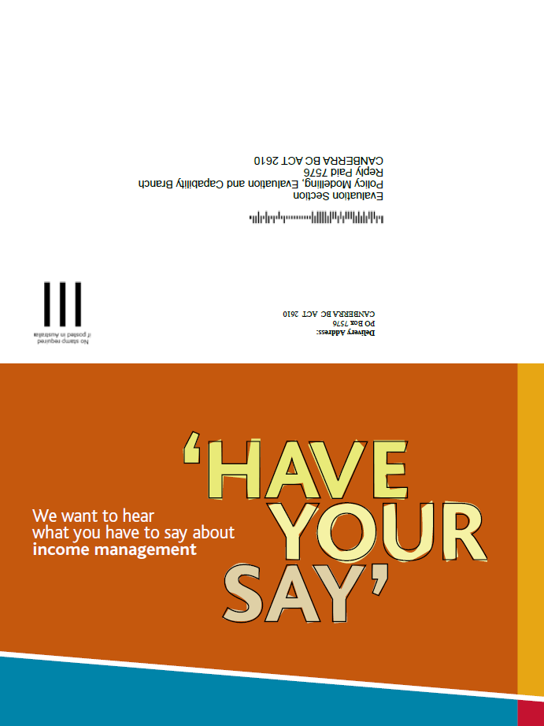
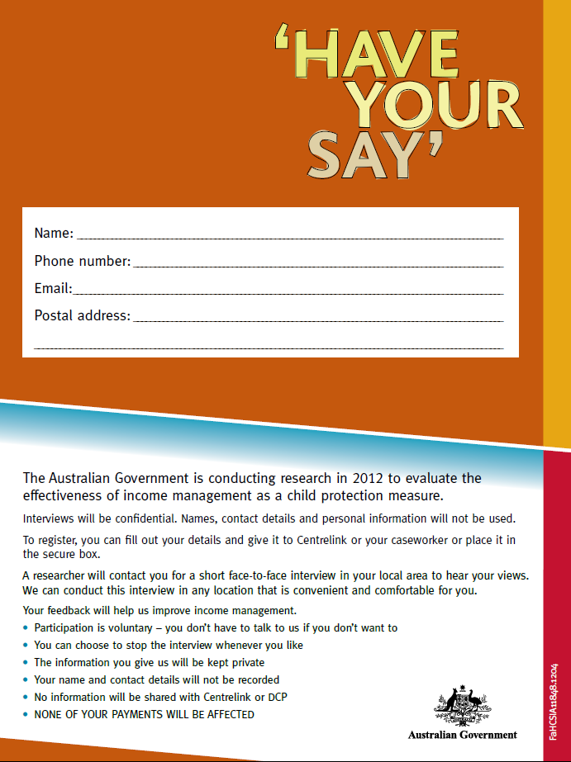
Appendix B.2: Opt out letter
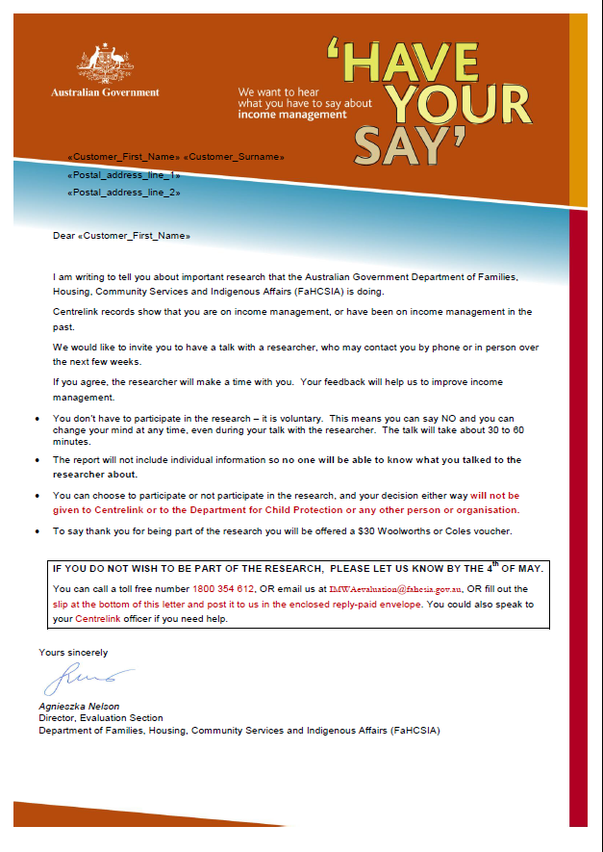
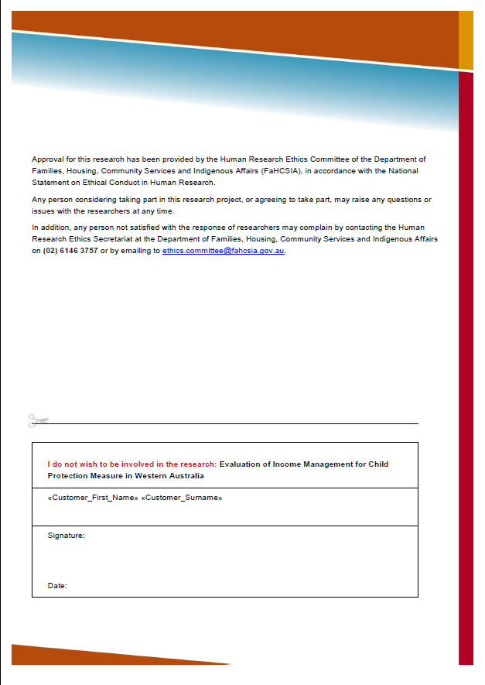
Appendix B.3: Interview consent form
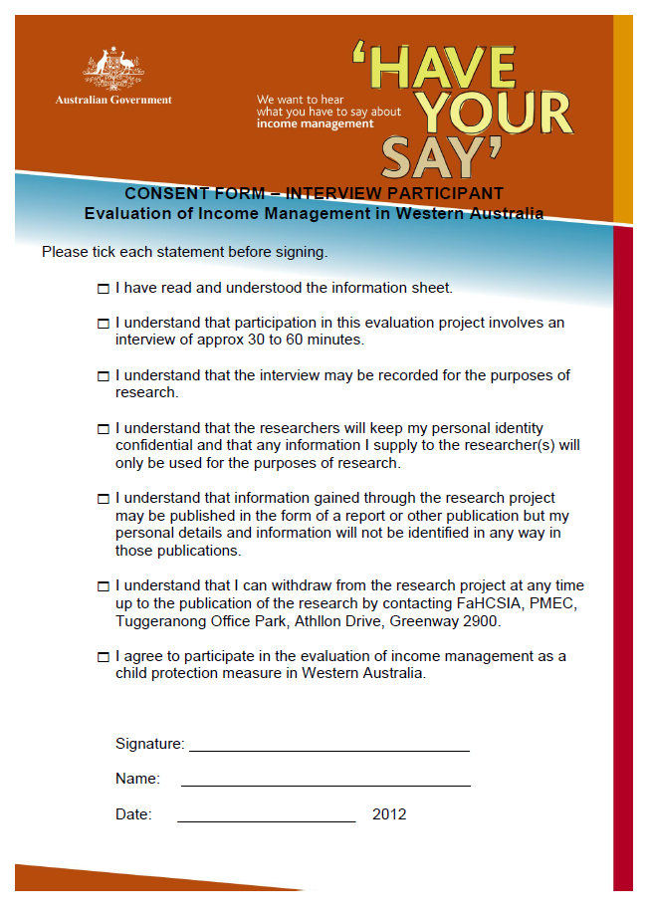

Appendix B.4: Focus group consent form
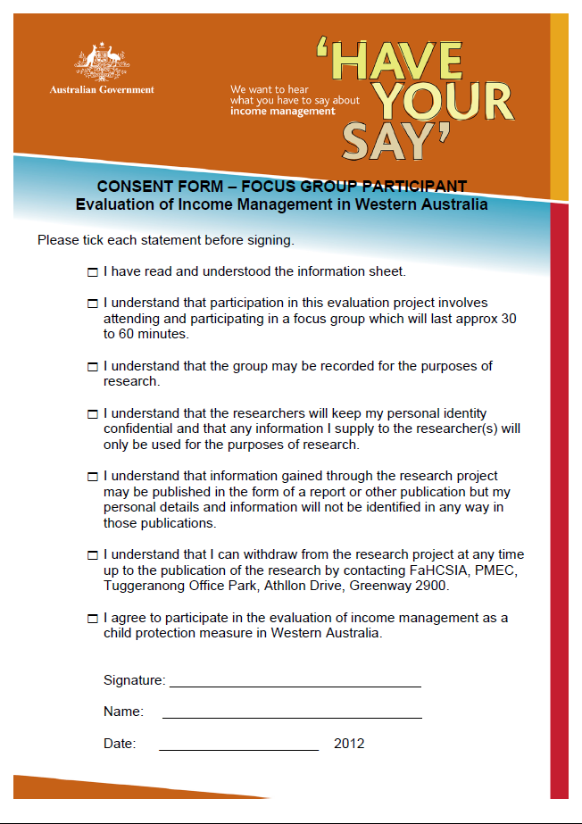

Appendix B.5: Fact sheet for Department of Human Services staff
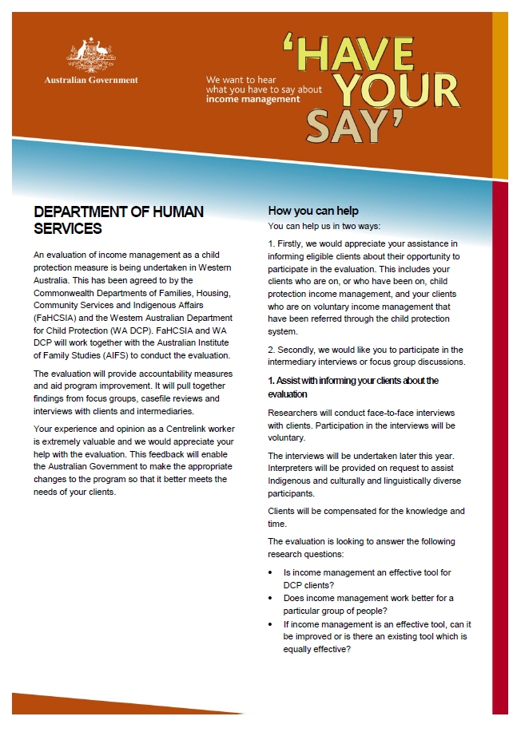
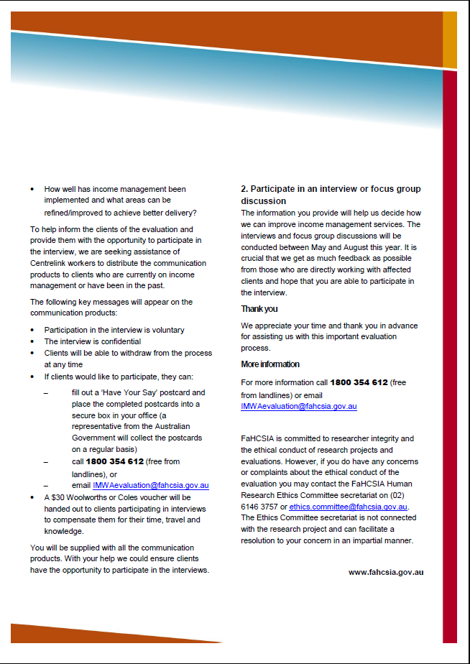
Appendix B.6: Fact sheet for Western Australian Department for Child Protection staff
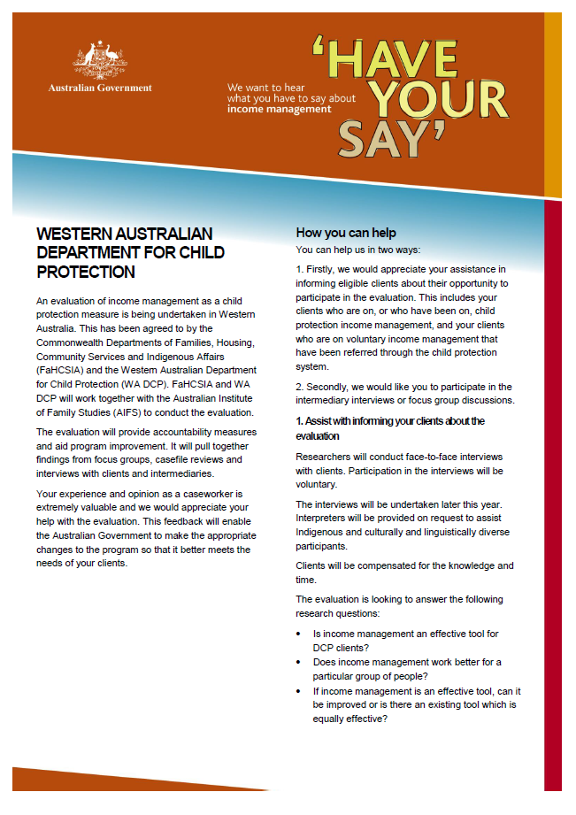
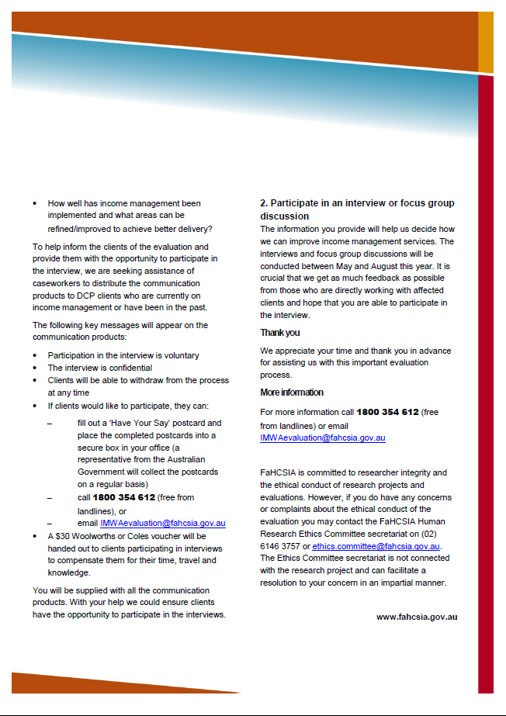
Appendix B.7: Fact sheet for financial counsellors and money management service providers
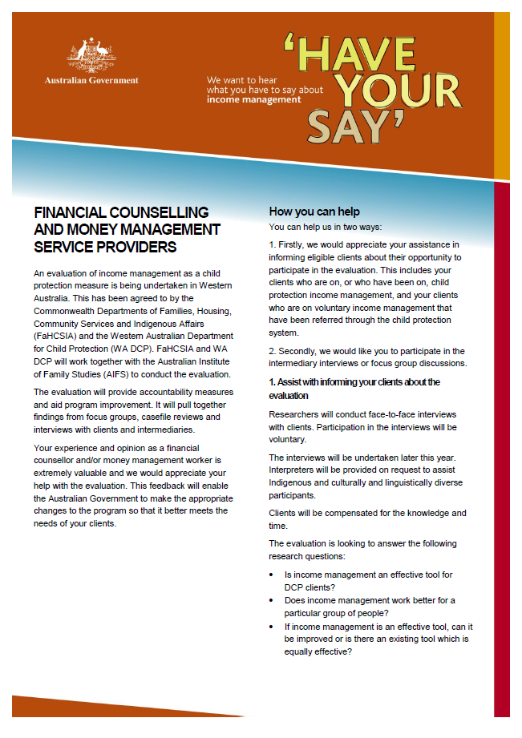
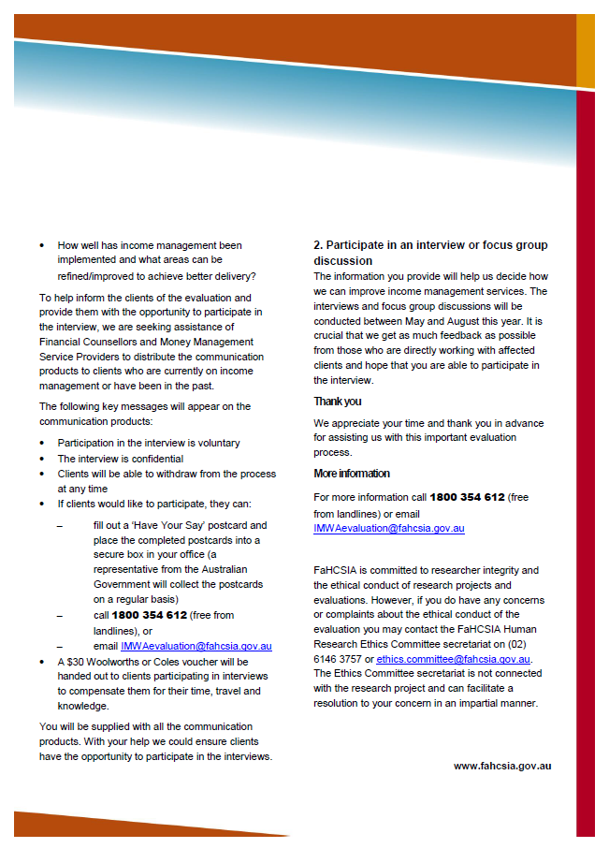
Appendix B.8: Fact sheet for intermediaries and non-government organisations in the Perth Metro and WA Goldfields regions
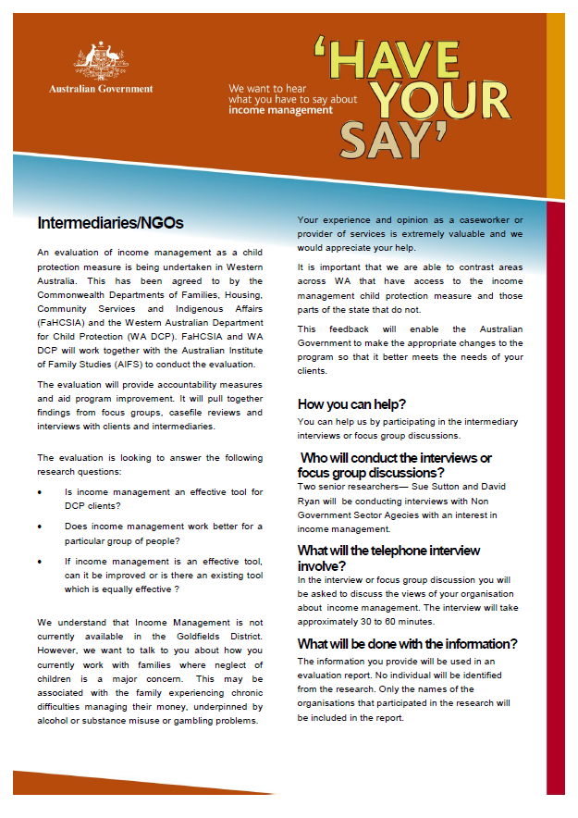
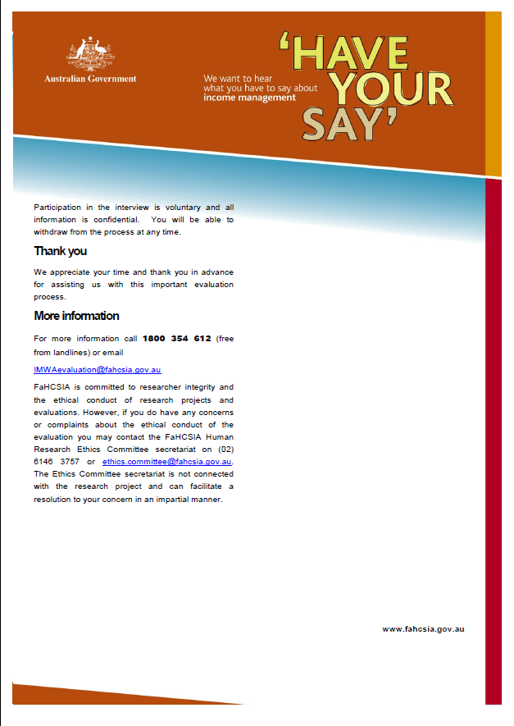

References
Australian Institute of Health and Welfare 2010, ‘Evaluation of income management in the Northern Territory’ in Occasional Paper No. 34, Department of Families, Housing, Community Services and Indigenous Affairs. www.fahcsia.gov.au/sites/default/files/documents/05_2012/op34.pdf

Bray, JR, Gray, M, Hand, K, Bradbury, B, Eastman, C, Katz, I 2012, Evaluating New Income Management in the Northern Territory: first evaluation report, Social Policy Research Centre, University of New South Wales, for the Department of Families, Housing, Community Services and Indigenous Affairs. http://www.fahcsia.gov.au/our-responsibilities/families-and-children/programs-services/income-management/evaluating-new-income-management-in-the-northern-territory-first-evaluation-report

Buckmaster, L, Ey, C and Klapdor, M 2012, Income Management: an overview, Parliament of Australia. http://www.aph.gov.au/About_Parliament/Parliamentary_Departments/Parliamentary_Library/pubs/BN/2011-2012/IncomeManagementOverview

Commonwealth Social Security (Administration) Act 1999 http://www.comlaw.gov.au/Details/C2004A00580

Commonwealth Social Security and Other Legislation Amendment (Welfare Payment Reform) Act 2007 http://www.comlaw.gov.au/Details/C2007A00130

Department of Families, Housing, Community Services and Indigenous Affairs 2012, Aims of income management. http://www.fahcsia.gov.au/our-responsibilities/families-and-children/programs-services/income-management/aims-of-income-management

Department of Families, Housing, Community Services and Indigenous Affairs 2012, Cape York Welfare Reform Evaluation. www.fahcsia.gov.au/sites/default/.../cywr_evaluation_report_v1.2.docx

Department of Families, Housing, Community Services and Indigenous Affairs 2013, Financial Management Program. http://www.fahcsia.gov.au/our-responsibilities/communities-and-vulnerable-people/programs-services/financial-management-program

Higgins, DJ 2007, Cooperation and coordination: An evaluation of the Family Court of Australia’s Magellan case-management model, Family Court of Australia, Canberra. www.aifs.gov.au/institute/pubs/magellan/magellan.pdf

National Health and Medical Research Council 2007, National Statement on the Ethical Conduct of Human Research, Updated May 2013. http://www.nhmrc.gov.au/guidelines/publications/e72

ORIMA Research 2010, Evaluation of the Child Protection Scheme of Income Management and Voluntary Income Management Measures in Western Australia Report, for the Department of Families, Housing, Community Services and Indigenous Affairs.
http://www.fahcsia.gov.au/our-responsibilities/families-and-children/publications-articles/evaluation-of-the-child-protection-scheme-of-income-management-and-voluntary-income-management-measures-in-western-australia

Western Australian Department for Child Protection and Family Support 2012, Casework Practice Manual http://manuals.dcp.wa.gov.au/manuals/cpm/Pages/default.aspx

