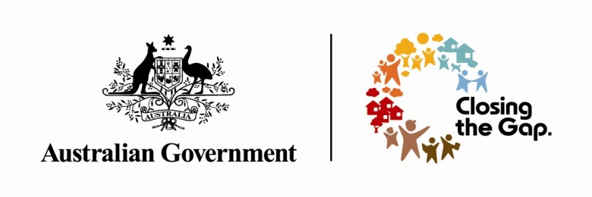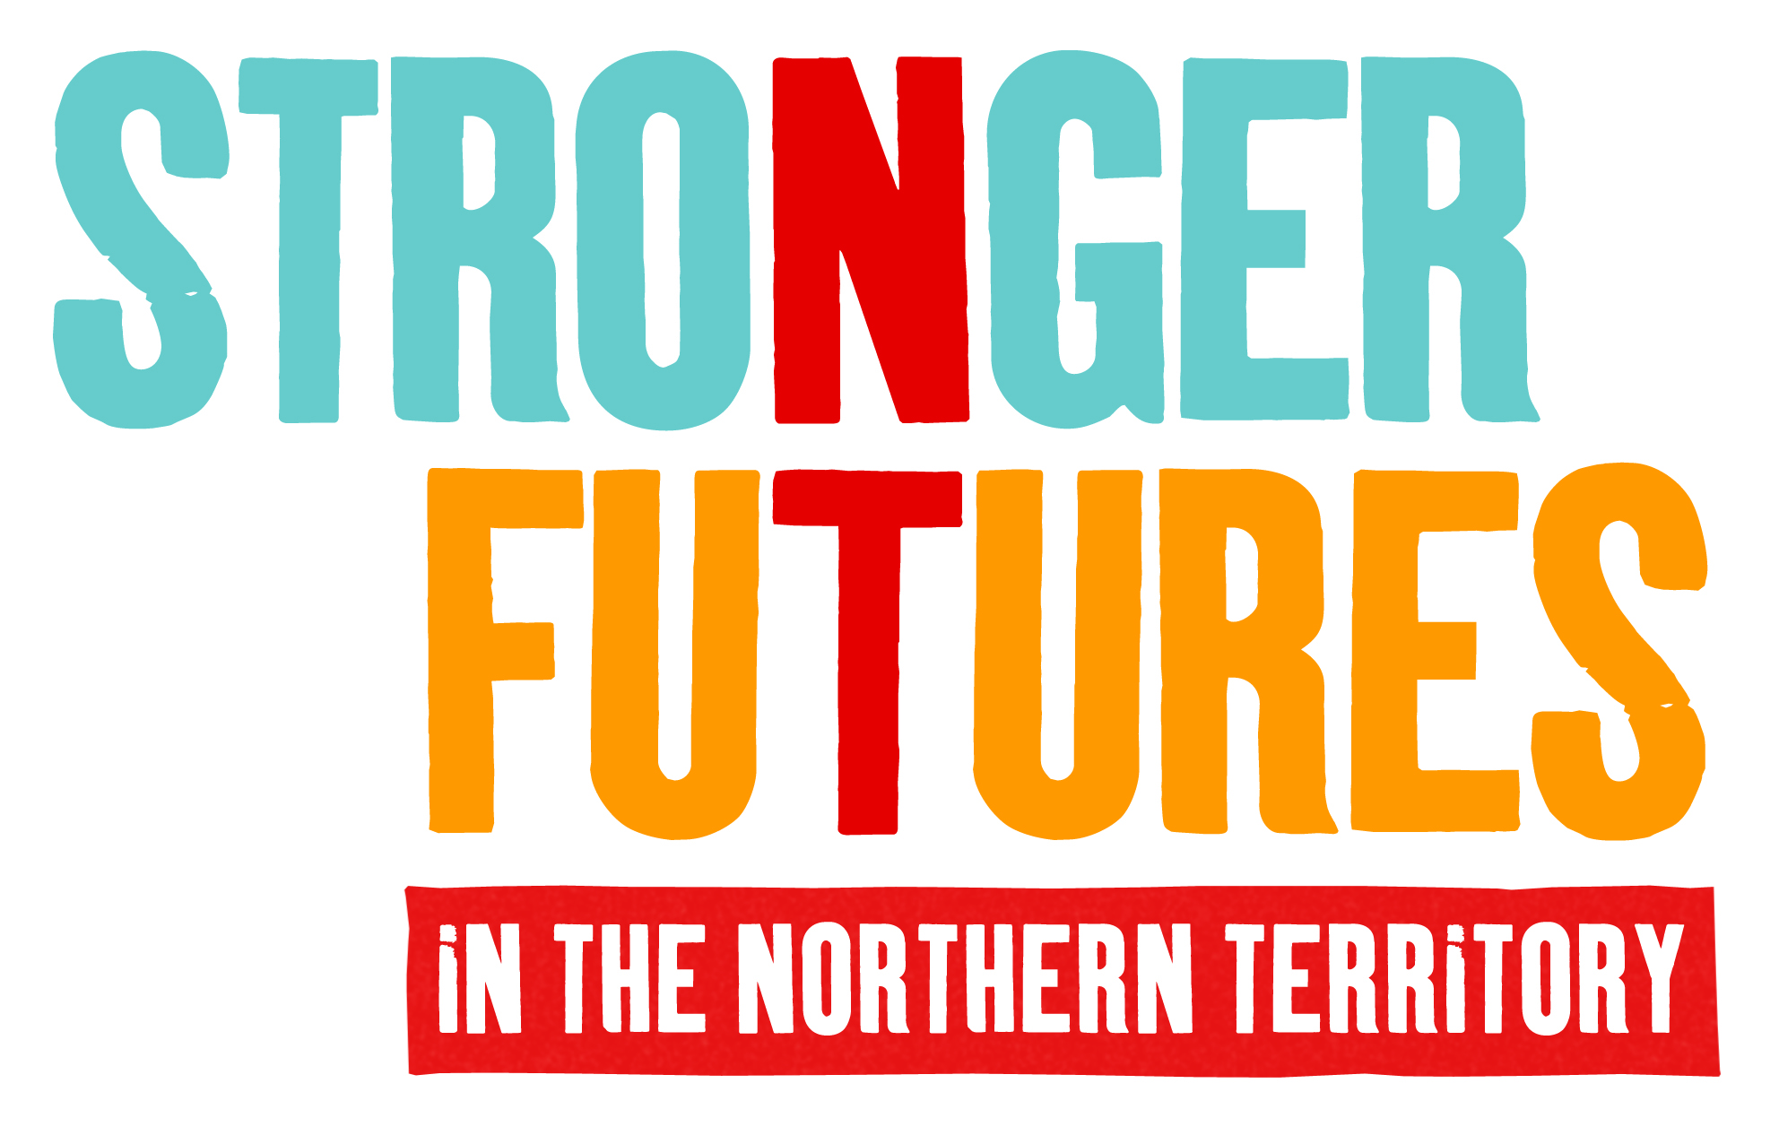

Stronger Futures in the Northern Territory: Classification Education Project and Prohibited Material Restrictions
The Australian Government is publishing this implementation plan because it is committed to working with Aboriginal people in the Northern Territory, their representatives and leaders to effectively implement Stronger Futures in the Northern Territory measures.
In particular the Government is inviting comments, ideas and suggestions for the community education project proposed in this plan to complement the legislated prohibited material restrictions.

Stronger Futures in the Northern Territory
The Australian Government has made a ten-year commitment to work with Aboriginal people in the Northern Territory to build strong, independent lives, where communities, families and children are safe and healthy. Stronger Futures in the Northern Territory is a $3.4 billion investment and responds directly to what Aboriginal people told the Government what is important to them.
The Australian Government will work with Aboriginal people in both large and small communities to support local jobs, tackle alcohol abuse and encourage children to go to school, as well as provide basic services, including health, education and police. The Australian Government will talk to Aboriginal people in each community about how best to deliver services under Stronger Futures, providing Aboriginal people with more responsibility for services within their own community.
The Australian Government will support Aboriginal organisations to deliver services under Stronger Futures in the Northern Territory and all services will be expected to employ Aboriginal people wherever possible.

Stronger Futures in the Northern Territory prohibited material measure
The prohibited material measure is one part of the Stronger Futures in the Northern Territory approach to address the serious levels of social and economic disadvantage experienced by Aboriginal people in the Northern Territory.

What is prohibited material?
Prohibited material may include extremely violent and/or sexually explicit publications such as magazines, films, photographs, computer games, mobile phone downloads, contents of USB/memory sticks and such material in any other medium which contains computer data or other forms of recording from which sounds or pictorial matter may be reproduced.
Prohibited material includes material that is Refused Classification or classified X 18+, or would likely be Refused Classification or would likely be classified X 18+. Refused Classification material is banned across Australia and X 18+ films are prohibited in the States. (For an explanation of the classifications see the Classification website www.classification.gov.au.)

What is the objective of this measure?
The objective of this measure is stated in the Stronger Futures in the Northern Territory legislation which was passed by the Australian Parliament in June 2012.
The objective is “to enable special measures to be taken to protect children living in Indigenous communities in the Northern Territory from being exposed to prohibited material.”

Why is this measure included in the Stronger Futures in the Northern Territory package of measures?
In the consultations that have been held with Aboriginal people in the Northern Territory since 2008, the Australian Government sought views about the benefits and problems of prohibited material restrictions and whether there is a need for them. This is a sensitive topic in many respects and often difficult for people to talk about. Where people did comment, they often said that the restrictions on this material should remain in place in order to protect children from seeing this material.
It is important to appreciate that when people talked about prohibited material, pornography and very violent and disturbing material, they were not referring to the prohibited material and pornography managed under the National Classification Scheme but to their beliefs and values about this kind of material. This means that material referred to as ‘prohibited material’ or ‘pornography’ in the consultations is likely to encompass a much broader range of material than ‘prohibited material’ under the National Classification Scheme and as defined in the Classification (Publications, Films and Computer Games) Act 1995.
To illustrate this, some of the comments made by individuals in the consultations are presented below:
2008 consultations

How do people control porn on television through cable TV? So what is the difference between watching porn on cable TV and not on video and what does this mean, how [are] they going to control this?

Child abuse and neglect is a problem world wide for all of us, as is school truancy, pornography and alcohol.

Little kids are also using obscene language, using mobile phones and sending photos.

2009 consultations
Don’t want kids to see pornography or violent movies.
Don’t have pornography here now and don’t want it in future.
Restrictions are good because we need to protect the children from this.

2011 consultations
I don’t want the ban lifted because it protects young people. Adults should be able to access it if they want but it is bad for kids to grow up with it. It is my worst nightmare for my daughter to think that it is okay.
Mobile phone porn is a problem. Young people getting it on their phones.
This stuff is foreign to us, this stuff coming into the community. We learned the right way through our parents in the past. There is still a problem with the internet and mobile phones, we need a block for the pornography. What can the Government do about this? Can they stop it?

How is the Australian Government tackling the issue of prohibited material in remote Aboriginal communities in the Northern Territory?
This measure has two elements – legislation and funding for Stronger Futures in the Northern Territory classification community education project. There has already been consultations and a parliamentary inquiry on the legislation. We are seeking comments now on the proposed community education element. Information on the legislation is provided however to inform you and provide some context to the community education project.

Legislation
The prohibited material measure is additional effort to support existing government strategies to protect children from exposure to harmful material in the real and virtual worlds. This additional effort is in response to the consultation feedback and recognises that the living conditions in some communities mean that people may not be able to control their or their children’s exposure to such material and that they may be more vulnerable to harm from this material.
Under the National Classification Scheme, Northern Territory laws regulating films, computer games and certain publications apply across the Northern Territory. Under the Stronger Futures legislation, additional restrictions apply in most remote Northern Territory Aboriginal communities. These restrictions prohibit the possession and supply of prohibited material in prohibited material areas.
It is estimated that around 45,000 people live in the prohibited material areas, that is, the areas where these additional restrictions apply.
These restrictions are set out in Part 10 of the Classification (Publications, Films and Computer Games) Act 1995.
Prohibited material areas continue the previous prescribed areas. New prohibited material areas can only be established if they are supported by the community and after there has been community consultation. The Federal Minister can cease the restrictions in a particular prohibited material area only after people living in the community have had an opportunity to make submissions and the Minister is satisfied that criteria relating to the well-being and safety of people living in the area have been considered.
The legislation applying the additional restrictions will continue until 2022. The Stronger Futures legislation also requires that the prohibited material restrictions be reviewed in two years’ time, that is, 2014.
The income management arrangements operating in the Northern Territory do not allow people to spend their welfare income on pornography or alcohol. The aim of income management is to help people spend their money on the essentials for themselves, their family and children such as food, clothing and rent.

Stronger Futures Classification Education Project
Along with the additional restrictions that have been made through the Stronger Futures legislation, the Australian Government is also providing $1.09 million in funding for a Stronger Futures classification community education project (the classification project).
The objective of this classification project is the same as the prohibited materials legislative objective, that is, to enable special measures to be taken to protect children living in Indigenous communities from being exposed to prohibited material.
The Australian Government expects that this information should be developed and delivered in a culturally competent and culturally sensitive manner. The material is intended to promote safety and wellbeing, support behaviour which respects others in the community and oneself, strengthens personal independence and responsibility, and is inclusive.
The classification education project will draw on existing and credible resources on classification and cybersafety, and will help guide people living in remote Northern Territory Aboriginal communities to existing helplines and complaints services related to content, classification and media.
An additional goal of the classification project is to inform Aboriginal communities about their ability to request the Australian Government Minister for Indigenous Affairs to vary or remove the restrictions in a prohibited material area and the matters the Minister will need to consider in making such a decision. The project will include the provision of information to community members about how they may apply to have the restrictions changed or removed and the decision-making process that follows an application.

Stronger Futures Commitment to Aboriginal Service Providers and Aboriginal Employment
Under Stronger Futures, the Australian Government is strongly committed to developing the capacity of Indigenous service delivery organisations and increasing employment opportunities for Aboriginal people. Aboriginal employment targets are being set for all Stronger Futures measures to encourage service providers to invest in employing Aboriginal staff and developing their skills.
The Australian Government will therefore seek a suitable Indigenous peak organisation in the Northern Territory as the service-provider to deliver this project. We will also be looking to the service provider to achieve a target of 100 per cent Aboriginal staff in the direct delivery of the project to Aboriginal people.
In addition to community awareness raising, the classification project presents an opportunity to build the capacity of an Indigenous organisation whose aims and objectives are directed to the protection of children in the rapidly changing area of content, classification and child safety, to play a more active education and advocacy role in the best interests of Aboriginal children.

Funding and governance arrangements
The funding available for this project is:
Year | 2012-13 | 2013-14 | 2014-15 | 2015-16 | 2016-17 | Total
Australian Government  Funding | $210,000 | $214,000 | $219,000 | $223,000 | $228,000 | $1,094,000

Program guidelines detailing eligibility conditions for this funding have been prepared and will be published on the FaHCSIA website.
To help strengthen the service-provider’s capacity, the Department of Families, Housing, Community Services and Indigenous Affairs will work with the service provider to provide links to government agencies that have expertise and information that may be useful in the delivery of the project. There will be clear and regular reporting, deliverables and milestones to be achieved by the service provider under the terms and conditions of the funding agreement.

What this measure does not involve or try to achieve?
There is no requirement in the legislation for there to be signs notifying of the prohibited material restrictions. It is important however that people are informed of their obligations. As people in the Northern Territory would be aware, the Australian Government has responded to community concerns about signs and is working with the Northern Territory Government, Indigenous communities, land councils and the Local Government Association of the Northern Territory to make signs more respectful.
All 250 of the blue signs notifying alcohol and pornography restrictions have been removed across the Northern Territory and replaced with 49 redesigned, more respectful highway signs, strategically positioned on borders, major highway intersections, airstrips and barge landings. Government Engagement Coordinators and Indigenous Engagement Officers are actively engaging their communities to redesign community signs, replacing text with community agreed wording, including local Aboriginal artwork.
The Stronger Futures prohibited material measure is just one of a wide range of measures in place to protect children from exposure to harmful material and risks to their safety in the virtual and real worlds. It is not intended to be a comprehensive response to such risks, but is additional to existing measures for the intended benefit of people living in remote communities.

Expected outcomes and outputs
Outputs
The expected output is the development and delivery of culturally appropriate information and a community education for Aboriginal people living in remote communities about the Stronger Futures restrictions in the context of the National Classification Scheme and strategies to protect children so they can grow up safe and healthy.
Outcomes
The expected outcome from the community education project is that as parents and consumers, Aboriginal people in remote communities are:

- aware of the classification markings and the classification of pictures, magazines, DVDs and games that are suitable or not suitable for children to see, use or buy;
- that Aboriginal parents and caregivers have access to culturally appropriate resources and materials to better understand the potentially harmful impact of exposure and access to prohibited material on children’s development;
- that Aboriginal people have information available to them about where to complain to about content including on line, television, phone, publications or images; and
- that community members are aware that there is a process available to apply to the Australian Government Minister for Indigenous Affairs for the Stronger Futures prohibited material restrictions to be removed or varied if the Minister is satisfied that certain checks have been made and criteria have been met.

Evaluation, monitoring and review
The Stronger Futures legislation requires that this measure be reviewed in 2014. Implementation of the measure will be reported in the six monthly Stronger Futures in the Northern Territory monitoring report. The effectiveness of this measure in contributing to the protection of children living in Indigenous communities in the Northern Territory from being exposed to prohibited material will also be assessed as part of the Stronger Futures in the Northern Territory evaluation strategy.
It is proposed that community awareness and views about the measure be collected using a participative research survey used to assess other Stronger Futures measures.

Lead agency
The Department of Families, Housing, Community Services and Indigenous Affairs is the lead agency on the implementation of this measure.
Legislated measure: Key dates/milestones
16 July 2012 Commencement of the amendments which continue the prohibited material restrictions for 10 years.
20 July 2012 Chief Minister’s Department and Department of Justice notified in writing that legislation had commenced and prohibited material restrictions would continue.
August 2014 Review of measure must have commenced.
August 2015 Review of measure completed and report prepared and tabled.
15 July 2022 Restrictions sunset.
Proposed key dates/milestones for the classification project
To end February 2013 Comments on draft implementation plan.
Program guidelines published.
March 2013 Seek expressions of interest on basis of restricted invitation to Indigenous providers.
Early April 2013 Select provider.
April 2013 Funding agreement signed and work commences.
September 2013 Trial and assessment of project materials and education presentations in several community settings.
September 2013-2017 Project roll-out, review in 2014 and continuous improvement up to project closure.

Contact and questions
If you have any questions please contact Margaret Henderson, Stronger Futures in the Northern Territory Branch, Department of Families, Housing, Community Services and Indigenous Affairs on 02 6146 3600.

The National Classification Scheme is a cooperative arrangement between the Commonwealth, States and Territories under which films (including videos and DVDs) computer games and certain publications are classified.

