Characteristics of
Disability Support Pension
Recipients

June 2012

CONTENTS

LIST OF TABLES 3
LIST OF FIGURES 4
INTRODUCTION 5
HIGHLIGHTS 6
1 Population characteristics 8
1.1 Population and growth 8
1.2 Age 10
1.3 State/Territory 15
1.4 Country of birth 16
1.5 Relationship status 19
1.6 Home ownership 22
1.7 Age and home ownership 25
2 Primary medical condition 26
2.1 Medical condition 26
2.2 Top three primary medical conditions by age range and sex 32
3 Earnings and income support duration 35
3.1 Earnings 35
3.2 Income support duration 40
4 Finalised claims 45
4.1 Finalised claims by age and sex 45
4.2 Grants by primary medical condition 49
4.3 Rejections 57
5 Where DSP recipients are coming from and going to 63
5.1 Where DSP recipients are coming from 63
5.2 Where DSP recipients are exiting to 66

LIST OF TABLES

Table 1 – DSP population and growth by sex – June 1972 to June 2012 8
Table 2 – Recipients by age range and sex – June 2012 10
Table 3 – Recipients by age range – June 2001 to June 2012 11
Table 4 – Recipients aged over/under 55 by sex – June 2001 to June 2012 13
Table 5 – Recipients by State/Territory – June 2012 15
Table 6 – Recipients by top countries of birth – June 2012 16
Table 7 – Recipients by country of birth – Australia/other – June 2001 to June 2012 17
Table 8 – Recipients by relationship status and sex – June 2012 19
Table 9 – Recipients by relationship status – June 2001 to June 2012 20
Table 10 – Recipients by homeownership status and sex – June 2012 22
Table 11 – Recipients by homeownership status and sex – June 2001 to June 2012 23
Table 12 – Recipients by homeownership status and age – June 2012 25
Table 13 – Recipients by sex and primary medical condition – June 2012 26
Table 14 – Recipients by primary medical condition – top 5/other – June 2001 to June 2012 28
Table 15 – Proportion of recipients by primary medical condition (top 5), by sex – June 2001 to June 2012 30
Table 16 – Psychological/psychiatric recipients by age range and sex – June 2012 32
Table 17 – Musculo-skeletal & connective tissue recipients by age range and sex – June 2012 33
Table 18 – Intellectual/learning recipients by age range and sex – June 2012 34
Table 19 – Recipients by earnings range and sex – fortnight to 29 June 2012 35
Table 20 – Recipients with earnings/no earnings by sex – June 2007 to June 2012 36
Table 21 – Recipients with earnings by earnings range – June 2007 to June 2012 38
Table 22 – Recipients by income support duration and sex – June 2012 40
Table 23 – Recipients by income support duration – June 2007 to June 2012 41
Table 24 – Recipients income support duration under/over 15 years – June 2007 to June 2012 43
Table 25 – Finalised claims by age and sex – 2011-12 45
Table 26 – Finalised claims and grant rate – 2006-07 to 2011-12 47
Table 27 – Grants by medical condition – 2011-12 49
Table 28 – Grants by top 5 primary medical conditions – 2006-07 to 2011-12 51
Table 29 – Grants by sex by primary medical condition – 2006-07 to 2011-12 53
Table 30 – Grants by top 5 primary medical conditions and age range – 2011-12 55
Table 31 – Rejections by reason and sex – 2011-12 57
Table 32 – Rejections by main reasons – 2006-07 to 2011-12 59
Table 33 – Rejections by sex by top 5 rejection reasons – 2006-07 to 2011-12 61
Table 34 – New entrants by previous income support type – 2012 63
Table 35 – New entrants by prior income support type – 2001 to 2012 64
Table 36 – Exits by subsequent status/income support payment type – 2012 66
Table 37 – Exits by subsequent income support type –2001 to 2012 67

LIST OF FIGURES

Figure 1 – DSP population and growth – June 1972 to June 2012 9
Figure 2 – Recipients by age range and sex – June 2012 10
Figure 3 – Recipients by age range – June 2001 to June 2012 12
Figure 4 – Recipients aged 55 and over by sex – June 2001 to June 2012 14
Figure 5 – Recipients by State/Territory – June 2012 15
Figure 6 – Recipients by top 10 overseas countries of birth (excl. Australia) – June 2012 16
Figure 7 – Australian born by sex – June 2001 to June 2012 18
Figure 8 – Recipients by relationship status and sex – June 2012 19
Figure 9 – Recipients by relationship status – June 2001 to June 2012 21
Figure 10 – Recipients by homeownership status and sex – June 2012 22
Figure 11 – Homeownership rate by sex – June 2001 to June 2012 24
Figure 12 – Recipients by homeownership status and age – June 2012 25
Figure 13 – Recipients - top 5 primary medical conditions by sex – June 2012 27
Figure 14 – Recipients by top 3 primary medical conditions – June 2001 to June 2012 29
Figure 15 – Recipients’ sex by top 3 primary medical conditions – June 2001 to June 2012 31
Figure 16 – Psychological/psychiatric recipients by age range and sex – June 2012 32
Figure 17 – Musculo-skeletal & connective tissue recipients by age range and sex – June 2012 33
Figure 18 – Intellectual/learning recipients by age range and sex – June 2012 34
Figure 19 – Recipients with earnings by range and sex - fortnight to 29 June 2012 35
Figure 20 – Recipients with earnings by sex – June 2007 to June 2012 37
Figure 21 – Recipients with earnings by earnings range – 2007, 2010 and 2012 39
Figure 22 – Recipients by income support duration and sex– June 2012 40
Figure 23 – Recipients by income support duration – June 2007 to June 2012 42
Figure 24 – Recipients on income support for 15 years and over by sex – June 2007 to June 2012 44
Figure 25 – Grant rate by age range and sex – 2011-12 46
Figure 26 – Grant rate by sex – 2006-07 to 2011-12 48
Figure 27 – Grants by top 5 primary medical conditions – 2011-12 50
Figure 28 – Grants by top 5 primary medical conditions – 2006-07 to 2011-12 52
Figure 29 – Grants by sex by primary medical condition – 2006-07 to 2011-12 54
Figure 30 – Grants for top 5 medical conditions by age range – 2011-12 56
Figure 31 – Rejections by top 4 reasons and sex – 2011-12 58
Figure 32 – Rejections by main reasons – 2006-07 to 2011-12 60
Figure 33 – Rejections by sex by top 3 rejection reasons – 2006-07 to 2011-12 62
Figure 34 – New entrants by previous income support type – 2012 63
Figure 35 – New entrants by prior income support type – 2001 to 2012 65
Figure 36 – Exits by subsequent status/income support payment type – 2012 66
Figure 37 – Exits by subsequent income support type – 2001 to 2012 68

INTRODUCTION

This report has been published annually since 2001 and provides the characteristics of the population of Disability Support Pension (DSP) recipients.

Who is the Disability Support Pension for?

DSP is designed to give people an adequate means of support if they are unable to work for at least 15 hours per week at or above the relevant minimum wage, independent of a program of support, due to a permanent physical, intellectual or psychiatric impairment.

Eligibility Requirements

To qualify for DSP a person must be 16 years or over and be under age pension age at the date of claim lodgement (as at June 2012 – 64.5 years for women and 65 years for men) and:
- be permanently blind; or
- have a physical, intellectual or psychiatric impairment assessed at 20 points or more under impairment tables*; and
- have an inability, as a result of impairment, to work 15 hours or more per week for the next two years; and
- have an inability, as a result of impairment, to undertake a training activity which would equip the person for work within the next two years.
In addition the person must have become unable to work while in Australia, or have 10 years qualifying Australian residence.
* If at least 20 points are not allocated under a single impairment table, must have also actively participated in a Program of Support.
Notes

- The information contained in this report has been sourced from Department of Human Services administrative data as at 29 June 2012 and previous editions of this report. If an alternative source of data has been used it has been noted.
- Where items have been grouped in this report resulting percentages may not be equal to the sum of the constituent figures due to rounding.

HIGHLIGHTS

DSP population

At June 2012, the DSP population was 827,460, an increase of 1.1 percent over the June 2011 population of 818,850.

DSP by sex

As at June 2012 there were 444,690 male and 382,770 female DSP recipients. Between June 2011 and June 2012, females showed a greater percentage growth than males. Female recipient numbers increased by 2.8 percent over that year, while the number of men receiving DSP fell by 0.4 percent.

The trend for the population of women receiving DSP to grow at a faster rate than men has emerged over the last fifteen years. Since the 1990s there have been a number of policy changes that have affected women including:
- a gradual increase in the qualifying age for Age Pension;
- the closure to new entrants of alternative payments received primarily or solely by women (for example, Wife Pension, Widow B Pension and Partner Allowance); and
- a tightening of the eligibility criteria for Parenting Payment as part of the Welfare to Work changes.

DSP by medical condition

The primary medical conditions of the DSP population are primarily represented by three main categories:
- Psychological/psychiatric – 30.3 percent;
- Musculo-skeletal and connective tissue – 27.3 percent; and
- Intellectual/learning - 12.0 percent.
Since 2004 the proportion of recipients reporting against the Musculo-skeletal and connective tissue category has been falling while the proportions for Psychological/psychiatric and Intellectual/learning have been rising over the period since 2001. The proportion of DSP recipients with a Psychological/psychiatric primary medical condition surpassed Musculo-skeletal and connective tissue for the first time in 2011.

Claims processed

There were 134,157 DSP claims processed between June 2011 and June 2012, with 65,049 grants (48.5 percent) and 69,108 rejections (51.5 percent). The overall grant rate rose from 63.0 percent in 2006-07 to 64.5 percent in 2008-09, but has since fallen to 48.5 percent in 2011-12.

The grant rate for 16-19 year olds in 2011-12 was 64.0 percent, dropping in the 20-24 year age group to 40.5 percent and then rising as the age of the claimant increases.
In 2011-12 rejections on medical grounds accounted for 76.8 percent of rejections and rejections for non-medical reasons were 23.2 percent of rejections.

The main reason a claim was rejected was that the claimant was assessed as having an impairment of less than 20 points (20,447, 29.6 percent).

This was followed by ‘Medical condition not fully diagnosed, treated and stabilised’ which accounted for 19,276 rejections (27.9 percent). This is a new rejection reason that was introduced in September 2011 and until that point, claims rejected because a person’s condition was not fully diagnosed, treated and stabilised were reflected under the rejection reasons ‘Disability is short-term’ and ‘Less than 20 points impaired’.

‘Disability is short-term’ and ‘Failed to supply requested information’ each accounted for 14.6 percent of rejections in 2011-12.

The proportion of rejections because the claimant’s impairment was ‘less than 20 points’ rose consistently between 2006-07 and 2009-10. This dropped considerably during 2010-11 (21.5 percentage points) and further in 2011-12, largely due to changes to rejection reason coding conventions in these years.

Entrants to DSP

At June 2012, there were 61,509 DSP recipients who were not receiving DSP in June 2011. Of these ‘new entrants’ to DSP, 48.4 percent were not in receipt of another income support payment at June 2011 and 51.6 percent were income support recipients, with 37.0 percent on Newstart Allowance at June 2011.

Exits from DSP

At June 2012, there were 52,899 ‘exits’ from DSP (i.e. people who were receiving DSP in June 2011 but were no longer receiving DSP as at June 2012). Of these exits, transfers to Age Pension accounted for 57.4 percent and movement off income support payments (including deceased recipients) accounted for 40.2 percent.

Population characteristics

Population and growth

Table 1 details the DSP population and annual growth, for the years from 1972 to 2012 by sex.

Table 1 – DSP population and growth by sex – June 1972 to June 2012
Year | Female count | Change from previous year female count | Females as a % of Total count | Male count | Change from previous year male count | Males  as a % of Total count | Total count | Change from previous year Total count | Annual % growth over previous year
1972 | 61,685 |  | 44.4% | 77,133 |  | 55.6% | 138,818
1973 | 64,304 | 2,619 | 43.0% | 85,305 | 8,172 | 57.0% | 149,609 | 10,791 | 7.8%
1974 | 64,643 | 339 | 41.2% | 92,140 | 6,835 | 58.8% | 156,783 | 7,174 | 4.8%
1975 | 65,967 | 1,324 | 39.1% | 102,817 | 10,677 | 60.9% | 168,784 | 12,001 | 7.7%
1976 | 67,669 | 1,702 | 36.8% | 116,118 | 13,301 | 63.2% | 183,787 | 15,003 | 8.9%
1977 | 69,754 | 2,085 | 34.4% | 133,209 | 17,091 | 65.6% | 202,963 | 19,176 | 10.4%
1978 | 67,699 | -2,055 | 33.0% | 137,245 | 4,036 | 67.0% | 204,944 | 1,981 | 1.0%
1979 | 70,084 | 2,385 | 31.9% | 149,759 | 12,514 | 68.1% | 219,843 | 14,899 | 7.3%
1980 | 70,892 | 808 | 30.9% | 158,327 | 8,568 | 69.1% | 229,219 | 9,376 | 4.3%
1981 | 68,062 | -2,830 | 30.7% | 153,889 | -4,438 | 69.3% | 221,951 | -7,268 | -3.2%
1982 | 65,503 | -2,559 | 30.2% | 151,146 | -2,743 | 69.8% | 216,649 | -5,302 | -2.4%
1983 | 64,617 | -886 | 29.3% | 155,672 | 4,526 | 70.7% | 220,289 | 3,640 | 1.7%
1984 | 67,511 | 2,894 | 28.1% | 173,063 | 17,391 | 71.9% | 240,574 | 20,285 | 9.2%
1985 | 70,449 | 2,938 | 27.2% | 188,713 | 15,650 | 72.8% | 259,162 | 18,588 | 7.7%
1986 | 72,912 | 2,463 | 26.6% | 200,898 | 12,185 | 73.4% | 273,810 | 14,648 | 5.7%
1987 | 75,760 | 2,848 | 26.2% | 213,290 | 12,392 | 73.8% | 289,050 | 15,240 | 5.6%
1988 | 77,745 | 1,985 | 26.2% | 219,168 | 5,878 | 73.8% | 296,913 | 7,863 | 2.7%
1989 | 80,510 | 2,765 | 26.2% | 227,285 | 8,117 | 73.8% | 307,795 | 10,882 | 3.7%
1990 | 83,462 | 2,952 | 26.4% | 233,251 | 5,966 | 73.6% | 316,713 | 8,918 | 2.9%
1991 | 89,535 | 6,073 | 26.8% | 244,699 | 11,448 | 73.2% | 334,234 | 17,521 | 5.5%
1992 | 104,861 | 15,326 | 27.7% | 273,697 | 28,998 | 72.3% | 378,558 | 44,324 | 13.3%
1993 | 115,101 | 10,240 | 28.3% | 291,471 | 17,774 | 71.7% | 406,572 | 28,014 | 7.4%
1994 | 127,111 | 12,010 | 29.1% | 309,123 | 17,652 | 70.9% | 436,234 | 29,662 | 7.3%
1995 | 139,758 | 12,647 | 30.1% | 324,672 | 15,549 | 69.9% | 464,430 | 28,196 | 6.5%
1996 | 158,979 | 19,221 | 31.8% | 340,256 | 15,584 | 68.2% | 499,235 | 34,805 | 7.5%
1997 | 174,907 | 15,928 | 33.2% | 352,607 | 12,351 | 66.8% | 527,514 | 28,279 | 5.7%
1998 | 191,797 | 16,890 | 34.7% | 361,539 | 8,932 | 65.3% | 553,336 | 25,822 | 4.9%
1999 | 204,342 | 12,545 | 35.4% | 373,340 | 11,801 | 64.6% | 577,682 | 24,346 | 4.4%
2000 | 219,929 | 15,587 | 36.5% | 382,351 | 9,011 | 63.5% | 602,280 | 24,598 | 4.3%
2001 | 231,572 | 11,643 | 37.1% | 392,354 | 10,003 | 62.9% | 623,926 | 21,646 | 3.6%
2002 | 252,022 | 20,450 | 38.2% | 406,893 | 14,539 | 61.8% | 658,915 | 34,989 | 5.6%
2003 | 260,557 | 8,535 | 38.7% | 412,777 | 5,884 | 61.3% | 673,334 | 14,419 | 2.2%
2004 | 277,913 | 17,356 | 39.9% | 418,829 | 6,052 | 60.1% | 696,742 | 23,408 | 3.5%
2005 | 286,709 | 8,796 | 40.6% | 420,073 | 1,244 | 59.4% | 706,782 | 10,040 | 1.4%
2006 | 296,545 | 9,836 | 41.6% | 415,618 | -4,455 | 58.4% | 712,163 | 5,381 | 0.8%
2007 | 301,123 | 4,578 | 42.2% | 413,033 | -2,585 | 57.8% | 714,156 | 1,993 | 0.3%
2008 | 318,883 | 17,760 | 43.5% | 413,484 | 451 | 56.5% | 732,367 | 18,211 | 2.6%
2009 | 334,828 | 15,945 | 44.2% | 422,290 | 8,806 | 55.8% | 757,118 | 24,751 | 3.4%
2010 | 359,125 | 24,297 | 45.3% | 433,456 | 11,166 | 54.7% | 792,581 | 35,463 | 4.7%
2011 | 372,250 | 13,125 | 45.5% | 446,600 | 13,144 | 54.5% | 818,850 | 26,269 | 3.3%
2012 | 382,770 | 10,520 | 46.3% | 444,690 | -1,910 | 53.7% | 827,460 | 8,610 | 1.1%

As at June 2012, the number of people receiving DSP was 827,460. The number of DSP recipients grew by 8,610 (1.1 percent) between June 2011 and June 2012.
At June 2012 males represented 53.7 percent of the DSP population and females 46.3 percent. The female population increased by 2.8 percent between June 2011 and June 2012, while the male population decreased by 0.4 percent.

During the 12 months to June 2012 the DSP population grew by 8,610. Female numbers increased by 10,520 while the number of males decreased by 1,910.

Figure 1 shows overall trends in population by sex and growth in the years from June 1972 to June 2012.

Figure 1 – DSP population and growth – June 1972 to June 2012
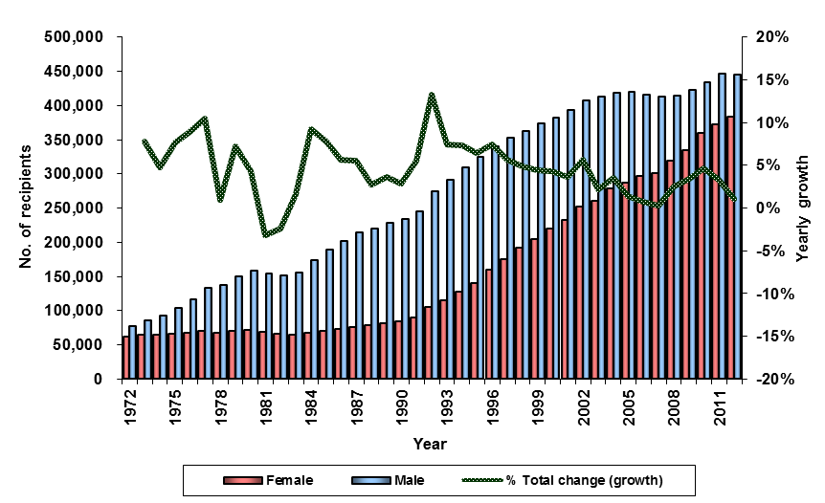

The highest rate of growth in the DSP population over the period was 13.3 percent in 1992 and the lowest was -3.2 percent in 1981.

Age

Table 2 details the DSP recipient population as at June 2012 by gender and age range.

Table 2 – Recipients by age range and sex – June 2012
Age range (years) | Female count | % of female Total | Male count | % of male Total | Total count | % of Total count
16-19 | 7,488 | 2.0% | 12,829 | 2.9% | 20,317 | 2.5%
20-24 | 14,163 | 3.7% | 20,264 | 4.6% | 34,427 | 4.2%
25-29 | 16,076 | 4.2% | 21,974 | 4.9% | 38,050 | 4.6%
30-34 | 18,297 | 4.8% | 25,479 | 5.7% | 43,776 | 5.3%
35-39 | 23,401 | 6.1% | 31,857 | 7.2% | 55,258 | 6.7%
40-44 | 33,907 | 8.9% | 42,246 | 9.5% | 76,153 | 9.2%
45-49 | 43,594 | 11.4% | 50,544 | 11.4% | 94,138 | 11.4%
50-54 | 58,224 | 15.2% | 60,966 | 13.7% | 119,190 | 14.4%
55-59 | 71,160 | 18.6% | 69,812 | 15.7% | 140,972 | 17.0%
60-64 | 86,532 | 22.6% | 92,874 | 20.9% | 179,406 | 21.7%
65 and over | 9,928 | 2.6% | 15,845 | 3.6% | 25,773 | 3.1%
Total | 382,770 | 100.0% | 444,690 | 100.0% | 827,460 | 100.0%

Figure 2 shows the proportion of DSP recipients by age range and sex as at June 2012.

Figure 2 – Recipients by age range and sex – June 2012
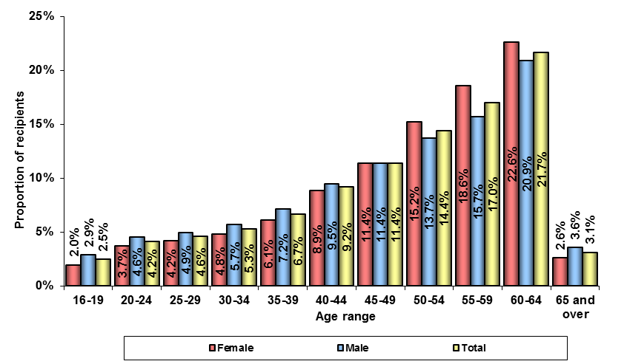

The number of DSP recipients in each age range increases up to Age Pension age. In the 50 to 59 year age range the proportion of recipients by sex is nearly even with females accounting for 49.7 percent of the total. For the 16 to 49 year age range only 43.3 percent are female.

As at June 2012, over half (56.2 percent) of all DSP recipients were over 50 years old and 3.1 percent aged over 65 years.

Table 3 details the number and proportion of DSP recipients by age range for the years from June 2001 to June 2012.

Table 3 – Recipients by age range – June 2001 to June 2012
Year | 16-24 years count | 16-24 years  as a % of  Total count | 25-34 years count | 25-34 years  as a % of Total count | 35-44 years count | 35-44 years  as a % of Total count | 45-54 years count | 45-54 years  as a % of Total count | 55-64 years count | 55-64 years  as a % of Total count | 65 years & over count | 65 years & over  as a % of Total count | Total count
2001 | 39,368 | 6.3% | 66,057 | 10.6% | 108,102 | 17.3% | 168,654 | 27.0% | 238,740 | 38.3% | 3,005 | 0.5% | 623,926
2002 | 41,976 | 6.4% | 68,679 | 10.4% | 113,055 | 17.2% | 174,195 | 26.4% | 257,552 | 39.1% | 3,458 | 0.5% | 658,915
2003 | 42,748 | 6.3% | 70,132 | 10.4% | 114,719 | 17.0% | 177,055 | 26.3% | 263,525 | 39.1% | 5,155 | 0.8% | 673,334
2004 | 44,761 | 6.4% | 71,541 | 10.3% | 117,134 | 16.8% | 182,500 | 26.2% | 274,768 | 39.4% | 6,038 | 0.9% | 696,742
2005 | 46,017 | 6.5% | 71,891 | 10.2% | 117,819 | 16.7% | 185,823 | 26.3% | 278,862 | 39.5% | 6,370 | 0.9% | 706,782
2006 | 46,222 | 6.5% | 70,889 | 10.0% | 117,256 | 16.5% | 185,514 | 26.0% | 285,098 | 40.0% | 7,184 | 1.0% | 712,163
2007 | 46,013 | 6.4% | 70,198 | 9.8% | 116,629 | 16.3% | 187,529 | 26.3% | 284,539 | 39.8% | 9,248 | 1.3% | 714,156
2008 | 46,144 | 6.3% | 70,443 | 9.6% | 118,298 | 16.2% | 191,241 | 26.1% | 295,570 | 40.4% | 10,671 | 1.5% | 732,367
2009 | 48,074 | 6.3% | 73,093 | 9.7% | 122,293 | 16.2% | 198,736 | 26.2% | 301,300 | 39.8% | 13,622 | 1.8% | 757,118
2010 | 51,087 | 6.4% | 76,437 | 9.6% | 127,117 | 16.0% | 206,594 | 26.1% | 314,832 | 39.7% | 16,514 | 2.1% | 792,581
2011 | 53,805 | 6.6% | 80,096 | 9.8% | 131,658 | 16.1% | 213,511 | 26.1% | 319,199 | 39.0% | 20,581 | 2.5% | 818,850
2012 | 54,744 | 6.6% | 81,826 | 9.9% | 131,411 | 15.9% | 213,328 | 25.8% | 320,378 | 38.7% | 25,773 | 3.1% | 827,460

Figure 3 shows the proportion of DSP recipients in each age range for the years 2001 to 2012.

Figure 3 – Recipients by age range – June 2001 to June 2012
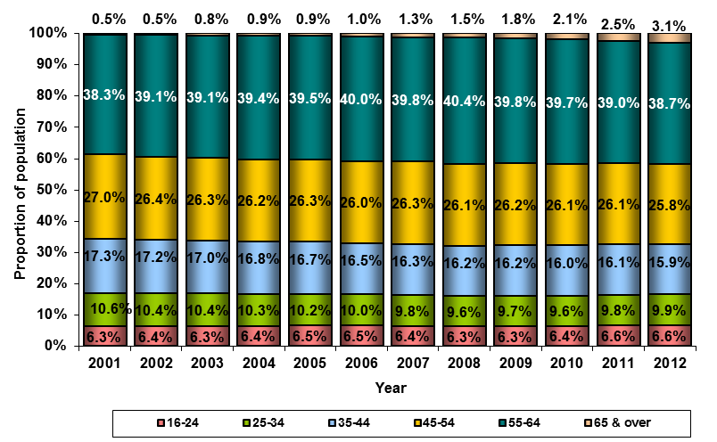

Between June 2001 and June 2012 there have been some changes in the age profile of DSP recipients. While the proportion in the 16 to 24 year age range has increased slightly from 6.3 to 6.6 percent, there have been decreases in the proportion of those recipients aged between 25 and 54 years of age. The 55 to 64 year age range increased between 2001 and 2008 (38.3 to 40.4 percent) but has since declined to 38.7 percent at June 2012. The 65 years and over age range increased from 0.5 to 3.1 percent over the period.

Table 4 details the number and proportion of DSP recipients by sex and whether they were under or over 55 years old for the years from June 2001 to June 2012.

Table 4 – Recipients aged over/under 55 by sex – June 2001 to June 2012
Year | 16-54 years female count | 16-54 years females  as a % of Total count | 16-54 years male count | 16-54 years males  as a % of Total count | 16-54 years  Sub-Total count | 16-54 years Sub-Total as a % of Total count | 55 years  & over female count | 55 years  & over females  as a % of Total count | 55 years  & over male count | 55 years  & over  males  as a % of Total count | 55 years  & over  Sub-Total count | 55 years  & over  Sub-Total  as a % of  Total count | Total count
2001 | 159,233 | 25.5% | 222,948 | 35.7% | 382,181 | 61.3% | 72,339 | 11.6% | 169,406 | 27.2% | 241,745 | 38.7% | 623,926
2002 | 166,867 | 25.3% | 231,038 | 35.1% | 397,905 | 60.4% | 85,155 | 12.9% | 175,855 | 26.7% | 261,010 | 39.6% | 658,915
2003 | 169,770 | 25.2% | 234,884 | 34.9% | 404,654 | 60.1% | 90,787 | 13.5% | 177,893 | 26.4% | 268,680 | 39.9% | 673,334
2004 | 175,243 | 25.2% | 240,693 | 34.5% | 415,936 | 59.7% | 102,670 | 14.7% | 178,136 | 25.6% | 280,806 | 40.3% | 696,742
2005 | 178,667 | 25.3% | 242,883 | 34.4% | 421,550 | 59.6% | 108,042 | 15.3% | 177,190 | 25.1% | 285,232 | 40.4% | 706,782
2006 | 179,037 | 25.1% | 240,844 | 33.8% | 419,881 | 59.0% | 117,508 | 16.5% | 174,774 | 24.5% | 292,282 | 41.0% | 712,163
2007 | 180,813 | 25.3% | 239,556 | 33.5% | 420,369 | 58.9% | 120,310 | 16.8% | 173,477 | 24.3% | 293,787 | 41.1% | 714,156
2008 | 186,768 | 25.5% | 239,358 | 32.7% | 426,126 | 58.2% | 132,115 | 18.0% | 174,126 | 23.8% | 306,241 | 41.8% | 732,367
2009 | 196,195 | 25.9% | 246,001 | 32.5% | 442,196 | 58.4% | 138,633 | 18.3% | 176,289 | 23.3% | 314,922 | 41.6% | 757,118
2010 | 206,275 | 26.0% | 254,960 | 32.2% | 461,235 | 58.2% | 152,850 | 19.3% | 178,496 | 22.5% | 331,346 | 41.8% | 792,581
2011 | 214,634 | 26.2% | 264,436 | 32.3% | 479,070 | 58.5% | 157,616 | 19.2% | 182,164 | 22.2% | 339,780 | 41.5% | 818,850
2012 | 215,150 | 26.0% | 266,159 | 32.2% | 481,309 | 58.2% | 167,620 | 20.3% | 178,531 | 21.6% | 346,151 | 41.8% | 827,460

Figure 4 shows the change in the proportion of DSP recipients aged 55 and over by sex for the years from June 2001 to June 2012.

Figure 4 – Recipients aged 55 and over by sex – June 2001 to June 2012
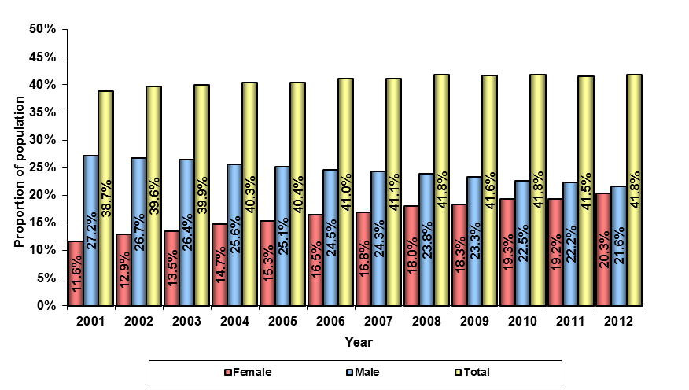

The overall proportion of DSP recipients who were aged 55 and over at the date of data extraction rose slightly between June 2001 and June 2012. As at June 2001, 38.7 percent of recipients were aged 55 and over and by June 2012 that proportion had risen to 41.8 percent.

However, the gender mix of the cohort has changed. The proportion of male DSP recipients 55 and over was 27.2 percent of the total DSP population in June 2001 but by June 2012 that proportion had fallen to 21.6 percent. Conversely, the proportion of female DSP recipients aged 55 and over was 11.6 percent of the total DSP population in June 2001 but this had increased to 20.3 percent in June 2012.

The number of males aged 55 and over on DSP was 182,164 at June 2011 but had decreased to 178,531 by June 2012.

State/Territory

Table 5 details the number and proportion of DSP recipients by State or Territory of residence as at June 2012.

Table 5 – Recipients by State/Territory – June 2012
State/Territory | Female count | % of female Total | Male count | % of male Total | Total count | % of Total count
New South Wales | 123,065 | 32.2% | 145,519 | 32.7% | 268,584 | 32.5%
Victoria | 96,606 | 25.2% | 104,077 | 23.4% | 200,683 | 24.3%
Queensland | 73,578 | 19.2% | 89,459 | 20.1% | 163,037 | 19.7%
South Australia | 35,200 | 9.2% | 40,980 | 9.2% | 76,180 | 9.2%
Western Australia | 29,881 | 7.8% | 33,906 | 7.6% | 63,787 | 7.7%
Tasmania | 12,795 | 3.3% | 15,167 | 3.4% | 27,962 | 3.4%
Northern Territory | 4,489 | 1.2% | 5,768 | 1.3% | 10,257 | 1.2%
ACT | 4,040 | 1.1% | 4,277 | 1.0% | 8,317 | 1.0%
Not Coded/Overseas | 3,116 | 0.8% | 5,537 | 1.2% | 8,653 | 1.0%
Total | 382,770 | 100.0% | 444,690 | 100.0% | 827,460 | 100.0%

Figure 5 shows the proportion of DSP recipients by State or Territory of residence and sex as at June 2012.

Figure 5 – Recipients by State/Territory – June 2012
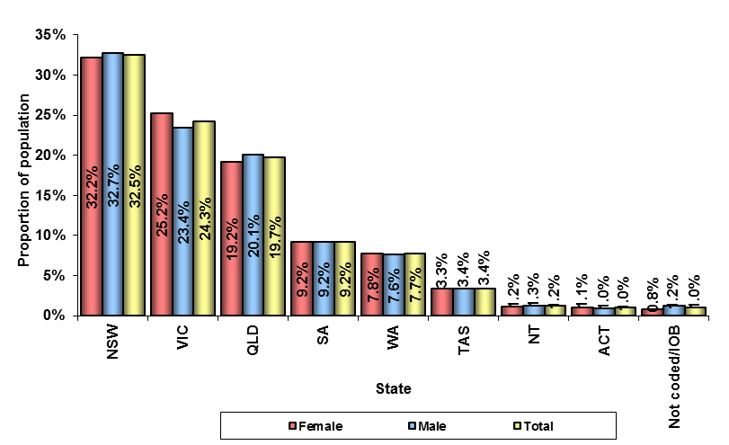

As expected, the majority of DSP recipients resided in the more populous Australian states. New South Wales was the largest with 32.5 percent of the DSP population, while the Australian Capital Territory was the smallest with 1.0 percent.

Country of birth

Table 6 details the top countries of birth of DSP recipients as at June 2012 by sex.

Table 6 – Recipients by top countries of birth – June 2012
Country of birth | Female count | % of female Total | Male count | % of male Total | Total count | % of Total count
Australia | 283,905 | 74.2% | 342,341 | 77.0% | 626,246 | 75.7%
UK/Ireland/Eire | 18,210 | 4.8% | 21,354 | 4.8% | 39,564 | 4.8%
New Zealand | 7,211 | 1.9% | 8,059 | 1.8% | 15,270 | 1.8%
Lebanon | 5,660 | 1.5% | 6,140 | 1.4% | 11,800 | 1.4%
Vietnam | 4,985 | 1.3% | 5,251 | 1.2% | 10,236 | 1.2%
Yugoslavia | 4,315 | 1.1% | 4,615 | 1.0% | 8,930 | 1.1%
Italy | 4,089 | 1.1% | 4,123 | 0.9% | 8,212 | 1.0%
Greece | 4,017 | 1.0% | 3,998 | 0.9% | 8,015 | 1.0%
Iraq | 2,914 | 0.8% | 3,540 | 0.8% | 6,454 | 0.8%
Turkey | 3,451 | 0.9% | 2,573 | 0.6% | 6,024 | 0.7%
Germany | 2,111 | 0.6% | 2,395 | 0.5% | 4,506 | 0.5%
Other | 41,902 | 10.9% | 40,301 | 9.1% | 82,203 | 9.9%
Total | 382,770 | 100.0% | 444,690 | 100.0% | 827,460 | 100.0%

Figure 6 shows the proportion of DSP recipients born outside Australia as at June 2012 by country of birth and sex.

Figure 6 – Recipients by top 10 overseas countries of birth (excl. Australia) – June 2012
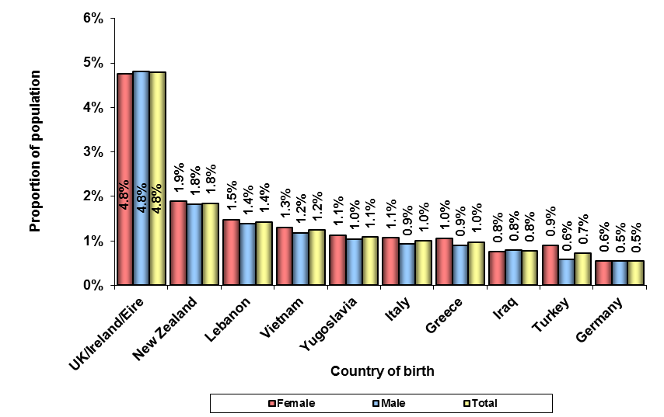
Notes:
Percentages within chart are a proportion of the overall DSP population by sex.
UK includes Ireland & Eire.

Nearly 76 percent of DSP recipients were born in Australia (74.2 percent of females and 77.0 percent of males). The second largest group was born in the United Kingdom (4.8 percent).

Table 7 details the number and proportion of DSP recipients by whether they were born in Australia or overseas for the years from June 2001 to June 2012.

Table 7 – Recipients by country of birth – Australia/other – June 2001 to June 2012
Year | Australian born female count | Australian born females  as a % of  Total count | Australian born male count | Australian born males  as a % of  Total count | Australian born Sub-Total count | Australian born Sub-Total  as a % of  Total count | Overseas born female count | Overseas born  females  as a % of  Total count | Overseas born male count | Overseas born  males  as a % of  Total count | Overseas born Sub-Total count | Overseas born Sub-Total  as a % of  Total count | Total count
2001 | 171,941 | 27.6% | 276,527 | 44.3% | 448,468 | 71.9% | 59,631 | 9.6% | 115,827 | 18.6% | 175,458 | 28.1% | 623,926
2002 | 187,296 | 28.4% | 289,169 | 43.9% | 476,465 | 72.3% | 64,726 | 9.8% | 117,724 | 17.9% | 182,450 | 27.7% | 658,915
2003 | 193,877 | 28.8% | 295,432 | 43.9% | 489,309 | 72.7% | 66,680 | 9.9% | 117,345 | 17.4% | 184,025 | 27.3% | 673,334
2004 | 205,852 | 29.5% | 302,417 | 43.4% | 508,269 | 72.9% | 72,061 | 10.3% | 116,412 | 16.7% | 188,473 | 27.1% | 696,742
2005 | 212,093 | 30.0% | 305,951 | 43.3% | 518,044 | 73.3% | 74,616 | 10.6% | 114,122 | 16.1% | 188,738 | 26.7% | 706,782
2006 | 219,102 | 30.8% | 304,828 | 42.8% | 523,930 | 73.6% | 77,443 | 10.9% | 110,790 | 15.6% | 188,233 | 26.4% | 712,163
2007 | 222,369 | 31.1% | 304,696 | 42.7% | 527,065 | 73.8% | 78,754 | 11.0% | 108,337 | 15.2% | 187,091 | 26.2% | 714,156
2008 | 234,264 | 32.0% | 307,248 | 42.0% | 541,512 | 73.9% | 84,619 | 11.6% | 106,236 | 14.5% | 190,855 | 26.1% | 732,367
2009 | 246,074 | 32.5% | 316,289 | 41.8% | 562,363 | 74.3% | 88,754 | 11.7% | 106,001 | 14.0% | 194,755 | 25.7% | 757,118
2010 | 263,994 | 33.3% | 327,671 | 41.3% | 591,665 | 74.7% | 95,131 | 12.0% | 105,785 | 13.3% | 200,916 | 25.3% | 792,581
2011 | 275,059 | 33.6% | 340,469 | 41.6% | 615,528 | 75.2% | 97,191 | 11.9% | 106,131 | 13.0% | 203,322 | 24.8% | 818,850
2012 | 283,905 | 34.3% | 342,341 | 41.4% | 626,246 | 75.7% | 98,865 | 11.9% | 102,349 | 12.4% | 201,214 | 24.3% | 827,460

Figure 7 shows the proportion of Australian born DSP recipients between June 2001 and June 2012 by sex.

Figure 7 – Australian born by sex – June 2001 to June 2012
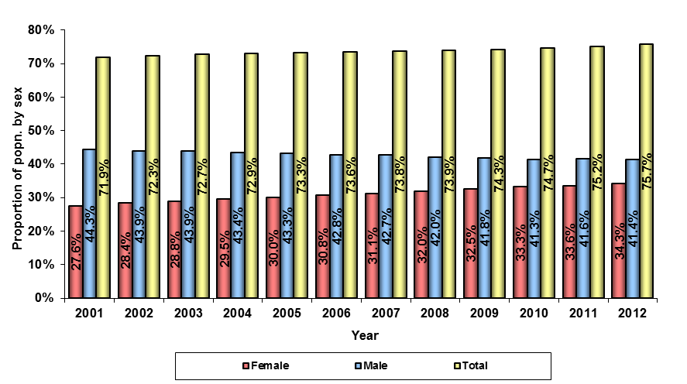

In June 2001, the majority of DSP recipients (71.9 percent – 27.6 percent females and 44.3 percent males) were Australian-born. By June 2012, the percentage of DSP recipients who were Australian born had risen to 75.7 percent – 34.3 percent female and 41.4 percent male.

Although the number of male DSP recipients has risen by 13.3 percent from 2001 to 2012 (see Table 1), the number and proportion of male recipients born overseas has fallen from 115,827 (18.6 percent) as at June 2001 to 102,349 (12.4 percent) as at June 2012.

Relationship status

Table 8 details the DSP recipient population as at June 2012 by relationship status and sex.

Table 8 – Recipients by relationship status and sex – June 2012
Relationship status | Female count | % of female Total | Male count | % of male Total | Total count | % of Total count
Married | 92,559 | 24.2% | 105,901 | 23.8% | 198,460 | 24.0%
Defacto | 20,313 | 5.3% | 23,416 | 5.3% | 43,729 | 5.3%
Single | 123,852 | 32.4% | 197,813 | 44.5% | 321,665 | 38.9%
Seperated | 92,880 | 24.3% | 92,048 | 20.7% | 184,928 | 22.3%
Divorced | 34,435 | 9.0% | 19,985 | 4.5% | 54,420 | 6.6%
Widowed | 18,676 | 4.9% | 5,490 | 1.2% | 24,166 | 2.9%
Registered | 55 | 0.0% | 37 | 0.0% | 92 | 0.0%
Total | 382,770 | 100.0% | 444,690 | 100.0% | 827,460 | 100.0%

Figure 8 shows the proportion of DSP recipients as at June 2012 by relationship status and sex.

Figure 8 – Recipients by relationship status and sex – June 2012
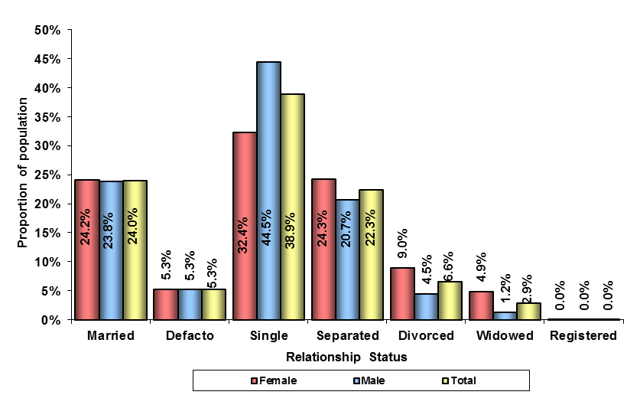

As at June 2012, the majority of DSP recipients (70.7 percent) were non-partnered and 29.3 percent were partnered in married, de facto or registered relationships.

Males are over twelve percent more likely to be single than females (44.5 percent compared to 32.4 percent); females are more heavily represented in the divorced, separated or widowed categories.
Table 9 details the number and percentage of DSP recipients who were partnered and non-partnered by sex for the years from June 2001 to June 2012.

Table 9 – Recipients by relationship status – June 2001 to June 2012
Year | Partnered female count | Partnered females  as a % of Total count | Partnered male count | Partnered males  as a % of Total count | Partnered Sub-Total count | Partnered Sub-Total  as a % of Total count | Not partnered  female count | Not partnered females  as a % of Total count | Not partnered  male count | Not partnered males  as a % of Total count | Not partnered Sub-Total count | Not partnered Sub-Total as a % of Total count | Total count
2001 | 68,295 | 10.9% | 172,666 | 27.7% | 240,961 | 38.6% | 163,277 | 26.2% | 219,688 | 35.2% | 382,965 | 61.4% | 623,926
2002 | 76,446 | 11.6% | 174,574 | 26.5% | 251,020 | 38.1% | 175,576 | 26.6% | 232,319 | 35.3% | 407,895 | 61.9% | 658,915
2003 | 79,555 | 11.8% | 172,098 | 25.6% | 251,653 | 37.4% | 181,002 | 26.9% | 240,679 | 35.7% | 421,681 | 62.6% | 673,334
2004 | 86,203 | 12.4% | 168,389 | 24.2% | 254,592 | 36.5% | 191,710 | 27.5% | 250,440 | 35.9% | 442,150 | 63.5% | 696,742
2005 | 89,363 | 12.6% | 162,936 | 23.1% | 252,299 | 35.7% | 197,346 | 27.9% | 257,137 | 36.4% | 454,483 | 64.3% | 706,782
2006 | 93,861 | 13.2% | 156,793 | 22.0% | 250,654 | 35.2% | 202,684 | 28.5% | 258,825 | 36.3% | 461,509 | 64.8% | 712,163
2007 | 95,458 | 13.4% | 150,408 | 21.1% | 245,866 | 34.4% | 205,665 | 28.8% | 262,625 | 36.8% | 468,290 | 65.6% | 714,156
2008 | 101,594 | 13.9% | 145,861 | 19.9% | 247,455 | 33.8% | 217,289 | 29.7% | 267,623 | 36.5% | 484,912 | 66.2% | 732,367
2009 | 106,200 | 14.0% | 143,267 | 18.9% | 249,467 | 32.9% | 228,628 | 30.2% | 279,023 | 36.9% | 507,651 | 67.1% | 757,118
2010 | 112,589 | 14.2% | 140,053 | 17.7% | 252,642 | 31.9% | 246,536 | 31.1% | 293,403 | 37.0% | 539,939 | 68.1% | 792,581
2011 | 112,262 | 13.7% | 137,333 | 16.8% | 249,595 | 30.5% | 259,988 | 31.8% | 309,267 | 37.8% | 569,255 | 69.5% | 818,850
2012 | 112,927 | 13.6% | 129,354 | 15.6% | 242,281 | 29.3% | 269,843 | 32.6% | 315,336 | 38.1% | 585,179 | 70.7% | 827,460

Figure 9 shows the percentage of partnered recipients by sex for the years from June 2001 to June 2012.

Figure 9 – Recipients by relationship status – June 2001 to June 2012
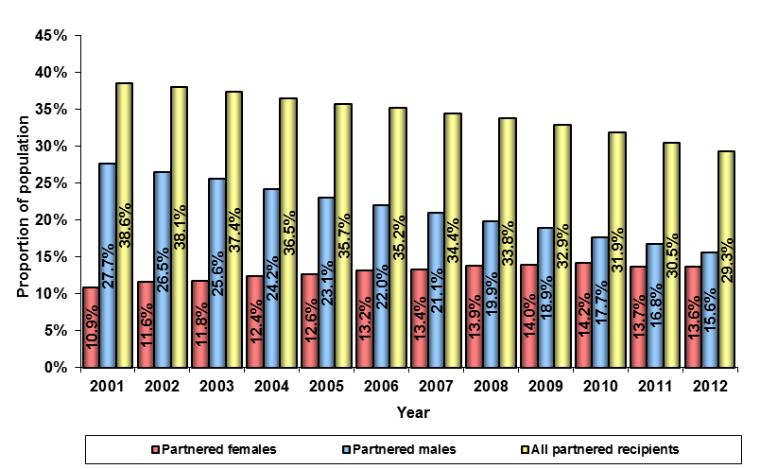

In June 2001, partnered recipients accounted for 38.6 percent of the DSP recipient population (10.9 percent female and 27.7 percent male). Over the years to June 2012, that figure fell to 29.3 percent (13.6 percent female and 15.6 percent male).

While the number of male DSP recipients has risen by 13.3 percent from 2001 to 2012 (see Table 1), the number of male recipients who are partnered has decreased by 25.1 percent from 172,666 as at June 2001 to 129,354 as at June 2012.

At the same time the number of partnered females has risen by 65.4 percent while the number of females overall has risen by 65.3 percent.

Homeownership

Table 10 details the June 2012 DSP recipient population by homeownership status and sex. Homeowners are recipients who own or are buying a home.

Table 10 – Recipients by homeownership status and sex – June 2012
Home ownership status | Female count | % of female Total | Male count | % of male Total | Total count | % of Total count
Homeowner | 124,007 | 32.4% | 116,995 | 26.3% | 241,002 | 29.1%
Non-homeowner* | 258,763 | 67.6% | 327,695 | 73.7% | 586,458 | 70.9%
Total | 382,770 | 100.0% | 444,690 | 100.0% | 827,460 | 100.0%
* Note: Non-homeowner includes ‘unknown’ status

Figure 10 shows the proportion of DSP recipients by homeownership status and sex as at June 2012.

Figure 10 – Recipients by homeownership status and sex – June 2012
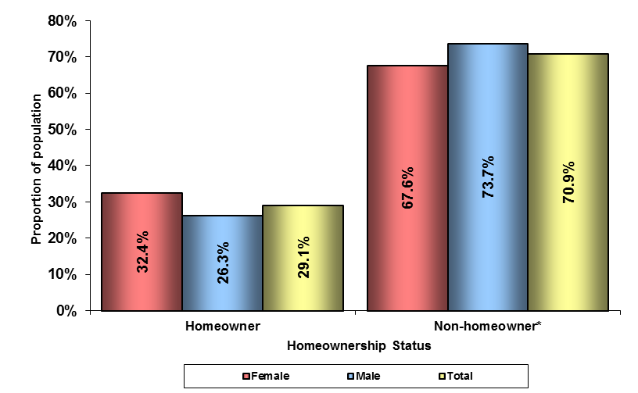

As at June 2012, the majority of DSP recipients (70.9 percent) were non-homeowners. A higher proportion of females than males receiving DSP own a home, (32.4 percent compared to 26.3 percent).
Table 11 details the number and percentage of DSP recipients who were homeowners by sex for the years from June 2001 to June 2012.

Table 11 – Recipients by homeownership status and sex – June 2001 to June 2012
Year | Female home owner count | Female home owners as a % of  combined female  home owner & non-home owner counts | Female non-home owner* count | Female non-home owners* as a % of  combined female  home owner & non-home owner counts | Male home owner count | Male home owners as a % of  combined male  home owner & non-home owner counts | Male non-home owner* count | Male non-home owners* as a % of  combined male  home owner & non-home owner  counts | Home owner Sub-Total count | Home owner Sub-Total  as a % of Total count | Non-home owner* Sub-Total count | Non-home owner* Sub-Total  as a % of Total count | Total Count
2001 | 79,239 | 34.2% | 152,333 | 65.8% | 149,444 | 38.1% | 242,910 | 61.9% | 228,683 | 36.7% | 395,243 | 63.3% | 623,926
2002 | 88,228 | 35.0% | 163,794 | 65.0% | 152,650 | 37.5% | 254,243 | 62.5% | 240,878 | 36.6% | 418,037 | 63.4% | 658,915
2003 | 90,753 | 34.8% | 169,804 | 65.2% | 151,369 | 36.7% | 261,408 | 63.3% | 242,122 | 36.0% | 431,212 | 64.0% | 673,334
2004 | 98,136 | 35.3% | 179,777 | 64.7% | 149,014 | 35.6% | 269,815 | 64.4% | 247,150 | 35.5% | 449,592 | 64.5% | 696,742
2005 | 100,733 | 35.1% | 185,976 | 64.9% | 144,802 | 34.5% | 275,271 | 65.5% | 245,535 | 34.7% | 461,247 | 65.3% | 706,782
2006 | 104,623 | 35.3% | 191,922 | 64.7% | 138,626 | 33.4% | 276,992 | 66.6% | 243,249 | 34.2% | 468,914 | 65.8% | 712,163
2007 | 104,088 | 34.6% | 197,035 | 65.4% | 133,437 | 32.3% | 279,596 | 67.7% | 237,525 | 33.3% | 476,631 | 66.7% | 714,156
2008 | 110,474 | 34.6% | 208,409 | 65.4% | 129,443 | 31.3% | 284,041 | 68.7% | 239,917 | 32.8% | 492,450 | 67.2% | 732,367
2009 | 114,761 | 34.3% | 220,067 | 65.7% | 127,767 | 30.3% | 294,523 | 69.7% | 242,528 | 32.0% | 514,590 | 68.0% | 757,118
2010 | 122,104 | 34.0% | 237,021 | 66.0% | 125,399 | 28.9% | 308,057 | 71.1% | 247,503 | 31.2% | 545,078 | 68.8% | 792,581
2011 | 122,084 | 32.8% | 250,166 | 67.2% | 123,867 | 27.7% | 322,733 | 72.3% | 245,951 | 30.0% | 572,899 | 70.0% | 818,850
2012 | 124,007 | 32.4% | 258,763 | 67.6% | 116,995 | 26.3% | 327,695 | 73.7% | 241,002 | 29.1% | 586,458 | 70.9% | 827,460
*Note: Non-homeowner includes ‘unknown’ status
2001 data source: Pensions SuperCross database 1/6/01 – Centrelink administrative data

Figure 11 shows the homeownership rate of DSP recipients by sex for the years from June 2001 to June 2012.

Figure 11 – Homeownership rate by sex – June 2001 to June 2012
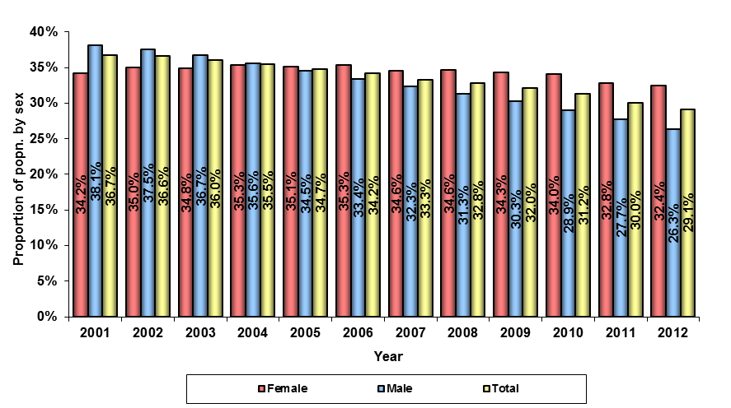

In the years from June 2001 to June 2012 the homeownership rate for DSP recipients has fallen from 36.7 percent to 29.1 percent. While the female homeownership rate has fluctuated between 32.4 and 35.3 percent over the period, the male homeownership rate has fallen from 38.1 percent in June 2001 to 26.3 percent in June 2012.

In June 2001 there were 149,444 male DSP recipients who were homeowners – 24.0 percent of the total DSP population. By June 2012 this figure had fallen to 116,995 – 14.1 percent of the DSP recipient population.

Age and homeownership

Table 12 details the number and percentage of DSP recipient homeowners by age range as at June 2012.

Table 12 – Recipients by homeownership status and age – June 2012
Age range (years) | Home owner count | Home owners  as a % of Total count | Non-home owners* count | Non-home owners  as a % of Total count | Total count | % of Total count
16-19 | 193 | 0.1% | 20,124 | 3.4% | 20,317 | 2.5%
20-24 | 381 | 0.2% | 34,046 | 5.8% | 34,427 | 4.2%
25-29 | 1,213 | 0.5% | 36,837 | 6.3% | 38,050 | 4.6%
30-34 | 2,874 | 1.2% | 40,902 | 7.0% | 43,776 | 5.3%
35-39 | 6,009 | 2.5% | 49,249 | 8.4% | 55,258 | 6.7%
40-44 | 12,019 | 5.0% | 64,134 | 10.9% | 76,153 | 9.2%
45-49 | 20,741 | 8.6% | 73,397 | 12.5% | 94,138 | 11.4%
50-54 | 34,570 | 14.3% | 84,620 | 14.4% | 119,190 | 14.4%
55-59 | 55,923 | 23.2% | 85,049 | 14.5% | 140,972 | 17.0%
60-64 | 94,872 | 39.4% | 84,534 | 14.4% | 179,406 | 21.7%
65 & over | 12,207 | 5.1% | 13,566 | 2.3% | 25,773 | 3.1%
Total | 241,002 | 100.0% | 586,458 | 100.0% | 827,460 | 100.0%
*Note: Non-homeowner includes ‘unknown’ status.

Figure 12 shows the number of homeowners and non-homeowners by age range as at June 2012.

Figure 12 – Recipients by homeownership status and age – June 2012
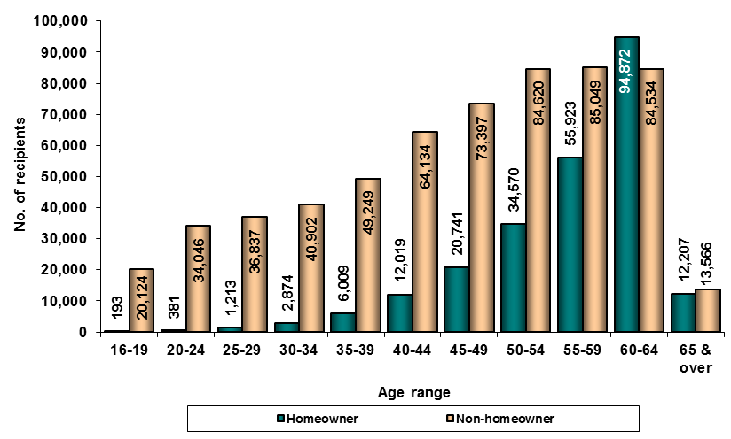

Over 80 percent of the DSP recipients who own their own home are over 50 years of age. Only in the 60 to 64 year age range are there more homeowners than non-homeowners.

Primary medical condition

Medical condition

Table 13 details the number and percentage of DSP recipients by sex and primary medical condition.

Table 13 – Recipients by sex and primary medical condition – June 2012
Primary medical condition | Female count | % of female Total | Male count | % of male Total | Total count | % of Total count
Psychological/Psychiatric | 113,553 | 29.7% | 136,963 | 30.8% | 250,516 | 30.3%
Musculo-Skeletal & Connective Tissue | 108,840 | 28.4% | 116,947 | 26.3% | 225,787 | 27.3%
Intellectual/Learning | 41,461 | 10.8% | 58,118 | 13.1% | 99,579 | 12.0%
Nervous System | 21,369 | 5.6% | 19,915 | 4.5% | 41,284 | 5.0%
Circulatory System | 12,351 | 3.2% | 22,622 | 5.1% | 34,973 | 4.2%
Sense Organs | 10,397 | 2.7% | 11,521 | 2.6% | 21,918 | 2.6%
Respiratory System | 11,254 | 2.9% | 10,465 | 2.4% | 21,719 | 2.6%
Acquired Brain Impairment | 6,420 | 1.7% | 14,260 | 3.2% | 20,680 | 2.5%
Endocrine & Immune System | 9,025 | 2.4% | 9,524 | 2.1% | 18,549 | 2.2%
Cancer/Tumour | 8,221 | 2.1% | 7,775 | 1.7% | 15,996 | 1.9%
Chronic Pain | 7,614 | 2.0% | 6,612 | 1.5% | 14,226 | 1.7%
Poorly Defined Cause | 9,752 | 2.5% | 3,570 | 0.8% | 13,322 | 1.6%
Congenital Anomalies | 6,065 | 1.6% | 6,547 | 1.5% | 12,612 | 1.5%
Granted Prior to 12/11/91 | 4,659 | 1.2% | 7,053 | 1.6% | 11,712 | 1.4%
Gastro-Intestinal System | 3,987 | 1.0% | 2,706 | 0.6% | 6,693 | 0.8%
Visceral Disorder | 2,454 | 0.6% | 3,454 | 0.8% | 5,908 | 0.7%
Urogenital System | 2,599 | 0.7% | 2,609 | 0.6% | 5,208 | 0.6%
Infectious Diseases | 925 | 0.2% | 1,678 | 0.4% | 2,603 | 0.3%
Amputation | 334 | 0.1% | 1,280 | 0.3% | 1,614 | 0.2%
Skin Disorders & Burns | 373 | 0.1% | 474 | 0.1% | 847 | 0.1%
Inherited Disorders | 354 | 0.1% | 368 | 0.1% | 722 | 0.1%
Reproductive System | 550 | 0.1% | 17 | 0.0% | 567 | 0.1%
Not Coded | 213 | 0.1% | 212 | 0.0% | 425 | 0.1%
Total | 382,770 | 100.0% | 444,690 | 100.0% | 827,460 | 100.0%

Figure 13 shows the percentage of DSP recipients of each sex and total for the top five primary medical conditions.

Figure 13 – Recipients - top 5 primary medical conditions by sex – June 2012
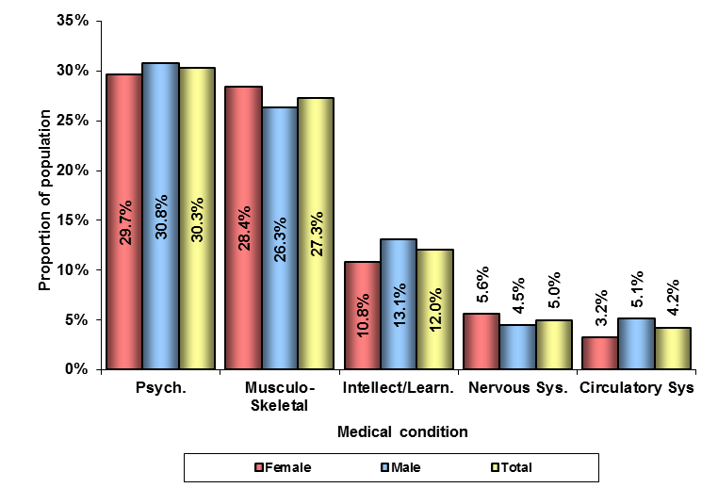

For both males and females, the most common medical categories were Psychological/psychiatric and Musculo-skeletal and connective tissue, followed by Intellectual/learning.

The distribution of primary medical conditions is very similar for both sexes. The conditions with the largest differences are Circulatory system (almost twice as many males as females, a 1.9 percentage point difference); Poorly defined cause (over two and a half times as many females as males, a 1.7 percentage point difference); and Acquired brain impairment (over twice as many males as females, a 1.5 percentage point difference).

Table 14 details the number and percentage of DSP recipients reported against the top five medical conditions and others for the years from June 2001 to June 2012.

Table 14 – Recipients by primary medical condition – top 5/other – June 2001 to June 2012
Year | Psychological/psychiatric count | Psychological/psychiatric  as a % of Total count | Musculo-skeletal  & connective tissue count | Musculo-skeletal  & connective tissue  as a % of Total count | Intellectual/learning count | Intellectual/learning  as a % of Total count | Nervous system count | Nervous system  as a % of Total count | Circulatory system count | Circulatory system  as a % of Total count | Other medical condition count | Other medical condition  as a % of Total count | Total count
2001 | 140,965 | 22.6% | 202,732 | 32.5% | 63,168 | 10.1% | 19,270 | 3.1% | 33,742 | 5.4% | 164,049 | 26.3% | 623,926
2002 | 155,998 | 23.7% | 219,740 | 33.3% | 67,090 | 10.2% | 20,505 | 3.1% | 35,485 | 5.4% | 160,097 | 24.3% | 658,915
2003 | 166,040 | 24.7% | 226,989 | 33.7% | 70,747 | 10.5% | 21,538 | 3.2% | 35,654 | 5.3% | 152,366 | 22.6% | 673,334
2004 | 177,048 | 25.4% | 237,103 | 34.0% | 74,453 | 10.7% | 22,650 | 3.3% | 36,507 | 5.2% | 148,981 | 21.4% | 696,742
2005 | 185,351 | 26.2% | 239,723 | 33.9% | 77,854 | 11.0% | 23,266 | 3.3% | 36,313 | 5.1% | 144,275 | 20.4% | 706,782
2006 | 190,793 | 26.8% | 239,309 | 33.6% | 80,742 | 11.3% | 24,203 | 3.4% | 36,101 | 5.1% | 141,015 | 19.8% | 712,163
2007 | 195,059 | 27.3% | 228,134 | 31.9% | 80,260 | 11.2% | 30,927 | 4.3% | 35,461 | 5.0% | 144,315 | 20.2% | 714,156
2008 | 202,421 | 27.6% | 227,641 | 31.1% | 82,368 | 11.2% | 33,368 | 4.6% | 35,627 | 4.9% | 150,942 | 20.6% | 732,367
2009 | 213,672 | 28.2% | 227,271 | 30.0% | 86,403 | 11.4% | 35,809 | 4.7% | 35,873 | 4.7% | 158,090 | 20.9% | 757,118
2010 | 227,420 | 28.7% | 231,412 | 29.2% | 91,824 | 11.6% | 38,147 | 4.8% | 36,558 | 4.6% | 167,220 | 21.1% | 792,581
2011 | 241,335 | 29.5% | 231,225 | 28.2% | 96,512 | 11.8% | 40,172 | 4.9% | 36,420 | 4.4% | 173,186 | 21.1% | 818,850
2012 | 250,516 | 30.3% | 225,787 | 27.3% | 99,579 | 12.0% | 41,284 | 5.0% | 34,973 | 4.2% | 175,321 | 21.2% | 827,460

Figure 14 shows the percentage of DSP recipients reported against the top three medical conditions for the years from June 2001 to June 2012.

Figure 14 – Recipients by top 3 primary medical conditions – June 2001 to June 2012
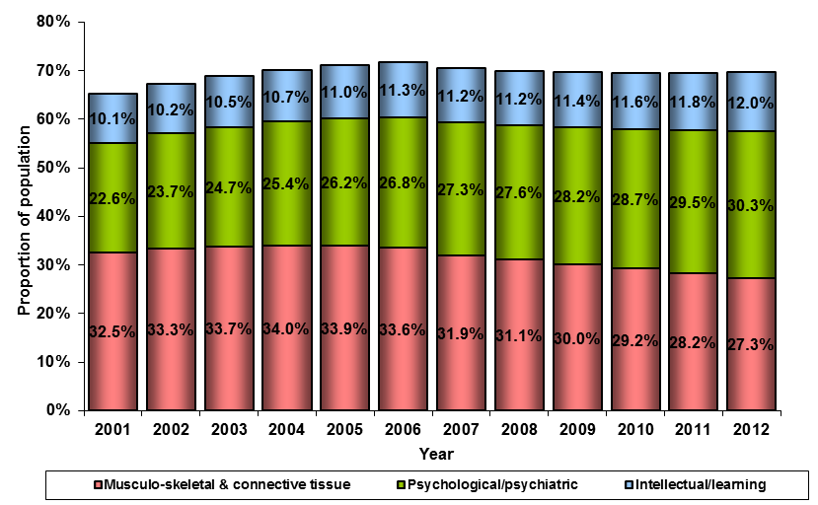

As at June 2001, nearly two thirds (65.2 percent) of DSP recipients had Musculo-skeletal and connective tissue, Psychological/psychiatric or Intellectual/learning as their primary medical condition. By June 2012 that figure was 69.6 percent. Of the three most common primary medical conditions, Psychological/psychiatric and Intellectual/learning have, in most years, been increasing in incidence while, Musculo-skeletal and connective tissue peaked at 34.0 percent of the recipient population in 2004 and has since had a decreasing representation. The number and proportion of DSP recipients with Psychological/psychiatric as their primary medical condition exceeded the number with Musculo-skeletal and connective tissue condition for the first time in 2011.

Table 15 details the percentage of DSP recipients of each sex reported against the top five primary medical conditions (and others) for the years from June 2001 to June 2012.

Table 15 – Proportion of recipients by primary medical condition (top 5), by sex – June 2001 to June 2012
Year | % of females with  Psychological/psychiatric  primary medical condition | % of males with  Psychological/psychiatric  primary medical condition | % of females with  Musculo-skeletal & connective tissue  primary medical condition | % of males with  Musculo-skeletal & connective tissue  primary medical condition | % of females with  Intellectual/learning  primary medical condition | % of males with  Intellectual/learning  primary medical condition | % of females with  Nervous system  primary medical condition | % of males with  Nervous system  primary medical condition | % of females with  Circulatory system  primary medical condition | % of males with  Circulatory system  primary medical condition | % of females with  Other primary medical conditions | % of males with  Other primary medical conditions
2001 | 25.3% | 21.0% | 30.8% | 33.5% | 11.5% | 9.3% | 3.8% | 2.7% | 3.3% | 6.7% | 25.2% | 26.9%
2002 | 26.0% | 22.2% | 32.0% | 34.2% | 11.3% | 9.5% | 3.8% | 2.7% | 3.4% | 6.6% | 23.7% | 24.7%
2003 | 26.8% | 23.3% | 32.5% | 34.5% | 11.5% | 9.9% | 3.9% | 2.8% | 3.4% | 6.5% | 22.0% | 23.0%
2004 | 27.0% | 24.3% | 33.4% | 34.5% | 11.3% | 10.3% | 3.9% | 2.8% | 3.5% | 6.4% | 20.9% | 21.7%
2005 | 27.5% | 25.3% | 33.5% | 34.2% | 11.4% | 10.8% | 3.9% | 2.9% | 3.5% | 6.3% | 20.1% | 20.6%
2006 | 27.7% | 26.1% | 33.6% | 33.6% | 11.4% | 11.3% | 4.0% | 3.0% | 3.6% | 6.1% | 19.7% | 19.9%
2007 | 27.8% | 27.0% | 31.7% | 32.1% | 11.2% | 11.3% | 5.0% | 3.8% | 3.5% | 6.1% | 20.8% | 19.8%
2008 | 27.8% | 27.5% | 31.3% | 30.9% | 10.9% | 11.5% | 5.2% | 4.0% | 3.5% | 5.9% | 21.4% | 20.0%
2009 | 28.2% | 28.3% | 30.4% | 29.7% | 10.8% | 11.9% | 5.4% | 4.2% | 3.4% | 5.8% | 21.8% | 20.2%
2010 | 28.4% | 29.0% | 30.0% | 28.5% | 10.7% | 12.3% | 5.4% | 4.3% | 3.4% | 5.6% | 22.1% | 20.3%
2011 | 29.2% | 29.7% | 29.1% | 27.5% | 10.8% | 12.6% | 5.5% | 4.4% | 3.3% | 5.4% | 22.1% | 20.3%
2012 | 29.7% | 30.8% | 28.4% | 26.3% | 10.8% | 13.1% | 5.6% | 4.5% | 3.2% | 5.1% | 22.3% | 20.3%

Figure 15 shows the percentage of DSP recipients of each sex for the top three primary medical conditions for the years from June 2001 to June 2012.

Figure 15 – Recipients’ sex by top 3 primary medical conditions – June 2001 to June 2012
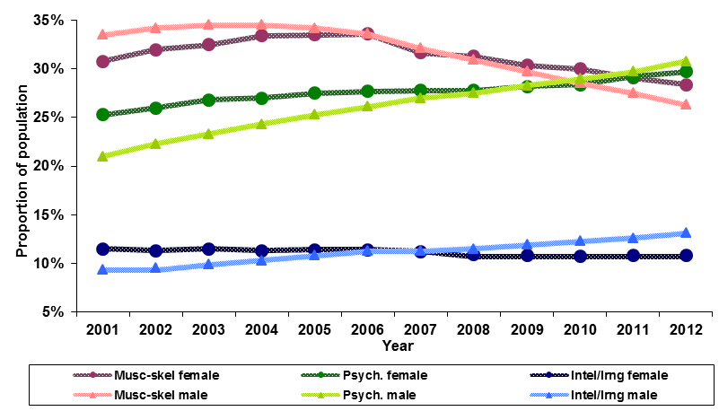

In the years from June 2001 to June 2012 there has been a change in the proportion of each sex with the top three medical conditions as their primary medical condition. While the proportion of recipients with Musculo-skeletal and connective tissue recorded as their primary medical condition has been decreasing generally, that trend is more pronounced in the male population than the female. Similarly, Psychological/ psychiatric has been increasing in proportion since 2001 and that trend is also occurring more with male recipients.

The proportion of females with Intellectual/learning recorded as their primary medical condition has fallen from 11.5 percent in June 2001 to 10.8 percent in June 2012 – this is the opposite of the male recipient population where the proportion of males reporting against the category has risen from 9.3 percent in 2001 to 13.1 percent in 2012.

Top three primary medical conditions by age range and sex

Psychological/psychiatric

Table 16 details the number and percentage of DSP recipients with Psychological/psychiatric as their primary medical condition by age range and sex.

Table 16 – Psychological/psychiatric recipients by age range and sex – June 2012
Age range (years) | Female count | % of female Total | Male count | % of  male Total | Total count | % of  Total count
16-24 | 5,210 | 4.6% | 10,437 | 7.6% | 15,647 | 6.2%
25-34 | 12,729 | 11.2% | 20,632 | 15.1% | 33,361 | 13.3%
35-44 | 23,670 | 20.8% | 33,378 | 24.4% | 57,048 | 22.8%
45-54 | 34,881 | 30.7% | 37,286 | 27.2% | 72,167 | 28.8%
55-64 | 35,276 | 31.1% | 33,092 | 24.2% | 68,368 | 27.3%
65 & over | 1,787 | 1.6% | 2,138 | 1.6% | 3,925 | 1.6%
Total | 113,553 | 100.0% | 136,963 | 100.0% | 250,516 | 100.0%

Figure 16 shows the percentage of DSP recipients with Psychological/psychiatric medical condition by age range and sex.

Figure 16 – Psychological/psychiatric recipients by age range and sex – June 2012

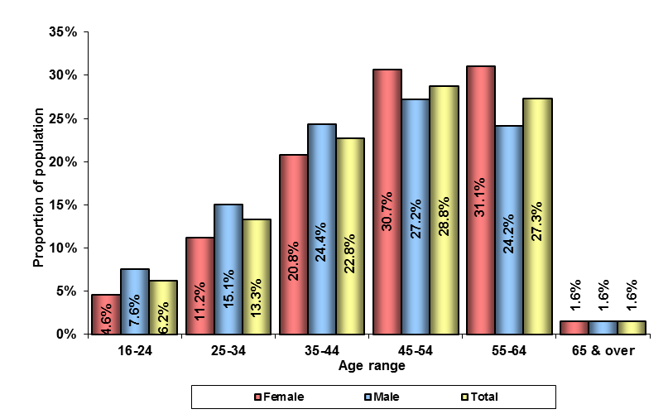
Psychological/psychiatric condition is the most common primary medical condition recorded and over half of recipients with this condition are aged 45 years and over.

There is a difference in the proportion of DSP recipients with a Psychological/ psychiatric condition according to gender and whether they are aged over 45 years. Females under 45 account for only 36.6 percent of all females with the condition; while for males with Psychological/psychiatric condition, 47.1 percent are under 45 years old.

Musculo-skeletal and connective tissue

Table 17 details the number and percentage of DSP recipients with Musculo-skeletal and connective tissue as their primary medical condition by age range and sex.

Table 17 – Musculo-skeletal & connective tissue recipients by age range and sex – June 2012
Age range (years) | Female count | % of female Total | Male count | % of  male Total | Total count | % of  Total count
16-24 | 753 | 0.7% | 685 | 0.6% | 1,438 | 0.6%
25-34 | 2,390 | 2.2% | 2,829 | 2.4% | 5,219 | 2.3%
35-44 | 8,653 | 8.0% | 11,725 | 10.0% | 20,378 | 9.0%
45-54 | 26,769 | 24.6% | 31,416 | 26.9% | 58,185 | 25.8%
55-64 | 66,201 | 60.8% | 64,365 | 55.0% | 130,566 | 57.8%
65 & over | 4,074 | 3.7% | 5,927 | 5.1% | 10,001 | 4.4%
Total | 108,840 | 100.0% | 116,947 | 100.0% | 225,787 | 100.0%

Figure 17 shows the percentage of DSP recipients with Musculo-skeletal and connective tissue recorded as their primary medical condition by age range and sex.

Figure 17 – Musculo-skeletal & connective tissue recipients by age range and sex – June 2012
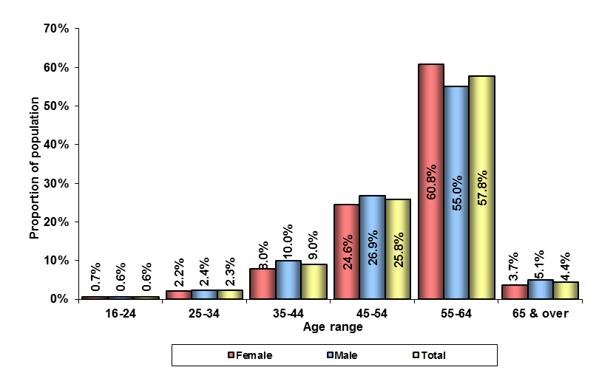

The age distribution for recipients with a primary medical condition of Musculo-skeletal and connective tissue is skewed strongly towards the older age ranges.

Intellectual/learning

Table 18 details the number and percentage of DSP recipients with Intellectual/learning as their primary medical condition by age range and sex.

Table 18 – Intellectual/learning recipients by age range and sex – June 2012
Age range (years) | Female count | % of female Total | Male count | % of  male Total | Total count | % of  Total count
16-24 | 10,302 | 24.8% | 15,887 | 27.3% | 26,189 | 26.3%
25-34 | 10,255 | 24.7% | 14,627 | 25.2% | 24,882 | 25.0%
35-44 | 7,865 | 19.0% | 10,965 | 18.9% | 18,830 | 18.9%
45-54 | 7,595 | 18.3% | 9,816 | 16.9% | 17,411 | 17.5%
55-64 | 5,031 | 12.1% | 6,265 | 10.8% | 11,296 | 11.3%
65 & over | 413 | 1.0% | 558 | 1.0% | 971 | 1.0%
Total | 41,461 | 100.0% | 58,118 | 100.0% | 99,579 | 100.0%

Figure 18 shows the percentage of DSP recipients with Intellectual/learning as their primary medical condition by age range and sex.

Figure 18 – Intellectual/learning recipients by age range and sex – June 2012
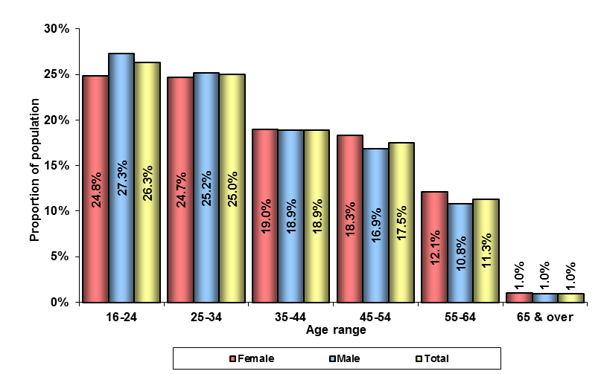

Recipients with Intellectual/learning conditions are predominantly in the younger age ranges.

There are only slight differences in the age distribution by sex for recipients with a slightly higher proportion of males in the under 35 age ranges.

Earnings and income support duration

Earnings

Table 19 details the number and percentage of DSP recipients by their earnings declared in the fortnight to 29 June 2012 by sex.

Table 19 – Recipients by earnings range and sex – fortnight to 29 June 2012
Earnings range | Female count | % of female Total | Male count | % of male Total | Total count | % of Total count
Nil earnings | 350,452 | 91.6% | 407,113 | 91.5% | 757,565 | 91.6%
Less than $250 | 14,597 | 3.8% | 18,146 | 4.1% | 32,743 | 4.0%
$250 to < $500 | 8,033 | 2.1% | 9,259 | 2.1% | 17,292 | 2.1%
$500 to < $750 | 4,617 | 1.2% | 4,398 | 1.0% | 9,015 | 1.1%
$750 to < $1,000 | 2,330 | 0.6% | 2,387 | 0.5% | 4,717 | 0.6%
$1,000 to < $1,250 | 1,313 | 0.3% | 1,487 | 0.3% | 2,800 | 0.3%
$1,250 to < $1,500 | 666 | 0.2% | 764 | 0.2% | 1,430 | 0.2%
$1500 and over | 762 | 0.2% | 1,136 | 0.3% | 1,898 | 0.2%
Total | 382,770 | 100.0% | 444,690 | 100.0% | 827,460 | 100.0%

Figure 19 shows the percentage of DSP recipients of each sex by their earnings declared in the fortnight to 29 June 2012.

Figure 19 – Recipients with earnings by range and sex - fortnight to 29 June 2012
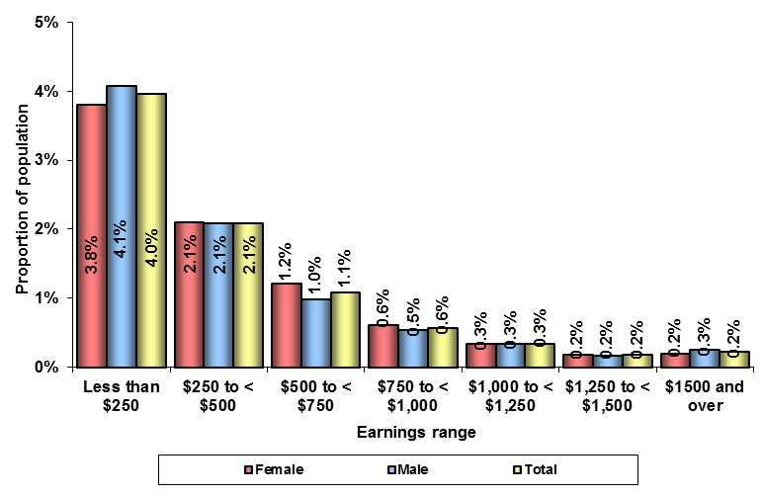

There were 69,895 DSP recipients (8.4 percent of all recipients) who declared earnings in the fortnight ending 29 June 2012.

There were 4.0 percent of DSP recipients with reported earnings of less than $250.00 in the fortnight. This is below the income free area for a couple.

A higher proportion of females than males declared earnings between $250 and $1,250 in the fortnight (4.3 percent for females compared to 3.9 percent for males).

Table 20 details the number and percentage of DSP recipients who reported earnings in the fortnight before the data extraction date, and those with no reported earnings, by sex for the years from June 2007 to June 2012.

Table 20 – Recipients with earnings/no earnings by sex – June 2007 to June 2012
Year | Females with earnings count | Females with earnings  as a % of Total count | Males with earnings count | Males with earnings  as a % of Total count | With earnings Sub-Total count | With earnings Sub-Total  as a % of Total count | Females without earnings count | Females without earnings  as a % of Total count | Males without earnings count | Males without earnings  as a % of Total count | Without earnings  Sub-Total count | Without earnings Sub-Total  as a % of Total count | Total count
2007 | 31,238 | 4.4% | 39,615 | 5.5% | 70,853 | 9.9% | 269,885 | 37.8% | 373,418 | 52.3% | 643,303 | 90.1% | 714,156
2008 | 32,585 | 4.4% | 39,322 | 5.4% | 71,907 | 9.8% | 286,298 | 39.1% | 374,162 | 51.1% | 660,460 | 90.2% | 732,367
2009 | 31,891 | 4.2% | 37,850 | 5.0% | 69,741 | 9.2% | 302,937 | 40.0% | 384,440 | 50.8% | 687,377 | 90.8% | 757,118
2010 | 31,856 | 4.0% | 37,336 | 4.7% | 69,192 | 8.7% | 327,269 | 41.3% | 396,120 | 50.0% | 723,389 | 91.3% | 792,581
2011 | 31,980 | 3.9% | 37,490 | 4.6% | 69,470 | 8.5% | 340,270 | 41.6% | 409,110 | 50.0% | 749,380 | 91.5% | 818,850
2012 | 32,318 | 3.9% | 37,577 | 4.5% | 69,895 | 8.4% | 350,452 | 42.4% | 407,113 | 49.2% | 757,565 | 91.6% | 827,460

Figure 20 shows the percentage of DSP recipients who reported earnings in the fortnight before the data extraction date, by sex for the years from 2007 to 2012.

Figure 20 – Recipients with earnings by sex – June 2007 to June 2012
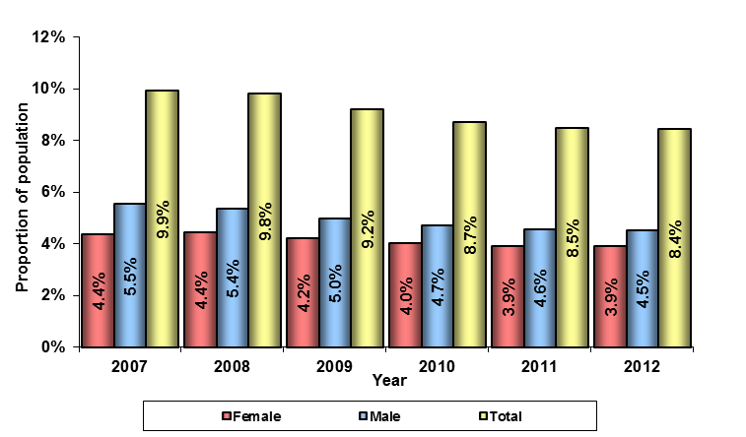
The proportion of DSP recipients with earnings in the fortnight before the data extraction date has fallen from 9.9 percent in 2007 to 8.4 percent in 2012.

In the years from 2007 to 2012 the number of male DSP recipients reporting earnings in the fortnight before the data extraction date fell by 2,038 – a fall of 5.1 percent - whereas the total male recipient population rose by 31,657 (7.7 percent).

Over the same years, the female DSP recipient population rose by 81,647 (27.1 percent) and the female population reporting earnings rose by 3.5 percent.

Table 21 details the number and percentage of DSP recipients who declared earnings by the earnings range for the years from 2007 to 2012.

Table 21 – Recipients with earnings by earnings range – June 2007 to June 2012
Year | Less than $250 count | Less than $250  as a % of Total count | $250 to less than $500 count | $250 to less than $500  as a % of Total count | $500 to less than $750 count | $500 to less than $750  as a % of Total count | $750 to less than $1,000 count | $750 to less than $1,000  as a % of Total count | $1,000 to less than $1,250 count | $1,000 to less than $1,250  as a % of Total count | $1,250 to less than $1,500 count | $1,250 to less than $1,500  as a % of Total count | $1,500 and over count | $1,500 and over  as a % of Total count | Total count
2007 | 37,617 | 53.1% | 14,208 | 20.1% | 8,429 | 11.9% | 5,356 | 7.6% | 2,780 | 3.9% | 1,236 | 1.7% | 1,227 | 1.7% | 70,853
2008 | 36,348 | 50.5% | 15,188 | 21.1% | 8,777 | 12.2% | 5,680 | 7.9% | 3,020 | 4.2% | 1,418 | 2.0% | 1,476 | 2.1% | 71,907
2009 | 35,211 | 50.5% | 15,339 | 22.0% | 8,454 | 12.1% | 5,045 | 7.2% | 2,852 | 4.1% | 1,377 | 2.0% | 1,463 | 2.1% | 69,741
2010 | 34,329 | 49.6% | 15,879 | 22.9% | 8,316 | 12.0% | 4,924 | 7.1% | 2,743 | 4.0% | 1,424 | 2.1% | 1,577 | 2.3% | 69,192
2011 | 33,650 | 48.4% | 16,360 | 23.5% | 8,636 | 12.4% | 4,772 | 6.9% | 2,760 | 4.0% | 1,510 | 2.2% | 1,782 | 2.6% | 69,470
2012 | 32,743 | 46.8% | 17,292 | 24.7% | 9,015 | 12.9% | 4,717 | 6.7% | 2,800 | 4.0% | 1,430 | 2.0% | 1,898 | 2.7% | 69,895

Figure 21 shows the percentage of DSP recipients who declared earnings by the earnings range for the years 2007, 2010 and 2012.

Figure 21 – Recipients with earnings by earnings range – 2007, 2010 and 2012
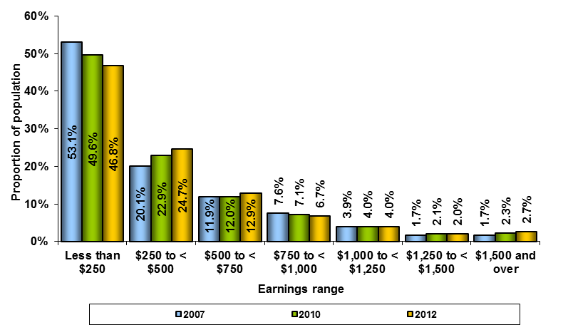

In the years from 2007 to 2012, the distribution of DSP recipients with earnings by the amount earned has remained relatively steady.

There has been a decrease in those earning less than $250 and an increase in most other categories. In particular the proportion of earnings in the $250 to less than $500 range has increased from 20.1 percent in June 2007 to 24.7 percent in June 2012.

Income support duration

Note: Duration on income support includes the period of time a person has been in receipt of DSP together with the period of time the person may have been in receipt of any other income support payment(s).

Table 22 details the number and percentage of DSP recipients by the duration of income support and sex as at June 2012.

Table 22 – Recipients by income support duration and sex – June 2012
Duration | Female count | % of female Total | Male count | % of male Total | Total count | % of Total count
Under 1 yr | 15,128 | 4.0% | 23,049 | 5.2% | 38,177 | 4.6%
1 to < 2 years | 17,999 | 4.7% | 22,543 | 5.1% | 40,542 | 4.9%
2 to < 3 years | 20,629 | 5.4% | 25,337 | 5.7% | 45,966 | 5.6%
3 to < 4 years | 21,556 | 5.6% | 27,648 | 6.2% | 49,204 | 5.9%
4 to < 5 years | 17,309 | 4.5% | 21,505 | 4.8% | 38,814 | 4.7%
5 to < 6 years | 15,213 | 4.0% | 18,622 | 4.2% | 33,835 | 4.1%
6 to < 7 years | 14,278 | 3.7% | 17,739 | 4.0% | 32,017 | 3.9%
7 to < 8 years | 14,431 | 3.8% | 17,473 | 3.9% | 31,904 | 3.9%
8 to < 9 years | 14,755 | 3.9% | 17,151 | 3.9% | 31,906 | 3.9%
9 to < 10 years | 14,231 | 3.7% | 17,225 | 3.9% | 31,456 | 3.8%
10 to < 15 years | 72,071 | 18.8% | 83,591 | 18.8% | 155,662 | 18.8%
15 to < 20 years | 83,201 | 21.7% | 80,674 | 18.1% | 163,875 | 19.8%
20 years and over | 61,969 | 16.2% | 72,133 | 16.2% | 134,102 | 16.2%
Total | 382,770 | 100.0% | 444,690 | 100.0% | 827,460 | 100.0%

Figure 22 shows the percentage of DSP recipients by the duration on income support by sex as at June 2012.

Figure 22 – Recipients by income support duration and sex– June 2012
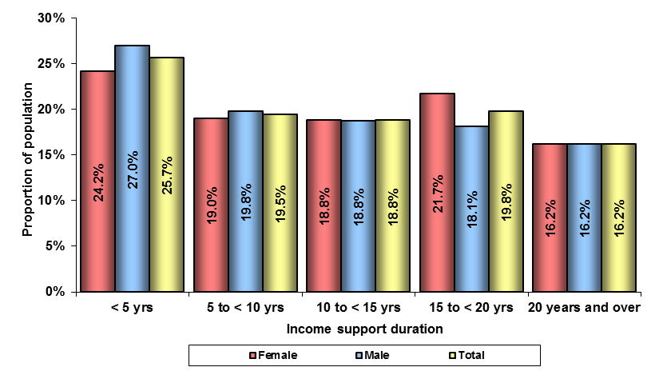

Over a third of DSP recipients (36.0 percent) have been in receipt of either DSP or another income support payment for fifteen years or more (37.9 percent of females and 34.4 percent of males). Proportionally, more males have been in receipt of income support for less than ten years (46.8 percent) than females (43.2 percent).
Table 23 details the DSP recipient population by their duration on income support for the years June 2007 to June 2012.

Table 23 – Recipients by income support duration – June 2007 to June 2012
Year | Less than 5 years count | Less than 5 years  as a % of Total count | 5 years to less than 10 years count | 5 years to less than 10 years  as a % of Total count | 10 years to less than 15 years count | 10 years to less than 15 years  as a % of Total count | 15 years to less than 20 years count | 15 years to less than 20 years  as a % of Total count | 20 years and over count | 20 years and over as a % of Total count | Total count
2007 | 166,330 | 23.3% | 187,734 | 26.3% | 192,530 | 27.0% | 89,705 | 12.6% | 77,857 | 10.9% | 714,156
2008 | 165,434 | 22.6% | 180,155 | 24.6% | 196,656 | 26.9% | 106,831 | 14.6% | 83,291 | 11.4% | 732,367
2009 | 184,056 | 24.3% | 173,288 | 22.9% | 188,238 | 24.9% | 123,404 | 16.3% | 88,132 | 11.6% | 757,118
2010 | 199,600 | 25.2% | 171,969 | 21.7% | 168,695 | 21.3% | 156,940 | 19.8% | 95,377 | 12.0% | 792,581
2011 | 214,463 | 26.2% | 165,404 | 20.2% | 159,650 | 19.5% | 166,871 | 20.4% | 112,462 | 13.7% | 818,850
2012 | 212,703 | 25.7% | 161,118 | 19.5% | 155,662 | 18.8% | 163,875 | 19.8% | 134,102 | 16.2% | 827,460

Figure 23 shows the percentage of DSP recipients in each of the income support duration ranges for the years from June 2007 to June 2012.

Figure 23 – Recipients by income support duration – June 2007 to June 2012
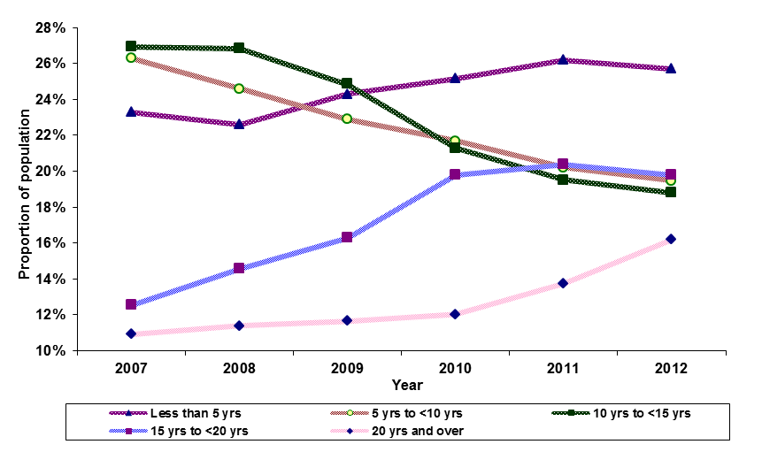

Between June 2007 and June 2012 the proportion of DSP recipients who had been in receipt of income support for less than five years or fifteen years or more increased whereas the percentage in receipt of DSP between five and less than fifteen years decreased.

Table 24 details the number and proportion of each sex of DSP recipients by whether they have been in receipt of income support for under or over fifteen years for the years from June 2007 to June 2012.

Table 24 – Recipients income support duration under/over 15 years – June 2007 to June 2012
Year | Females with duration under 15 years count | Females with duration under 15 years  as a % of Total count | Females with duration 15 years or over count | Females with duration 15 years or over as a % of Total count | Males with duration under 15 years count | Males with duration under 15 years  as a % of Total count | Males with duration 15 years or over duration count | Males with duration 15 years or over  as a % of Total count | Duration under 15 years Total count | Duration under 15 years  as a % of Total count | Duration 15 years or over Total count | Duration 15 years or over as a % of Total count | Total count
2007 | 230,535 | 76.6% | 70,588 | 23.4% | 316,059 | 76.5% | 96,974 | 23.5% | 546,594 | 76.5% | 167,562 | 23.5% | 714,156
2008 | 236,911 | 74.3% | 81,972 | 25.7% | 305,334 | 73.8% | 108,150 | 26.2% | 542,245 | 74.0% | 190,122 | 26.0% | 732,367
2009 | 241,757 | 72.2% | 93,071 | 27.8% | 303,825 | 71.9% | 118,465 | 28.1% | 545,582 | 72.1% | 211,536 | 27.9% | 757,118
2010 | 239,829 | 66.8% | 119,296 | 33.2% | 300,435 | 69.3% | 133,021 | 30.7% | 540,264 | 68.2% | 252,317 | 31.8% | 792,581
2011 | 237,440 | 63.8% | 134,810 | 36.2% | 302,077 | 67.6% | 144,523 | 32.4% | 539,517 | 65.9% | 279,333 | 34.1% | 818,850
2012 | 237,600 | 62.1% | 145,170 | 37.9% | 291,883 | 65.6% | 152,807 | 34.4% | 529,483 | 64.0% | 297,977 | 36.0% | 827,460

As at June 2007 over three quarters (76.5 percent) of DSP recipients had been in receipt of income support for less than fifteen years. By June 2012 that figure had fallen to 64.0 percent.

Figure 24 shows the proportion of each sex of DSP recipients with a total income support duration of fifteen years and over for the years from June 2007 to June 2012.

Figure 24 – Recipients on income support for 15 years and over by sex – June 2007 to June 2012
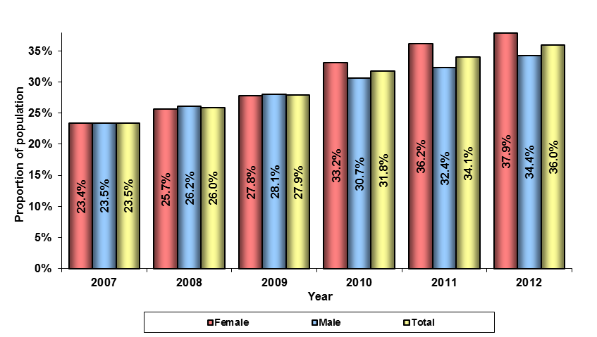

For the years from June 2007 to June 2009 the gender balance of recipients who had been in receipt of income support for fifteen years or more was similar and the proportion for both sexes had been growing at around 2 percent per year.

At June 2010 the previous balance began to change and at June 2012 37.9 percent of female DSP recipients (an increase of 1.7 percentage points over the previous year) had been in receipt of income support for fifteen years and over; whereas 34.4 percent of males (an increase of 2.0 percentage points over the previous year) are in that cohort.

Finalised claims

Finalised claims by age and sex

Table 25 details the volume and proportion of finalised claims by age range and sex for the period from June 2011 to June 2012.

Table 25 – Finalised claims by age and sex – 2011-12
Age range (years) | Female grant count | Female grant rate | Male grant count | Male grant rate | Total grant count | Grant rate | Female rejection count | Male rejection count | Total rejection count | Female Total claims count | Male Total claims count | Total claims count
16-19 | 2,437 | 59.8% | 3,960 | 66.9% | 6,397 | 64.0% | 1,639 | 1,959 | 3,598 | 4,076 | 5,919 | 9,995
20-24 | 1,161 | 38.7% | 1,498 | 41.9% | 2,659 | 40.5% | 1,838 | 2,076 | 3,914 | 2,999 | 3,574 | 6,573
25-29 | 1,198 | 41.2% | 1,643 | 41.8% | 2,841 | 41.5% | 1,711 | 2,291 | 4,002 | 2,909 | 3,934 | 6,843
30-34 | 1,455 | 42.8% | 1,980 | 42.4% | 3,435 | 42.6% | 1,943 | 2,689 | 4,632 | 3,398 | 4,669 | 8,067
35-39 | 2,099 | 44.8% | 2,430 | 43.9% | 4,529 | 44.3% | 2,586 | 3,108 | 5,694 | 4,685 | 5,538 | 10,223
40-44 | 2,933 | 43.6% | 3,105 | 45.2% | 6,038 | 44.4% | 3,799 | 3,770 | 7,569 | 6,732 | 6,875 | 13,607
45-49 | 3,650 | 44.1% | 3,546 | 46.6% | 7,196 | 45.3% | 4,619 | 4,063 | 8,682 | 8,269 | 7,609 | 15,878
50-54 | 4,486 | 45.8% | 4,092 | 47.3% | 8,578 | 46.5% | 5,303 | 4,558 | 9,861 | 9,789 | 8,650 | 18,439
55-59 | 5,314 | 50.1% | 5,238 | 50.7% | 10,552 | 50.4% | 5,291 | 5,095 | 10,386 | 10,605 | 10,333 | 20,938
60 & over | 5,748 | 54.1% | 7,076 | 54.6% | 12,824 | 54.4% | 4,885 | 5,885 | 10,770 | 10,633 | 12,961 | 23,594
Total | 30,481 | 47.6% | 34,568 | 49.3% | 65,049 | 48.5% | 33,614 | 35,494 | 69,108 | 64,095 | 70,062 | 134,157

Figure 25 shows the proportion of each sex granted DSP and the overall grant rate for each age range in the period from June 2011 to June 2012.

Figure 25 – Grant rate by age range and sex – 2011-12
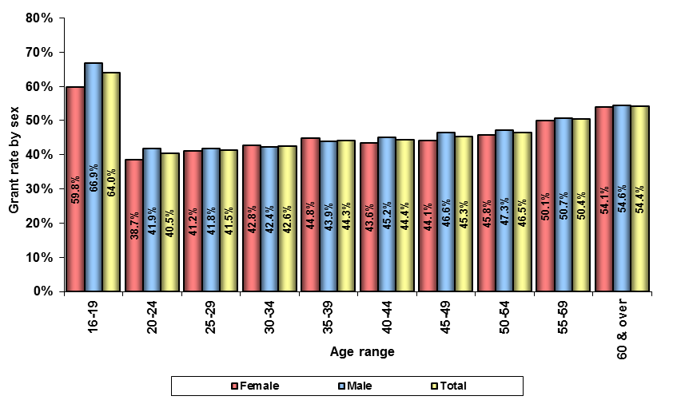

From June 2011 to June 2012, there were 134,157 new claims for DSP processed. Of these, 65,049 (48.5 percent) were granted DSP and 69,108 (51.5 percent) were rejected.

Excluding the 16 to 19 age range, the number of grants in each age range increases as the age of the claimant rises from 2,659 for 20 to 24 year olds to 12,824 for those claimants 60 years old and over.

Just over half (53.1 percent) of DSP grants were to males, and 46.9 percent were to females. More grants to claimants aged less than 45 and 60 years and over were to males than to females. There were more grants in the 45 to 59 age range to females than males.

The 16 to 19 year old range had a grant rate of 64.0 percent. For the other age ranges, the grant rate rises with each age incrementally from 40.5 percent for 20 to 24 year olds to 54.4 percent for those aged 60 and over. The grant rate for females was 47.6 percent and 49.3 percent for males.

Table 26 details the number and proportion of each sex granted DSP, DSP rejections and total claims for each year for the years ending from 2006-07 to 2011-12.

Table 26 – Finalised claims and grant rate – 2006-07 to 2011-12

Year | Female grant count | Female grant rate | Male grant count | Male grant rate | Total grant count | Grant rate | Female rejection count | Male rejection count | Total rejection count | Female total claim count | Male total claim count | Total claims count
2006-07 | 28,669 | 63.2% | 33,939 | 62.8% | 62,608 | 63.0% | 16,723 | 20,087 | 36,810 | 45,392 | 54,026 | 99,418
2007-08 | 36,901 | 64.5% | 37,778 | 63.7% | 74,679 | 64.1% | 20,296 | 21,555 | 41,851 | 57,197 | 59,333 | 116,530
2008-09 | 41,830 | 65.0% | 45,000 | 64.0% | 86,830 | 64.5% | 22,509 | 25,315 | 47,824 | 64,339 | 70,315 | 134,654
2009-10 | 43,988 | 64.2% | 47,143 | 63.6% | 91,131 | 63.9% | 24,557 | 27,021 | 51,578 | 68,545 | 74,164 | 142,709
2010-11 | 43,072 | 59.8% | 47,640 | 59.8% | 90,712 | 59.8% | 29,012 | 32,091 | 61,103 | 72,084 | 79,731 | 151,815
2011-12 | 30,481 | 47.6% | 34,568 | 49.3% | 65,049 | 48.5% | 33,614 | 35,494 | 69,108 | 64,095 | 70,062 | 134,157

Figure 26 shows the proportion of grants for each sex for the years from 2006-07 to 2011-12.

Figure 26 – Grant rate by sex – 2006-07 to 2011-12
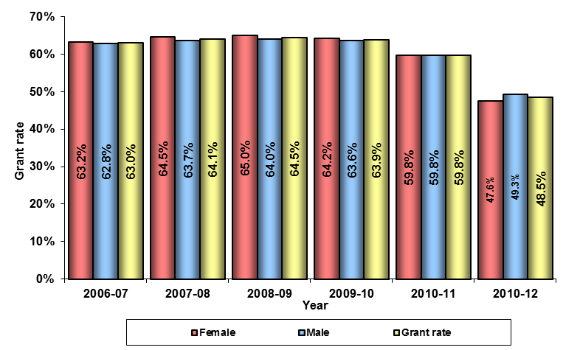
The number of DSP claims finalised rose from 99,418 in 2006-07 to 151,815 in
2010-11 and then fell to 134,157 in 2012. In 2006-07 females accounted for 45.7 percent of claims finalised and by 2011-12 that figure was 47.8 percent. The highest grant rate was 64.5 percent in 2008-09. In 2011-12 the grant rate had fallen to 48.5 percent.

In the financial year 2011-12 the grant rate for females was lower than the grant rate for males. Previously the grant rate for females had been slightly higher until 2010-11 when they were identical at 59.8 percent.

Grants by primary medical condition

Table 27 details the number and percentage of DSP grants between June 2011 and June 2012 by the primary medical condition of the claimant.

Table 27 – Grants by medical condition – 2011-12
Primary medical condition | Female count | % of female Total | Male count | % of male Total | Total grant count | % of Total grant count
Psychological/Psychiatric | 9,069 | 29.8% | 10,499 | 30.4% | 19,568 | 30.1%
Musculo-Skeletal & Connective Tissue | 7,760 | 25.5% | 7,491 | 21.7% | 15,251 | 23.4%
Cancer/Tumour | 2,651 | 8.7% | 3,183 | 9.2% | 5,834 | 9.0%
Intellectual/Learning | 1,832 | 6.0% | 3,035 | 8.8% | 4,867 | 7.5%
Nervous System | 1,837 | 6.0% | 1,698 | 4.9% | 3,535 | 5.4%
Circulatory System | 1,097 | 3.6% | 2,299 | 6.7% | 3,396 | 5.2%
Respiratory System | 986 | 3.2% | 1,017 | 2.9% | 2,003 | 3.1%
Endocrine & Immune System | 858 | 2.8% | 827 | 2.4% | 1,685 | 2.6%
Acquired Brain Impairment | 468 | 1.5% | 1,001 | 2.9% | 1,469 | 2.3%
Sense Organs | 672 | 2.2% | 770 | 2.2% | 1,442 | 2.2%
Chronic Pain | 667 | 2.2% | 604 | 1.7% | 1,271 | 2.0%
Poorly Defined Cause | 907 | 3.0% | 237 | 0.7% | 1,144 | 1.8%
Gastro-Intestinal System | 463 | 1.5% | 324 | 0.9% | 787 | 1.2%
Urogenital System | 350 | 1.1% | 374 | 1.1% | 724 | 1.1%
Congenital Anomalies | 284 | 0.9% | 328 | 0.9% | 612 | 0.9%
Visceral Disorder | 177 | 0.6% | 363 | 1.1% | 540 | 0.8%
Infectious Diseases | 81 | 0.3% | 153 | 0.4% | 234 | 0.4%
Other | 322 | 1.1% | 365 | 1.1% | 687 | 1.1%
Total | 30,481 | 100.0% | 34,568 | 100.0% | 65,049 | 100.0%

Figure 27 shows the percentage of grants in the period from June 2011 to June 2012 by the top five primary medical conditions and sex.

Figure 27 – Grants by top 5 primary medical conditions – 2011-12
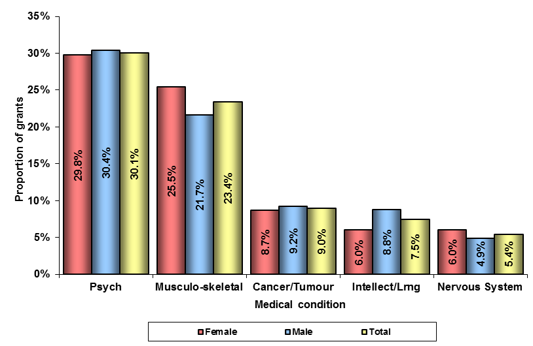

Psychological/psychiatric and Musculo-skeletal & connective tissue are the largest categories granted accounting for 53.5 percent of grants. This is similar to the proportion in the recipient population (see Table 14) where these two primary medical conditions account for 57.5 percent of the population.

Psychological/psychiatric and Musculo-skeletal & connective tissue are the primary medical conditions for 55.2 percent of all grants to females and 52.0 percent of all grants to males.

Table 28 details the count and proportion of DSP grants by medical condition (top five and others) for the years from 2006-07 to 2011-12.

Table 28 – Grants by top 5 primary medical conditions – 2006-07 to 2011-12
Year | Psychological/psychiatric grant count | Psychological/psychiatric grants  as a % of Total grant count | Musculo-skeletal & connective tissue  grant count | Musculo-skeletal & connective tissue grants  as a % of Total grant count | Intellectual/learning grant count | Intellectual/learning grants  as a % of Total grant count | Cancer/tumour grants count | Cancer/tumour grants  as a % of Total grant count | Circulatory system grant count | Circulatory system grants  as a % of Total grant count | Other medical condition grant count | Other medical condition grants  as a % of Total grant count | Total grant count
2006-07 | 15,020 | 24.0% | 18,807 | 30.0% | 3,674 | 5.9% | 4,889 | 7.8% | 4,248 | 6.8% | 15,970 | 25.5% | 62,608
2007-08 | 18,500 | 24.8% | 22,728 | 30.4% | 4,404 | 5.9% | 5,200 | 7.0% | 4,901 | 6.6% | 18,946 | 25.4% | 74,679
2008-09 | 23,134 | 26.6% | 25,479 | 29.3% | 5,971 | 6.9% | 5,713 | 6.6% | 5,334 | 6.1% | 21,199 | 24.4% | 86,830
2009-10 | 24,707 | 27.1% | 25,965 | 28.5% | 6,615 | 7.3% | 5,865 | 6.4% | 5,544 | 6.1% | 22,435 | 24.6% | 91,131
2010-11 | 26,247 | 28.9% | 25,190 | 27.8% | 6,171 | 6.8% | 6,101 | 6.7% | 5,174 | 5.7% | 21,829 | 24.1% | 90,712
2011-12 | 19,568 | 30.1% | 15,251 | 23.4% | 4,867 | 7.5% | 5,834 | 9.0% | 3,396 | 5.2% | 16,133 | 24.8% | 65,049

Figure 28 shows the proportion of DSP grants by the top five primary medical conditions for the years from 2006-07 to 2011-12.

Figure 28 – Grants by top 5 primary medical conditions – 2006-07 to 2011-12
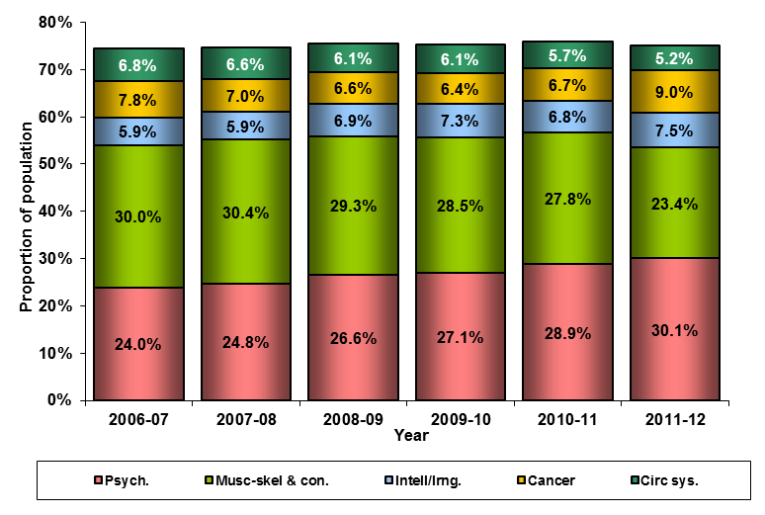
In the years from 2006-07 to 2011-12, the proportion of new grants in the Musculo-skeletal & connective tissue, have fallen from 30.0 percent to 23.4 percent. In the same period, Psychological/ psychiatric has risen in proportion from 24.0 percent to 30.1 percent of grants.
Table 29 details the proportion of new claims granted for each sex for the top five primary medical conditions for the years from 2006-07 to 2011-12.

Table 29 – Grants by sex by primary medical condition – 2006-07 to 2011-12
Year | Female  'Psychological/psychiatric' grants  as a % of Total female grants | Male  'Psychological/psychiatric' grants  as a % of Total male grants | Female  'Musculo-skeletal  & connective tissue' grants  as a % of Total female grants | Male  'Musculo-skeletal  & connective tissue' grants  as a % of Total male grants | Female  'Intellectual/learning' grants  as a % of Total female grants | Male  'Intellectual/learning' grants  as a % of Total male grants | Female  'Cancer/Tumour' grants  as a % of Total female grants | Male  'Cancer/Tumour' grants  as a % of Total male grants | Female  'Circulatory system' grants  as a % of Total female grants | Male  'Circulatory system' grants  as a % of Total male grants | Female  'Other' medical condition grants  as a % of Total female grants | Male  'Other' medical condition grants  as a % of Total male grants
2006-07 | 24.0% | 24.0% | 32.0% | 28.4% | 5.0% | 6.6% | 7.3% | 8.2% | 4.6% | 8.7% | 27.1% | 24.1%
2007-08 | 25.3% | 24.3% | 32.5% | 28.4% | 4.8% | 6.9% | 6.2% | 7.7% | 4.4% | 8.6% | 26.8% | 24.1%
2008-09 | 26.8% | 26.5% | 31.4% | 27.4% | 5.7% | 7.9% | 6.2% | 6.9% | 4.2% | 7.9% | 25.7% | 23.4%
2009-10 | 27.3% | 26.9% | 30.5% | 26.6% | 5.9% | 8.5% | 6.1% | 6.8% | 4.4% | 7.6% | 25.8% | 23.6%
2010-11 | 29.3% | 28.6% | 29.8% | 25.9% | 5.4% | 8.0% | 6.3% | 7.1% | 4.0% | 7.2% | 25.1% | 23.1%
2011-12 | 29.8% | 30.4% | 25.5% | 21.7% | 6.0% | 8.8% | 8.7% | 9.2% | 3.6% | 6.7% | 26.5% | 23.3%

Figure 29 shows the proportion of each sex granted DSP for the top three primary medical conditions for the years 2006-07 to 2011-12.

Figure 29 – Grants by sex by primary medical condition – 2006-07 to 2011-12
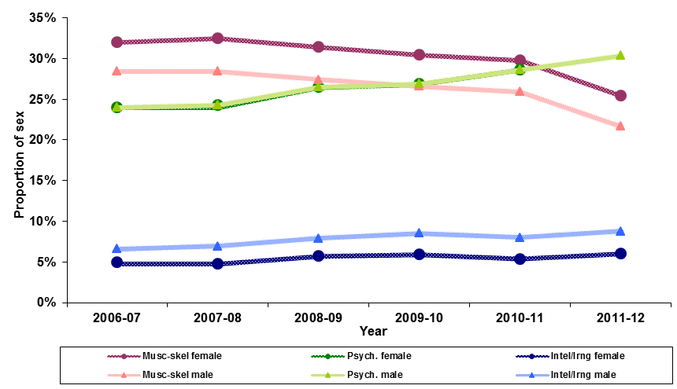

The higher proportion of females granted with Musculo-skeletal & connective tissue conditions than males has been consistent throughout the years from 2006-07 to
2011-12, as has the lower proportion of females granted with Intellectual/learning conditions.
Table 30 details the DSP grants made from June 2011 to June 2012 by the top five primary medical conditions and age range.

Table 30 – Grants by top 5 primary medical conditions and age range – 2011-12
Year | Psychological/psychiatric grant count | Psychological/psychiatric grants  as a % of  Total Psychological/psychiatric grants | Musculo-skeletal  & connective tissue grant count | Musculo-skeletal & connective tissue grants  as a % of  Total Musculo-skeletal  & connective tissue grants | Intellectual/learning grant count | Intellectual/learning grants  as a % of Total Intellectual/learning grants | Cancer/tumour grants count | Cancer/tumour grants  as a % of Total Cancer/tumour grants | Circulatory system grant count | Circulatory system grants  as a % of Total Circulatory system grant count
16-24 | 3,324 | 17.0% | 212 | 1.4% | 3,649 | 75.0% | 157 | 2.7% | 82 | 2.4%
25-34 | 3,527 | 18.0% | 654 | 4.3% | 436 | 9.0% | 249 | 4.3% | 99 | 2.9%
35-44 | 4,903 | 25.1% | 2,001 | 13.1% | 346 | 7.1% | 570 | 9.8% | 249 | 7.3%
45-54 | 4,642 | 23.7% | 4,253 | 27.9% | 301 | 6.2% | 1,637 | 28.1% | 781 | 23.0%
55 & over | 3,172 | 16.2% | 8,131 | 53.3% | 135 | 2.8% | 3,221 | 55.2% | 2,185 | 64.3%
Total | 19,568 | 100.0% | 15,251 | 100.0% | 4,867 | 100.0% | 5,834 | 100.0% | 3,396 | 100.0%

Figure 30 shows the proportion of the 2011-12 grants for each of the top five primary medical conditions by age range.

Figure 30 – Grants for top 5 medical conditions by age range – 2011-12
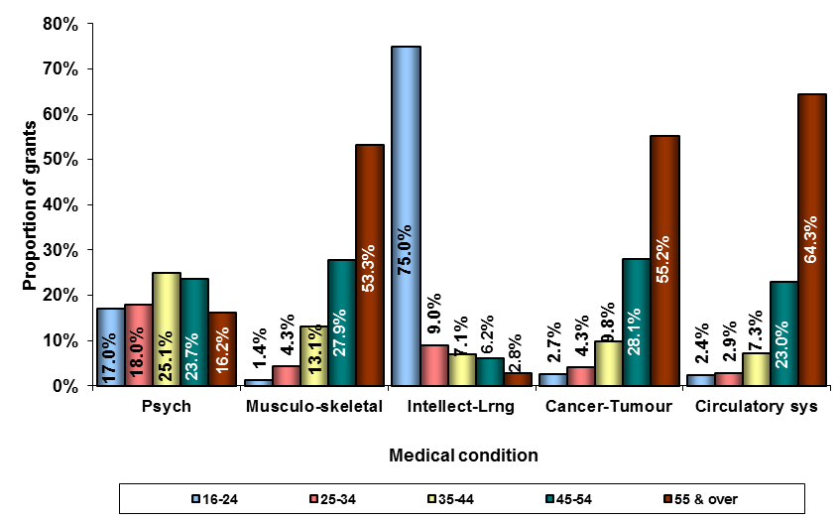

Where Musculo-skeletal and connective tissue was recorded as the primary medical condition, the majority of granted claims (53.3 percent) were to people aged 55 years and above. The number of claims granted rises as the age of the claimant increases.

Granted claims for people with Psychological/psychiatric as the primary medical condition are fairly evenly spread across all of the age ranges. Three quarters
(75.0 percent) of claims granted where Intellectual/learning was recorded as the primary medical condition, were to claimants in the 16 to 24 year age range.

The distribution of claims granted across age ranges for applicants with Cancer/tumour and Circulatory system recorded as their primary medical condition is a similar pattern to that of the Musculo-skeletal and connective tissue category with the number of claims granted rising as the age of the claimant increases.

Rejections

Table 31 details the number and proportion of claims rejected in the period from June 2011 to June 2012 by rejection reason and sex.

Table 31 – Rejections by reason and sex – 2011-12
Rejection reason | Female rejection reason count | % of Total female rejections count | Male rejection reason count | % of Total male rejections count | Total rejection reason count | % of Total rejections count
Medical rejection reasons
Impairment less than 20 points | 10,116 | 30.1% | 10,331 | 29.1% | 20,447 | 29.6%
Medical Condition Not Fully Diagnosed Treated Stabilised | 9,599 | 28.6% | 9,677 | 27.3% | 19,276 | 27.9%
Disability Is Short Term | 4,942 | 14.7% | 5,130 | 14.5% | 10,072 | 14.6%
Manifest - Temporary | 690 | 2.1% | 731 | 2.1% | 1,421 | 2.1%
>20 points Impaired/Can Work 15+ Hrs P/W | 274 | 0.8% | 398 | 1.1% | 672 | 1.0%
>20 points Impaired/Reskill 15+ Hrs P/W | 246 | 0.7% | 304 | 0.9% | 550 | 0.8%
Manifest - Not Sufficient Impairment | 159 | 0.5% | 171 | 0.5% | 330 | 0.5%
Manifest - Can Work 15+ Hrs P/W | 140 | 0.4% | 134 | 0.4% | 274 | 0.4%
Other | 30 | 0.1% | 33 | 0.1% | 63 | 0.1%
Sub-Total medical rejections | 26,196 | 77.9% | 26,909 | 75.8% | 53,105 | 76.8%
Non-medical rejection reasons
Failed To Supply Requested Information | 4,507 | 13.4% | 5,612 | 15.8% | 10,119 | 14.6%
Excess Income | 819 | 2.4% | 671 | 1.9% | 1,490 | 2.2%
Did Not Meet Program Of Support Requirements | 759 | 2.3% | 655 | 1.8% | 1,414 | 2.0%
Residence Related | 526 | 1.6% | 418 | 1.2% | 944 | 1.4%
Failed Agreement Specific Rules | 244 | 0.7% | 290 | 0.8% | 534 | 0.8%
Compensation Related | 267 | 0.8% | 557 | 1.6% | 824 | 1.2%
Withdrawn/Voluntary Surrender | 92 | 0.3% | 86 | 0.2% | 178 | 0.3%
Assets Over Limit *Auto | 69 | 0.2% | 88 | 0.2% | 157 | 0.2%
Does Not Meet Age Requirements | 31 | 0.1% | 39 | 0.1% | 70 | 0.1%
Other | 104 | 0.3% | 169 | 0.5% | 273 | 0.4%
Sub-Total non-medical rejection reasons | 7,418 | 22.1% | 8,585 | 24.2% | 16,003 | 23.2%
Total Rejections | 33,614 | 100.0% | 35,494 | 100.0% | 69,108 | 100.0%

Figure 31 shows the proportion of claims rejected for each sex in the period from June 2011 to June 2012, by the top four rejection reasons.

Figure 31 – Rejections by top 4 reasons and sex – 2011-12
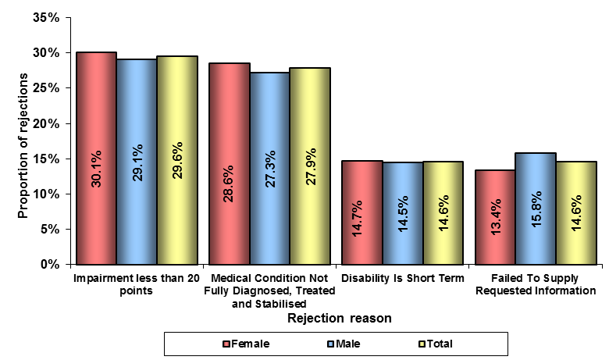

In 2011-12 134,157 claims for DSP were finalised. Of these, 69,108 were rejected (51.5 percent). Medical rejections comprised 76.8 percent of all rejections, while non-medical rejections comprised 23.2 percent.

The main reason for rejection was that the claimant was assessed as having an impairment of less than 20 points (29.6 percent of all rejections). This was followed by claims where the assessed medical condition was not fully diagnosed, treated and stabilised (27.9 percent). This is a new rejection reason that was introduced in September 2011 and until that point, claims rejected because a person’s condition was not fully diagnosed, treated and stabilised were reflected under the rejection reasons ‘Disability is short-term’ and ‘Less than 20 points impaired.

Males accounted for 51.4 percent of total rejections and females for 48.6 percent. Medical rejections comprised 77.9 percent of female rejections and 75.8 percent of male rejections.

For females, 30.1 percent of all rejections were because their impairment was less than 20 points. For males this figure was 29.1 percent. Failing to provide requested information accounted for 15.8 percent of male and 13.4 percent of female rejections.

Table 32 details the number and proportion of DSP rejections by top five rejection reasons and others for the years from 2006-07 to 2011-12.

Table 32 – Rejections by main reasons – 2006-07 to 2011-12
Year | Disability is short-term count | Disability is short-term  as a % of Total count | Less than 20 points impaired count | Less than 20 points impaired  as a % of Total count | Medical Condition Not Fully Diagnosed, Treated and Stabilised count | Medical Condition Not Fully Diagnosed, Treated and Stabilised  as a % of Total count | Failed to Supply Information count | Failed to Supply Information  as a % of Total count | Greater than 20 points impaired but can work 15+ hours per week count | Greater than 20 points impaired but can work 15+ hours per week  as a % of Total count | Other rejection reasons count | Other rejection reasons  as a % of Total count | Total count
2006-07 | 10,517 | 28.6% | 10,178 | 27.7% | - | - | 5,765 | 15.7% | 1,678 | 4.6% | 8,672 | 23.6% | 36,810
2007-08 | 5,876 | 14.0% | 18,338 | 43.8% | - | - | 7,760 | 18.5% | 1,717 | 4.1% | 8,160 | 19.5% | 41,851
2008-09 | 4,388 | 9.2% | 23,341 | 48.8% | - | - | 9,338 | 19.5% | 1,464 | 3.1% | 9,293 | 19.4% | 47,824
2009-10 | 4,221 | 8.2% | 27,628 | 53.6% | - | - | 9,021 | 17.5% | 1,540 | 3.0% | 9,414 | 18.3% | 51,578
2010-11 | 20,912 | 34.2% | 19,632 | 32.1% | - | - | 9,521 | 15.6% | 1,538 | 2.5% | 9,500 | 15.5% | 61,103
2011-12 | 10,072 | 14.6% | 20,447 | 29.6% | 19,276 | 27.9% | 10,119 | 14.6% | 672 | 1.0% | 8,522 | 12.3% | 69,108
Note: Significant fluctuations in counts for some rejection reasons are due to changes in rejection reason coding conventions.

Figure 32 shows the proportion of DSP rejections for the main reasons for rejections for the years from 2006-07 to 2011-12.

Figure 32 – Rejections by main reasons – 2006-07 to 2011-12
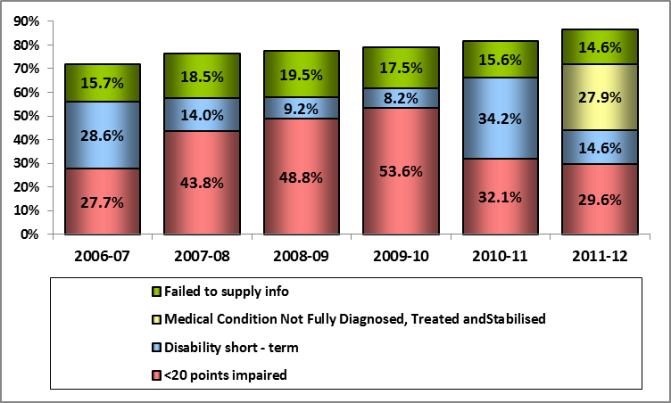

Significant fluctuations in counts for these rejection reasons are mainly due to changes in rejection reason coding conventions. ‘Medical conditions not fully diagnosed, treated and stabilised’ is a new rejection reason that was introduced in September 2011. Until that point, claims rejected because a person’s condition was not fully diagnosed, treated and stabilised were reflected under the rejection reasons ‘Disability is short term’ and ‘Less than 20 points impaired’.

In 2006-07 the proportion of rejections due to the claimant’s disability being considered as short-term was 28.6 percent. This rejection reason reduced considerably over the next three years, however, significantly increased during 2010-11 to 34.2 percent only to fall again in 2011-12 to 14.6 percent.

Over the same period the proportion of rejections because the claimant’s disability was of ‘less than 20 points’ rose consistently between 2006-07 to 2009-10, however it dropped considerably during 2010-11 (21.5 %) and a further 2.5 percent in 2011-12.

Table 33 details the percentage of clients of each sex with rejected DSP applications by the top five rejection reasons for the years 2006-07 to 2011-12.

Table 33 – Rejections by sex by top 5 rejection reasons – 2006-07 to 2011-12
Year | Female 'Disability is short-term'  as a % of Total female rejections | Male 'Disability is short-term'  as a % of Total male rejections | Female 'Less than 20 points impaired'  as a % of Total female rejections | Male 'Less than 20 points impaired'  as a % of Total male rejections | Female 'Medical Condition Not Fully  Diagnosed, Treated and Stabilised'  as a % of Total female rejections | Male 'Medical Condition Not Fully  Diagnosed, Treated and Stabilised'  as a % of Total male rejections | Female 'Failed to supply information'  as a % of Total female rejections | Male 'Failed to supply information'  as a % of Total male rejections | Female 'Greater than 20 points impaired  but can work 15+ hours per week'  as a % of Total female rejections | Male 'Greater than 20 points impaired  but can work 15+ hours per week'  as a % of Total male rejections | Female 'Other' rejection reasons  as a % of Total female rejections | Male 'Other' rejection reasons  as a % of Total male rejections
2006-07 | 28.8% | 28.4% | 28.5% | 26.9% | - | - | 15.2% | 16.1% | 4.2% | 4.9% | 23.3% | 23.7%
2007-08 | 14.2% | 13.9% | 45.4% | 42.3% | - | - | 17.7% | 19.3% | 3.8% | 4.4% | 18.9% | 20.1%
2008-09 | 9.1% | 9.3% | 50.4% | 47.4% | - | - | 18.5% | 20.5% | 2.8% | 3.3% | 19.2% | 19.5%
2009-10 | 8.0% | 8.4% | 55.1% | 52.2% | - | - | 16.4% | 18.5% | 2.7% | 3.3% | 17.8% | 17.6%
2010-11 | 34.6% | 33.9% | 33.4% | 31.0% | - | - | 14.4% | 16.6% | 1.8% | 2.1% | 15.8% | 16.4%
2011-12 | 14.7% | 14.5% | 30.1% | 29.1% | 28.6% | 27.3% | 13.4% | 15.8% | 0.8% | 1.1% | 41.0% | 39.5%

Figure 33 shows the percentage of each sex with rejected DSP applications by the top three rejection reasons for the year 2011-12.

Figure 33 – Rejections by sex by top 3 rejection reasons – 2006-07 to 2011-12
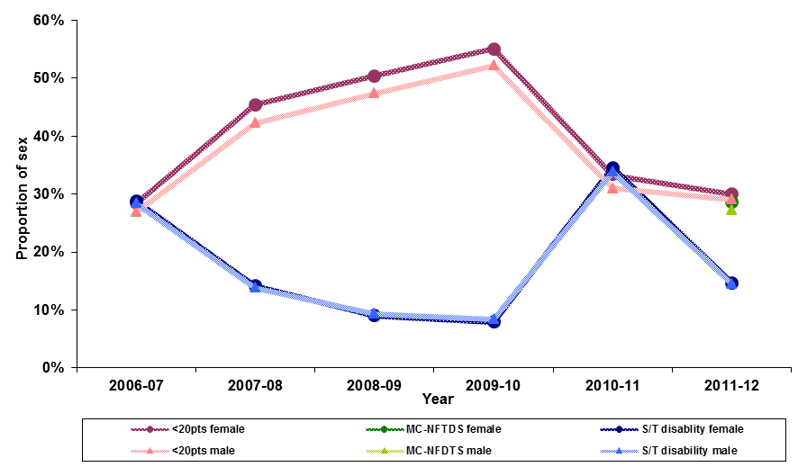

For the years from 2006-07 to 2011-12, a higher proportion of females than males were rejected on the basis that their impairment was assessed at less than twenty points against the Impairment Tables. A higher proportion of males than females were rejected for failing to supply requested information. Rejections because the claimant’s disability is short-term have remained gender-balanced.

Where DSP recipients are coming from and going to

Where DSP recipients are coming from

Table 34 details the number and proportion of ‘new entrants’ between June 2011 and June 2012 by their previous income support payment.

Table 34 – New entrants by previous income support type – 2012
Previous status/income support payment | New entrants count | % of Total  New entrants count
Non client | 29,780 | 48.4%
Newstart Allowance | 22,769 | 37.0%
Parenting Payment Single | 2,414 | 3.9%
Youth Allowance | 2,047 | 3.3%
Carer Payment | 1,687 | 2.7%
Parenting Payment Partnered | 664 | 1.1%
Sickness Allowance | 792 | 1.3%
Widow Allowance | 561 | 0.9%
Other income support payments | 795 | 1.3%
Total | 61,509 | 100.0%

Figure 34 shows the proportion of new entrants between June 2011 and June 2012 by their previous income support payment.

Figure 34 – New entrants by previous income support type – 2012
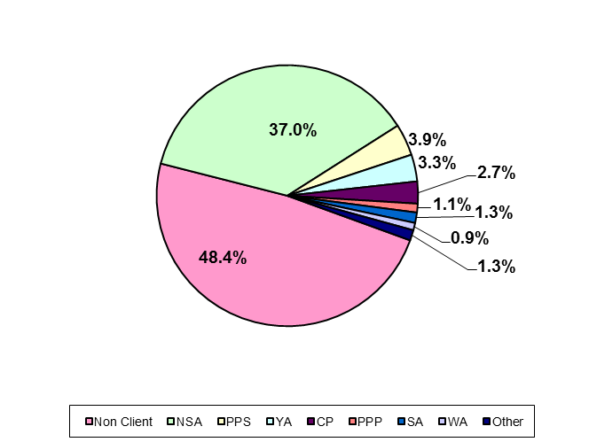

There were 61,509 DSP recipients in June 2012 who were not receiving DSP in June 2011. Of these ‘new entrants’, 48.4 percent were not receiving an income support payment at June 2011, while 51.6 percent were in receipt of another income support payment with Newstart Allowance being the largest accounting for 37.0 percent.

The remaining 15.5 percent of ‘new entrants’ to DSP were receiving a range of other payments, including Parenting Payment (Single & Partnered), Youth Allowance, Sickness Allowance and Partner Allowance.
Table 35 details the number and proportion of ‘new entrants’ for each reporting year by their previous income support type for the reporting years from 2001 to 2012.

Table 35 – New entrants by prior income support type – 2001 to 2012
Year* | Newstart Allowance count | Newstart Allowance as a % of  Total new entrants count | Parenting Payments count | Parenting Payments as a % of  Total new entrants count | Other payments count | Other payments as a % of  Total new entrants count | Total income support count | Total income support as a % of  Total new entrants count | Non client count | Non client count as a % of  Total new entrants count | Total new entrants count
2001 | 26,543 | 34.4% | 4,314 | 5.6% | 11,788 | 15.3% | 42,645 | 55.2% | 34,554 | 44.8% | 77,199
2002 | 27,787 | 35.0% | 3,754 | 4.7% | 12,839 | 16.2% | 44,380 | 55.9% | 35,070 | 44.1% | 79,450
2003 | 22,180 | 32.9% | 3,745 | 5.6% | 10,862 | 16.1% | 36,787 | 54.6% | 30,622 | 45.4% | 67,409
2004 | 22,739 | 32.3% | 4,045 | 5.7% | 11,698 | 16.6% | 38,482 | 54.6% | 32,024 | 45.4% | 70,506
2005 | 21,238 | 32.7% | 4,108 | 6.3% | 10,198 | 15.7% | 35,544 | 54.7% | 29,410 | 45.3% | 64,954
2006 | 18,954 | 32.8% | 3,751 | 6.5% | 8,546 | 14.8% | 31,251 | 54.1% | 26,547 | 45.9% | 57,798
2007 | 20,839 | 34.1% | 4,471 | 7.3% | 8,745 | 14.3% | 34,055 | 55.8% | 27,008 | 44.2% | 61,063
2008 | 24,398 | 35.2% | 8,326 | 12.0% | 6,172 | 8.9% | 38,896 | 56.2% | 30,355 | 43.8% | 69,251
2009 | 29,584 | 36.6% | 6,453 | 8.0% | 6,862 | 8.5% | 42,899 | 53.0% | 38,010 | 47.0% | 80,909
2010 | 32,065 | 37.7% | 6,142 | 7.2% | 7,844 | 9.2% | 46,051 | 54.2% | 38,972 | 45.8% | 85,023
2011 | 33,818 | 40.0% | 5,392 | 6.4% | 7,779 | 9.2% | 46,989 | 55.5% | 37,618 | 44.5% | 84,607
2012 | 22,769 | 37.0% | 3,078 | 5.0% | 5,882 | 9.6% | 31,729 | 51.6% | 29,780 | 48.4% | 61,509
* Note: ‘Year’ denotes reporting year – i.e. clients counted were in receipt of DSP as at June of that year but not at June of the year before.

Figure 35 shows the proportion of ‘new entrants’ for each reporting year by their previous income support payment type for the reporting years from 2001 to 2012.

Figure 35 – New entrants by prior income support type – 2001 to 2012
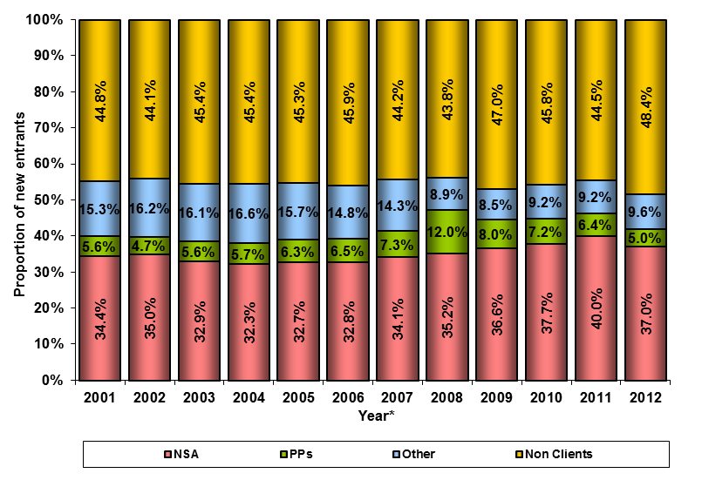
* Denotes year of report – ie clients counted were in receipt of DSP as at June of that year but not June of the year before.

In the 2001 reporting year, the proportion of ‘new entrants’ to DSP whose previous income support payment type was Newstart Allowance was 34.4 percent. In 2012 the proportion was 37.0 percent.

The proportion of ‘new entrants’ who were not in receipt of another income support payment a year before the report date was reasonably steady at around 45 percent in the reporting years from 2001 to 2011, excluding 2009 when the figure was 47.0 percent. In 2012 the proportion that were ‘new entrants’ increased to 48.4 percent.

Where DSP recipients are exiting to

Table 36 details the number and proportion of clients who were DSP recipients as at 24 June 2011 but no longer in receipt of DSP at 29 June 2012 (‘exits from DSP’) by their subsequent status or income support payment type.

Table 36 – Exits by subsequent status/income support payment type – 2012
Subsequent status / income support type | Exits count | % of Total Exits count
Age Pension | 30,366 | 57.4%
Deaths | 12,346 | 23.3%
Non client | 8,903 | 16.8%
Newstart/Youth Allowance | 559 | 1.1%
Carer Payment | 396 | 0.7%
Parenting Payment | 94 | 0.2%
Other income support payments | 235 | 0.4%
Total | 52,899 | 100.0%

Figure 36 shows the proportion of ‘exits from DSP’ by subsequent status or income support payment type as at June 2012.

Figure 36 – Exits by subsequent status/income support payment type – 2012
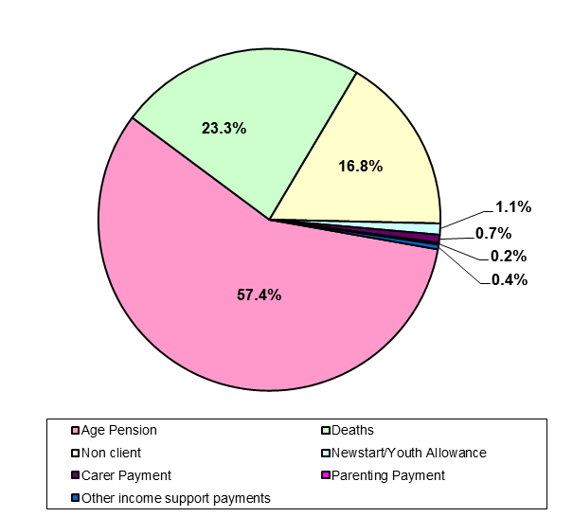

There were 52,899 clients who were in receipt of DSP as at 24 June 2011 who were no longer receiving that pension at 29 June 2012. Of these, 30,366 (57.4 percent) exited to Age Pension and 21,249 (40.2 percent) were no longer in receipt of income support or were deceased.

Table 37 details the number and proportion of ‘exits from DSP’ by their subsequent status or income support payment type for the reporting years from 2001 to 2012.

Table 37 – Exits by subsequent income support type –2001 to 2012
Year* | Age Pension count | Age Pension  as a % of Total exits | Other payment count | Other payment  as a % of Total exits | Total income support count | Total income support  as a % of Total exits | Non client  (includes deceased)  count | Non client (includes deceased) as a % of  Total exits | Total exits
2001 | 30,028 | 58.3% | 2,268 | 4.4% | 32,296 | 62.7% | 19,211 | 37.3% | 51,507
2002 | 25,315 | 52.5% | 2,511 | 5.2% | 27,826 | 57.8% | 20,354 | 42.2% | 48,180
2003 | 31,146 | 56.7% | 2,681 | 4.9% | 33,827 | 61.6% | 21,112 | 38.4% | 54,939
2004 | 24,246 | 50.2% | 2,828 | 5.9% | 27,074 | 56.0% | 21,260 | 44.0% | 48,334
2005 | 32,521 | 55.6% | 2,898 | 5.0% | 35,419 | 60.5% | 23,085 | 39.5% | 58,504
2006 | 26,224 | 48.4% | 3,692 | 6.8% | 29,916 | 55.2% | 24,245 | 44.8% | 54,161
2007 | 32,160 | 53.3% | 3,641 | 6.0% | 35,801 | 59.4% | 24,494 | 40.6% | 60,295
2008 | 24,431 | 47.8% | 3,652 | 7.1% | 28,083 | 54.9% | 23,047 | 45.1% | 51,130
2009 | 34,018 | 60.6% | 2,157 | 3.8% | 36,175 | 64.4% | 19,983 | 35.6% | 56,158
2010 | 27,478 | 55.4% | 1,502 | 3.0% | 28,980 | 58.5% | 20,580 | 41.5% | 49,560
2011 | 36,127 | 61.9% | 1,266 | 2.2% | 37,393 | 64.1% | 20,945 | 35.9% | 58,338
2012 | 30,366 | 57.4% | 1,284 | 2.4% | 31,650 | 59.8% | 21,249 | 40.2% | 52,899
* Note: ‘Year’ denotes the reporting year – i.e. the clients counted were not receiving DSP at June of that year but were DSP recipients at June of the previous year.

In the reporting years from 2001 to 2012 there is a fluctuation in the number of recipients exiting to Age Pension with odd numbered years having a higher value and even numbered years a lower value. This pattern coincides with the changing Age Pension qualification age for women, which has been rising by six months every two years.

Figure 37 shows the proportion of ‘exits from DSP’ by the subsequent status or income support type for the reporting years from 2001 to 2012.

Figure 37 – Exits by subsequent income support type – 2001 to 2012
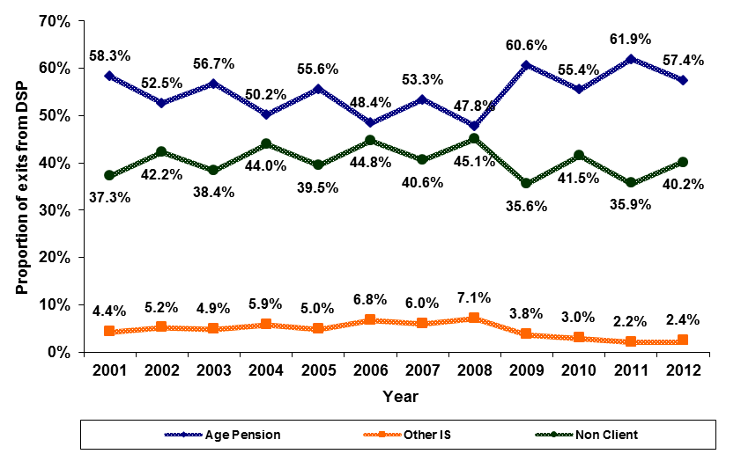

In the years from 2001 to 2008 the proportion of exits from DSP to Age Pension fell from 58.3 percent to 47.8 percent. In 2012 it stood at 57.4 percent.

Grant rate (%) = Grants/(Grants + Rejections) x 100
Note that the number of ‘new entrants’ is not the same as the number of grants. This is because ‘new entrants’ are people on DSP in June 2012 who were not receiving DSP in June 2011, while the number of grants is a count of claims granted during a period and some clients may be granted more than once in the period, ie they may be granted, cancelled and re-granted or no longer be receiving DSP as at June 2012.
See footnote 1 (page 6).
See footnote 2 (page 7)

